**1)Project:**

**Problem Statement:**

* Write a mapreduce and pig program to calculate the number of cases investigated under each FBI code.
* Write a mapreduce and pig program to calculate the number of cases investigated under FBI code 32.
* Write a mapreduce and pig program to calculate the number of

Arrests in theft district wise.

* Write a mapreduce and pig program to calculate the number of arrests done between October 2014 and October 2015.

**##Driver class:**

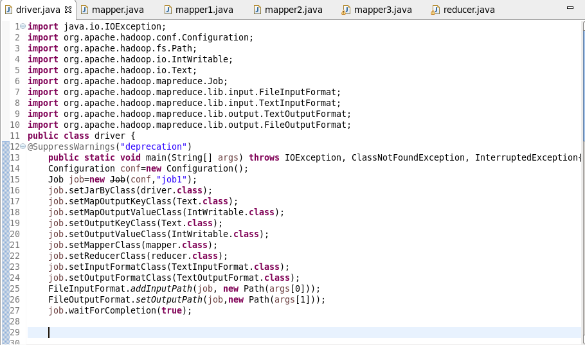

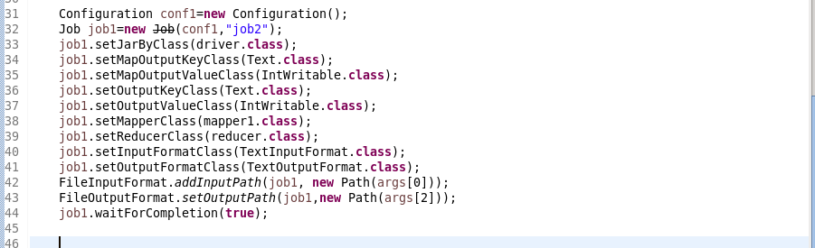

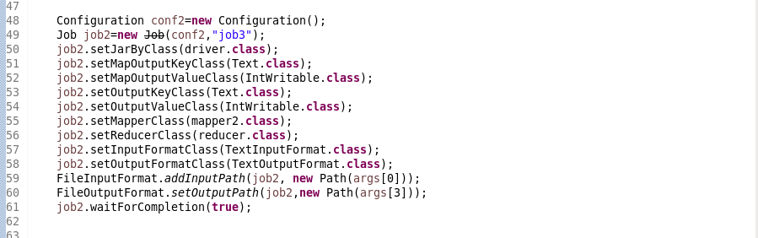

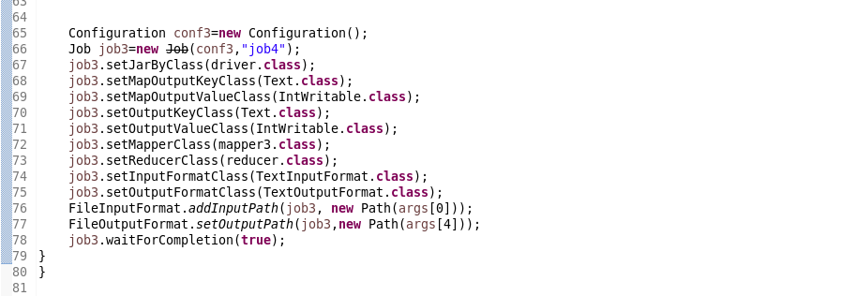

In this driver class (task class) we are creating 4 objects of job dedicated to each problem statement. Respective mapper class and reducer class are set. All the required configurations are set such as input path, output path etc.

All four jobs are included in same driver class.

**Problem1:**

**##Mapper class**

FBI code is given as key and count of 1 as value for each case.

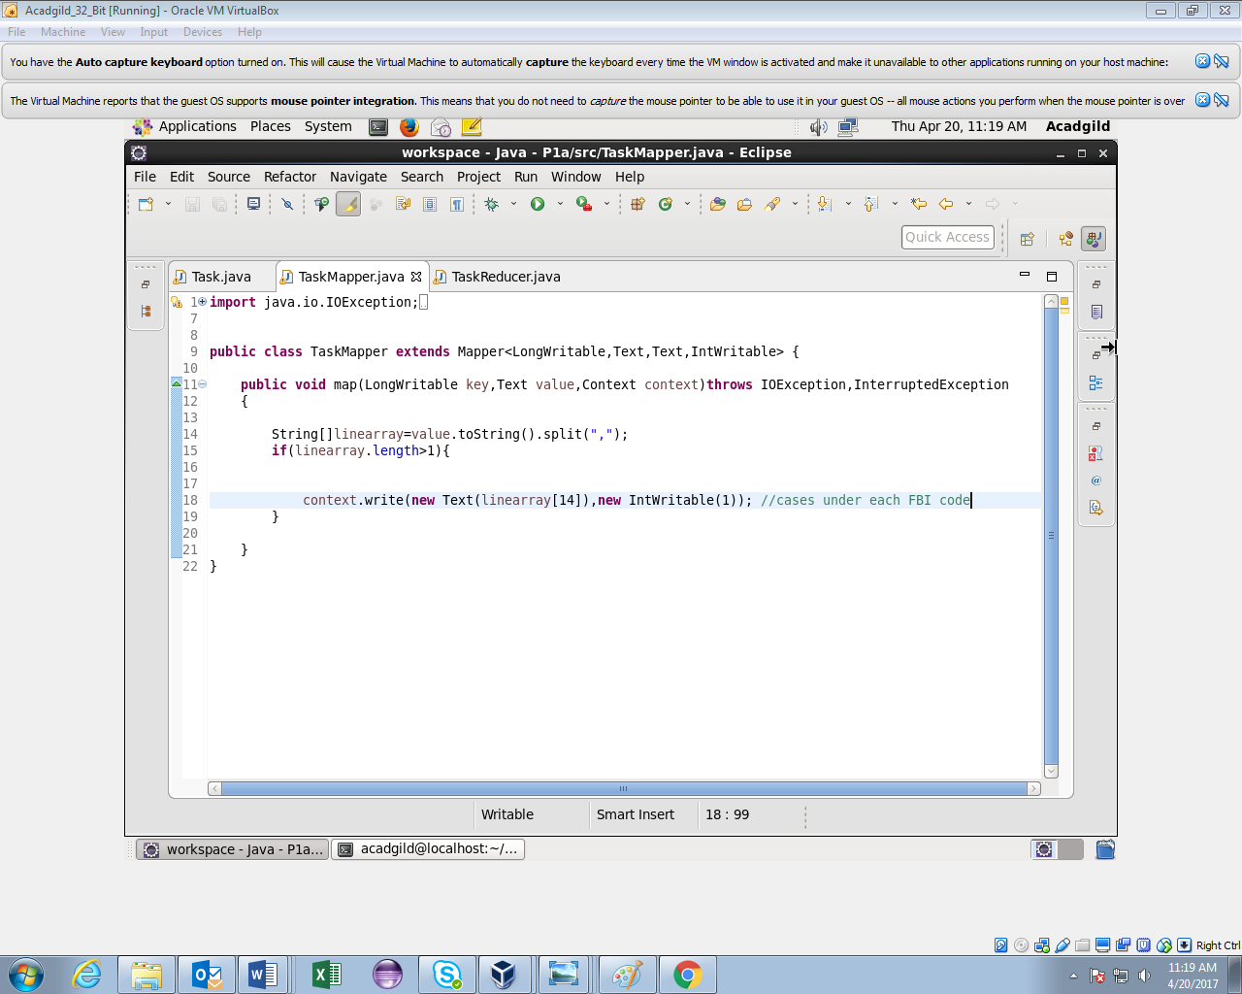

**##Reducer**

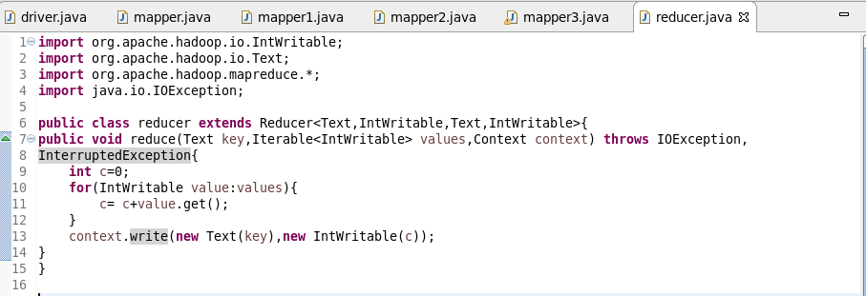

**##pig script**

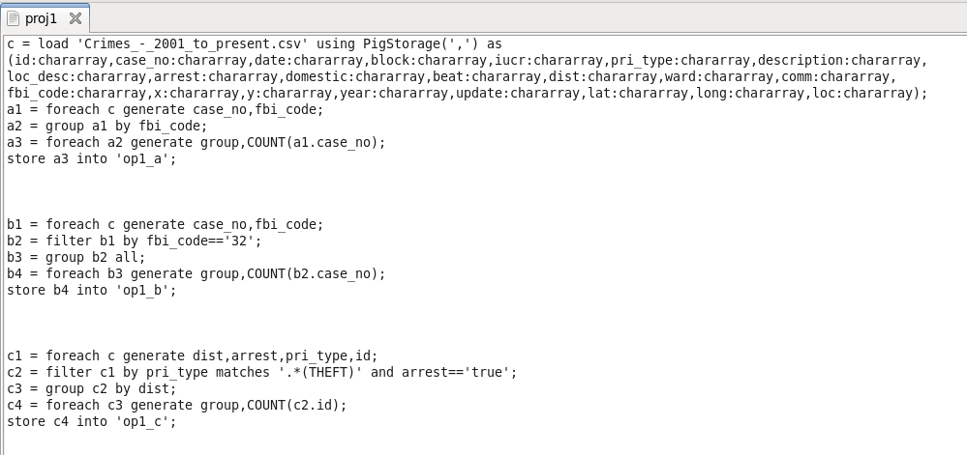

**##output**

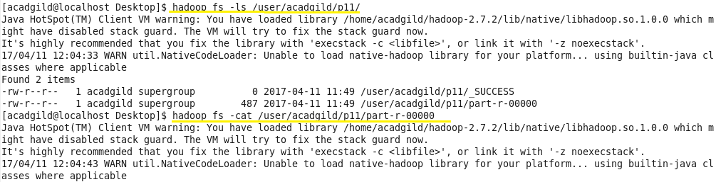

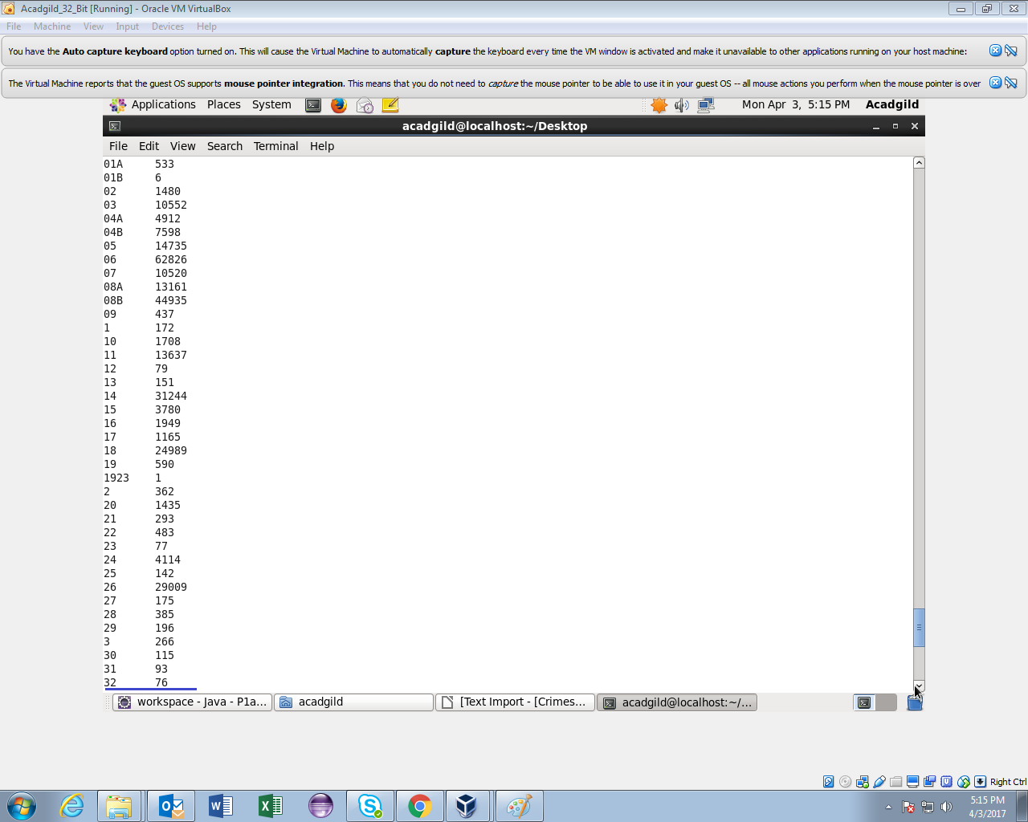

* It contains part file which holds the number of cases investigated under each FBI code.

**Problem 2:**

**##Mapper**

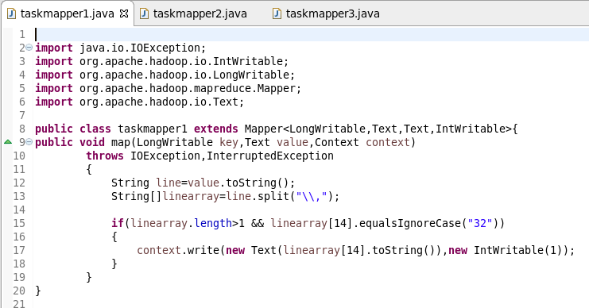

**##Reducer**



**##pig script:**



**##output**

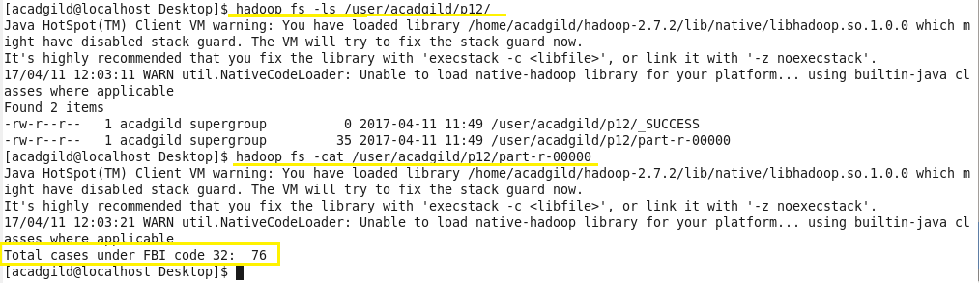

**Problem 3:**

**##mapper class**

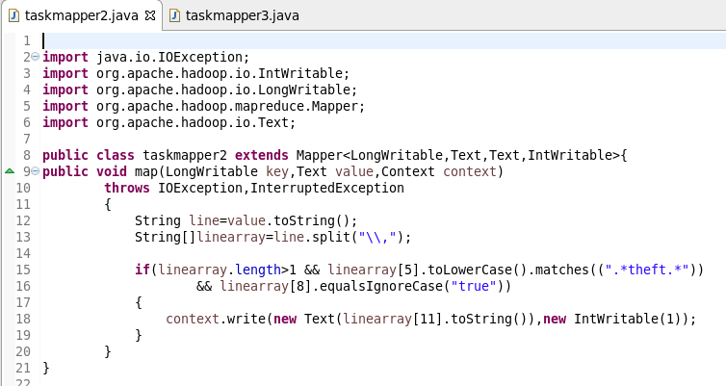

**##Reducer:**



**##pig script:**

**Output 3:**

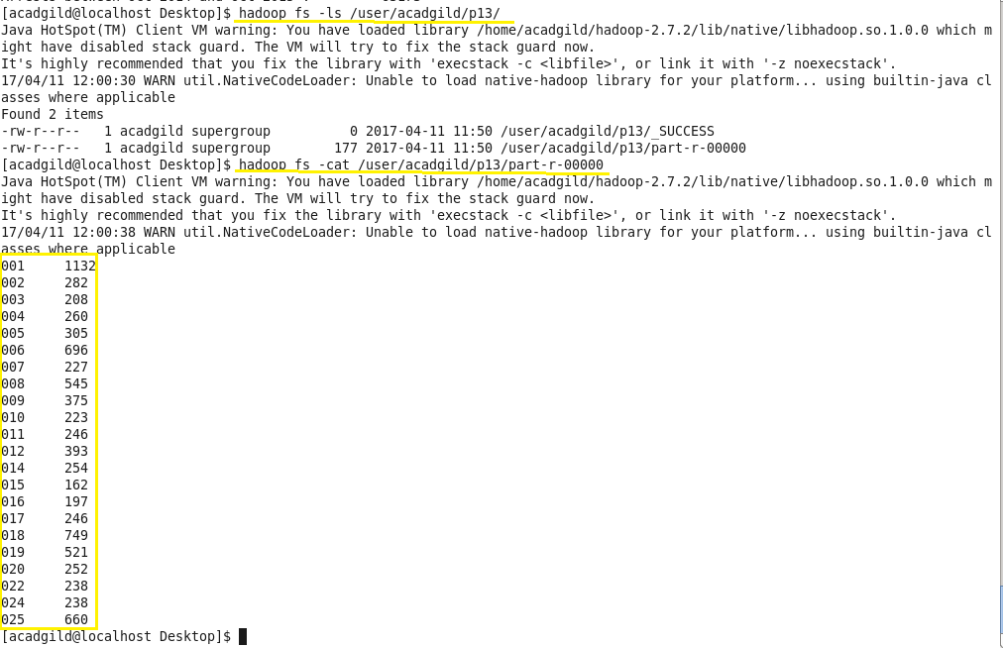

**problem 4:**

**##mapper:**

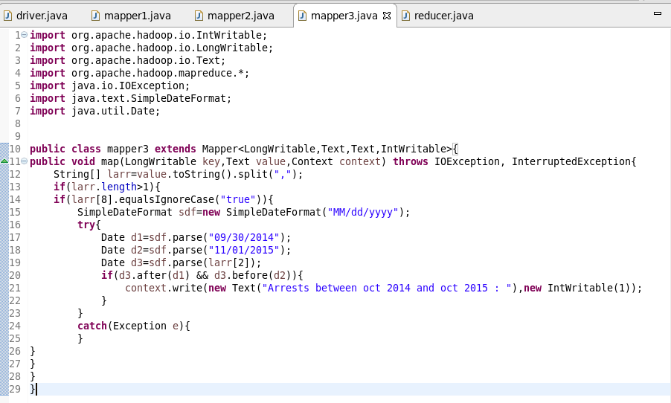

In this mapper class all the arrests between October 2014 and October 2015 are filtered and given as an input to the reducer.

**##Reducer class:**



**##PIG SCRIPT:**

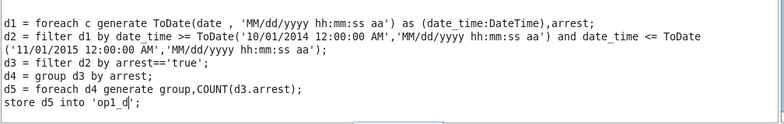

**Output 4:**

* number of arrests done between October 2014 and October 2015.

