**Project 2**

**USA Consumer Forum Data Analysis**

1. **Write a map reduce program to remove commas present inside the double quotes.**

**Note: Work on this problem statements after doing the data cleaning as mentioned above.**

**##Driver class**

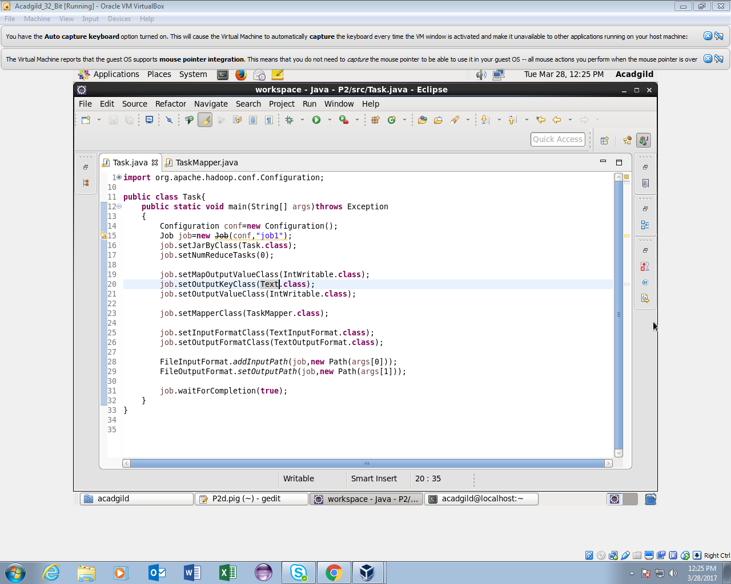

**##Mapper class**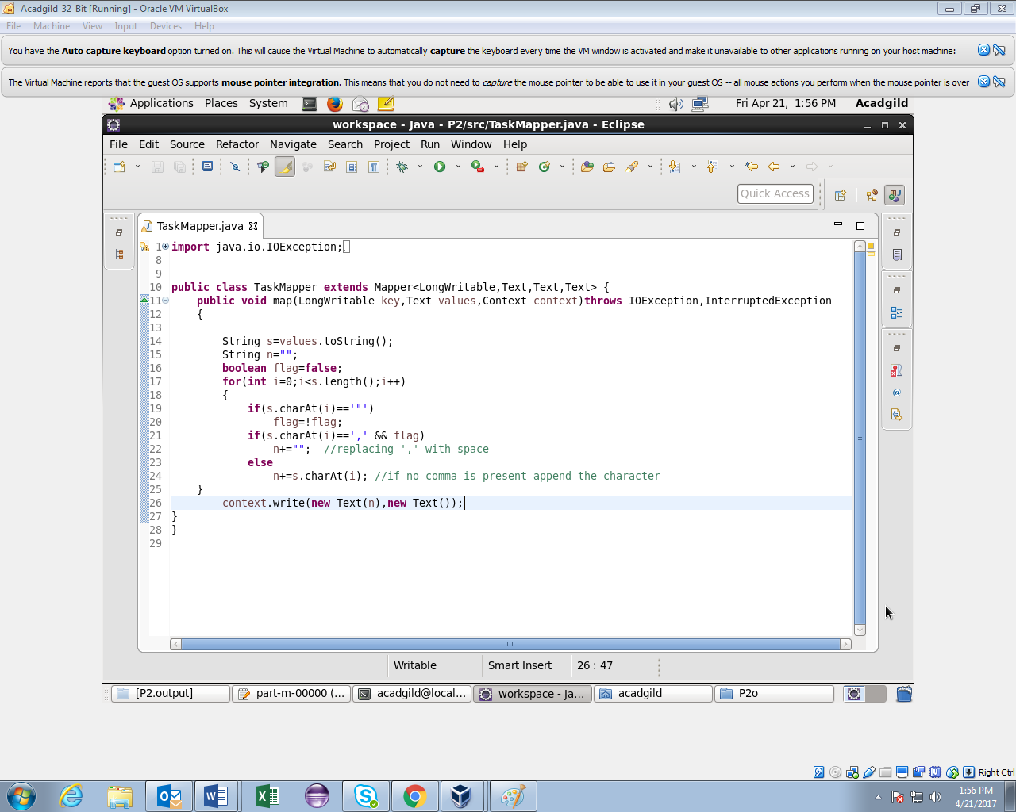

**##Running jar**

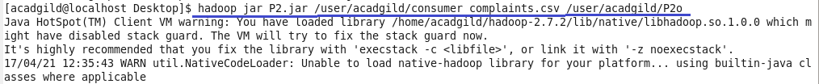

**##Output**

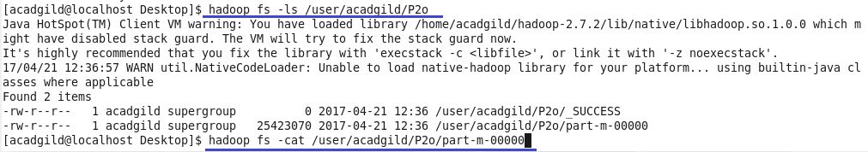

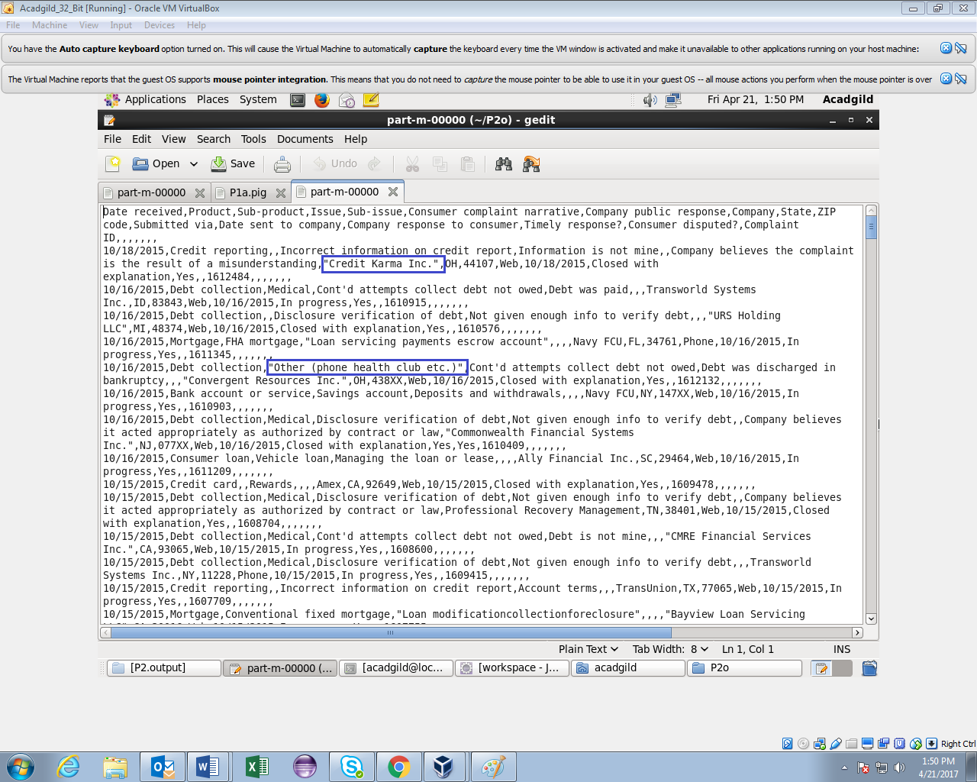

**The comma(,) within double quotes is replaced by space in the highlighted parts of the output.**

**The copy To Local command is used to copy the output file to the local file system after removing the commas between double quotes to perform pig script operations.**

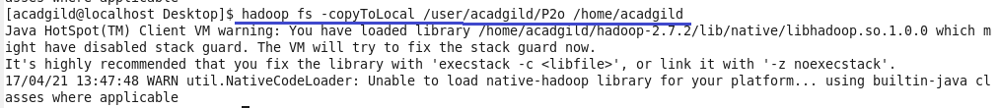

1. **Write a pig script to find no of complaints which got timely response**

**##Pig Script**

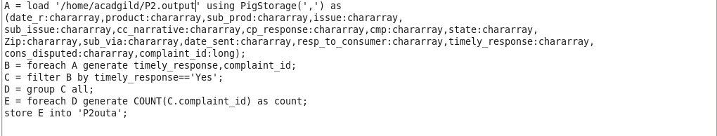

**##Running Pig Script**

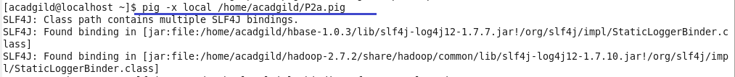

**##Output**

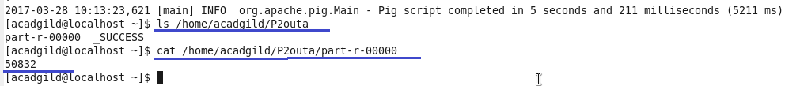

1. **Write a pig script to find no of complaints where consumer forum forwarded the complaint same day they received to respective company**

**##Pig Script**

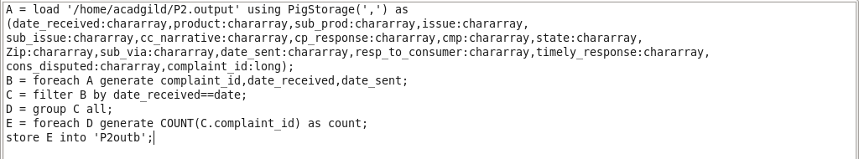

**##Running Pig Script**

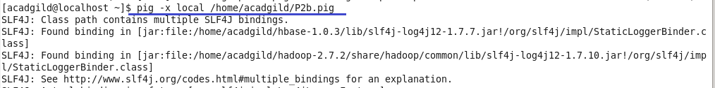

**##Output**

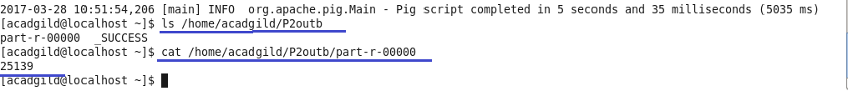

1. **Write a pig script to find list of companies topping in complaint chart (companies with maximum number of complaints)**

**##Pig Script**

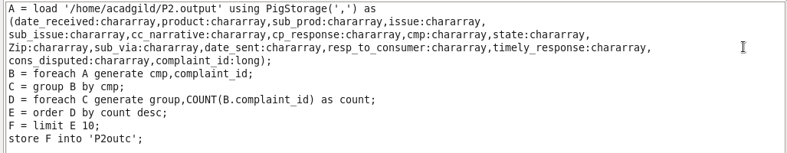

**##Running Pig Script**

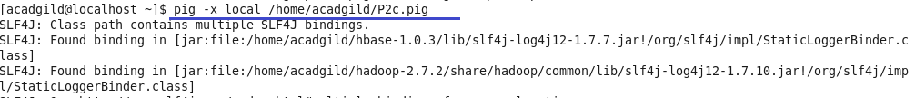

**##Output**

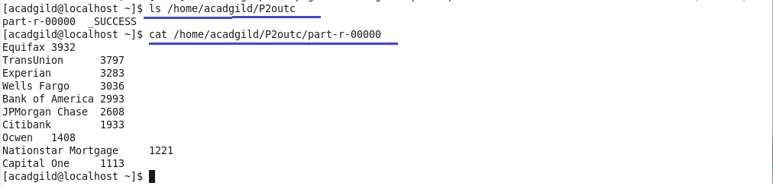

1. **Write a pig script to find no of complaints filed with product type has "Debt collection" for the year 2015.**

**##Pig Script**

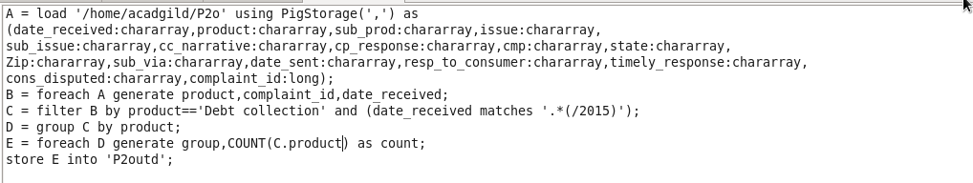

**##Running Pig Script**

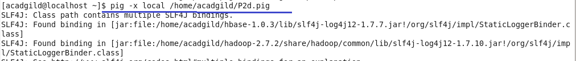

**##Output**

