**33.3)**

**● Integrate Hbase with Pig**

**● Load Data (Bulk Load) from HDFS to Hbase Table using Pig.**

**● Explain the procedures and code implemented with screenshots.**

**● Note: Candidates should Load their own data into Hbase table.**

**LOADING DATA INTO THE PIG USING LOAD COMMAND AND DUMPING USING DUMP COMMAND**

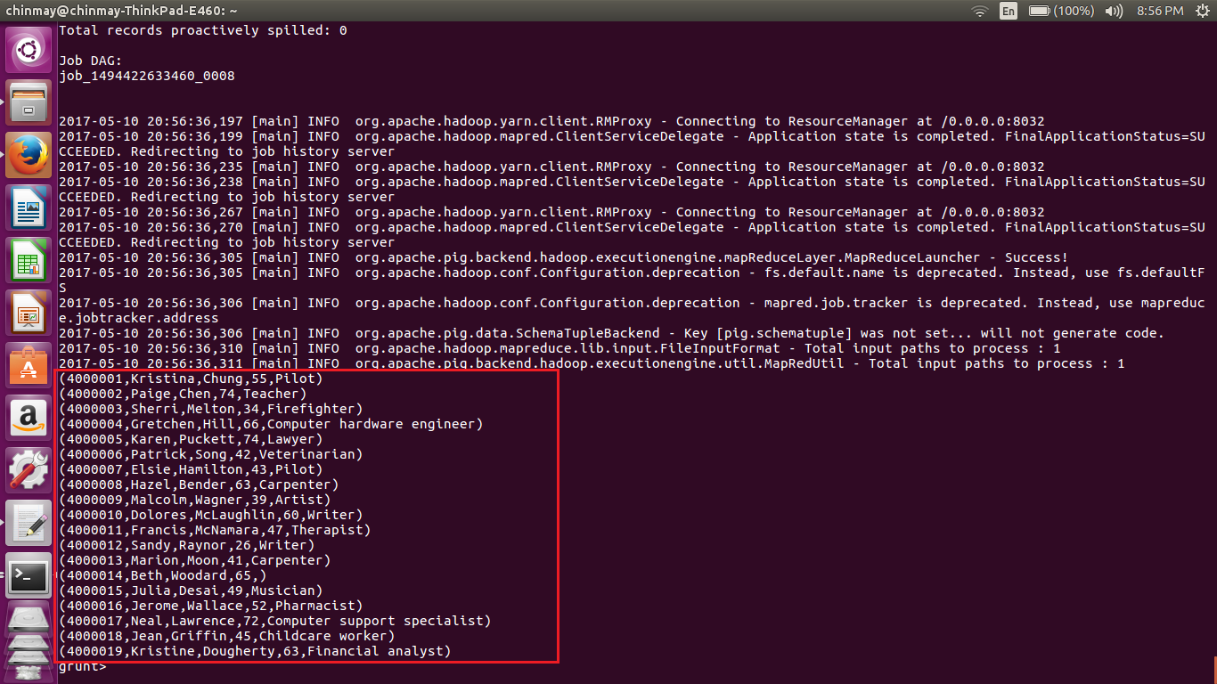

**STORING THE LOADED DATA INTO THE HBASE USING STORE COMMAND IN PIG**

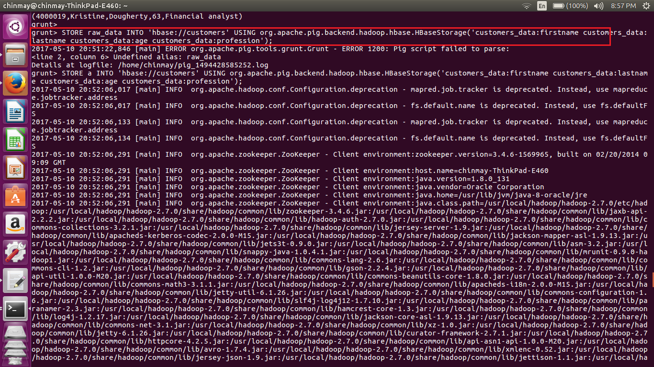

**DATA SUCCESSFULLY LOADED FROM HDFS TO HBASE USING PIG**

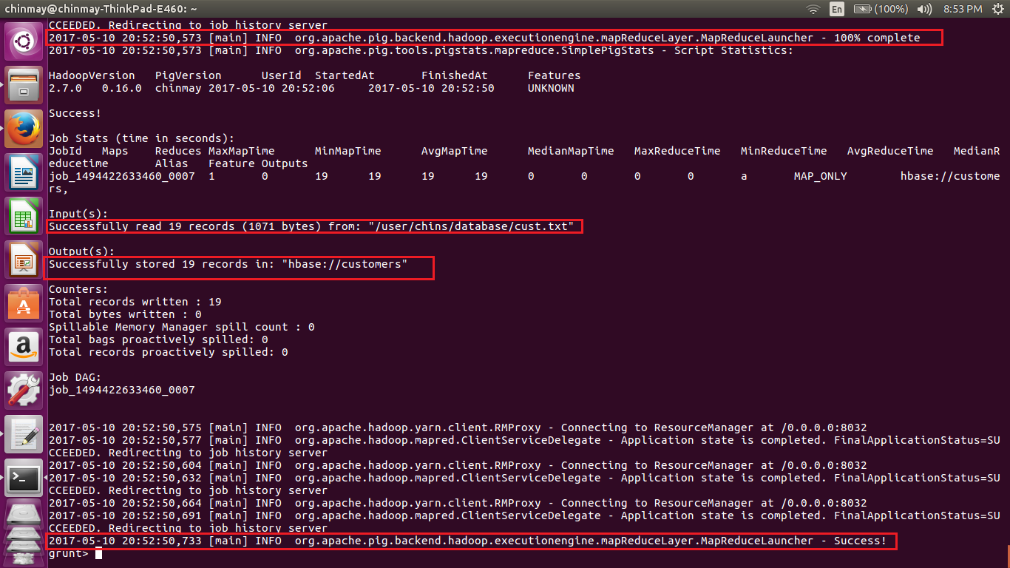

**USING SCAN COMMAND TO CHECK THE CONTENTS OF THE TABLE THAT HAS BEEN LOADED INTO HBASE FROM HDFS USING PIG**

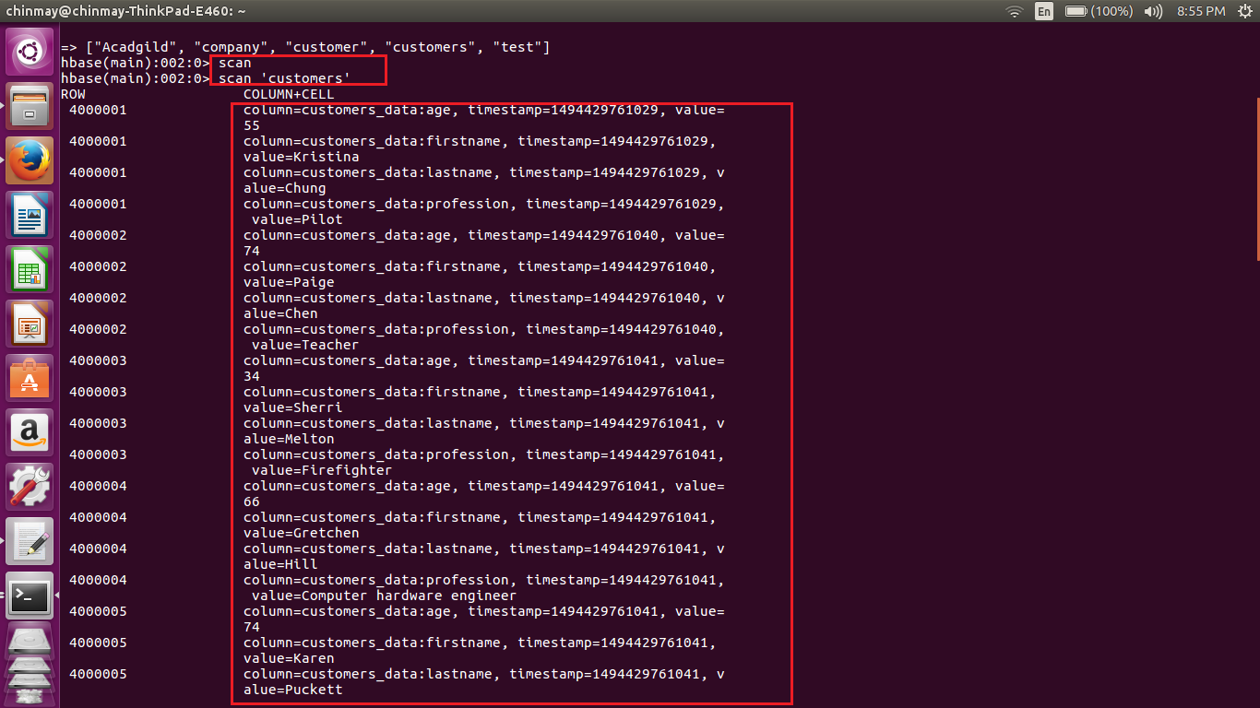

**DATA HAS BEEN LOADED SUCCESSFULLY FROM HDFS TO HBASE USING PIG**