**32.3)**

**● Write a Java client API to perform following operations:**

**● Use HBaseAdmin class and create the table named company with one column family name details.**

**● Create the method name insert and use put class to insert records to company table.**

Create HBase table program

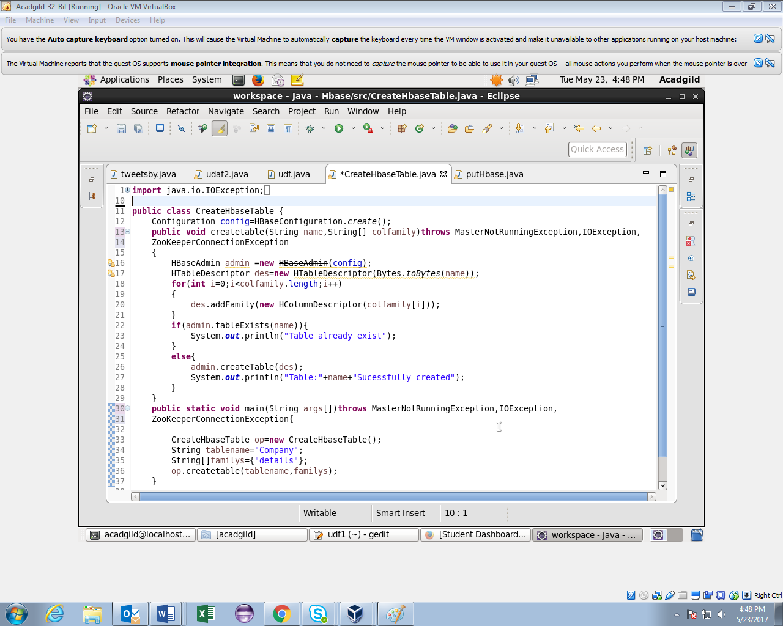

**After executing the *CreateHbaseTable* Java API program, we can see in the below image a message is displayed, stating Table named *Company* has been successfully created.**

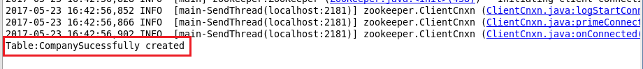

**Put HBase program**

**Put Operation:**

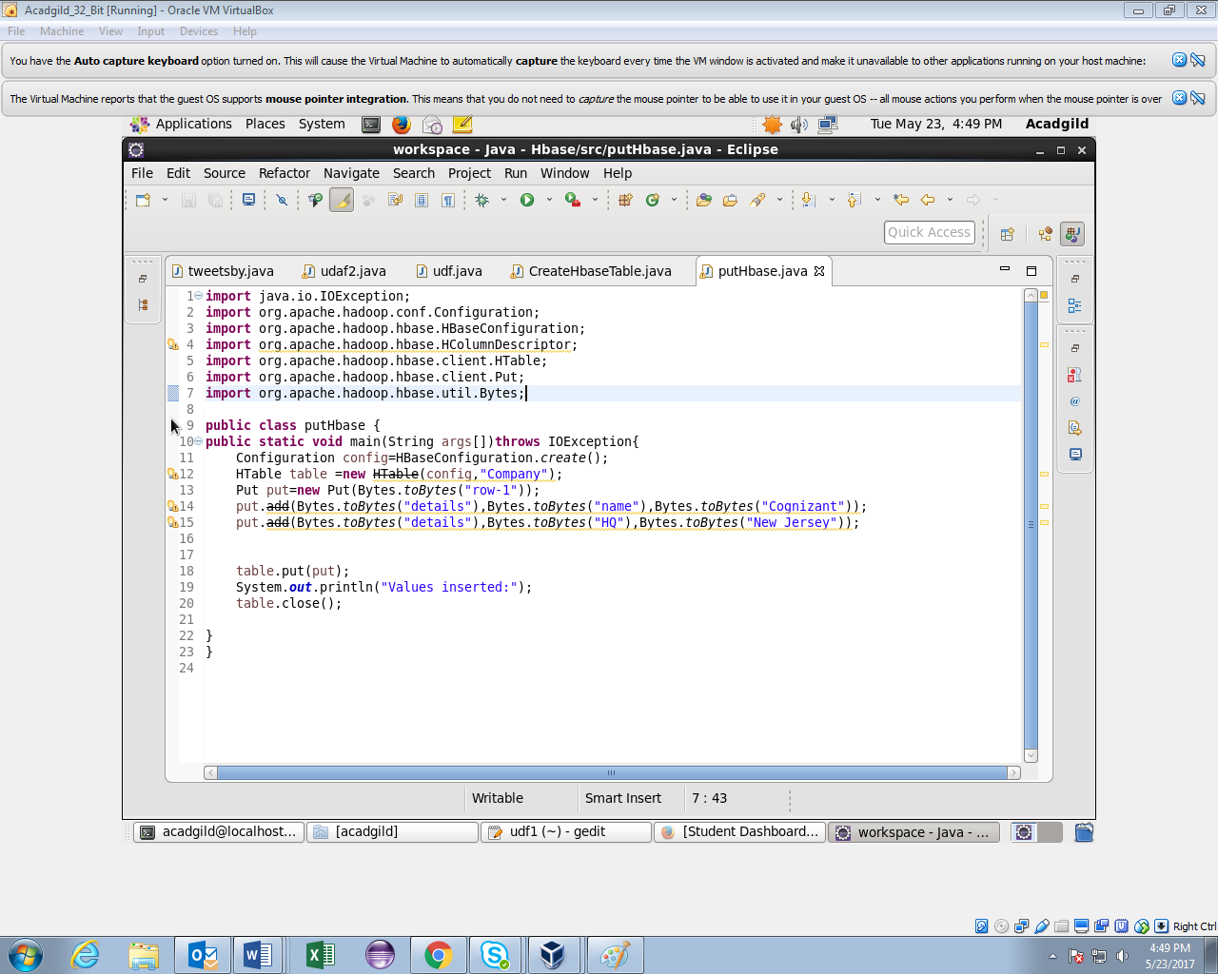

**putHbase Table Output:**

**After executing the above putHbase Java API program, we can observe in the below image that a successful message is thrown stating values inserted .**

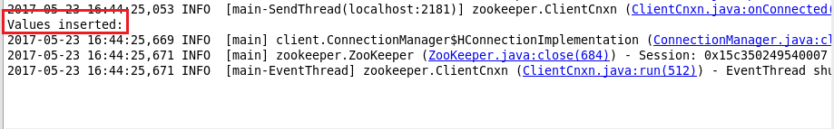

**Now, we can check whether the table Company has been successfully created or not in the HBase default database, using list command in the HBase terminal.**

**Thus, by using scan command in HBase terminal with the table name, we can see the table values of column family details as Cognizant and New Jersey respectively**.

