**33.2)**

**## Integrate Hbase with Hive**

**## Load Data (Bulk Load) from Hive table to Hbase Table**

**## Explain the procedures and code implemented with screenshots.**

**## Note: Candidates should Load their own data into Hbase table.**

**Create the HBase table employee with two column families personaldetails and deptdetails.**

**Insert the data into Hbase table**

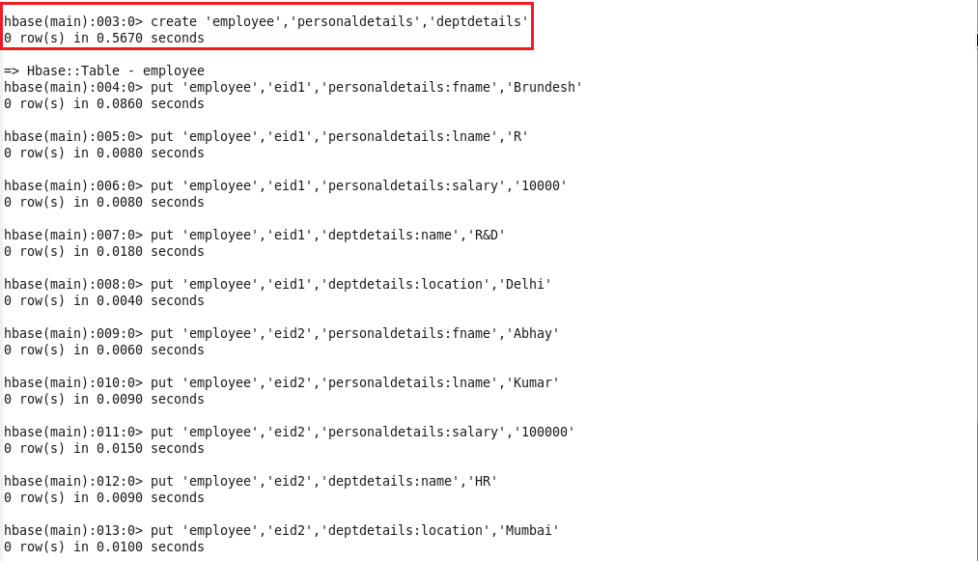

**Create the hive table pointing to hbase table for column family personaldetails.**

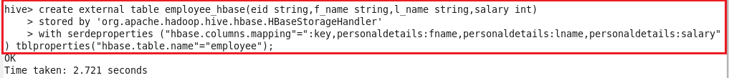

**Displaying the contents of hive table.**



**Cretae hbase table and scan the table (no data is loaded)**

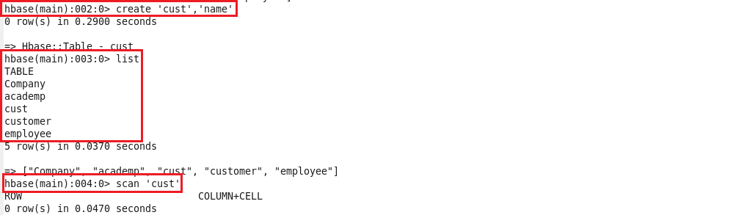

**Create a hive table,load data in it and display the contents.**

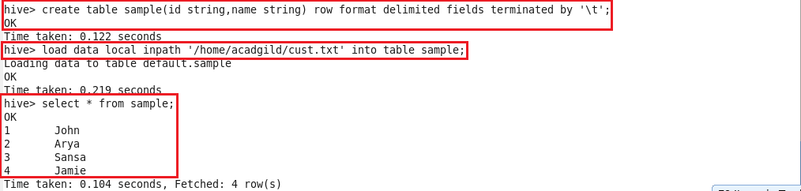

**Create external table and the loading the data from the above table:**

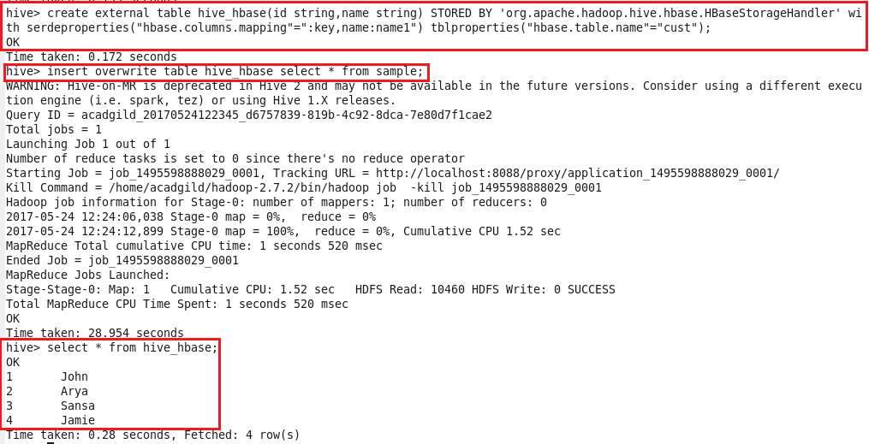

**Now when we scan hbase table data will be loaded in it.**

