**INPUT FILE FOR WORD COUNT**

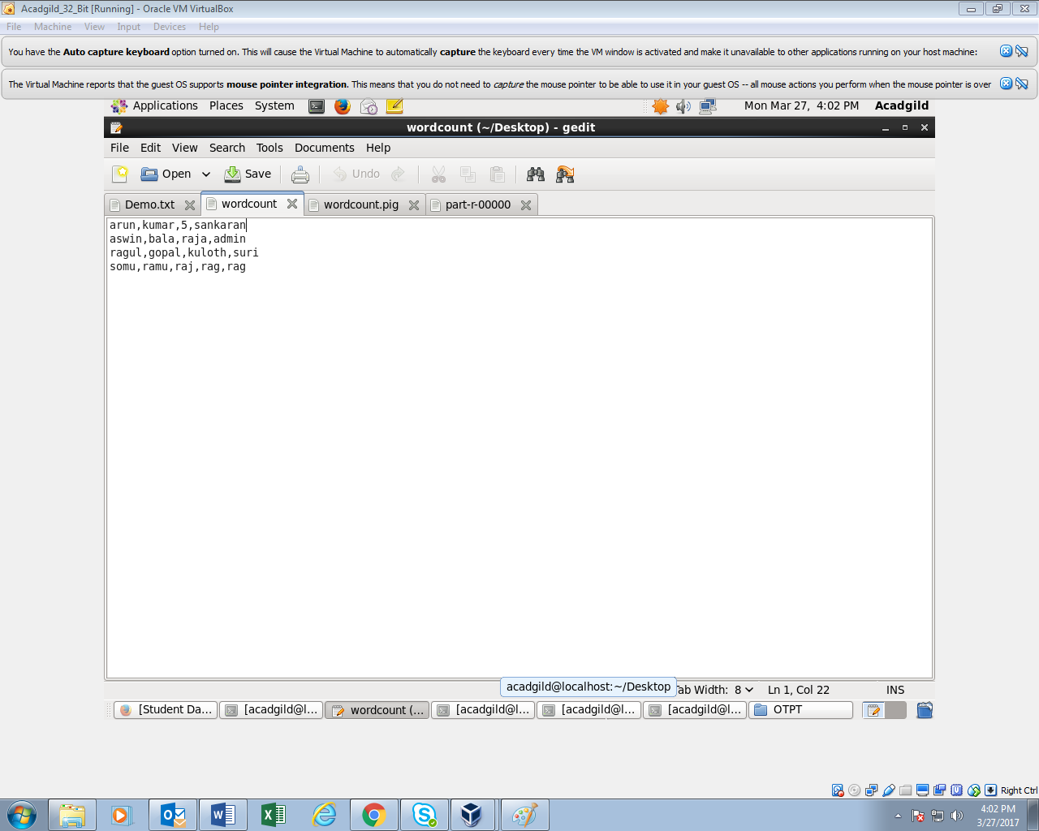

**Pig FILE TO BE EXECUTED FOR WORD COUNT**

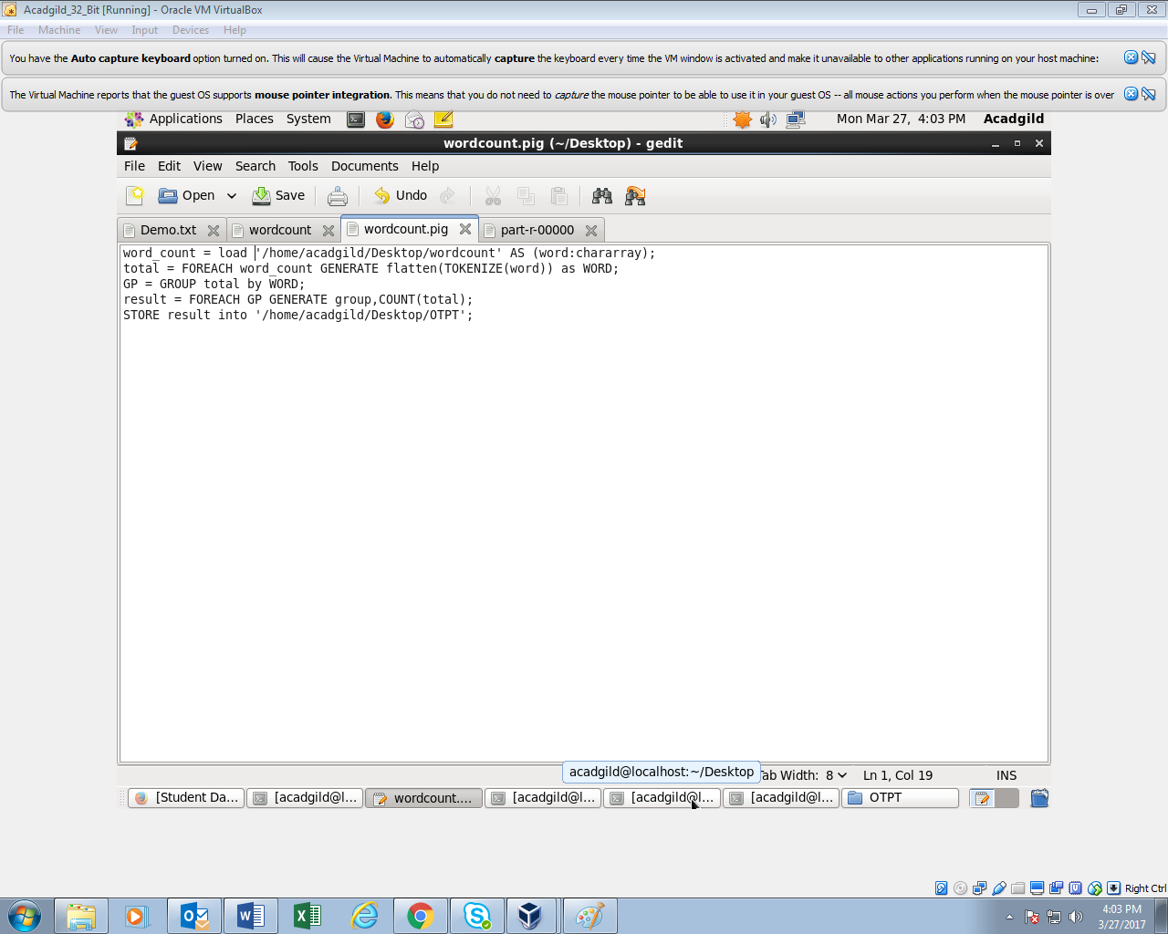

**EXECUTING THE PIG FILE IN TERMINAL**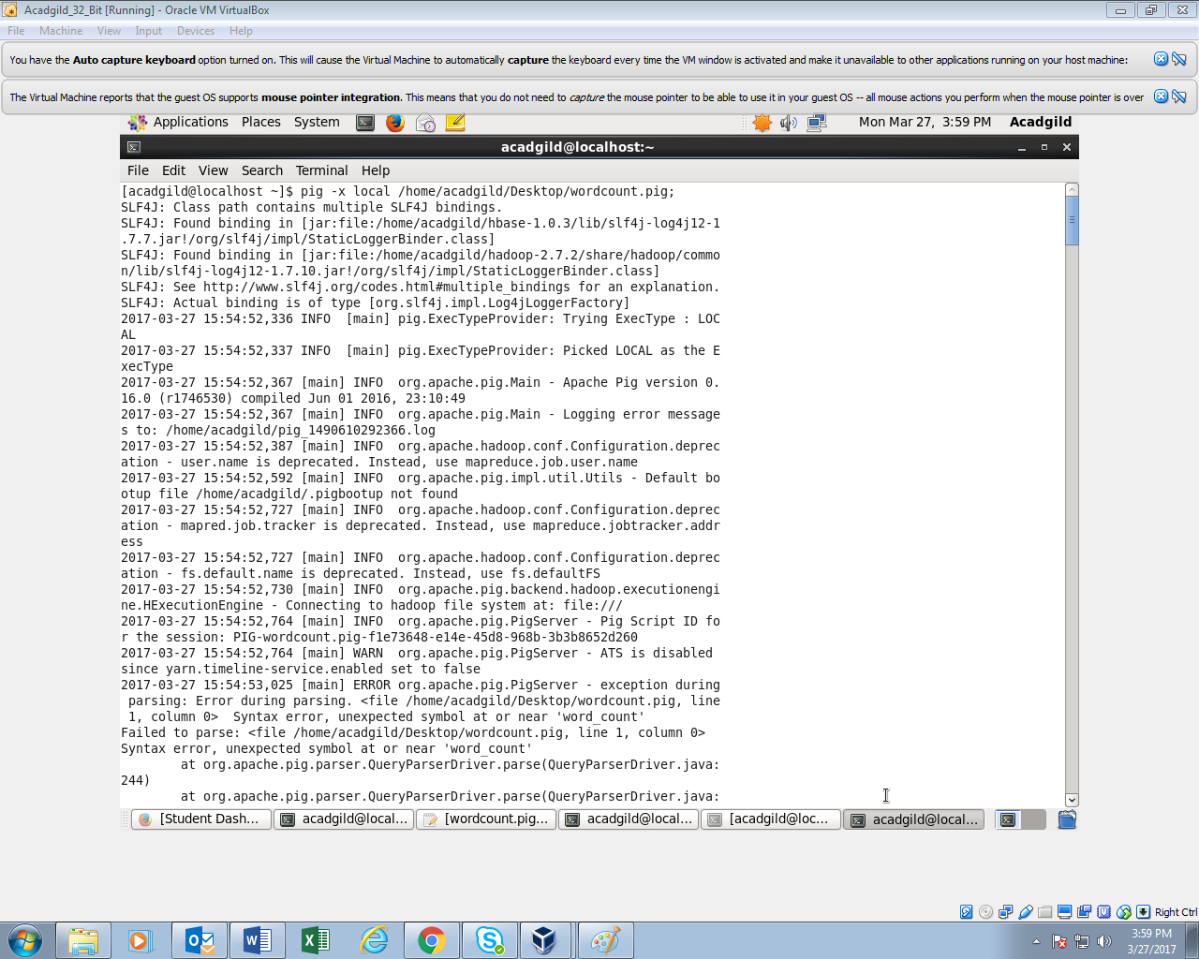

**TASK EXECUTED SUCCESSFULLY**

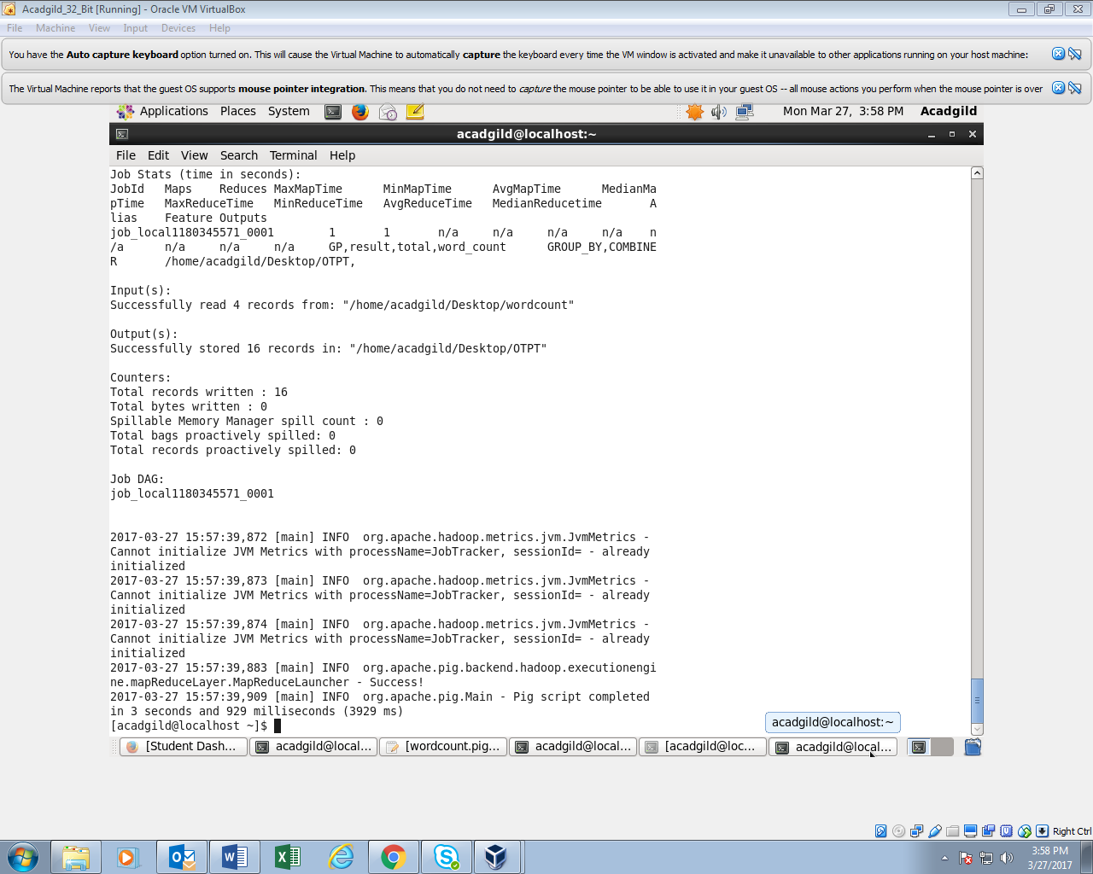

**OUTPUT:**