1.Top 5 employees (employee id and employee name) with highest rating.

PIGSCRIPT: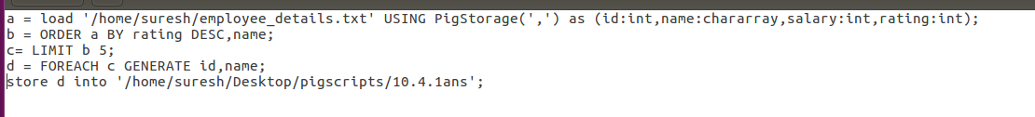

RUNNING PIGSCRIPT:

D:\Assignment10.3\10.4.1run.png

OUTPUT:

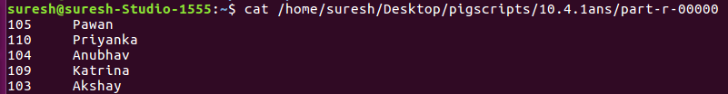

2.Top 3 employees (employee id and employee name) with highest salary, whose employee id is an odd number.

PIGSCRIPT

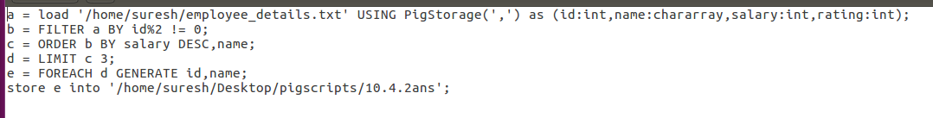

RUNNING PIGSCRIPT:

D:\Assignment10.3\10.4.2run.png

OUTPUT

3.Employee (employee id and employee name) with maximum expense

PIGSCRIPT: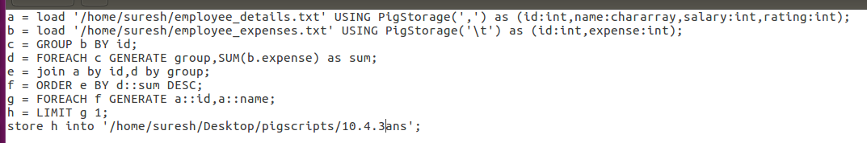

RUNNING PIGSCRIPT

D:\Assignment10.3\10.4.3run.png

OUTPUTD:\Assignment10.3\10.4.3ans.png

4. List of employees (employee id and employee name) having entries in employee_expenses file.

PIGSCRIPT  
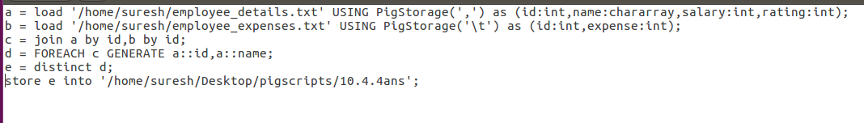

RUNNING PIGSCRIPT

D:\Assignment10.3\10.4.4run.png

OUTPUT

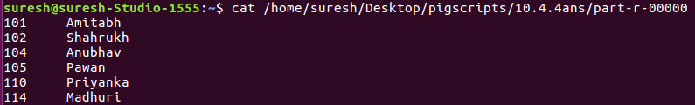

5. List of employees (employee id and employee name) having no entry in employee_expenses file.

PIGSCRIPT

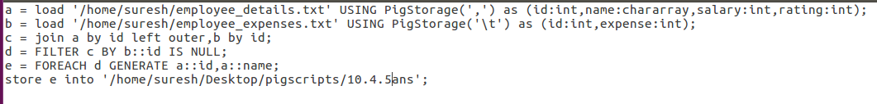

RUNNING PIGSCRIPT

D:\Assignment10.3\10.4.5run.png

OUTPUT

