10.4)

##Write a pig script find the average age of male and female persons died in the titanic tragedy

##Write a pig script to find the number of people died and survived in each class.

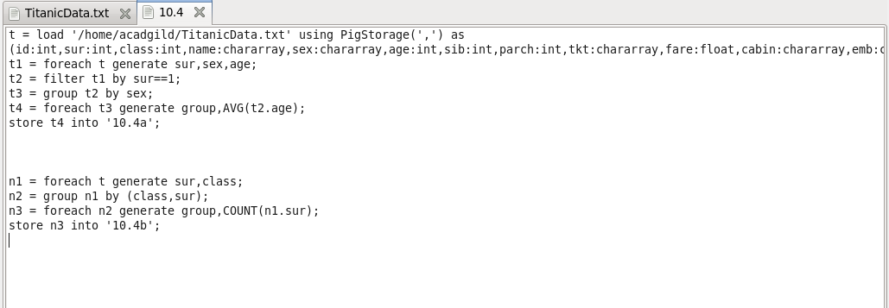

*Output:*

