**10.5**

**##Write a pig script to find the top 20 destination people travel the most: Based on the given data**

**##Write a pig script to find the top 20 locations from where people travel the most**

**Program :**

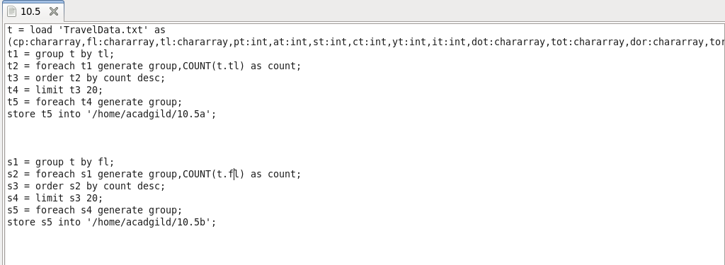

**Output :**

