1. Find the number of students who scored less than 5(50%).

LOGIC:FILTER GRADE LESS THAN 5 AND THEN MADE A COUNT OF THE RESULT

2. List the name of students who are from Alaska.

FILTER BY STATE EQUALS TO ALASKA AND THEN GENERATE NAME

3. How many government colleges are there in Alabama?

FILTER BY COL EQUAL TO GOVERNMENT AND STATE EQUAL TO ALABAMA AND MAKE A COUNT

4. List the name of students who are from Oregon and persuing BE.

FILTER BY STREAM EQUAL TO BE AND STATE EQUAL TO OREGON AND GENERATE NAME

PIG SCRIPT

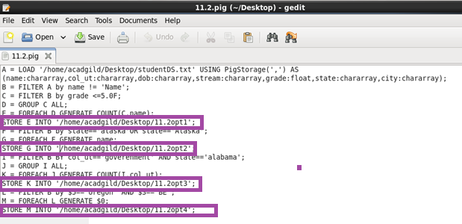

RUNNING JAR:

