11.3)Write a Pig UDF To find the tweets posted by @realDonaldTrump from the given dataset.

DATA SET DESCRIPTION

Column 1 : id Column 2 : handle Column 3 : text Column 4 : is_retweet Column 5 : original_author Column 6 : time Column 7 : in_reply_to_screen_name Column 8 : in_reply_to_status_id Column 9 : in_reply_to_user_id Column 10 : is_quote_status Column 11 : lang Column 12 : retweet_count Column 13 : favorite_count Column 14 : Longitude Column 15 : Latitude Column 16 : Place_id Column 17 : Place_full_name Column 18 : Place_name Column 19 : Place_type Column 20 : Place_country_code Column 21 : Place_country Column 22 : Place_contained_within Column 23 : Place_attributes Column 24 : Place_bounding_box Column 25 : Source_url Column 26 : Truncated Column 27 : Entities Column 28 : extended_entities

**Pig Script**

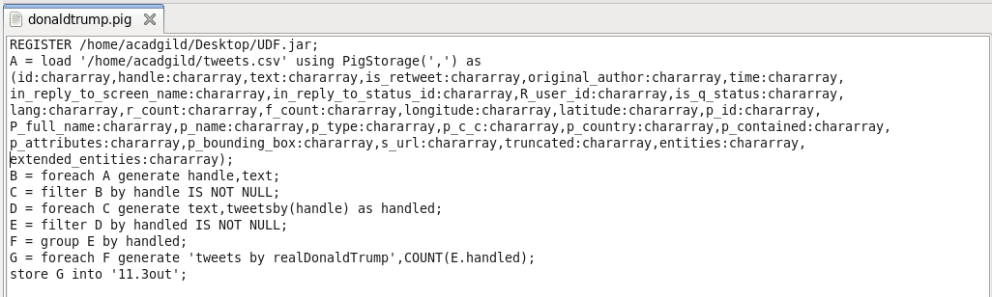

**UDF code**

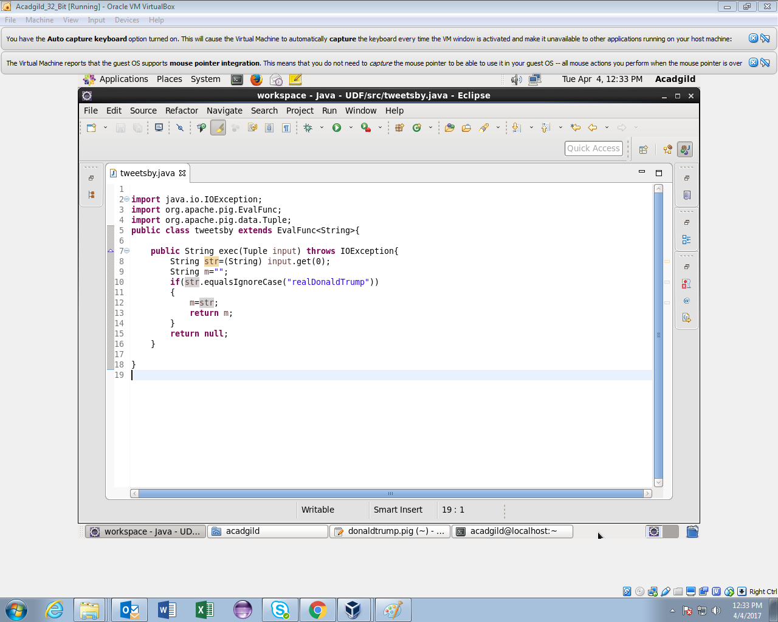

**Running Pig Script**

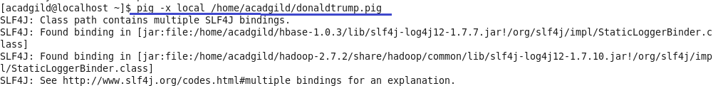

**Output**

