**11.4)**

**Twitter data analysis Write a pig script to find the count of each Hashtag in the dataset. You can download the twitter data from the below link:**

**Input:**

<https://github.com/prateekATacadgild/DatasetsForCognizant/blob/master/tweets.rar>

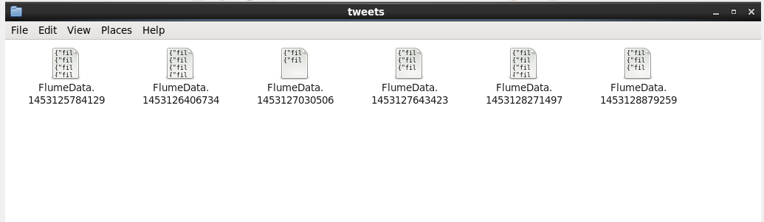

**Pig Script:**

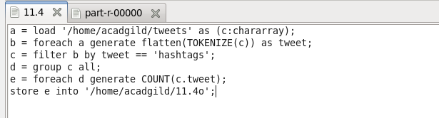

**Output:**

