**16.5)Write a map reduce program to join the below given two datasets using map side join. You can download the datasets from the below link** [**https://drive.google.com/open?id=0ByJLBTmJojjzSWhfXzI5NGh4RGM**](https://drive.google.com/open?id=0ByJLBTmJojjzSWhfXzI5NGh4RGM)

**Dataset description of dataset1.csv is as follows: id,first_name,last_name,email,gender,ip_address**

**Dataset description of tdataset2.csv is as follows: id,first_name,last_name**

##Driver class

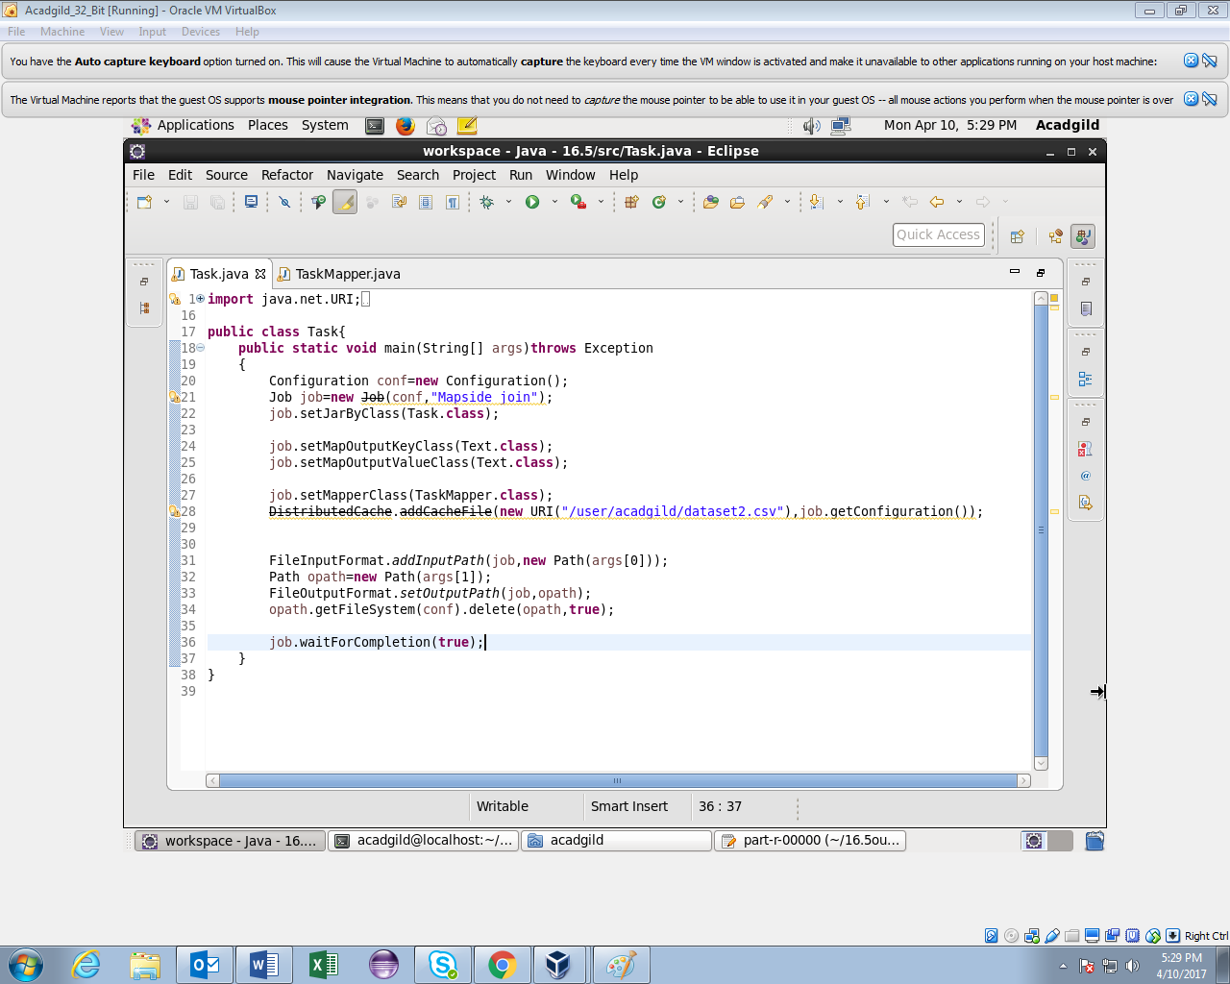

##Mapper class

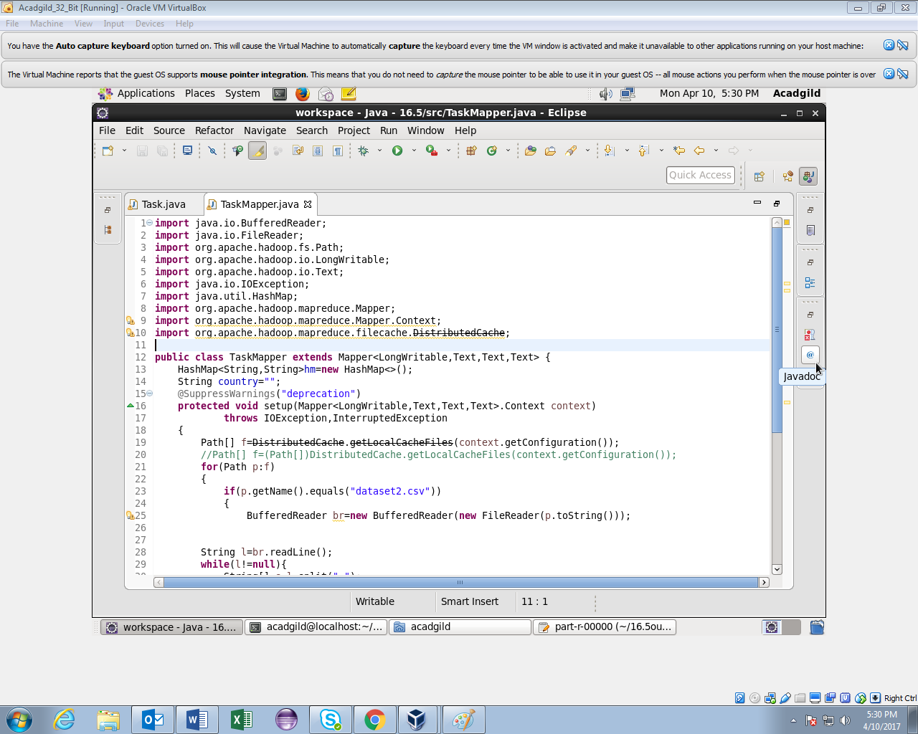

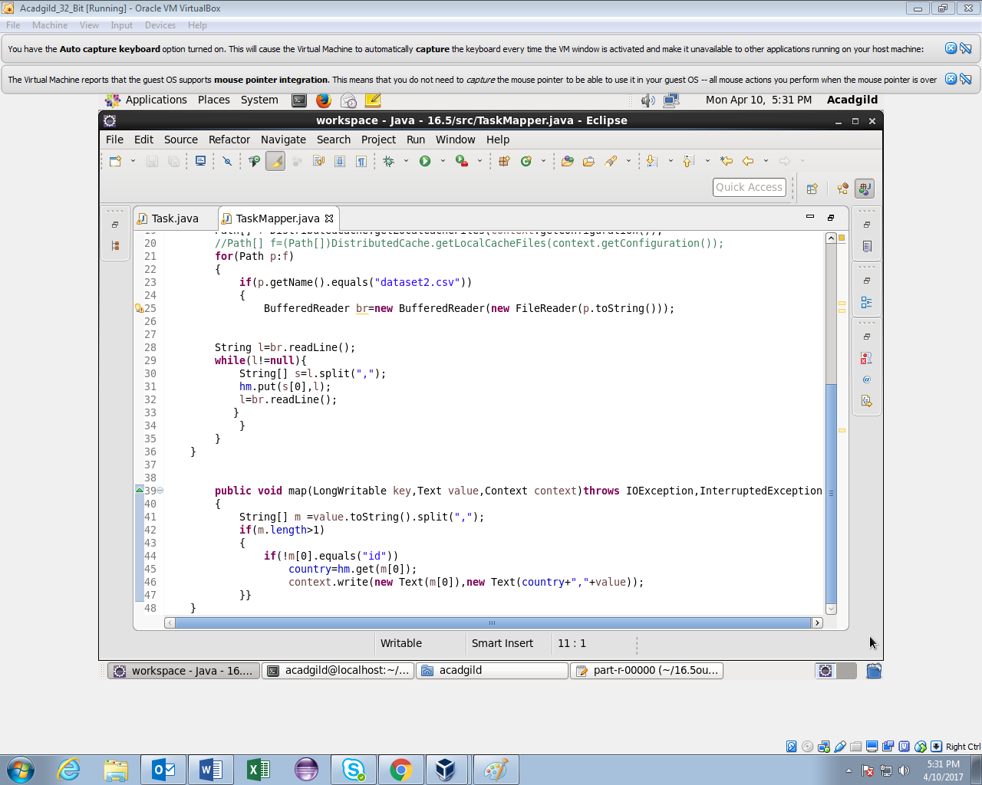

Running jar

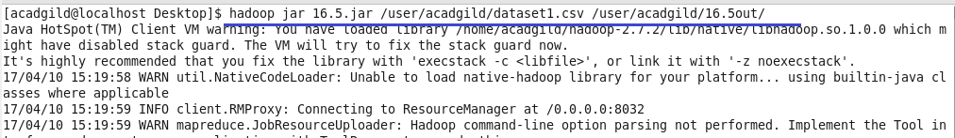

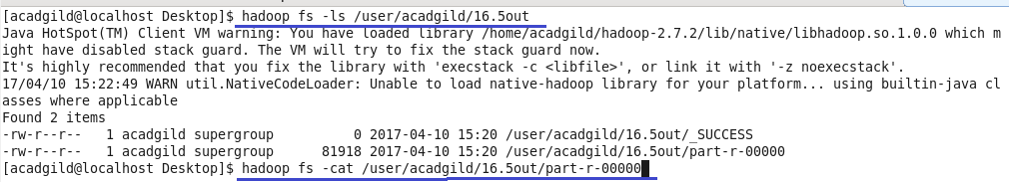

Output

first few records

