**16.6)**

**Write a map reduce program to join the below given two datasets using Reducer side join. You can download the datasets from the below link :**

<https://drive.google.com/open?id=0ByJLBTmJojjzSWhfXzI5NGh4RGM>

Dataset description of dataset1.csv is as follows: id,first_name,last_name,email,gender,ip_address

Dataset description of tdataset2.csv is as follows: id,first_name,last_name

**Program:**

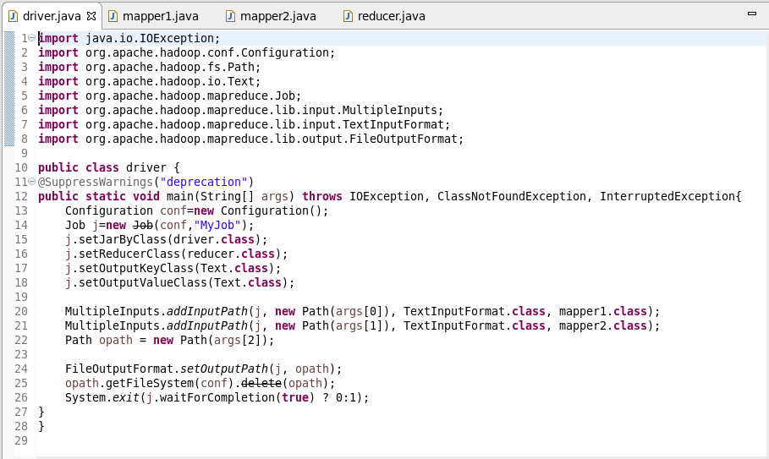

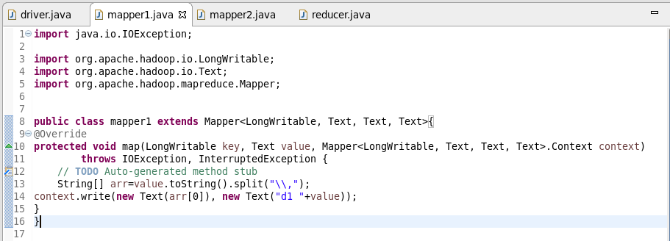

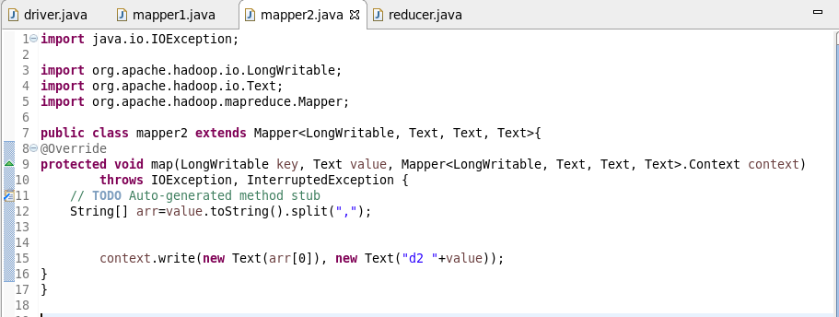

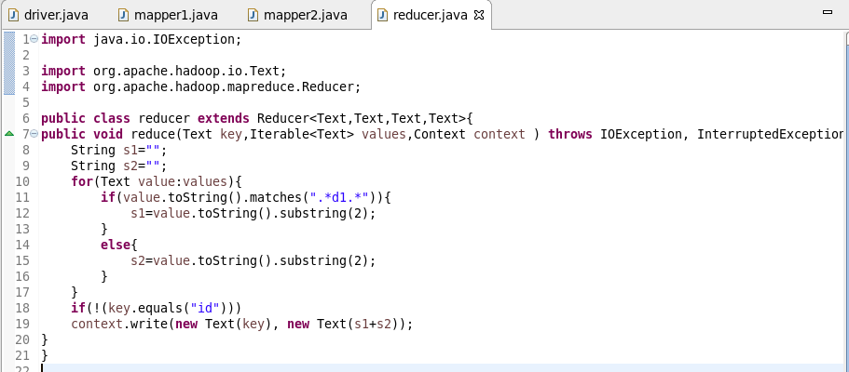

**Output:**

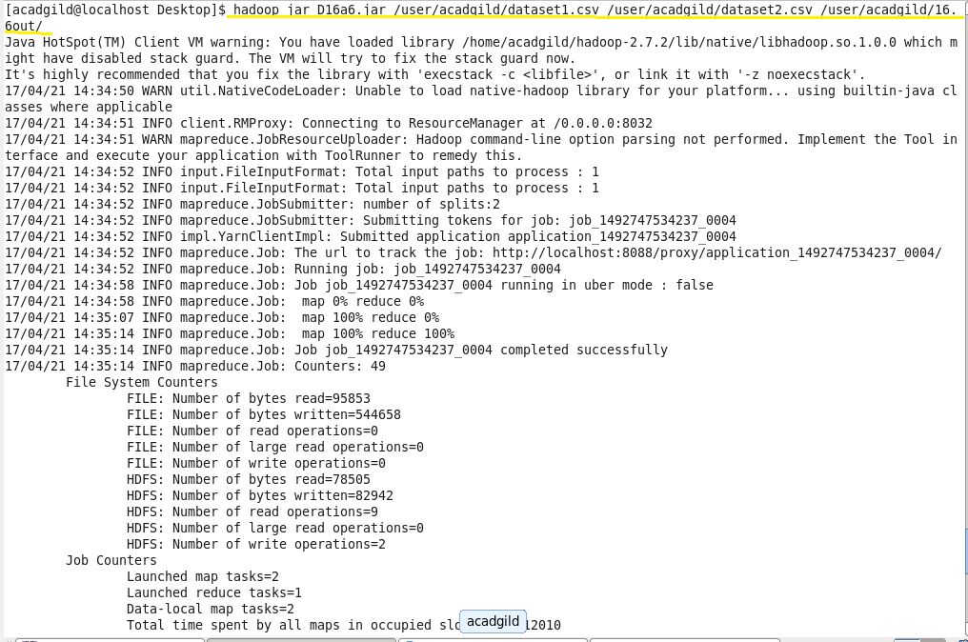

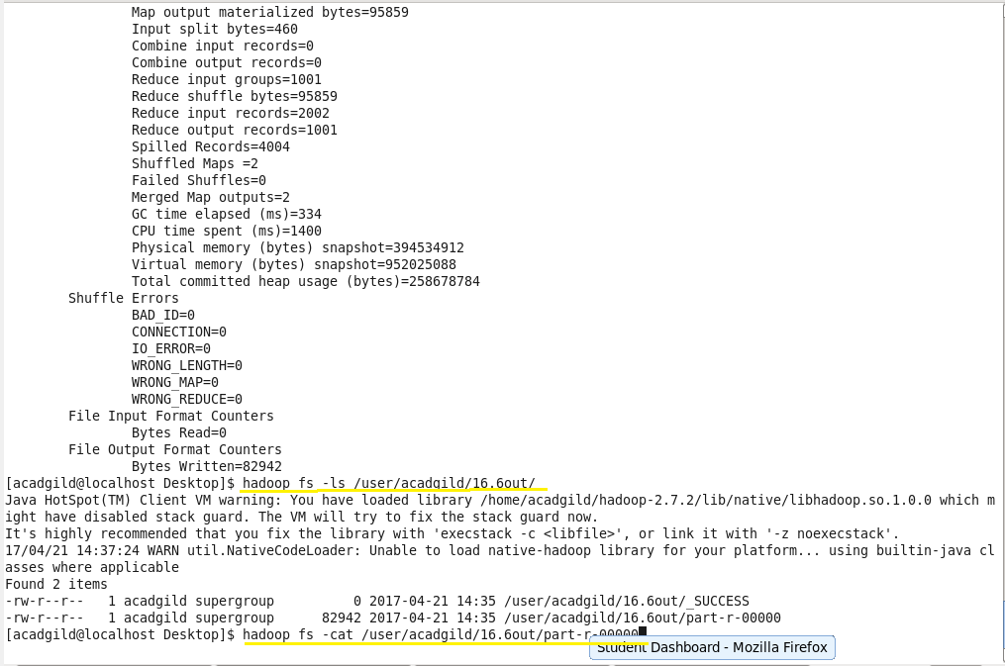



**screenshot of last few records is attached below:**

