**17.1)Write a program that accepts the job_id as argument and returns a custom counter and a system counter (total records input to the map tasks) associated with that job.**

**##Task class:**

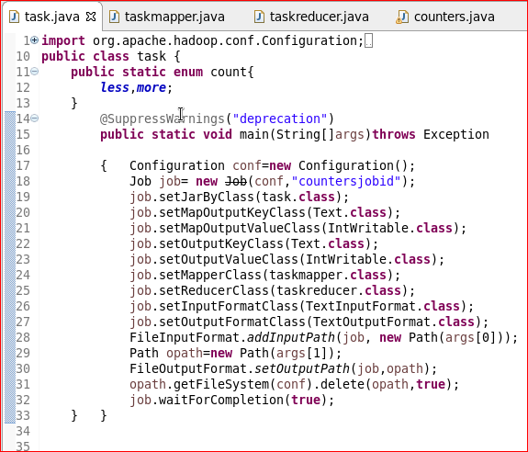

**##Mapper class:**

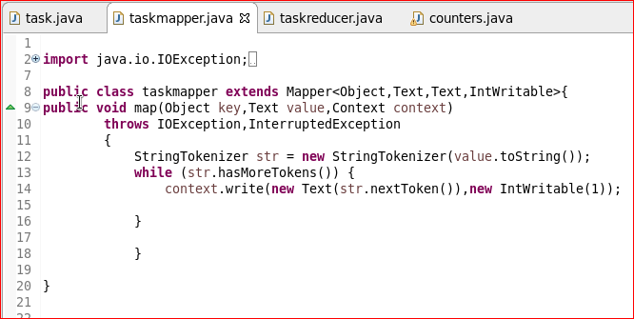

**##Reducer class:**

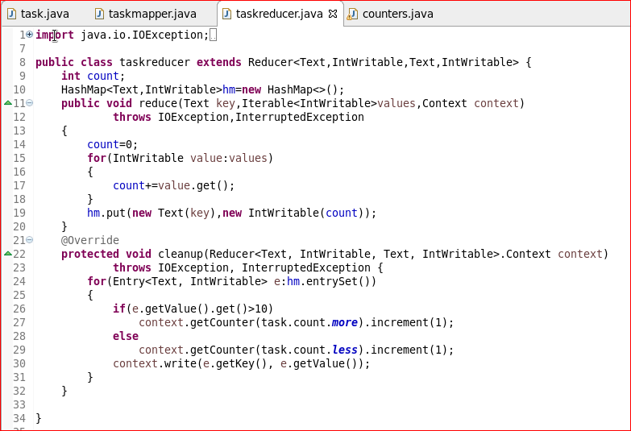

**##Counter class:**

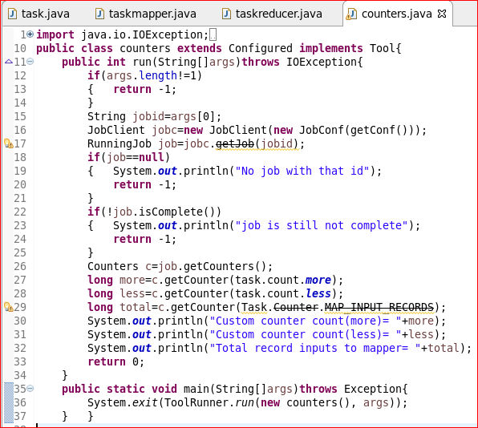

**##Running job (task):**

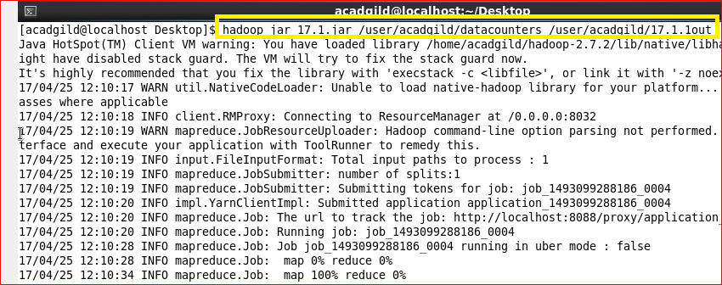

**##Output:**

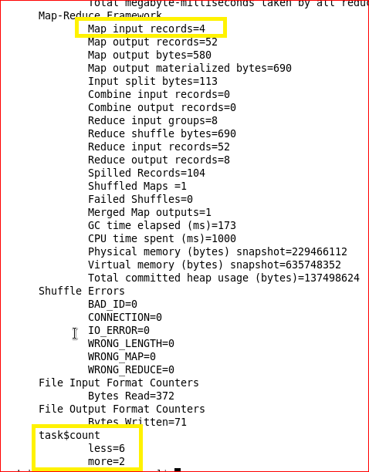

**##Running jar 2(printing job related counters):**

