**17.3)Write a mapreduce job that takes configuration from command line (min.word.count). Based on the configuration, it should perform count of words from a document and produce only those words in the output whose count is greater than or equal to the configuration.**

**Codes:**

**##Task class:**

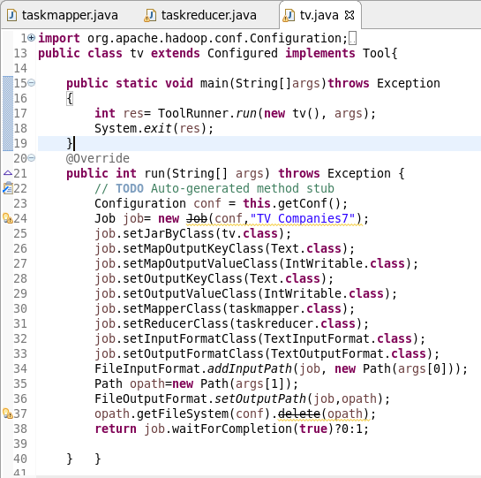

**##Mapper class:**

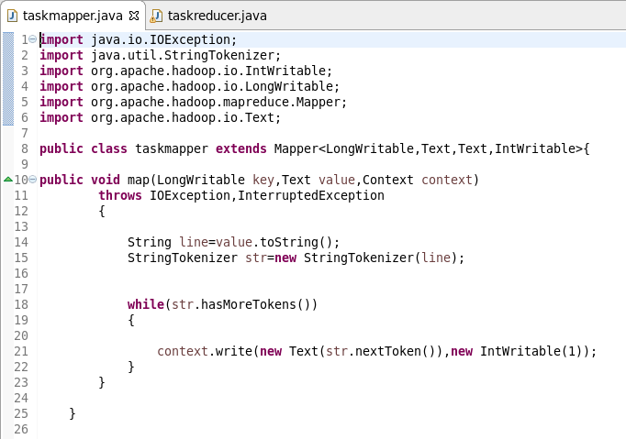

**##Reducer class:**

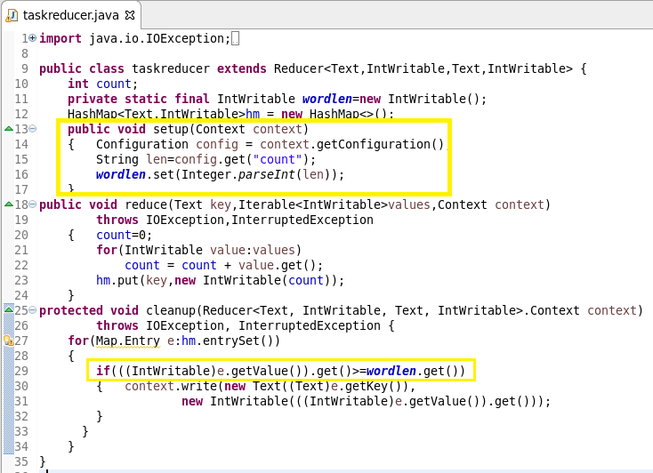

**##Dataset:**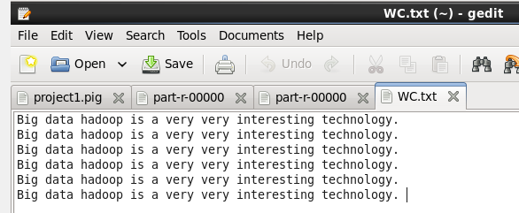

Running jar:

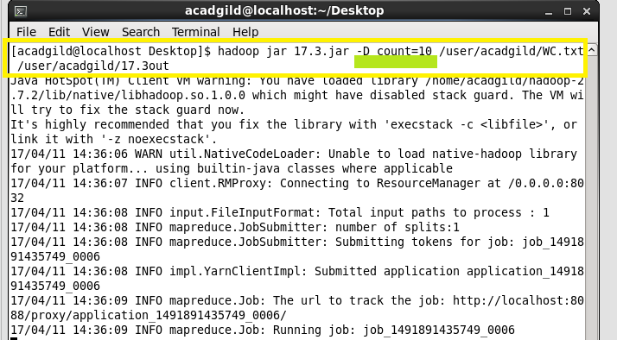

Output:

