**17.5)**

**Write a map reduce program to design a custom counter to count number of people are affected with 'PULMONARY' disease and 'BRONCHITIS & ASTHMA' in the state 'CA'.**

**##Task class:**

In this just create the Map only job, we are concentrating only on implementation of counters

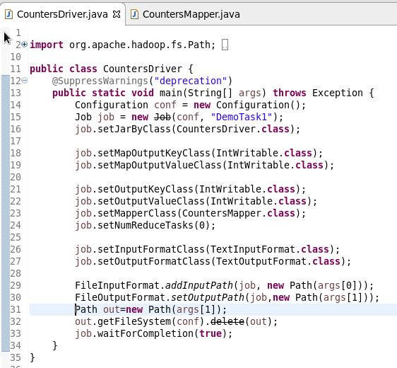

**##Mapper class:**

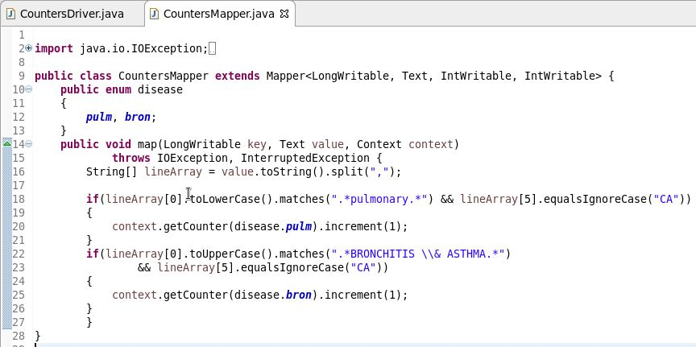

**Counters are defined by a Java enum, which serves to group related counters.**

**##Output:**

