**19.3)Write a MapReduce program that takes the output of Task 5 (refer session 7, assignment 1) as input, and produce output which is sorted on the total units sold. You may use a single reducer for the sorting. Use Sequence File formats as output of Task 5 and as input for this task.**

**##Input:**

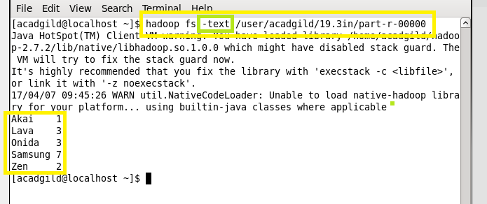

**##Task class:**

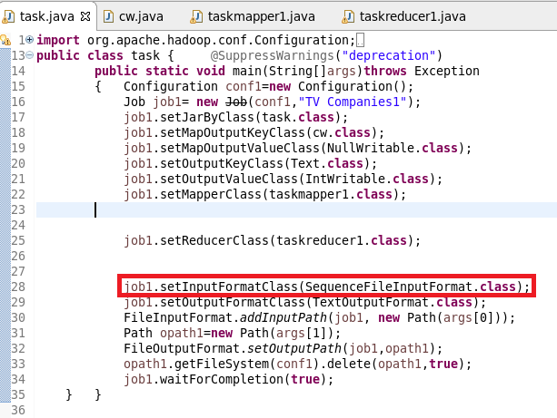

**##Mapper class:**

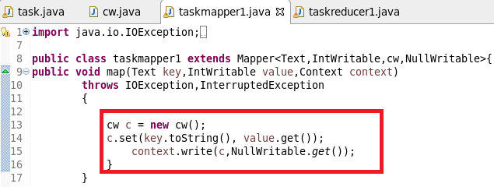

**##Reducer class:**

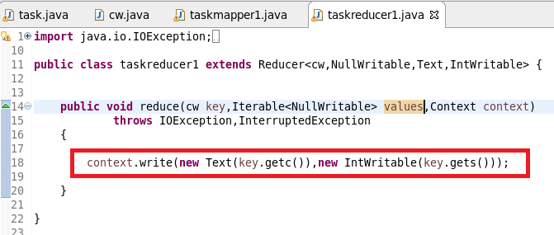

**##Composite key class:**

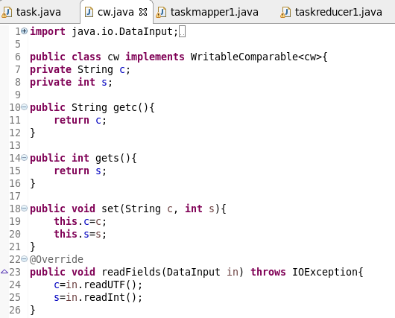

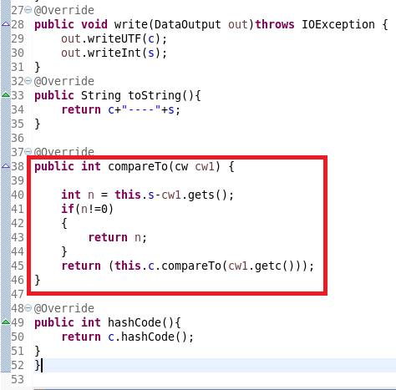

**##Running jar:**

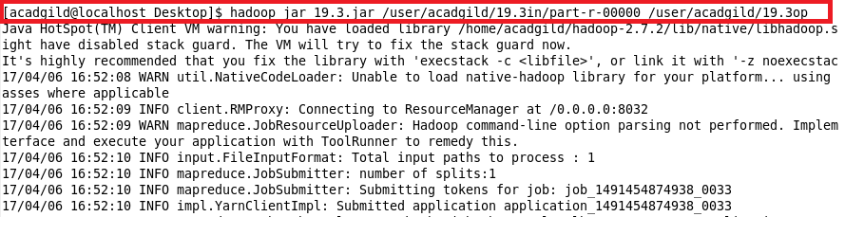

**##Output:**

