**20.1)**

**Task9: Enhance the MapReduce program of Task 8 (refer session 19, assignment 3) to use multiple reducers for sorting. The driver should accept three additional values: the minimum units sold, the maximum units sold and number of reducers to use. Use units sold as key and company as value. Write a custom partitioner to divide the keys on the basis of range. Take minimum to be 0 and maximum to be 10. Divide them across 2 reducers.**

**##Driver Class:**

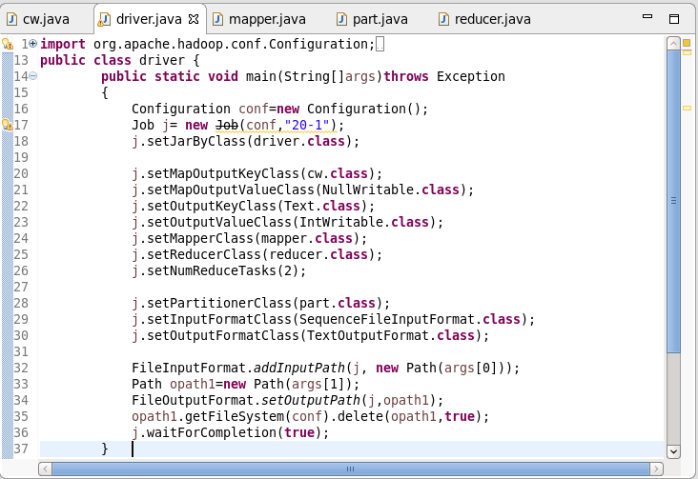

**##Mapper Class:**

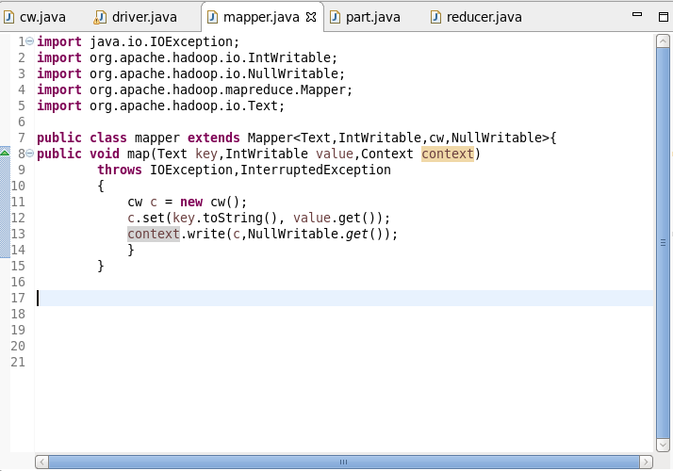

**##Reducer Class:**

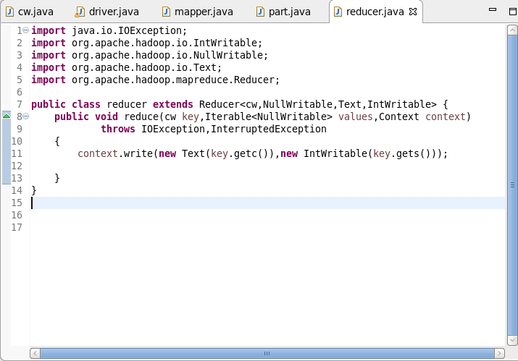

**##Composite key Class:**

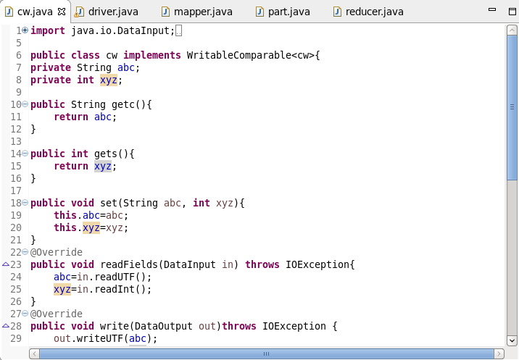

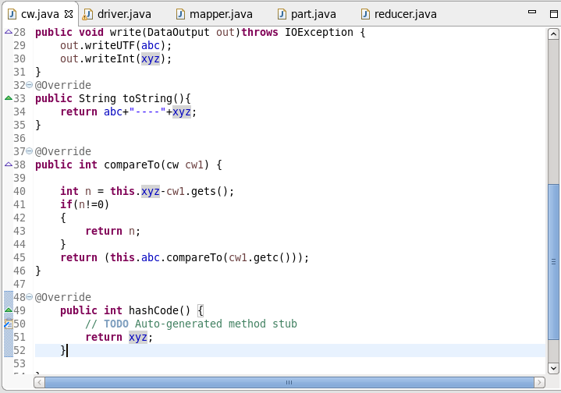

**##Partitioner Class:**

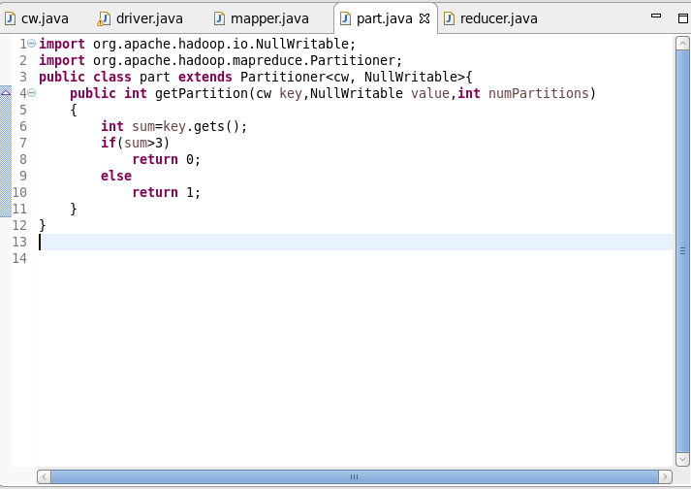

Execution Command:

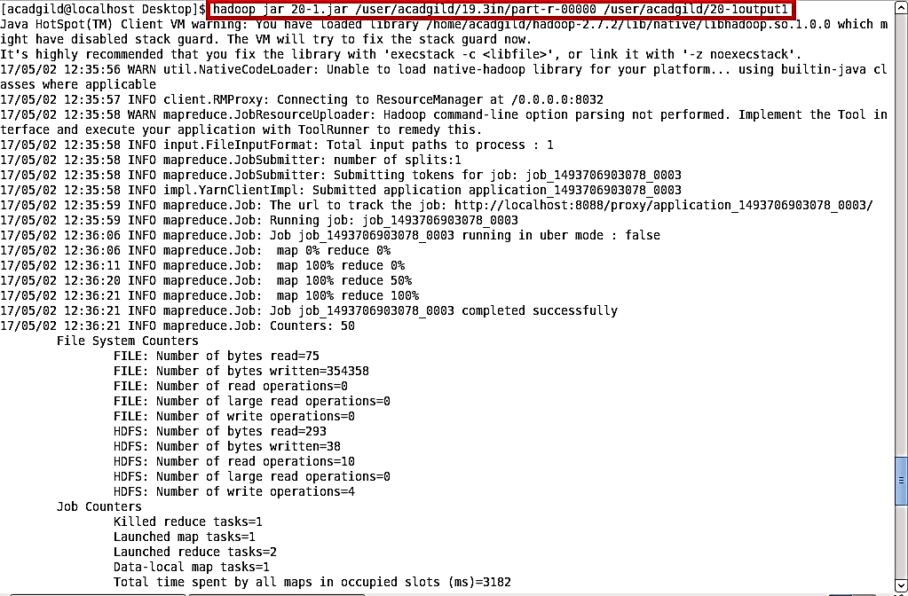

Output:

