**20.2)Task 10: Enhance the task 8 (refer session 19, assignment 1) to calculate the top 3 state-wise sales for each company. You may use multiple reducers for this activity.**

**##Driver Class:**

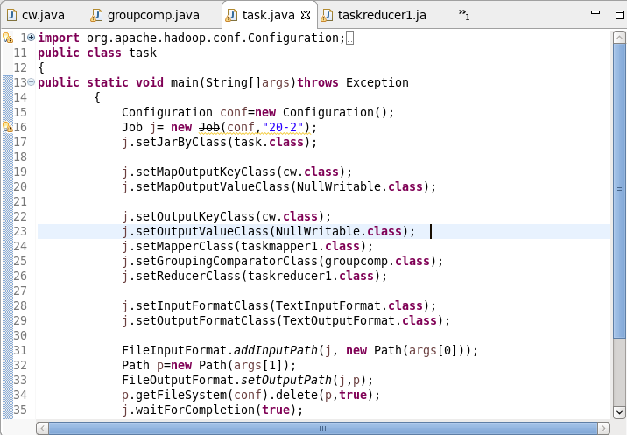

**##Mapper Class:**

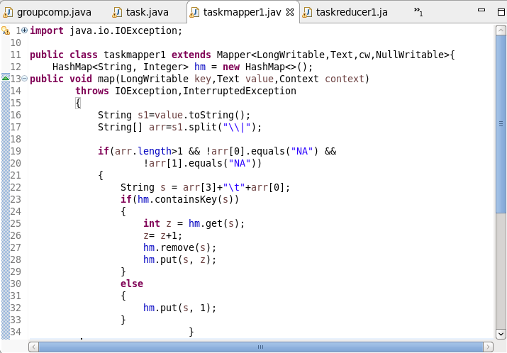

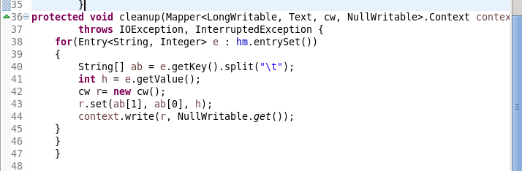

**##Reducer Class:**

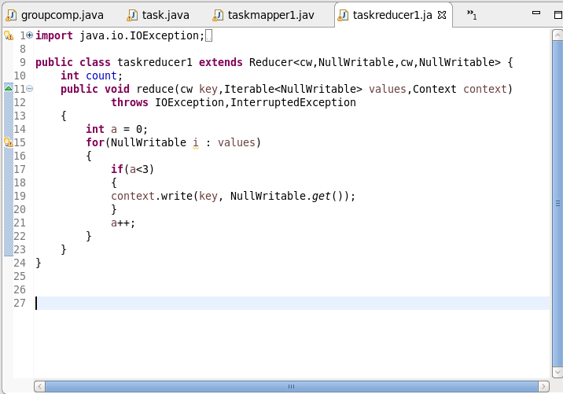

**Writable Comparator Class: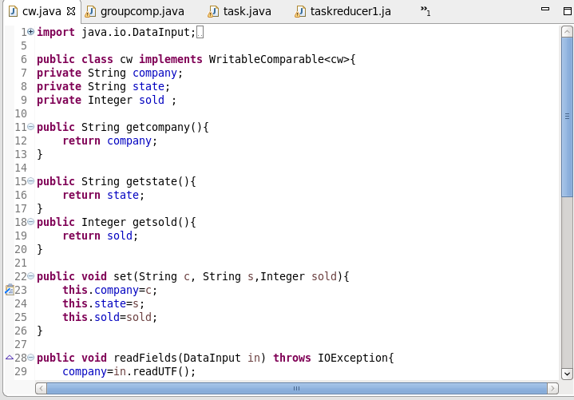:**

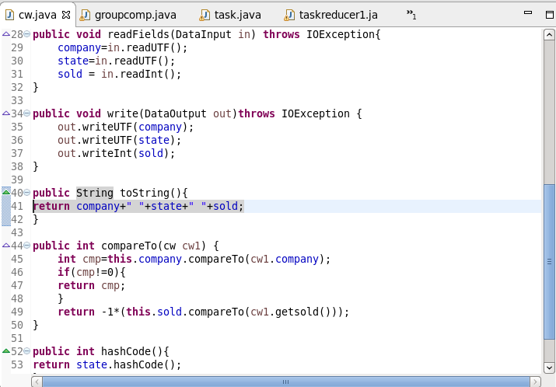

**Group Comparator Class:**

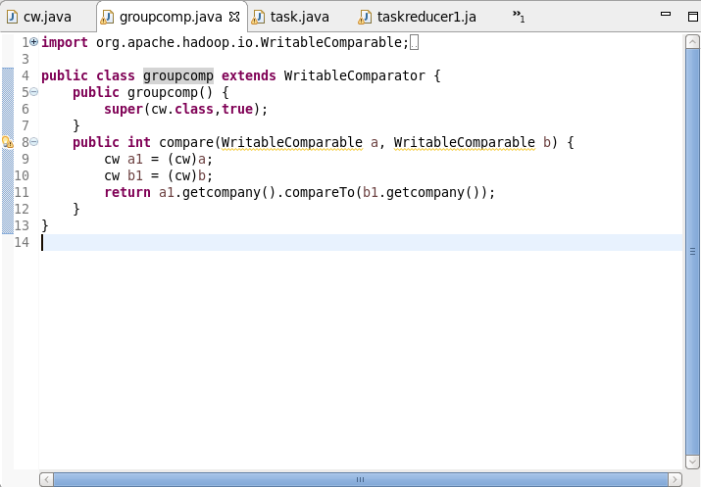

Execution Command:

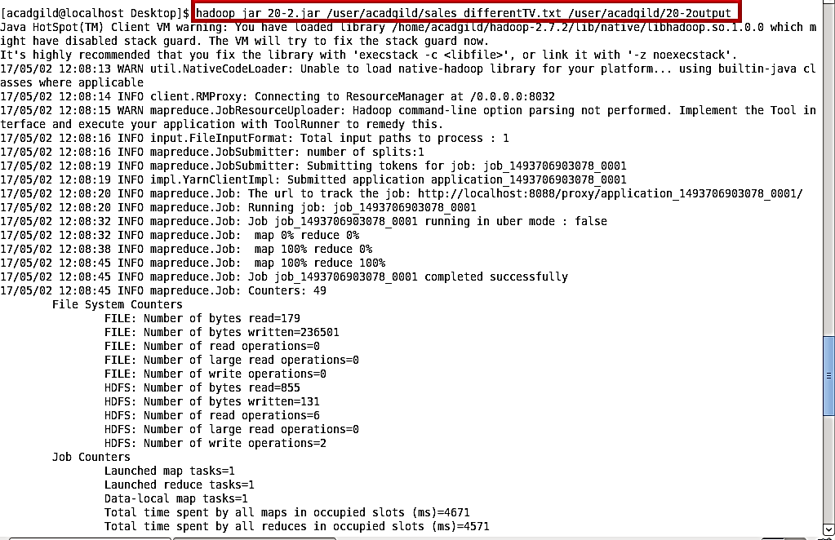

Output:

