**24.3) Calculate the number of employees corresponding to each skill from the table 'employee' which is loaded in the Demo.**

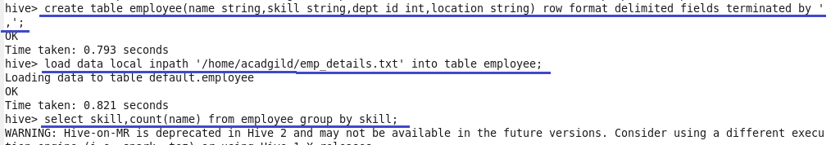

**##Output**

