**24.6)**

**1. Write a hive query to find the minimum temperature observed in a given weather station in a particular year.**

**2. Write a hive query to find the maximum temperature observed in a given weather station in a particular year.**

**3. Write a hive query to find the number of readings given by each weather station according to the dataset.**

**Data Definition: Column 1: Weather Station Column 2: Date(year/Month/Day) Column 3: Observation Type Column 4: Temperature**

1. **Write a hive query to find the minimum temperature observed in a given weather station in a particular year.**

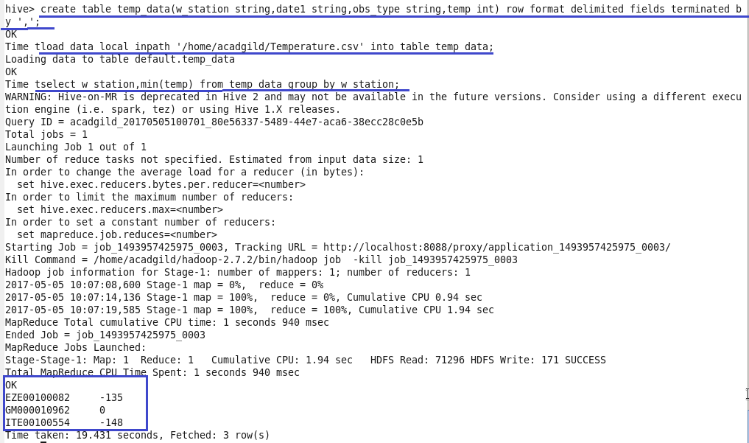

1. **Write a hive query to find the maximum temperature observed in a given**

**weather station in a particular year.**

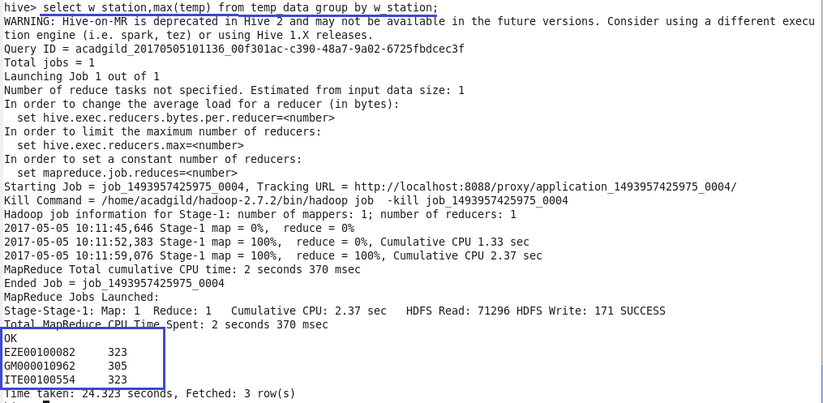

**3. Write a hive query to find the number of readings given by each weather station according to the dataset.**

