**25.1) Creating table and loading the data into table:**

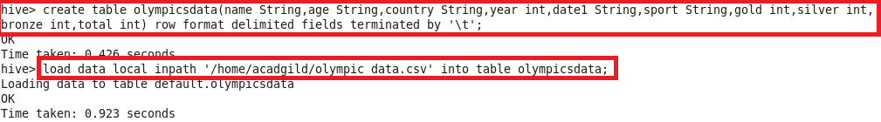

1. **Write a Hive program to find the number of medals won by each country in swimming.**

**Hive Program:**

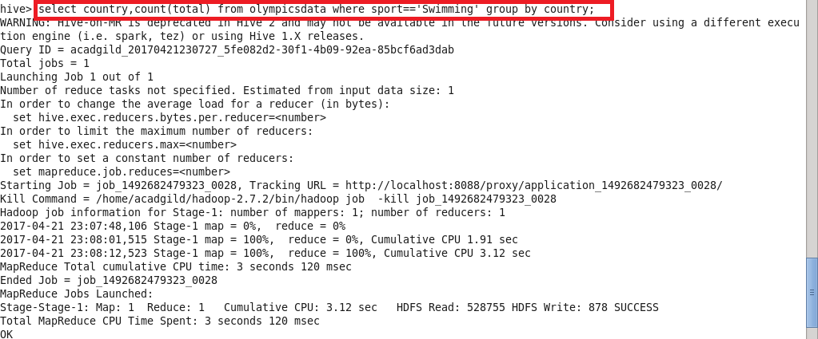

**Output:** 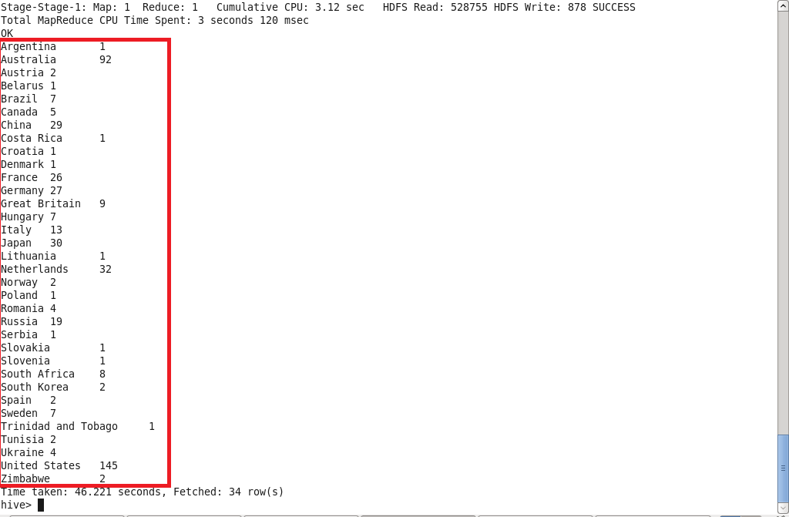

**2)Write a Hive program to find the number of medals that India won year wise.**

**Hive Program**

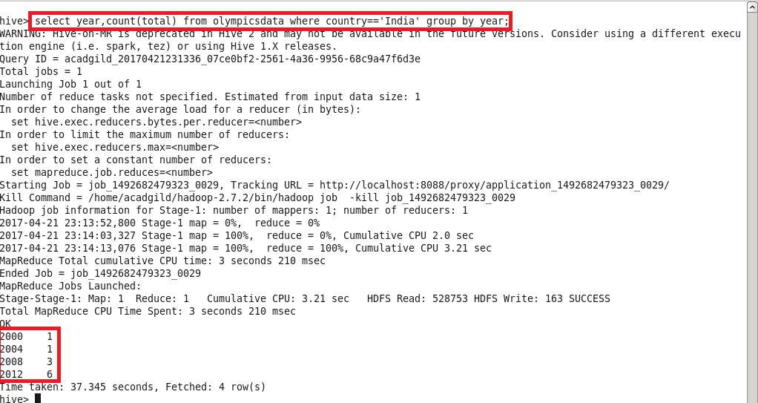

**Output**

