**25.4)**

**1) Write a hive query to find the top 20 destination people travel the most: Based on the given data**

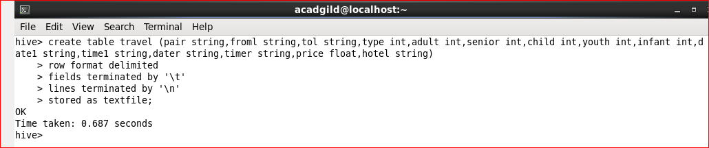

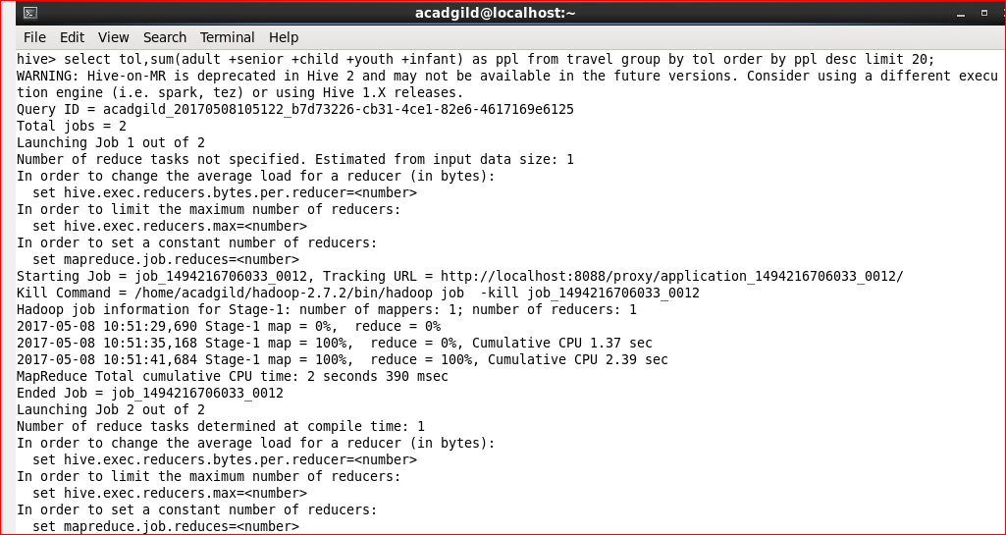

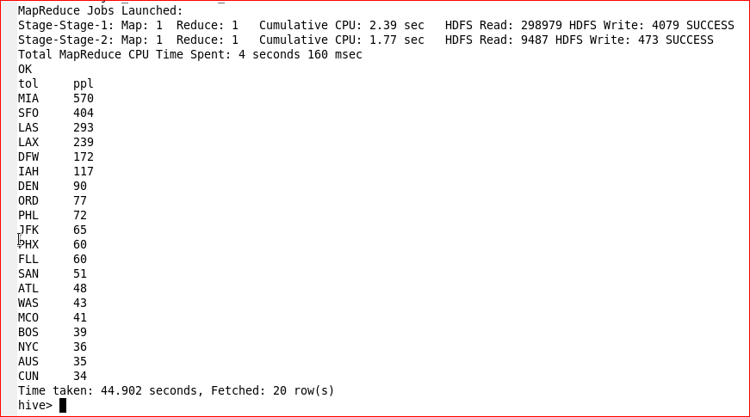

**2) Write a hive query to find the top 20 locations from where people travel the most**

