**25.6)**

**1) Write a hive query to find the city wise list all the Condos which is not less than ten thousand.**

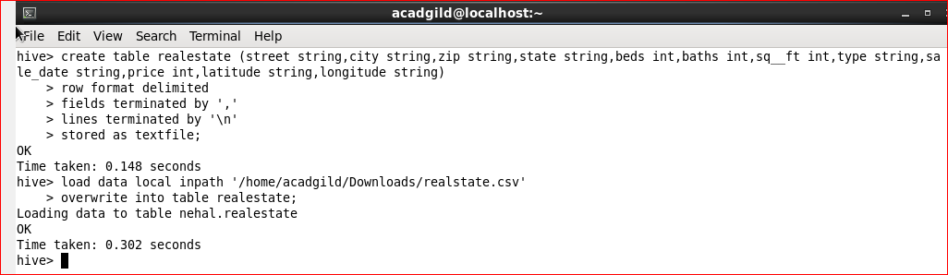

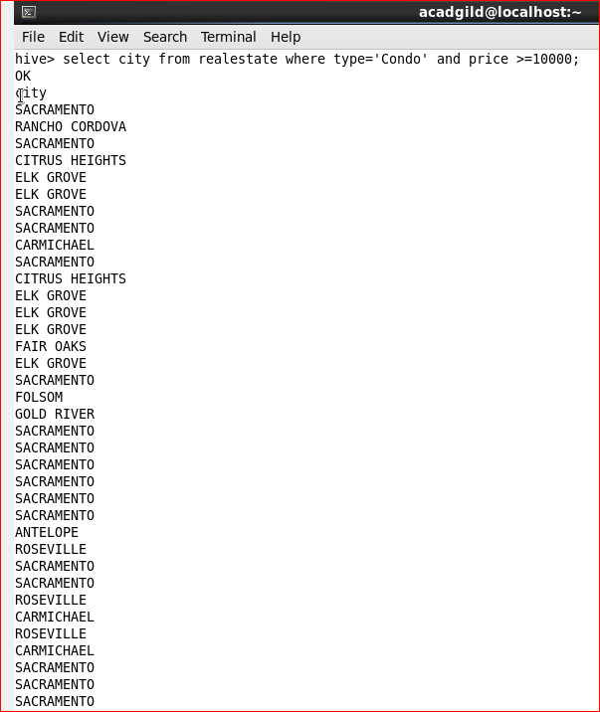

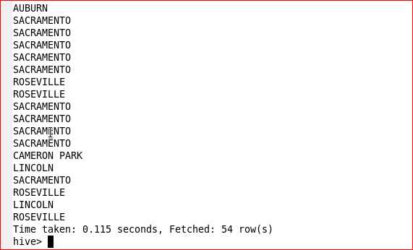

**2) Write a hive query to find which is the cheapest Condo in CA. name the city, street and price for the Condo.**

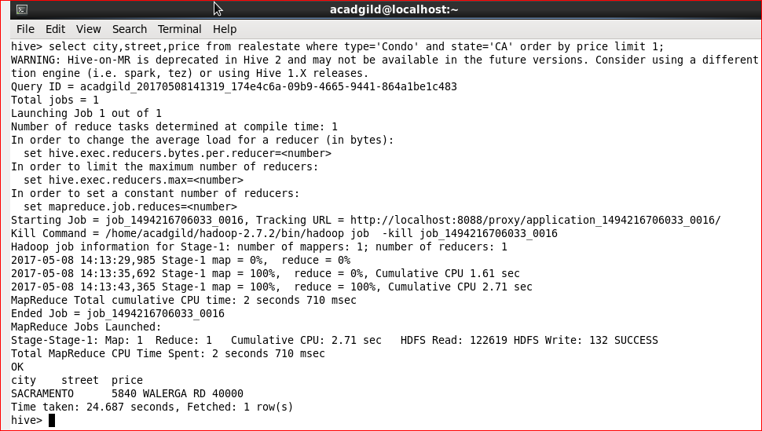

**3) Write a hive query to list top 5 residency details which lie in the budget of 60000-1200000, an area more than 1450, sold after 17th may, min bedroom 3 and, min bathroom 2.**

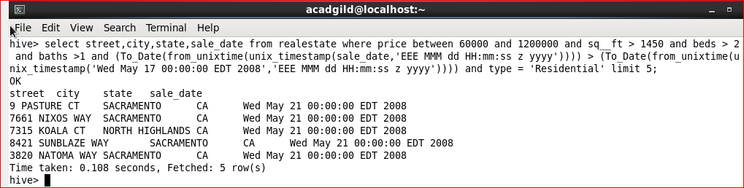

**4) Write a hive query to separate list of residential apartments with more than 2 beds. Also include columns in following order City, Baths, Sq_feet, Price, flat_type, Beds respectively.**

