**26.4)**

**Implement view in hive.**

**First we created table temperature_data and loaded data into it.**

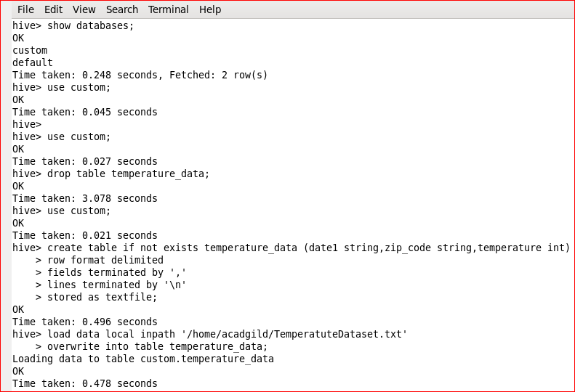

**Created view on table temperature_data to find out maximum temperature year-wise.**

