**27.4)**

**Run parallel jobs in hive by following the steps in the below blog link**

**Creating 4 tables and loading the datasets in them**

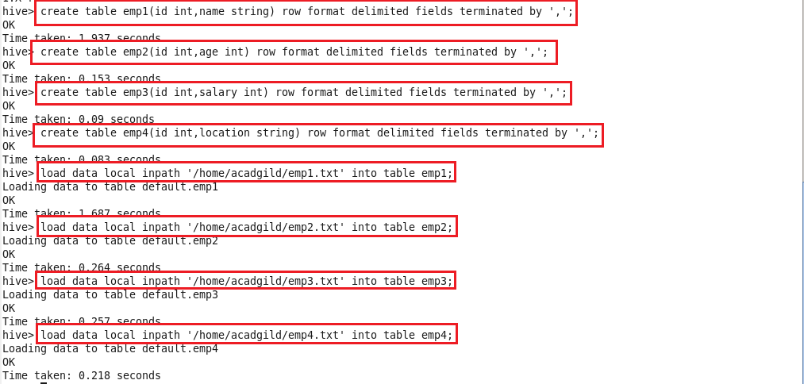

**Displaying the contents of the 4 tables**

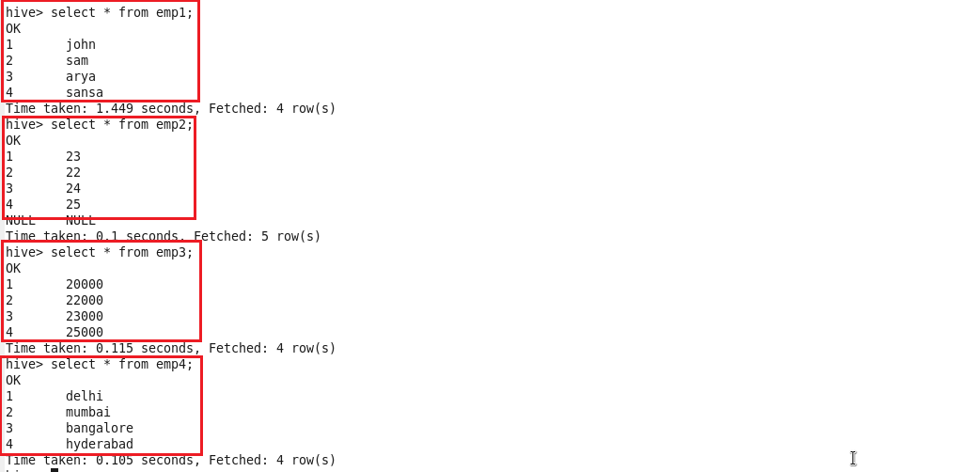

**Running parallel jobs**

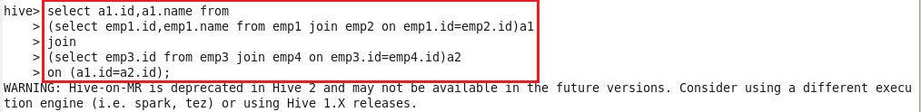

**Output**

