**29.1)**

**Write a hive UDF that implements functionality of string concat_ws (string SEP, array). This UDF will accept two arguments, one string and one array of string. It will return a single string where all the elements of the array are separated by the SEP.**

**Creating UDF class**

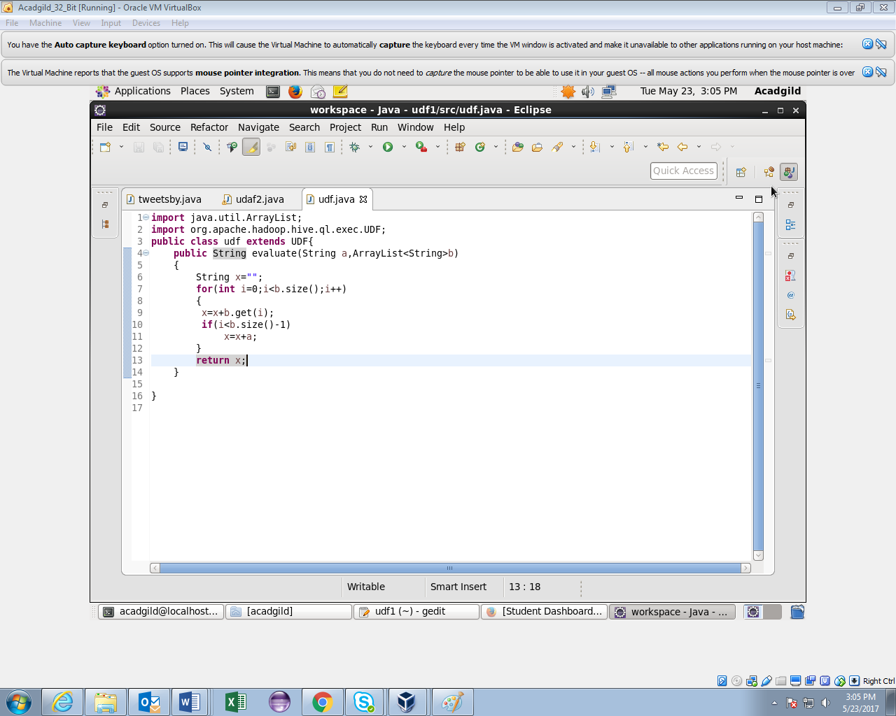

**Creating table and loading data in it.**

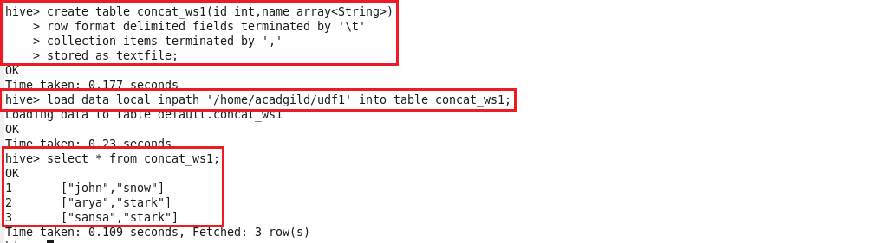

**Creating temporary function and using UDF.**

