**29.2)**

**Write a hive UDAF to find the largest integer in a column. Use your own dataset for the above problem statement and attach the steps performed, codes used with the result.**

**##UDAF class:**

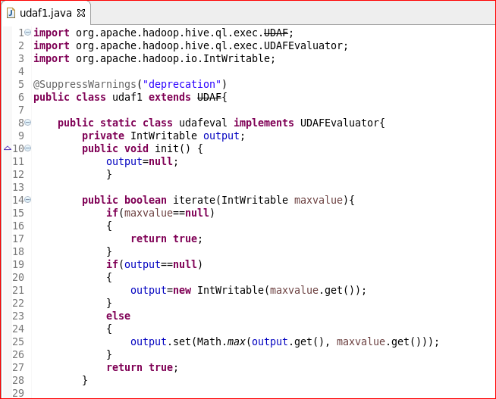

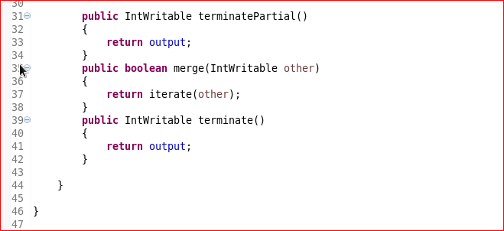

**Creating table and loading data into table:**

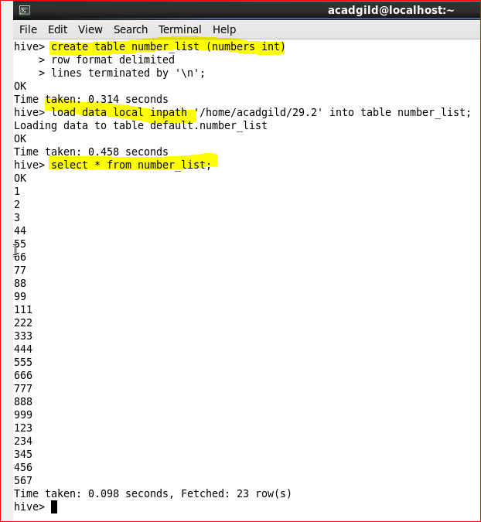

**Adding jar and creating temporary function:**

