**33.1)**

**Write Java client API to perform following operations:**

**● Create the method name get record and use get class to retrieve one record at a time record from company table.**

**● Create the method name display and use scan class to display all records from company table.**

**##writing java code to get only names from the table ‘customer’**

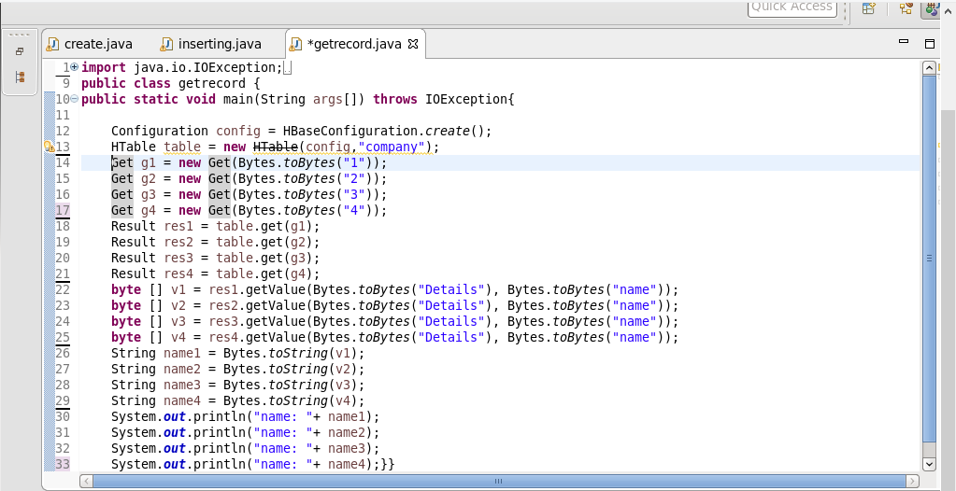

**##list of names from the table ‘customer’**

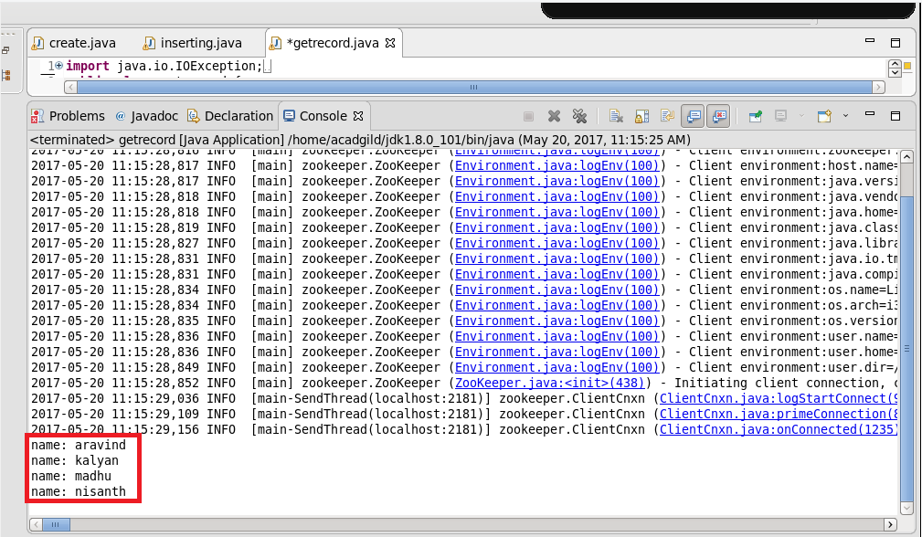

**##checking the contents of the table “company” using scan command**

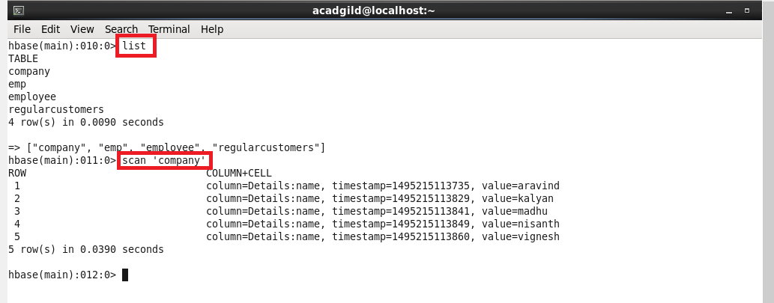

**-------------------------------------------------------------------------------------------------------------**

**2) Create the method name display and use scan class to display all records from company table.**

**##writting java code by using scan class to display all records from company table.**

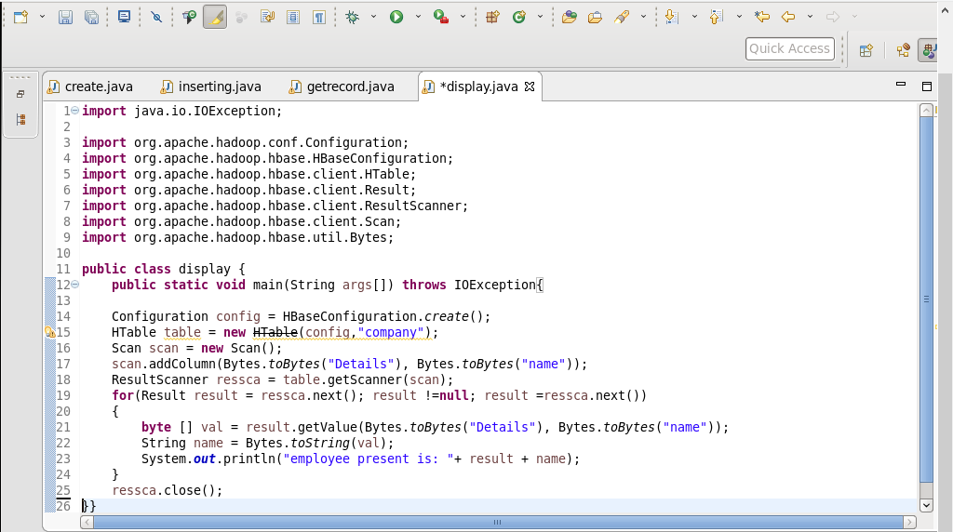

**##running java code(run as application) in eclipse**

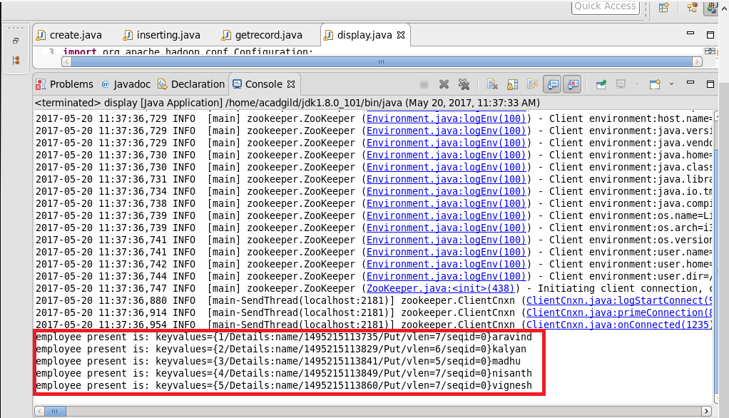

**##checking the contents of the table “company” using get command**

