**1)Write a Java program to copy a file from HDFS to LFS**

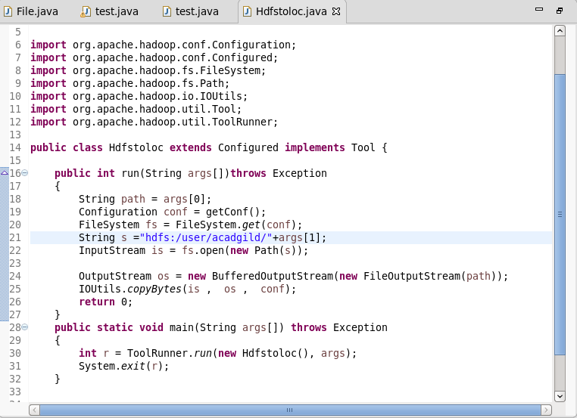

**Output .**

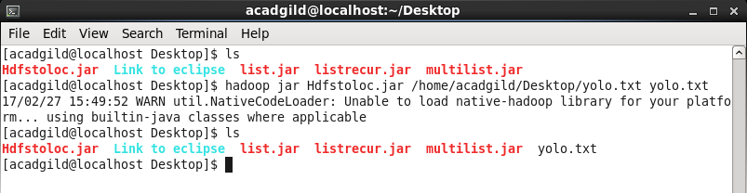

**2. Explain the importance and usage of the below terms in details ● DFSInputStream ● DFSOutputStream ● FSDataInputStream ● FSDataOutputStream**

**DFSInputStream :**

Called internally by FSDataInputStream.Handles communication of the namenodewith various datanodes. Handles integrity of data contained by the blocks.Manages data read activity in case of datanodefailure.

**FSDataInputStream :**

Provides stream (channel) for reading data.

FSDataInputStream

Lets the application read from a file

FSDataInputStream in = fs.open(new Path(uri));

**FSDataOutputStream :**

Provides stream (channel) for writing data.

OutputStreamout = fs.create(new Path(dst));

IOUtils.copyBytes(in, out, 4096, true);

**DFSOutputStream :**

Handles communication of the namenodewith various datanodes.

Called internally by FSDataOutputStream.