**Problem statement1: Find the number of GoogleKnowlege_Occupation people who were guests in the show, in a particular time period.**

**##Driver**

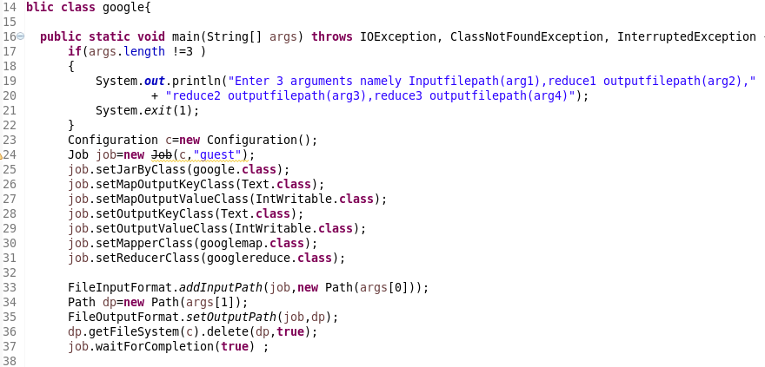

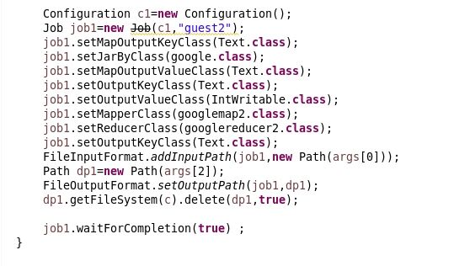

**##MAPPPER**

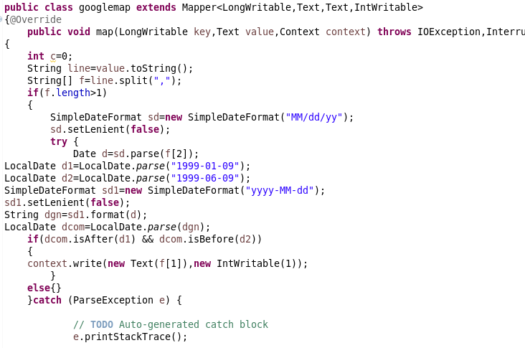

**##REDUCER**

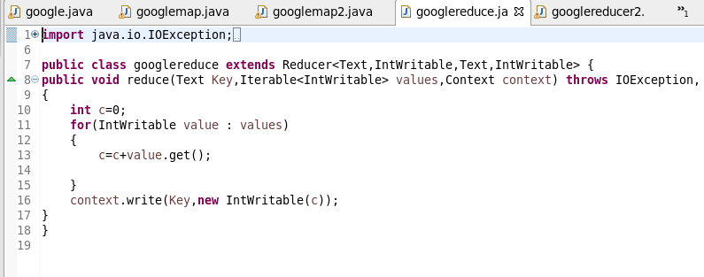

Problem statement2: Find the number of GoogleKnowledge occupation types in each group, who have been guests on the show.

##Mapper:

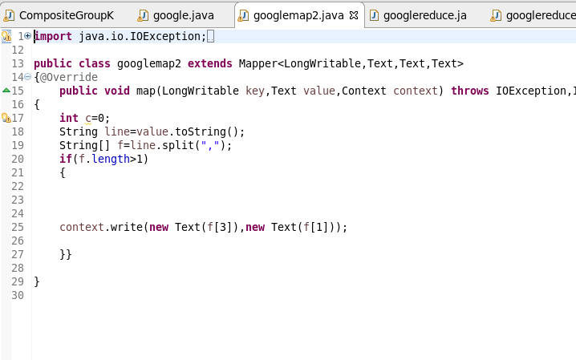

##Reducer:

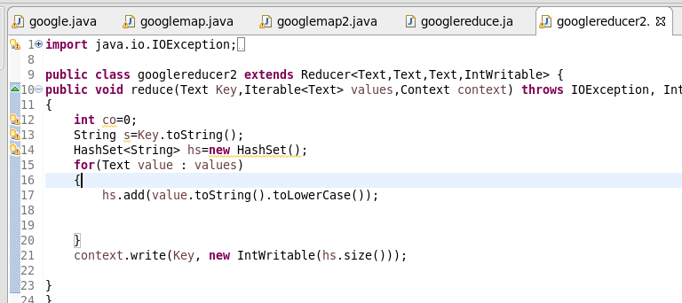

**##RUNNING JAR:**

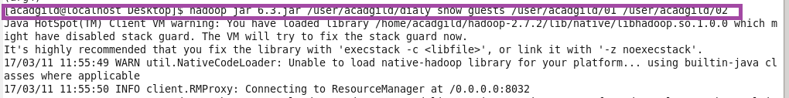

**##Output1:**

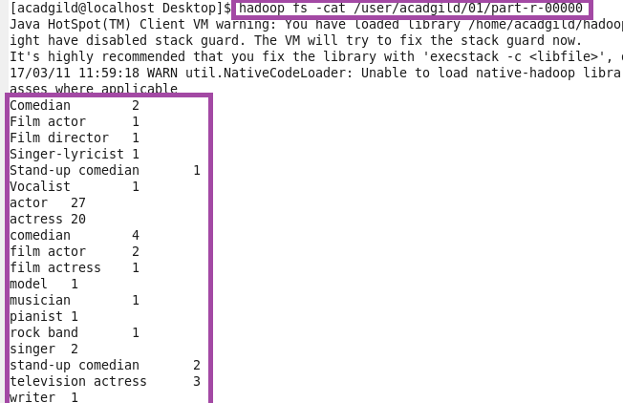



**##Output 2:**

