7.5)Write a map only job for the word count program and set the output format as sequence file.

##DRIVER

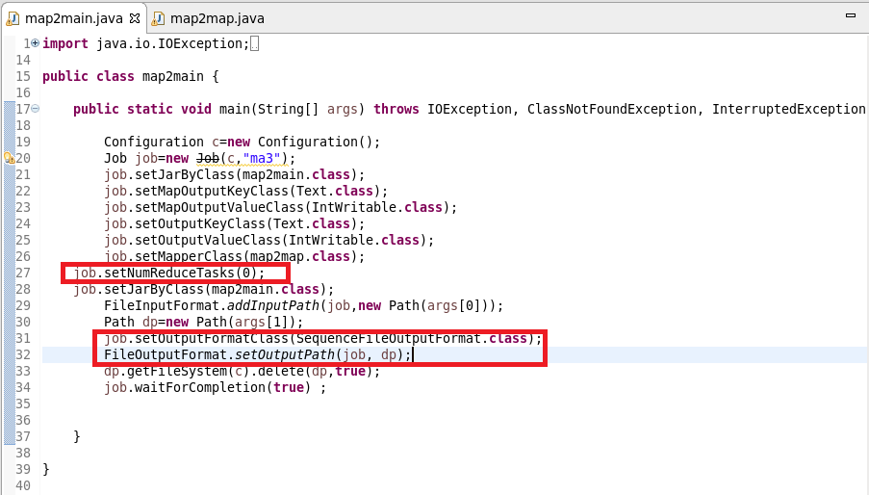

##MAPPER CLASS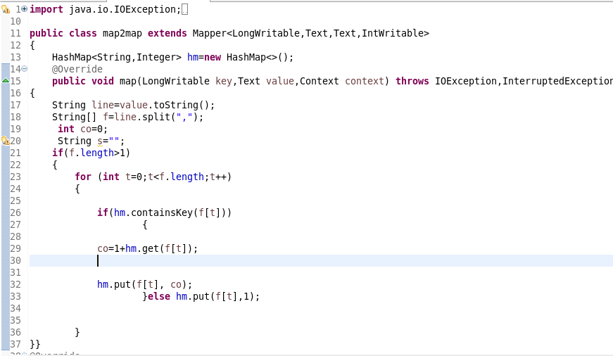

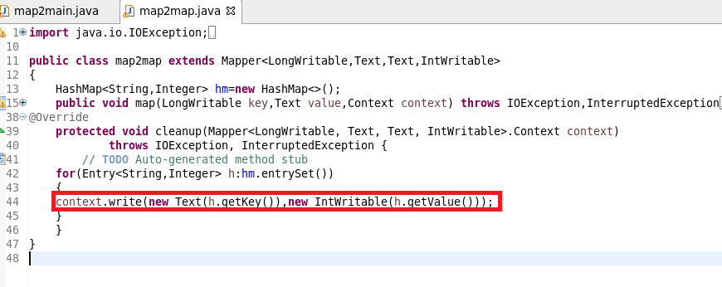

**##RUNNING JAR**

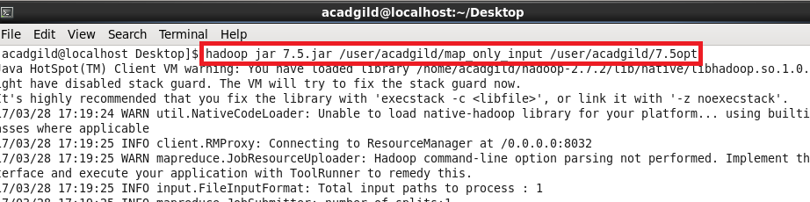

**##OUTPUT**

USED text COMMAND TO OPEN SEQUENCE FILE



