7.6)Write a map reduce program save the output of the word count program in XML format. You need to write a custom writable to save the output in XML format.

**Set output format class as XMLOutputFormat.class**

**##driver**

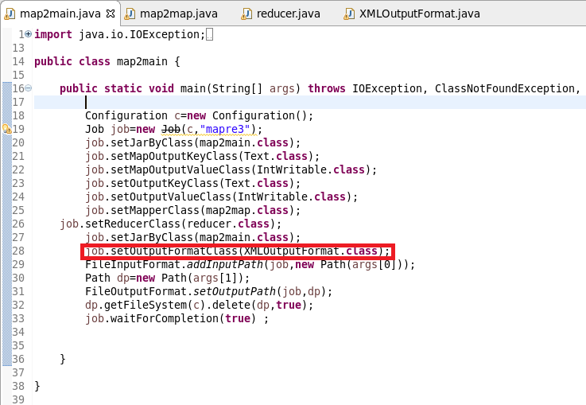

**##mapper**

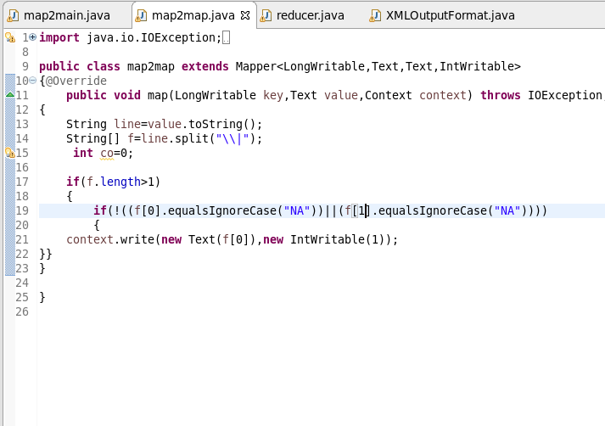

**##reducer**

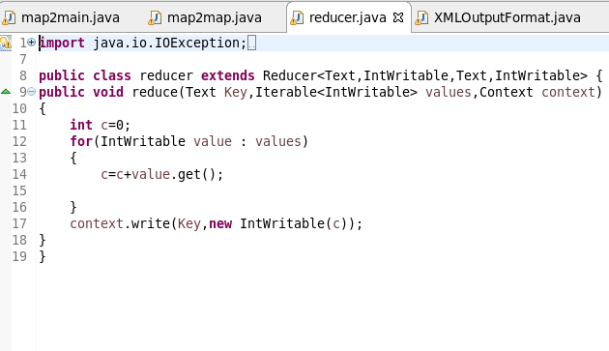

**##xmloutputformat:**

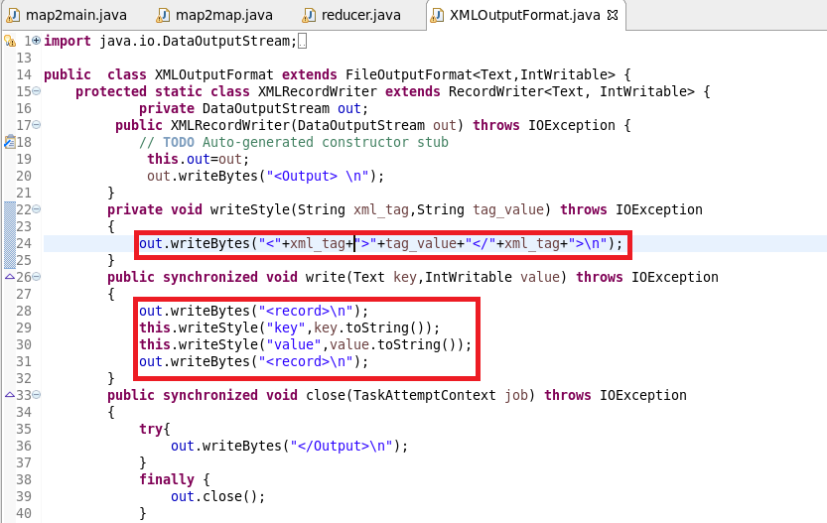

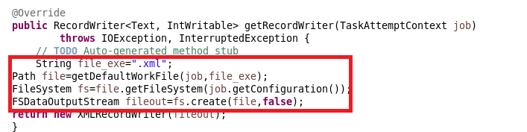

##running jar:

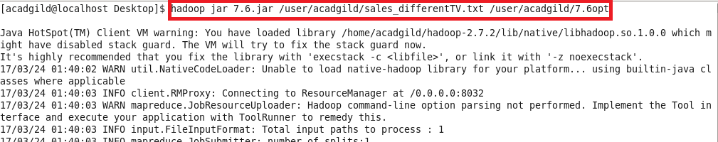

##output:

