**Petrol Data Analysis**

8.1)Problem Statement

Column name : Column1: District.ID I4N 1M1 varchar Column2: Distributor name shell varchar Column3: Buy rate (million) $957.70 varchar Column4: Sell rate(million) $5779.92 varchar Column5: volume IN(million cubic litre) 933, int Column6: volume OUT(million cubic litre) 843, int Column7: Year 1624 int Dataset Link : https://github.com/prateekATacadgild/mAPrEDuce/commit/7f78340c5d59d229 40587bb76bec94dd4781265f

1. Write a mapreduce program to find the total amount of petrol in volume sold by every distributor.
2. Write a mapreduce program to find which are the top 10 distributors ID's for selling petrol and also display the amount of petrol sold in volume

Task Class

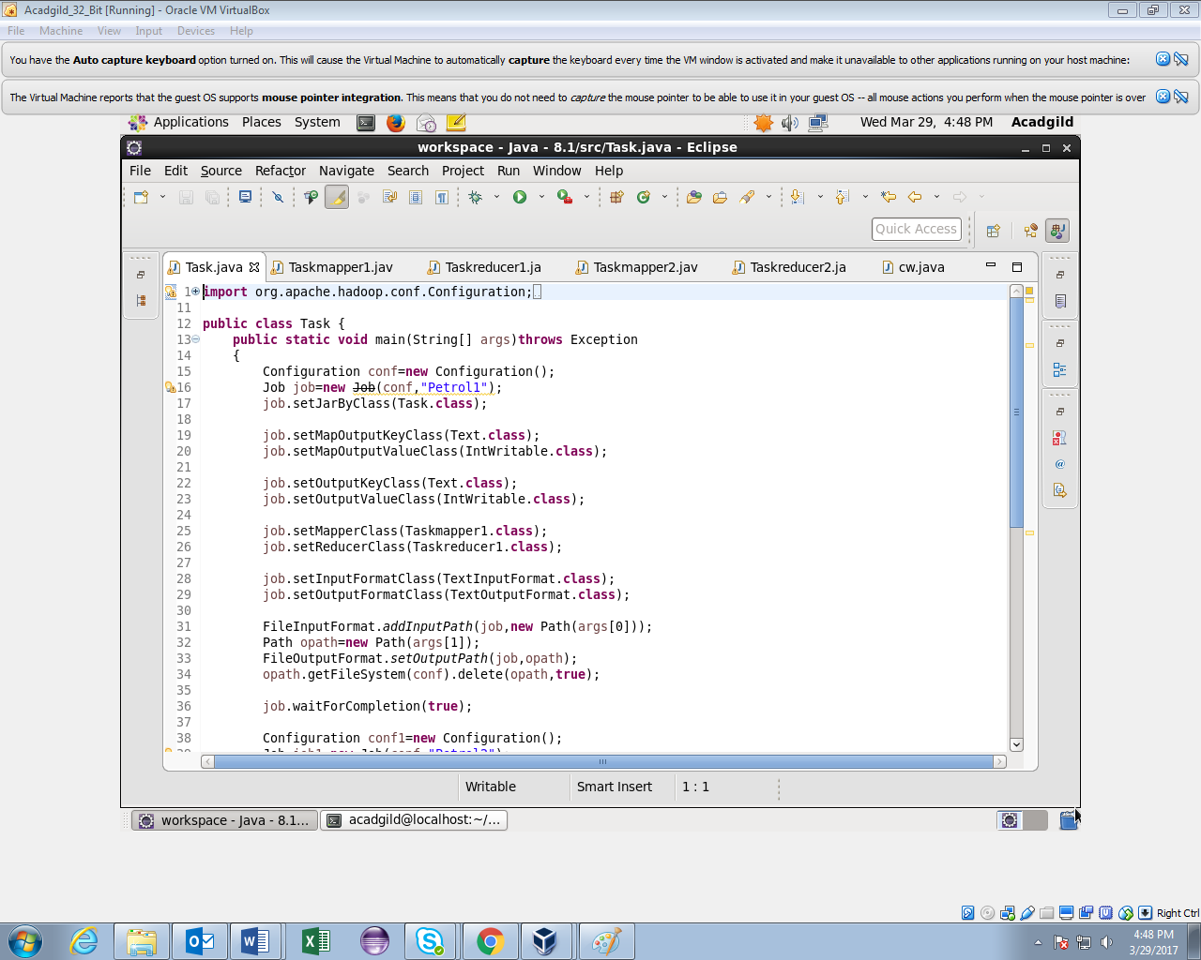

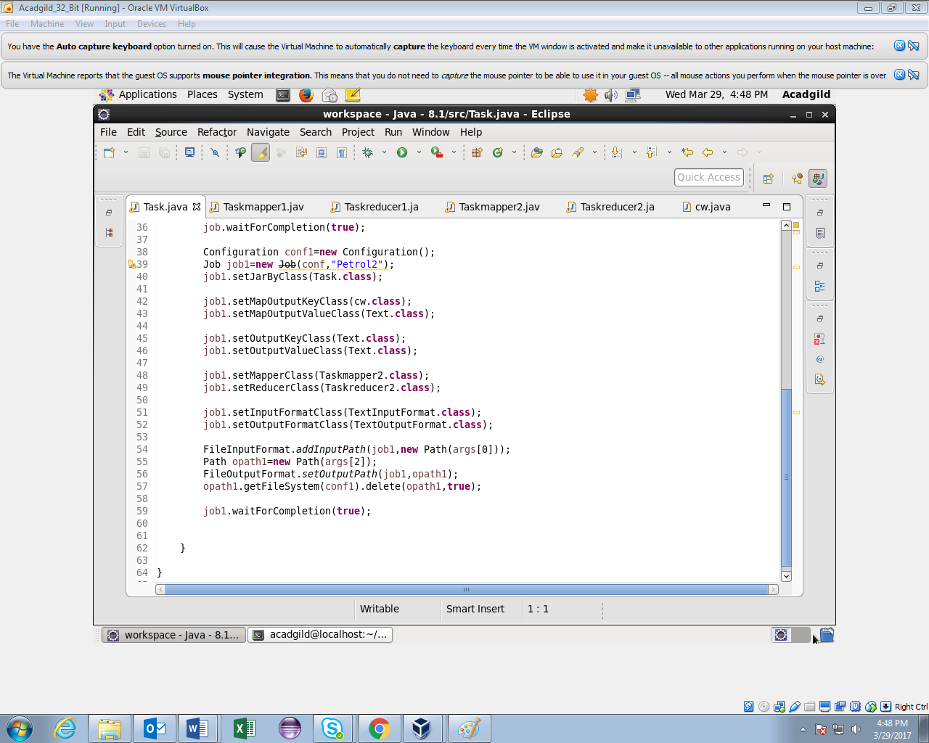

Task1 Mapper

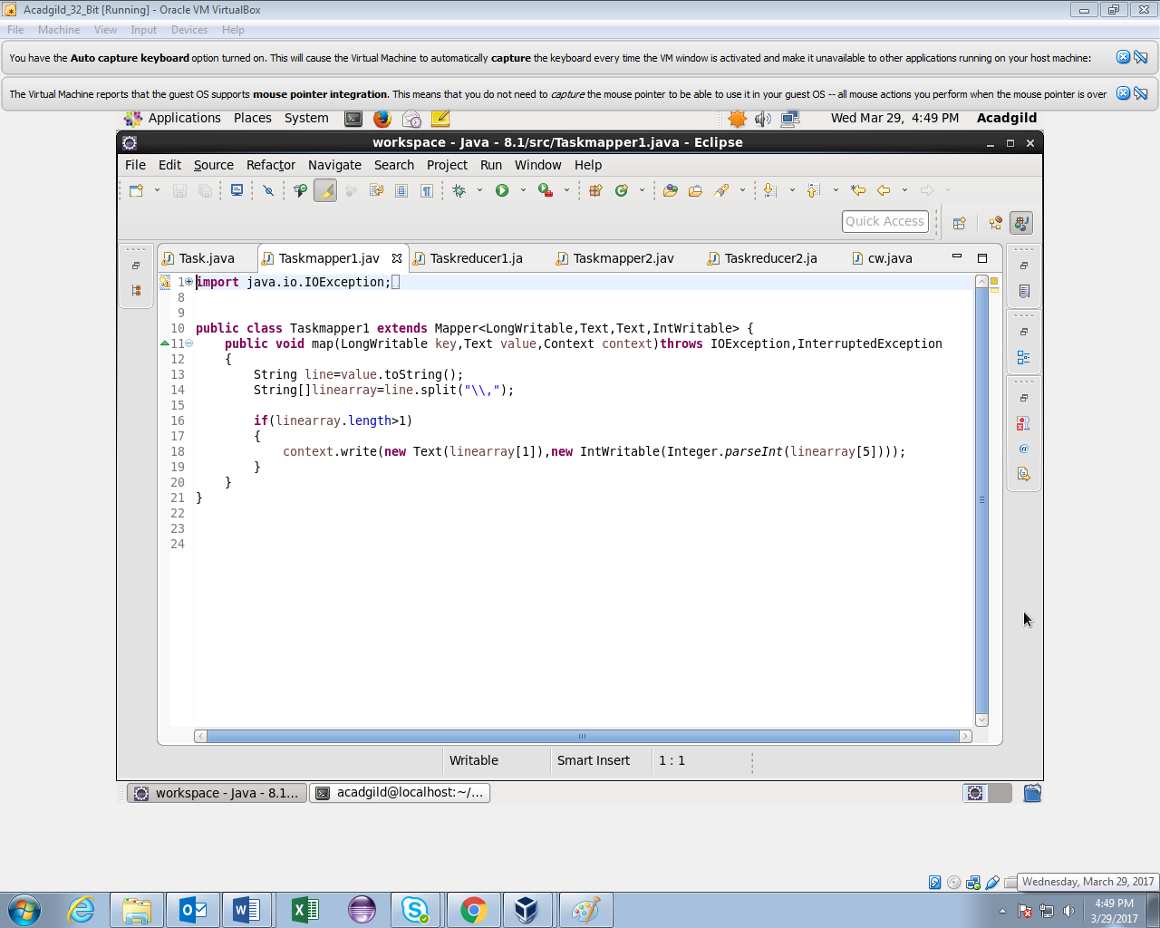

Task1 Reducer

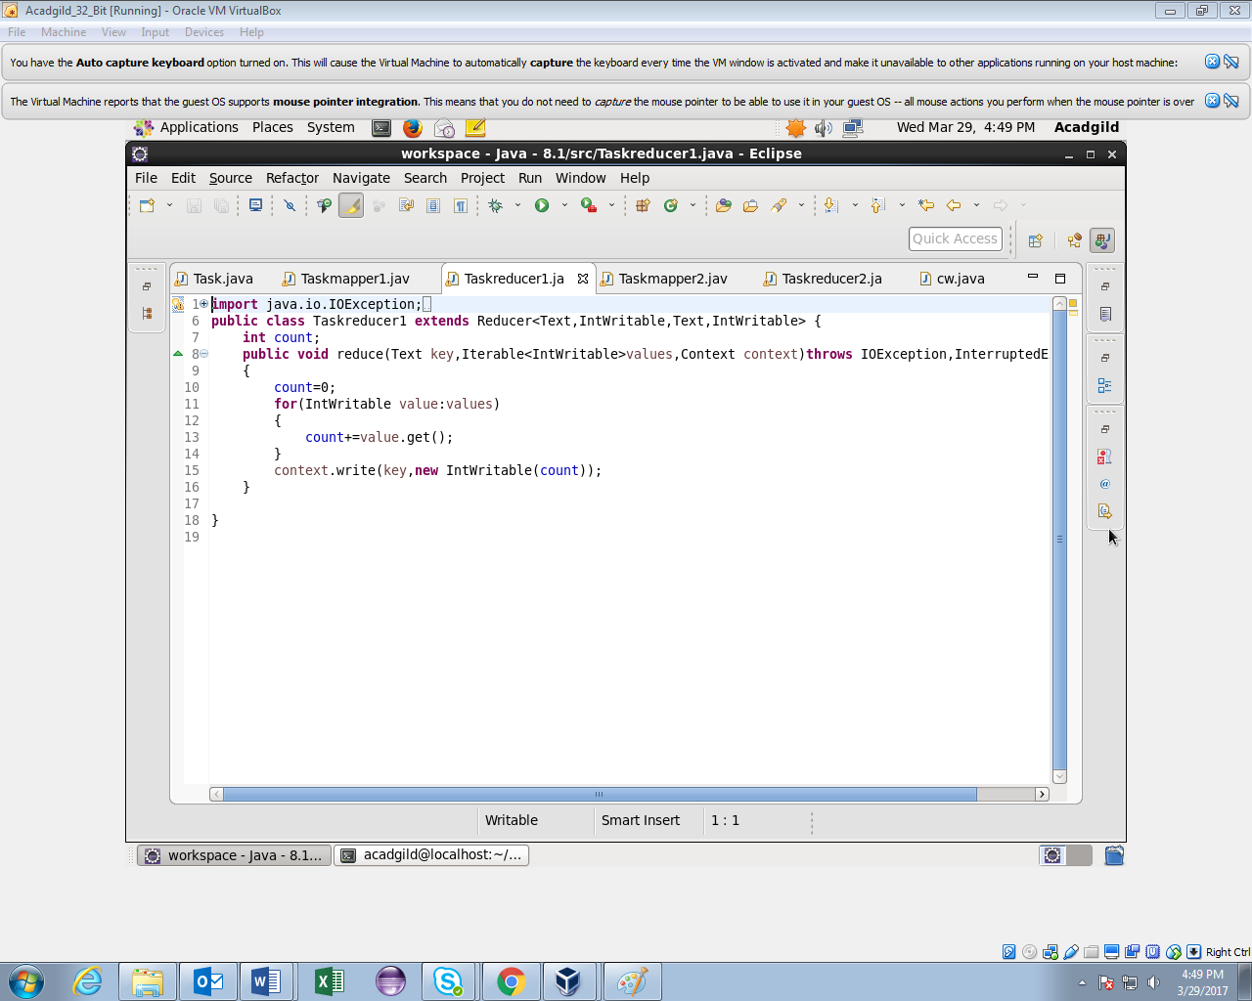

Task2 Mapper

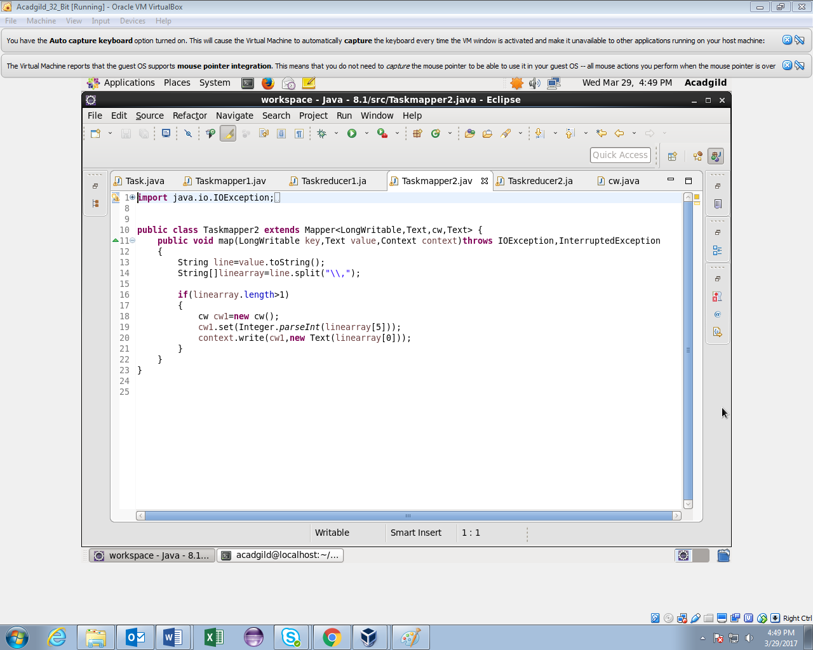

Task2 Reducer

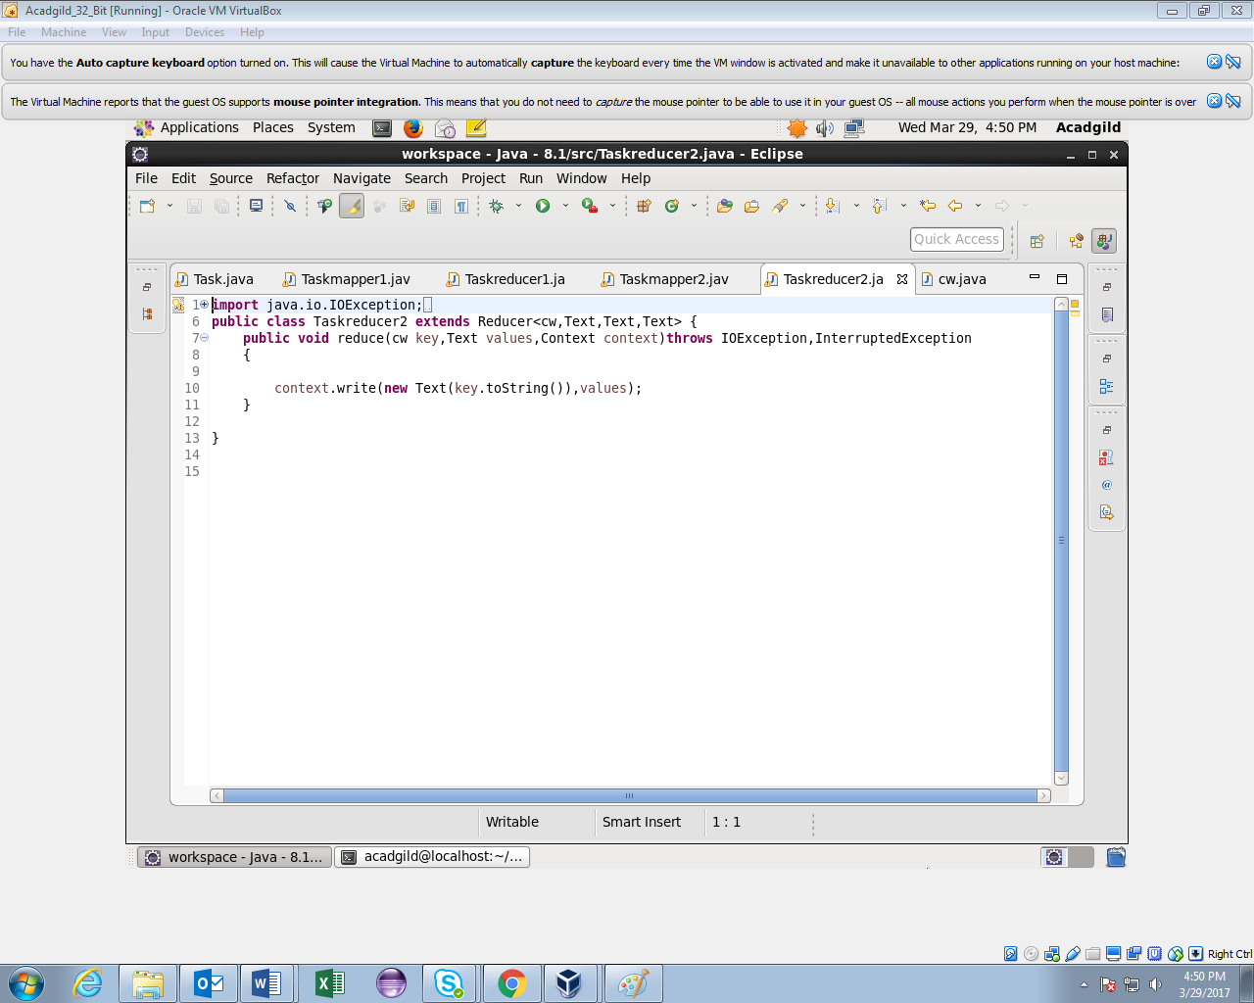

Writable Comparable class for composite key

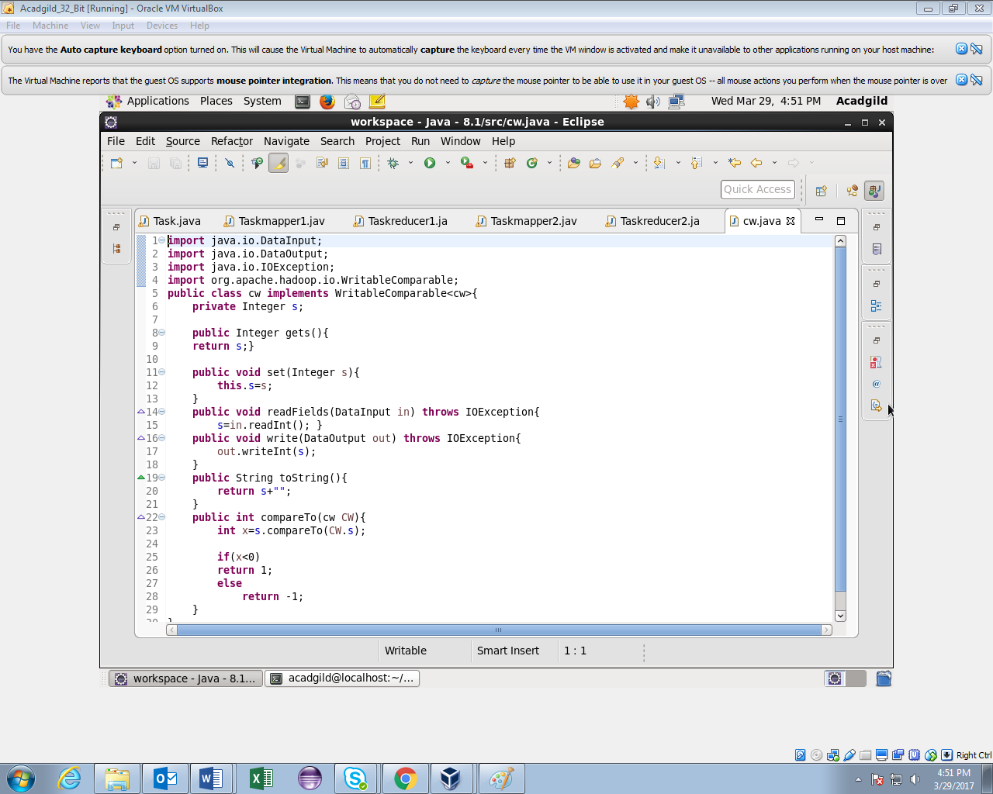

Running Jar

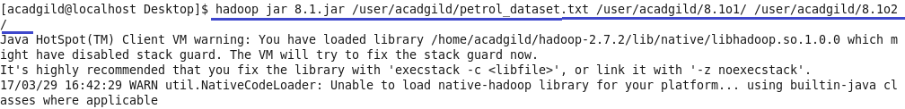

Task1 Output

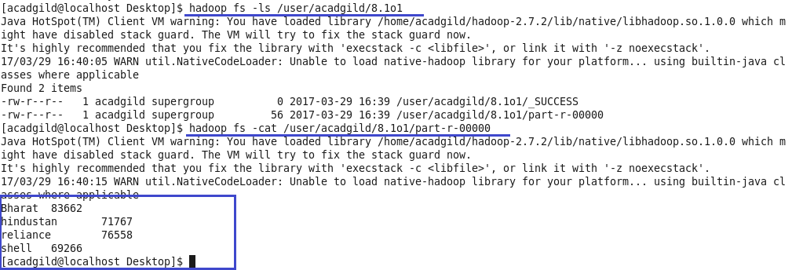

Task2 Output

