Explain in brief the architecture of Apache Hadoop Yarn.

##Part of the core Hadoop project, YARN is the architectural center of Hadoop time streaming, data science and batch processing to handle data stored in a single platform, unlocking an entirely new approach to analytics.

##YARN is the foundation of the new generation of Hadoop and is enabling organizations everywhere to realize a modern data architecture.

##YARN is the prerequisite for Enterprise Hadoop, providing resource management and a central platform to deliver consistent operations, security, and data governance tools across Hadoop clusters.

YARN also extends the power of Hadoop to incumbent and new technologies found within the data center so that they can take advantage of cost effective, linear-scale storage and processing. It provides ISVs and developers a consistent framework for writing data access applications that run IN Hadoop.

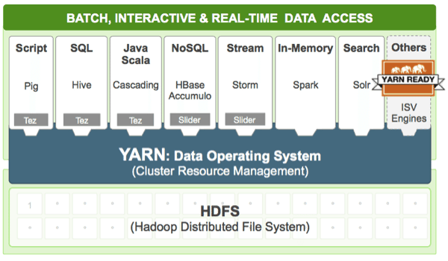

As its architectural center, YARN enhances a Hadoop compute cluster in the following ways:

Multi-tenancy:

YARN allows multiple access engines (either open-source or proprietary) to use Hadoop as the common standard for batch, interactive and real-time engines that can simultaneously access the same data set.

Multi-tenant data processing improves an enterprise’s return on its Hadoop investments

Cluster utilization:

YARN’s dynamic allocation of cluster resources improves utilization over more static MapReduce rules used in early versions of Hadoop

Scalability:

Data center processing power continues to rapidly expand. YARN’s ResourceManager focuses exclusively on scheduling and keeps pace as clusters expand to thousands of nodes managing petabytes of data.

Compatibility:

Existing MapReduce applications developed for Hadoop 1 can run YARN without any disruption to existing processes that already work