● SELF JOIN:

**Self-join** is used to join a table with itself as if the table were two relations, temporarily renaming at least one relat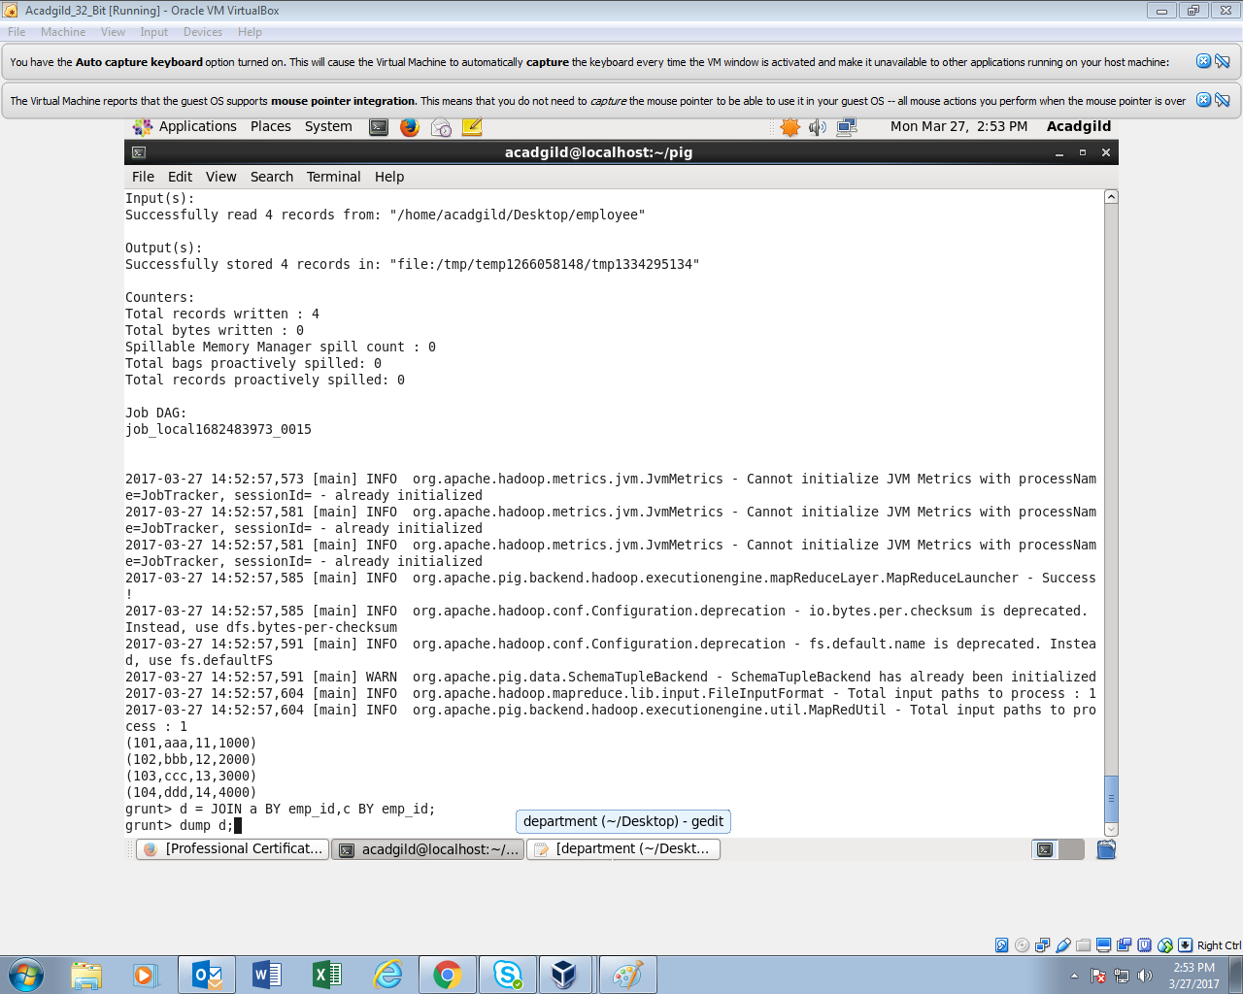ion.

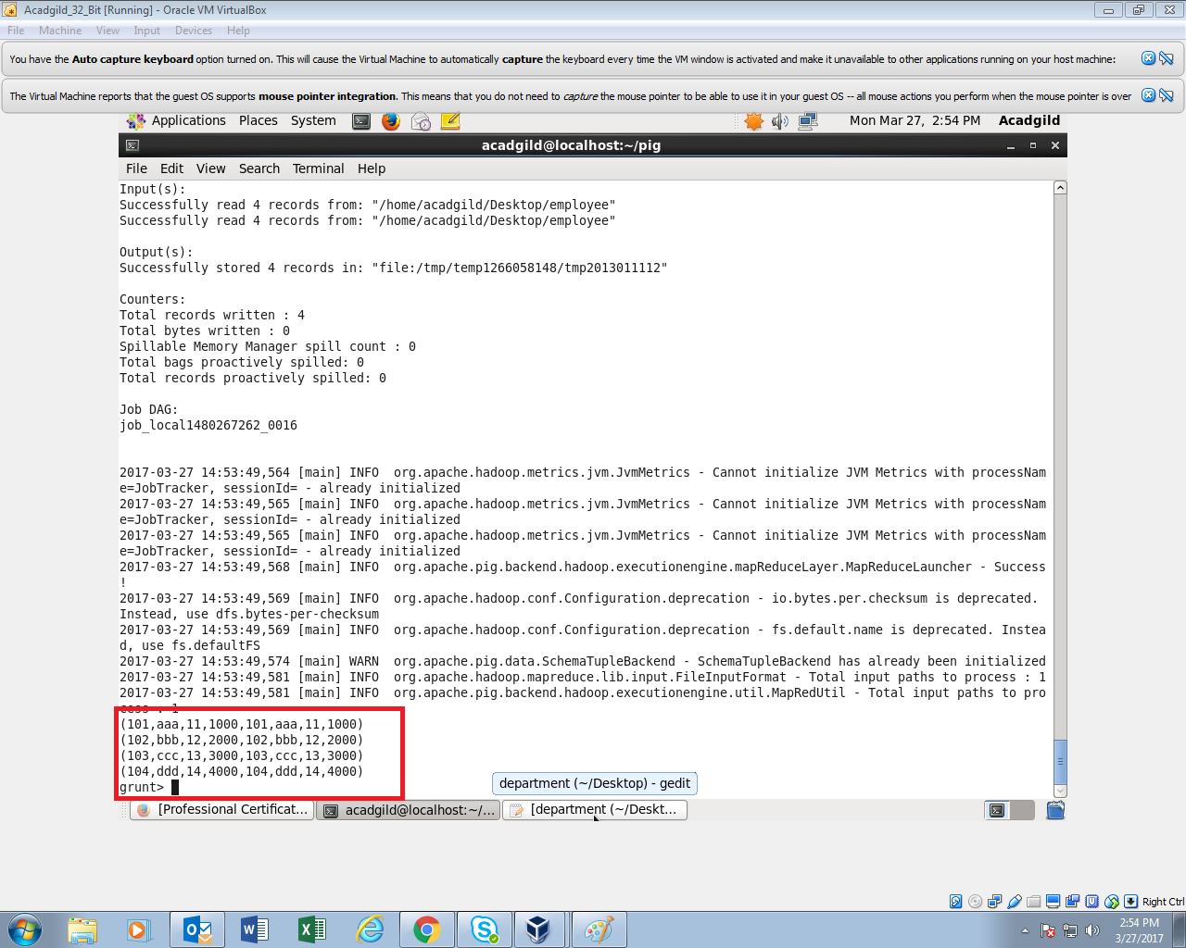

● INNER JOIN :

**Inner Join** is used quite frequently; it is also referred to as **equijoin**. An inner join returns rows when there is a match in both tables.

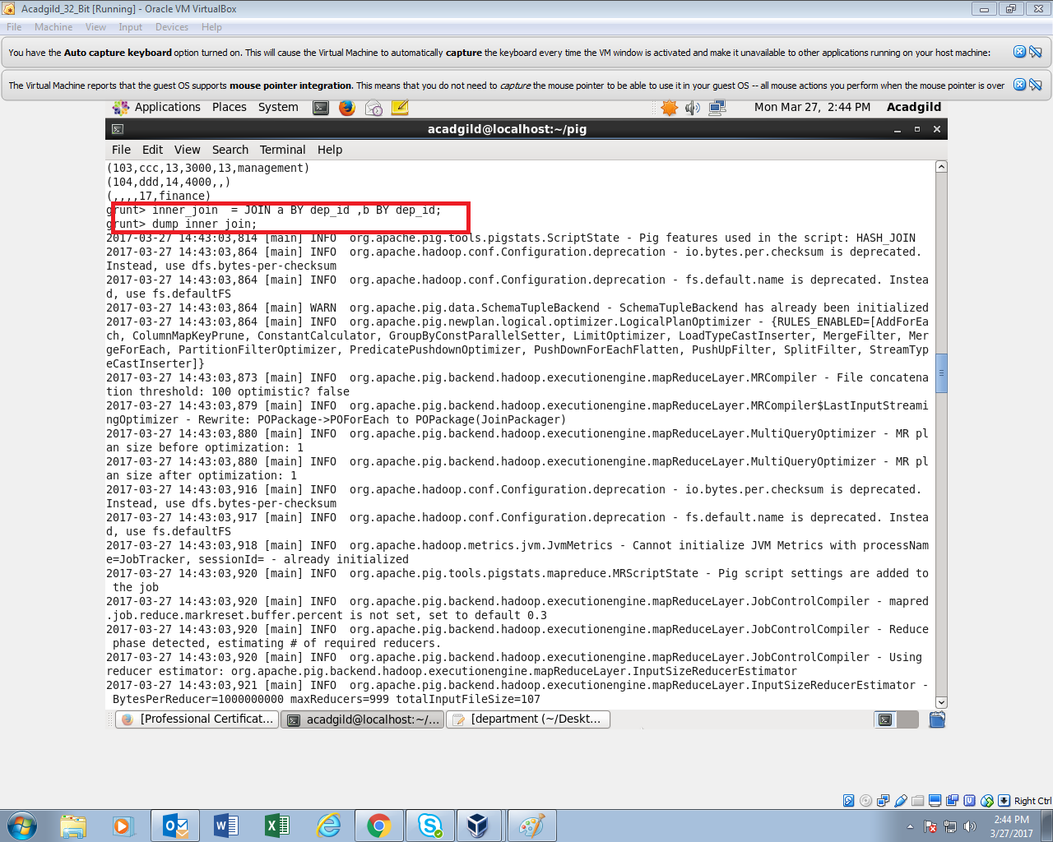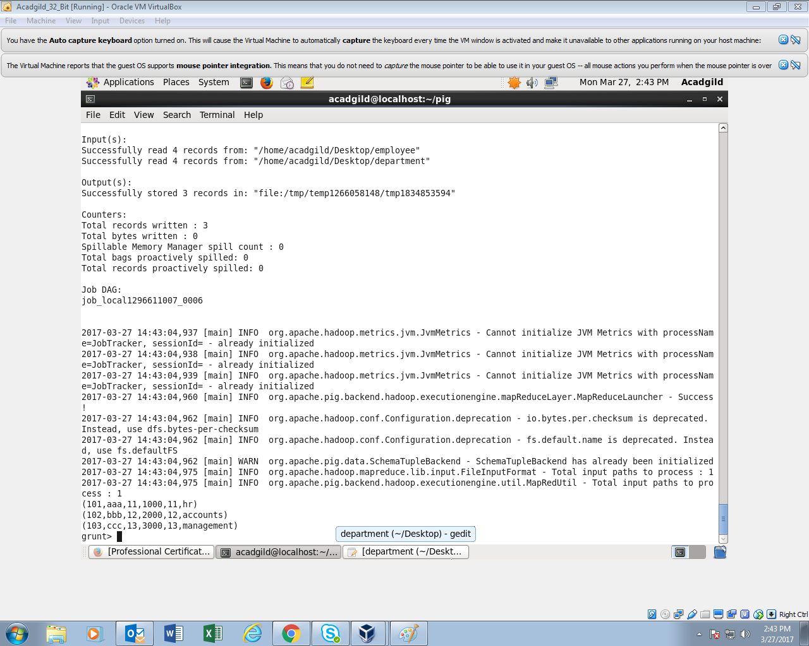

● LEFT OUTER JOIN :

The **left outer Join** operation returns all rows from the left table, even if there are no matches in the right relati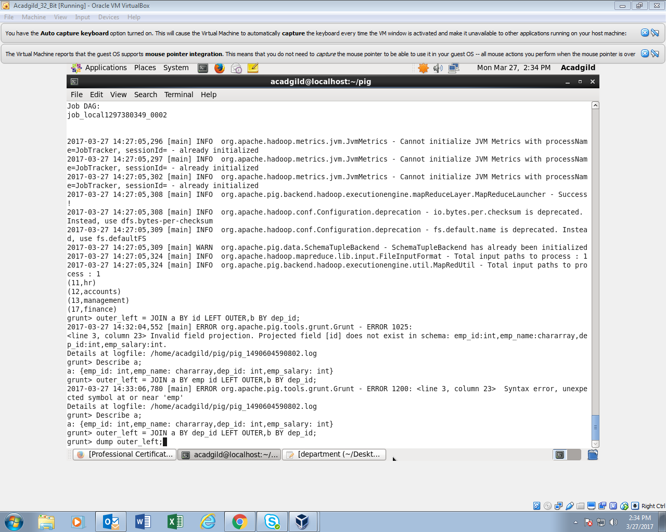on. 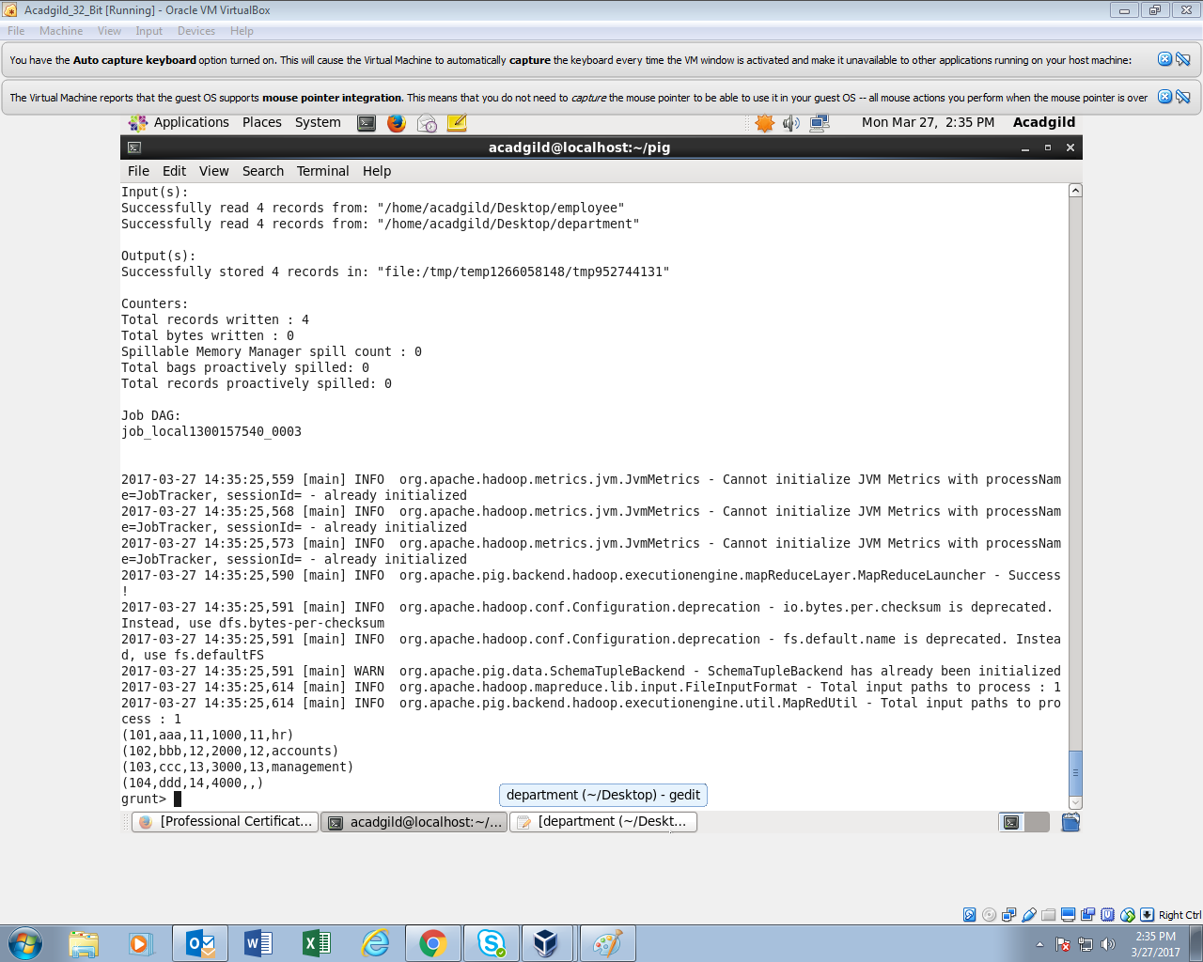

● RIGHT OUTER JOIN :

The **right outer join** operation returns all rows from the right table, even if there are no matches in the left table.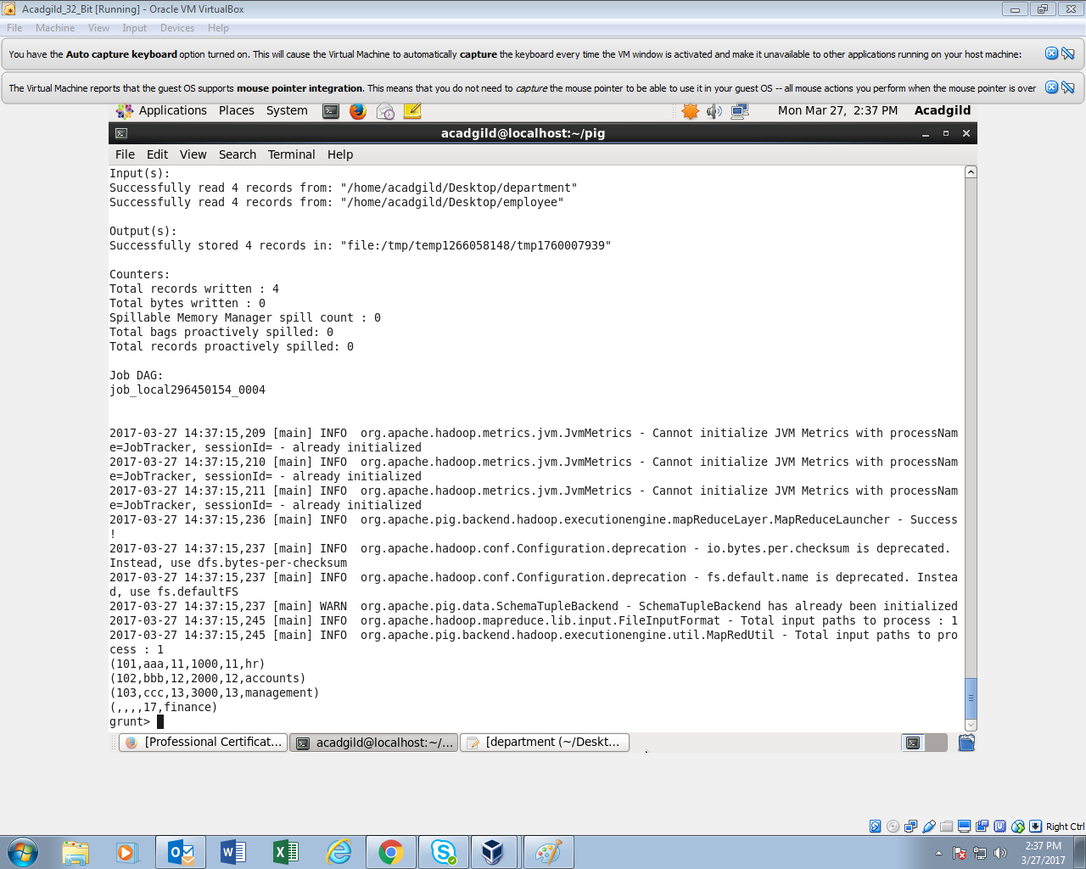

● FULL OUTER JOIN:

The **full outer join** operation returns rows when there is a match in one of the relations.