Journal of Pest Science
Online Resource 1
Rice production systems exposed to the rice root-knot nematode Meloidogyne graminicola: climatic suitability, water-saving transitions and climate change
Arun Arunachalam*, Narayana R, Amritha V.S., Mohankumar Shanmugam, Shandeep Ganeshan, Deeikshana Thirunavukkarasu
* Corresponding author: arunnematology@gmail.com (Department of Nematology, College of Agriculture, Kerala Agricultural University, Vellayani, Thiruvananthapuram 695522, India)

Contents
This file contains Tables S1–S3 and Figs. S1–S10. Tables S4–S9 are supplied as spreadsheet (.csv) files in Online Resource 2, together with the R script that reproduces every result:
- Table S4 The 14 training-data specifications: location, weighting, duplication, feature class, multiplier, threshold, suitable share and correlation with the centroid surface (Table_R2_variants.csv)
- Table S5 EPPO records, GADM correspondence, matching method, host mask and area-based weight (Meloidogyne_graminicola_EPPO_geocoded.csv; eppo_unit_crosswalk.csv)
- Table S6 Rice area in suitable climate by country, record status and surveillance priority (Table_R8_rice_exposure_by_country_full.csv; Table_R11_surveillance_priorities.csv). Taiwan, listed as unrecorded in the database output, is reclassified as recorded (Yao et al. 2020)
- Table S7 Projected change by climate model (Table_7b_change_by_gcm.csv); model agreement (Table_9_model_agreement.csv); novelty of the future extent and of gained area (Table_10_future_novelty.csv; Table_10b_gain_novelty.csv)
- Table S8 Projected change by country (Table_12_country_change_top.csv; Table_S3_country_change_full.csv) and on cropland (Table_13_crop_area_change.csv)
- Table S9 Centroid and latitudinal shift of suitable area (Table_11_centroid_and_latitude_shift.csv)
Figs. S1–S5 describe the centroid specification; Figs. S6–S10 the future projections of the primary specification.

Supplementary tables
Table S1 Model performance across successive refinements of the training dataset, centroid specification (best model by AICc at each stage; feature class LQ, regularisation multiplier 1 in all cases)
Model version | n | Predictors | AUC (train) | AUC (validation, random k-fold) | CBI (validation) | AICc
Pre-thinning, climate only | 109 | 4 | 0.877 | 0.865 | 0.872 | 2979.7
Post-thinning, climate only | 101 | 4 | 0.874 | 0.866 | 0.847 | 2900.3
Post-thinning + cropland (centroid specification) | 101 | 5 | 0.898 | 0.884 | 0.886 | 2885.0
Table S2 Comparison of random and spatially blocked cross-validation schemes for the five-predictor centroid specification
Cross-validation scheme | AUC (validation) | CBI (validation) | Train–validation AUC gap | 10th-percentile omission rate
Random 5-fold | 0.884 | 0.886 | 0.031 | 0.099
Spatial block, 4,482 km (imbalanced folds) | 0.755 | 0.674 | 0.141 | 0.288
Spatial block, 500 km (balanced folds) | 0.878 | 0.881 | 0.045 | 0.105
Table S3 Combined (GBIF + EPPO) versus GBIF-only training data under random cross-validation (centroid specification). These are not independent tests; see Table 5 of the main text for the withheld comparison
Metric | Combined model (GBIF + EPPO, n = 101) | GBIF-only model (n = 33)
AUC (train) | 0.898 | 0.954
AUC (validation, random k-fold) | 0.884 | 0.926
AUC validation SD | 0.029 | 0.093
CBI (validation) | 0.886 | 0.721
CBI validation SD | 0.045 | 0.163
Train–validation AUC gap | 0.031 | 0.073
10th-percentile omission rate | 0.099 | 0.162
EPPO presence hit rate (records used in training) | 89.7% | 55.9%
Predicted suitability at Slovakia (confirmed absence) | 0.131 | 0.002

Supplementary figures
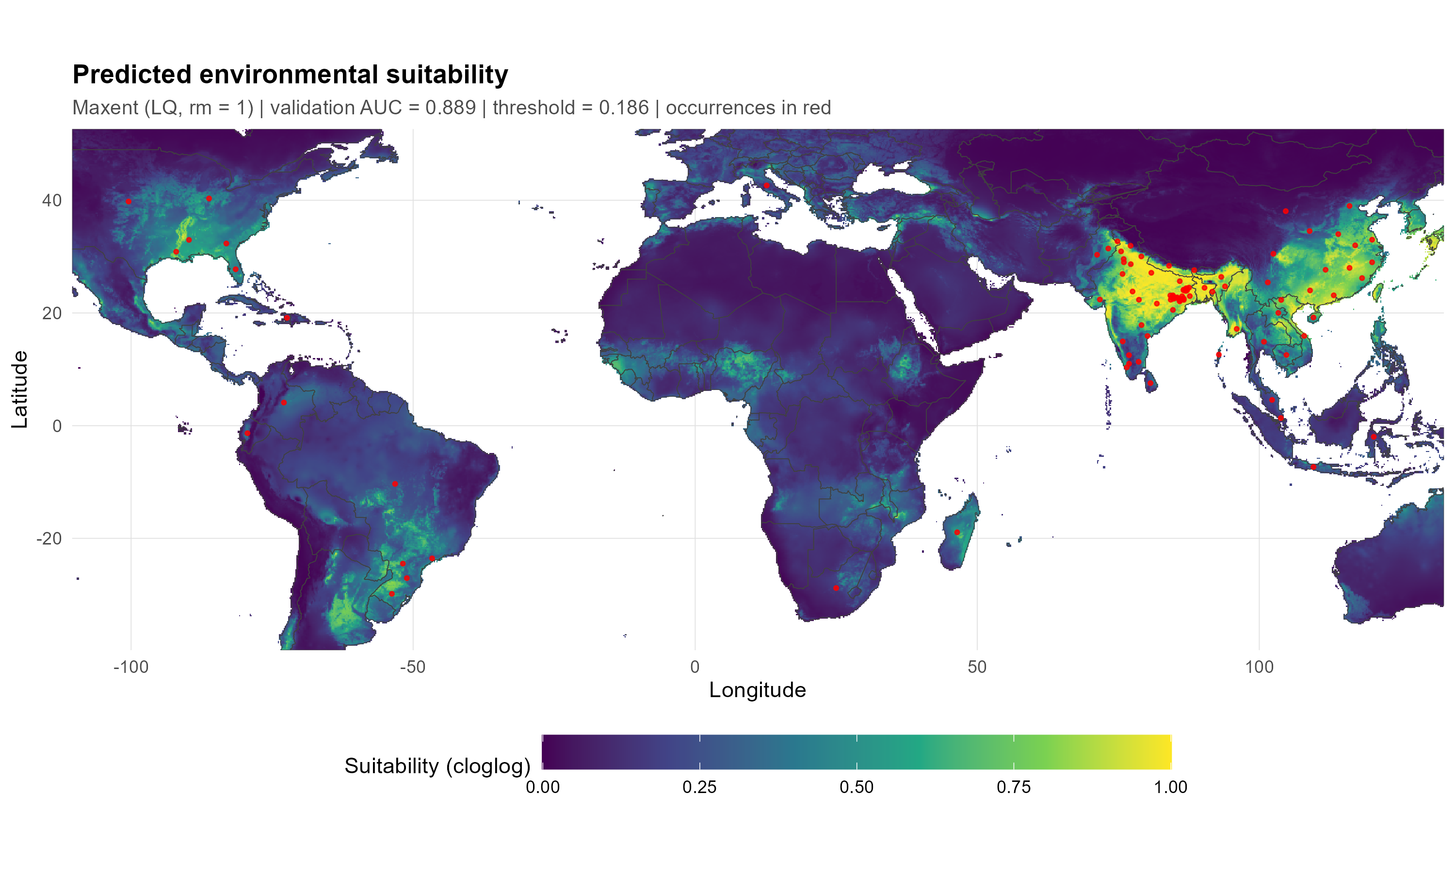
Fig. S1 Predicted suitability from the centroid specification (geocoded centroids, unweighted; linear and quadratic features, regularisation multiplier 1; threshold 0.186); occurrence records in red

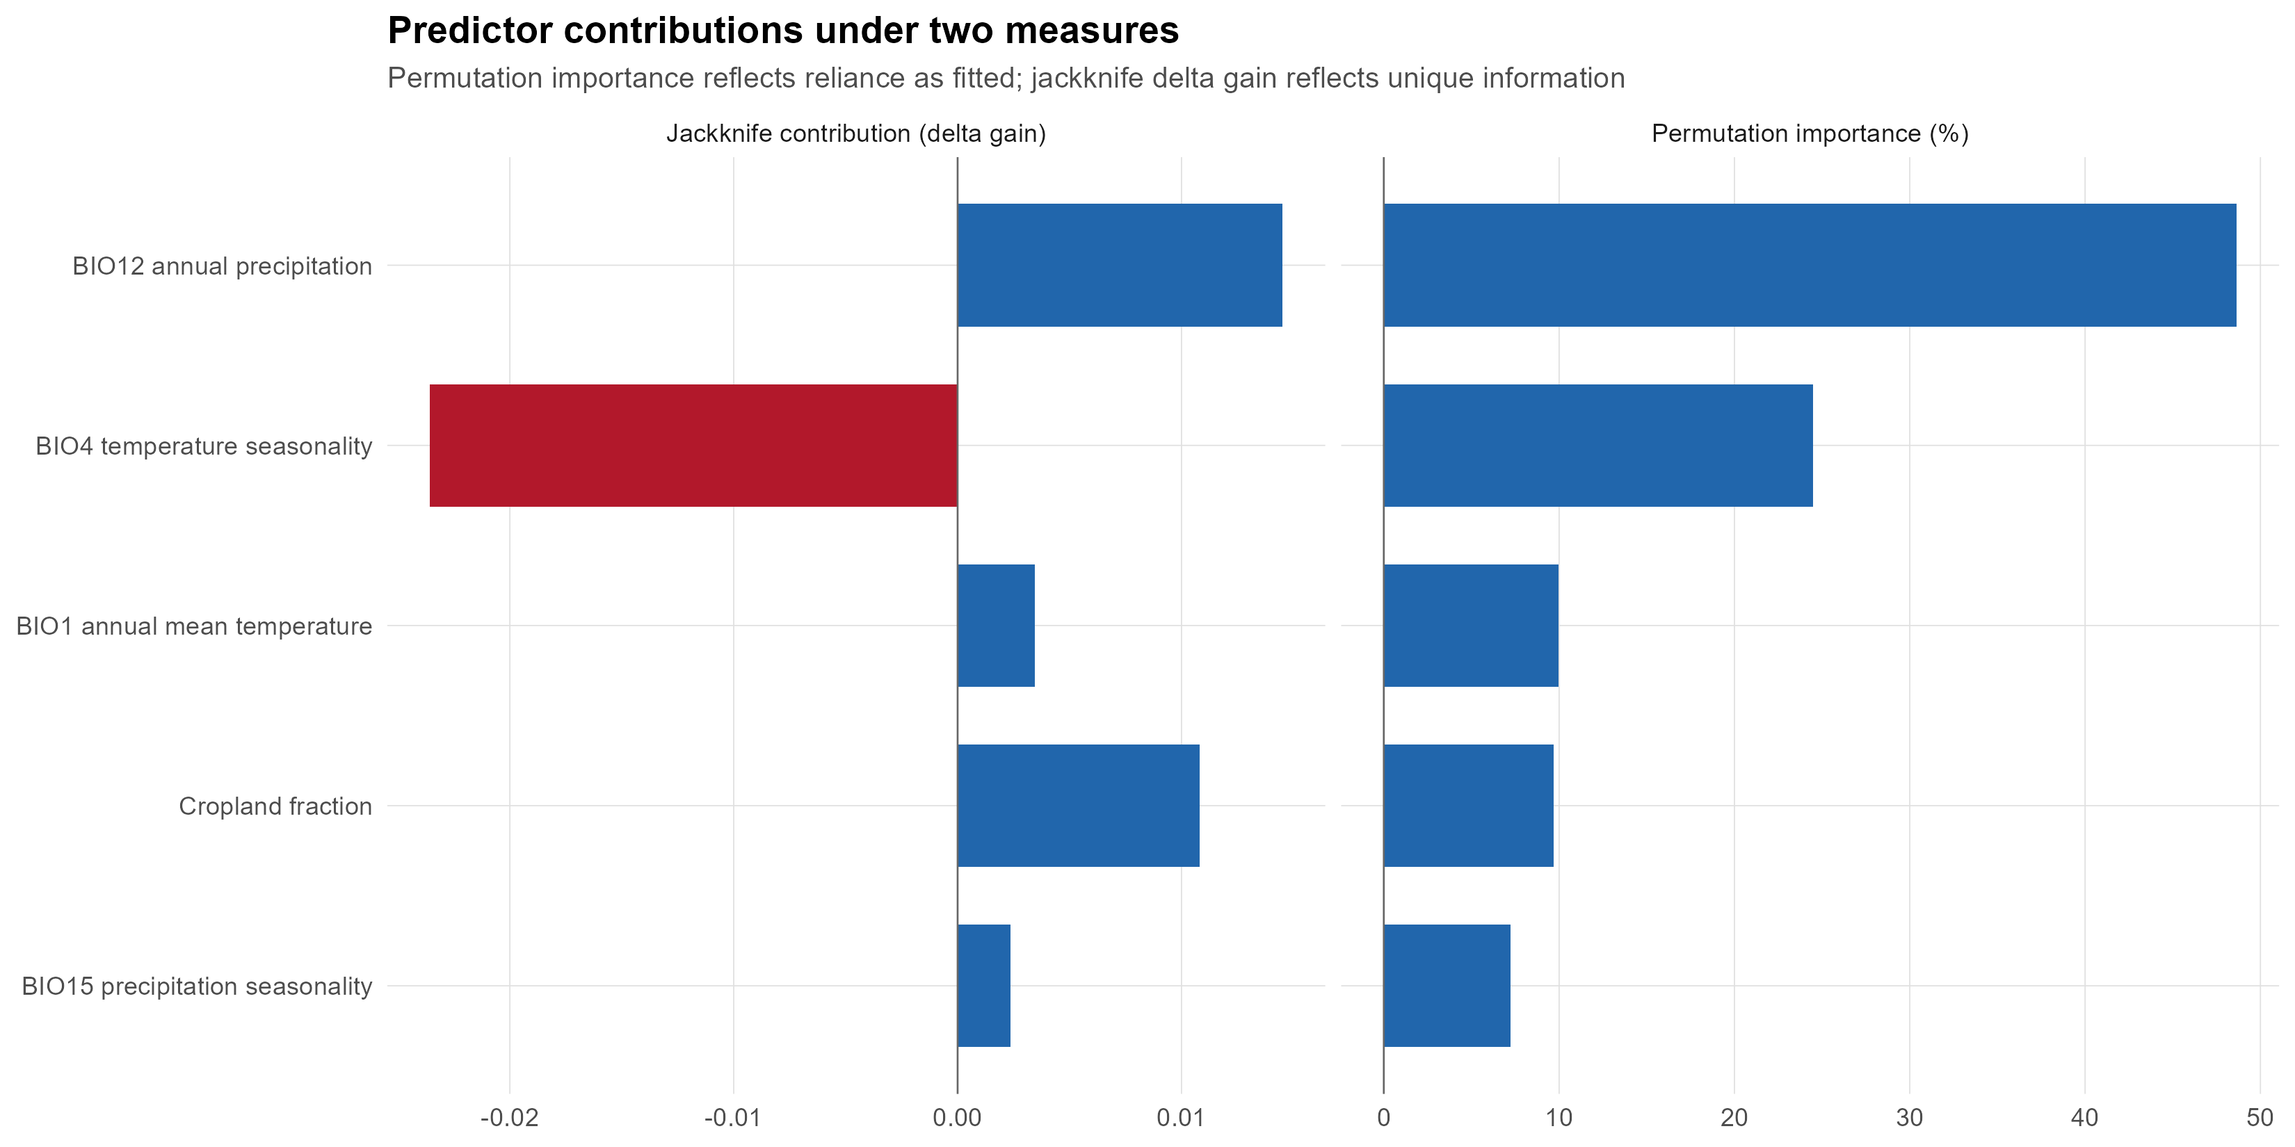
Fig. S2 Predictor contributions for the centroid specification: leave-one-out jackknife change in gain (left; the negative value for BIO4 reflects redundancy with BIO1) and permutation importance (right)

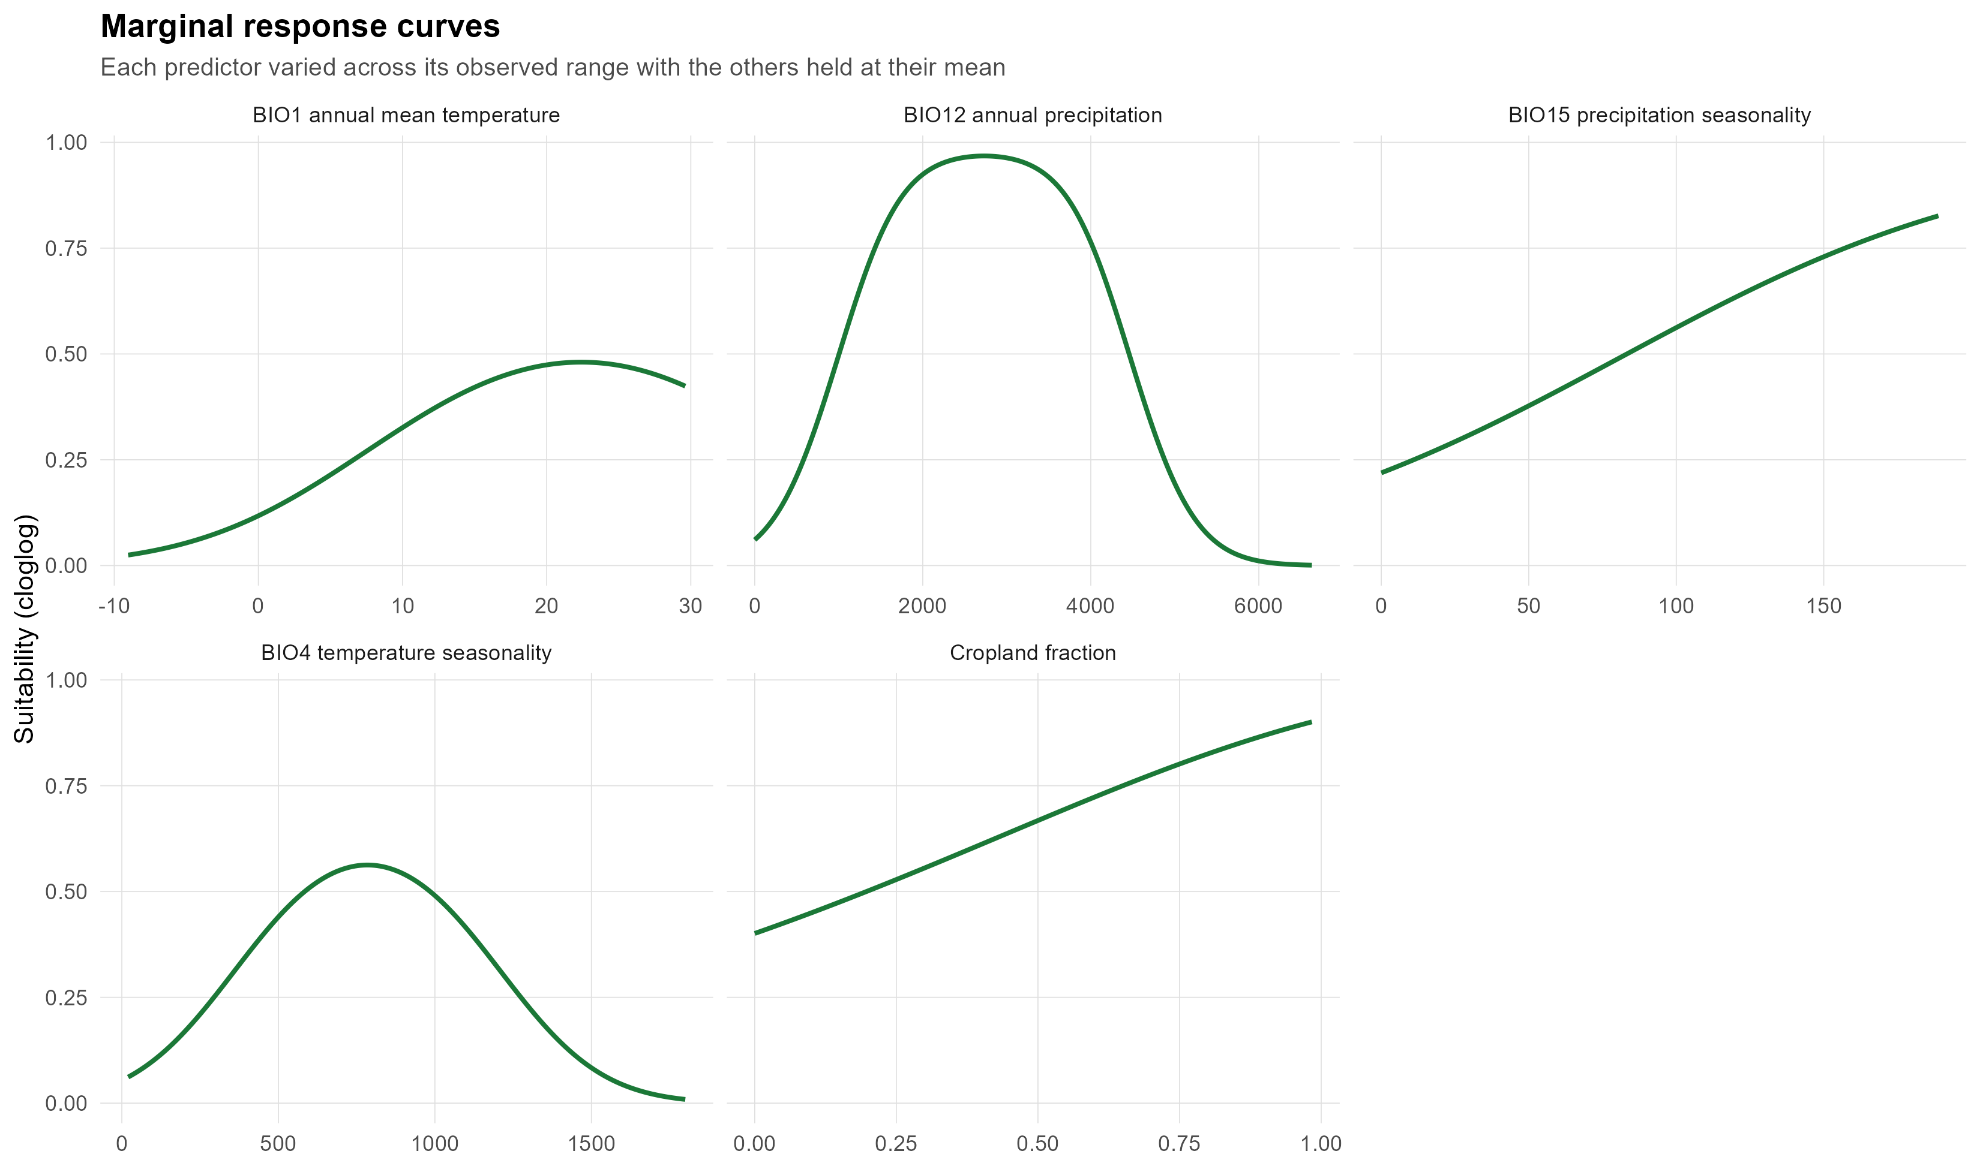
Fig. S3 Marginal response curves of the centroid specification; each predictor varied across its observed range with the others held at their mean (cloglog scale)

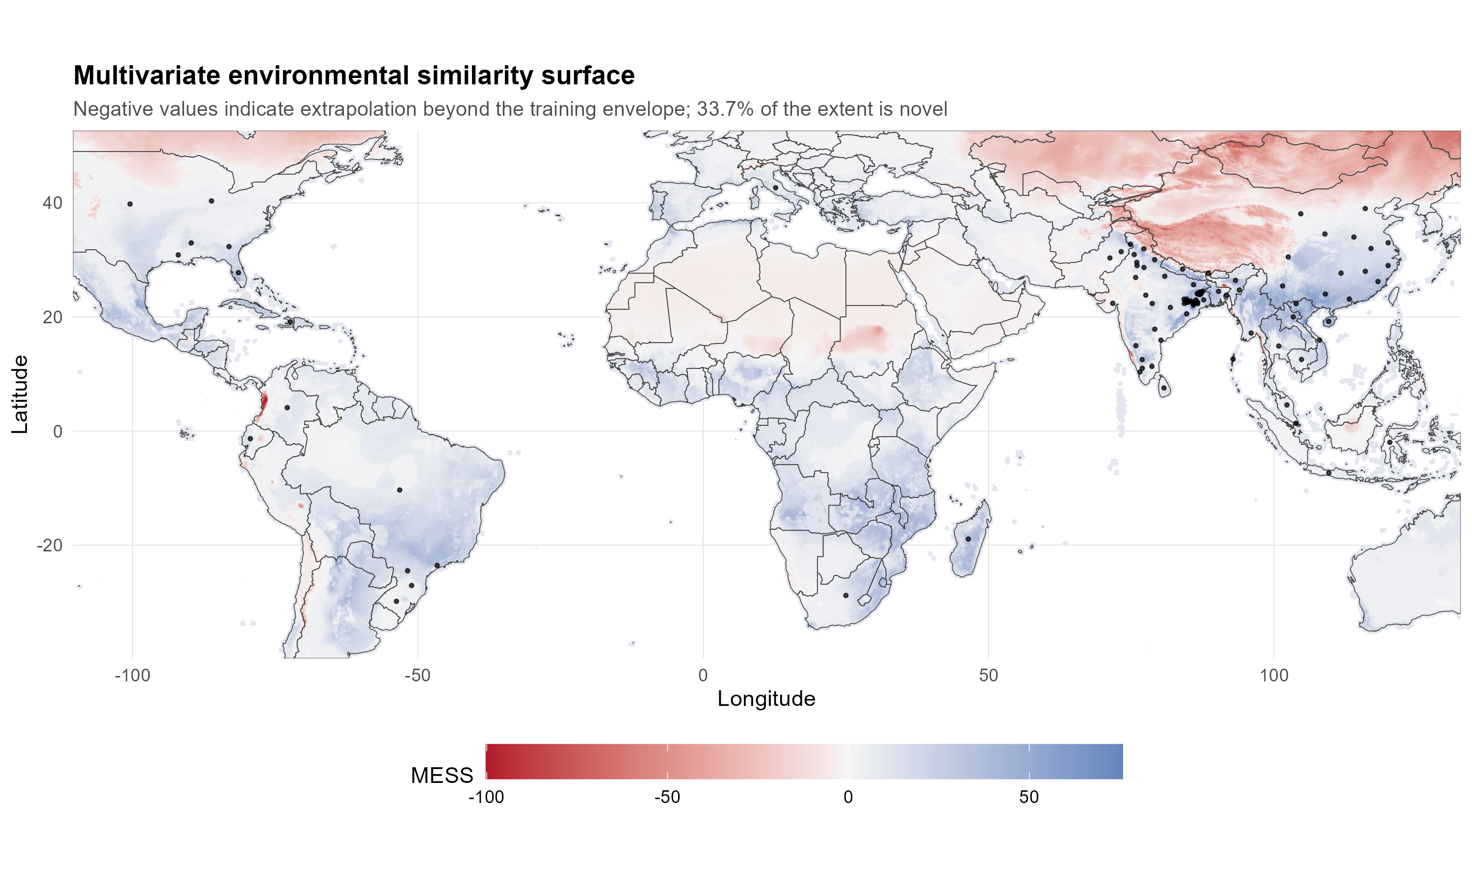
Fig. S4 Present-day multivariate environmental similarity surface (MESS) relative to the training records. Negative values (red) mark conditions outside the training envelope

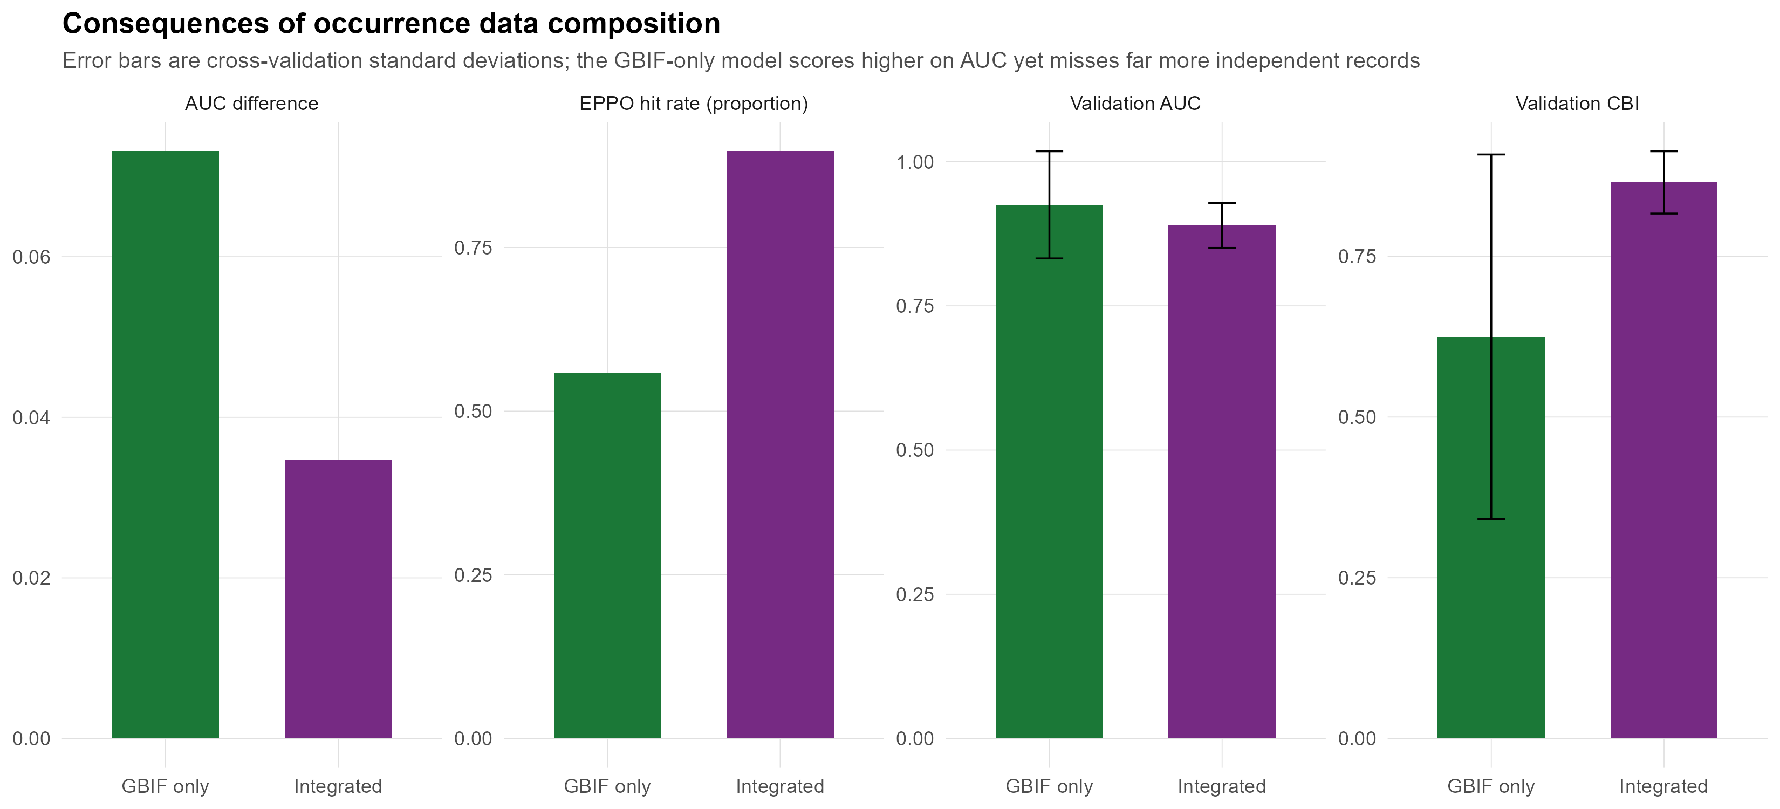
Fig. S5 Random cross-validation of the combined and GBIF-only training sets (centroid specification): train–validation AUC difference, EPPO hit rate, validation AUC and CBI (error bars: cross-validation SD). These are not independent tests; see Table 5 of the main text for the withheld comparison

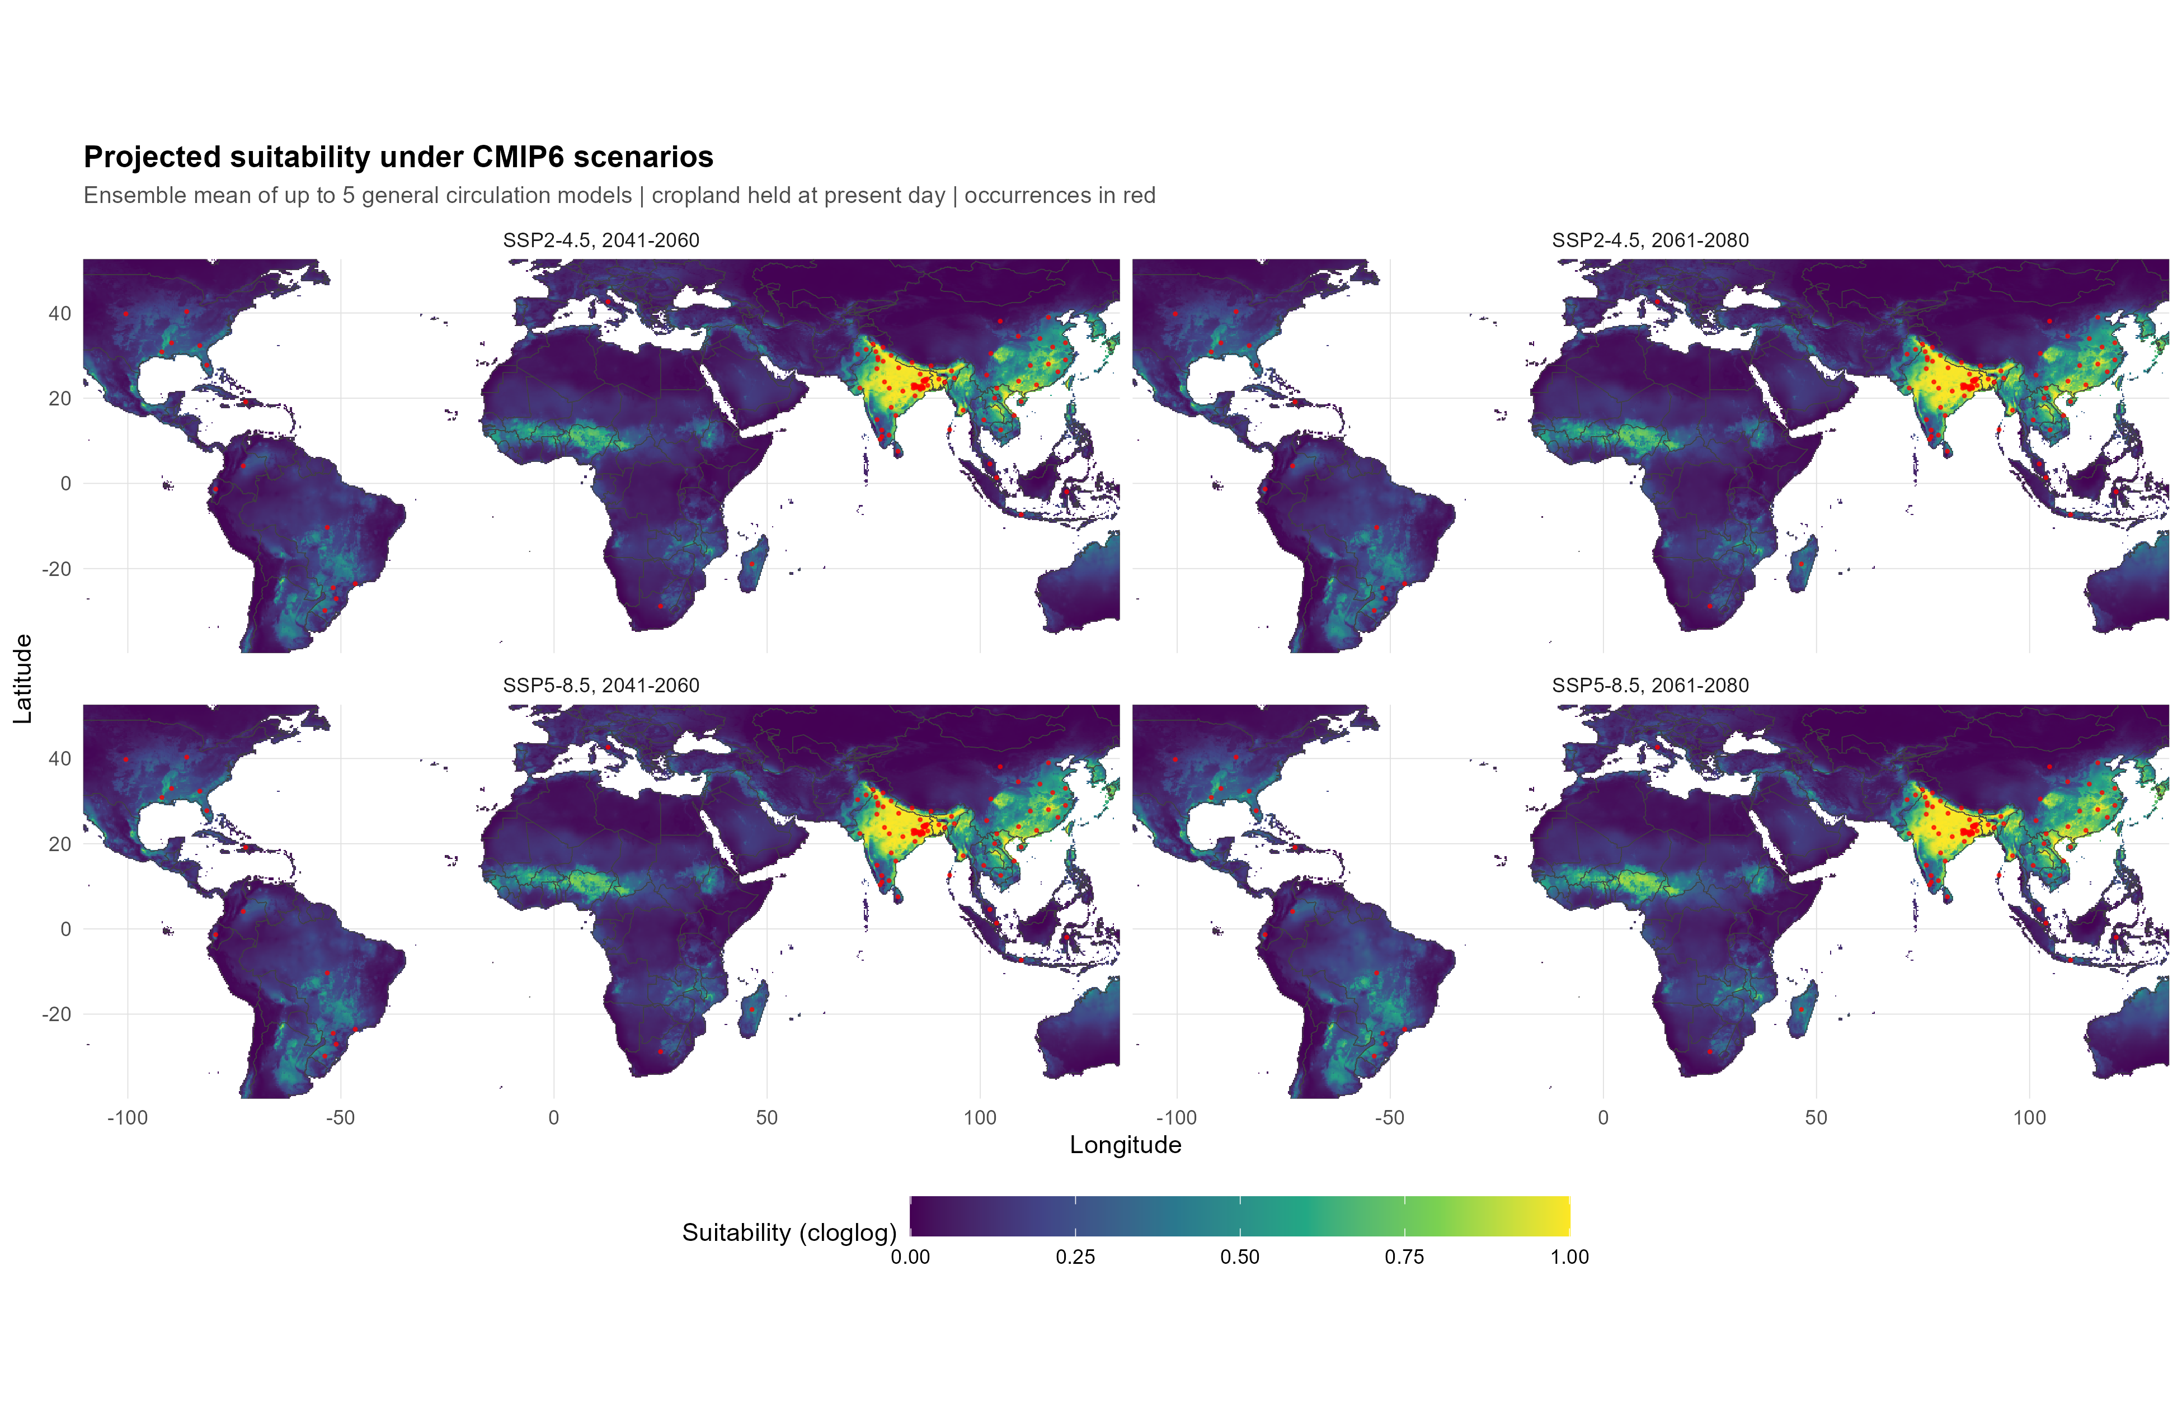
Fig. S6 Ensemble-mean projected suitability (primary specification; five CMIP6 models) for each scenario, with cropland held at present values

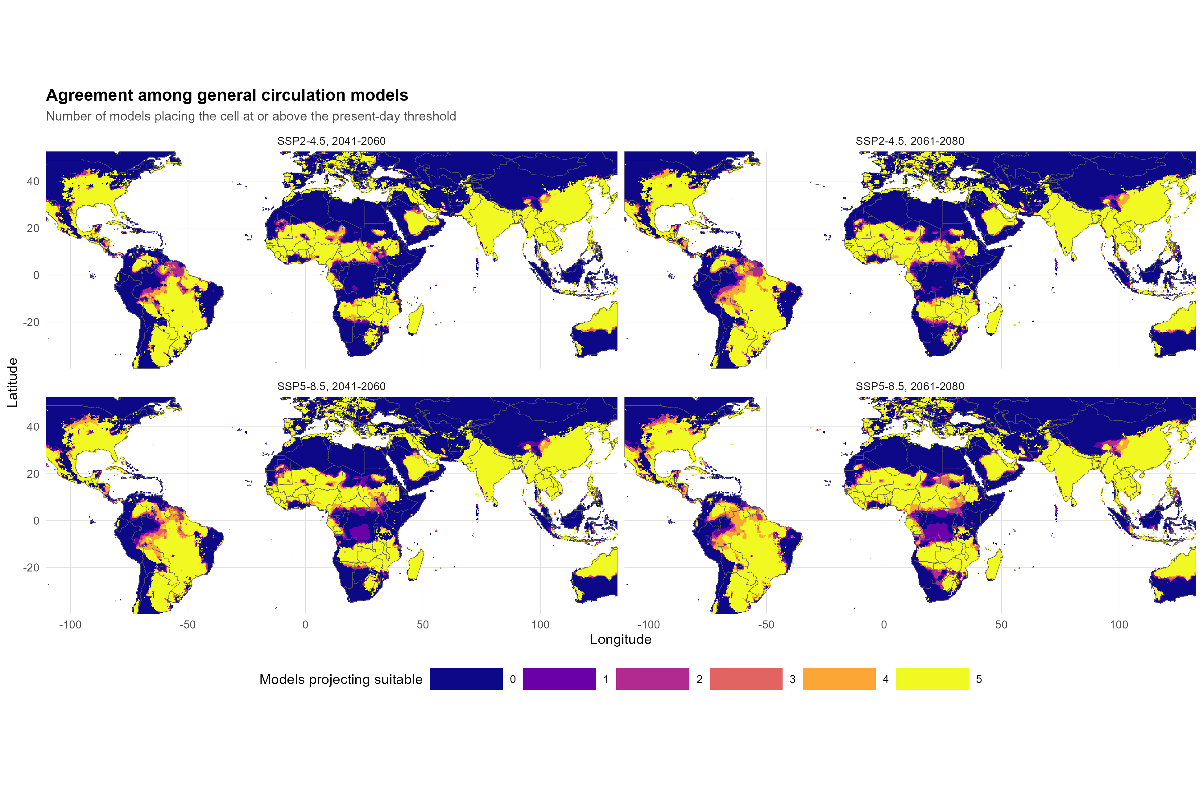
Fig. S7 Number of the five climate models projecting each cell as suitable at the present-day threshold, for each scenario

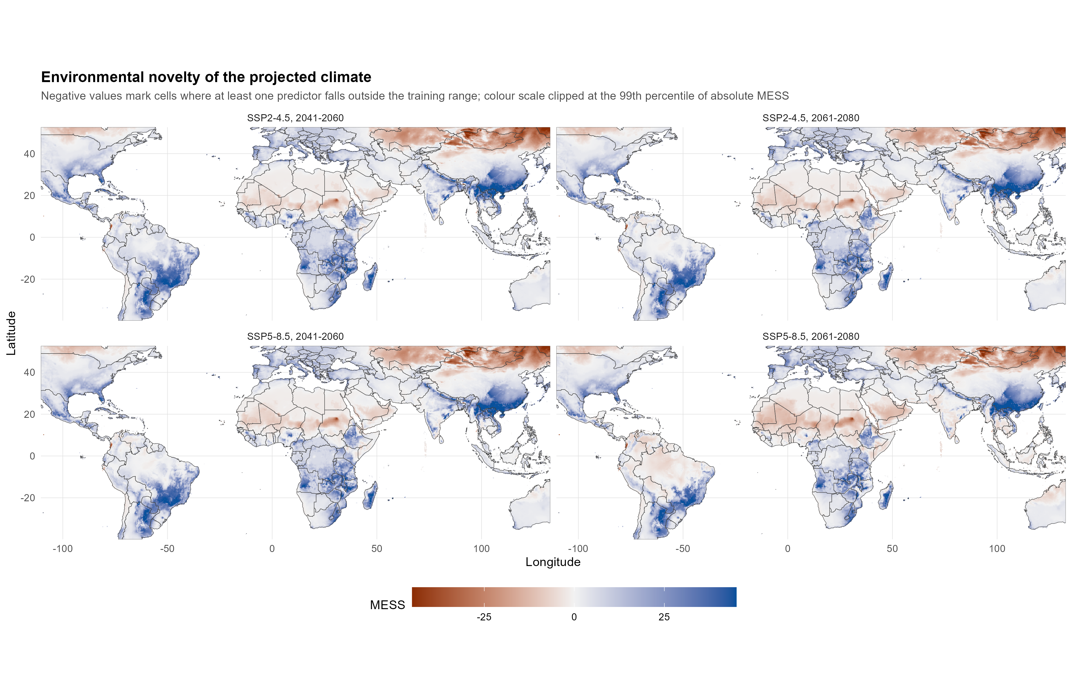
Fig. S8 Environmental novelty (MESS) of the projected climates relative to the training data; negative values mark cells where at least one predictor lies outside the training range

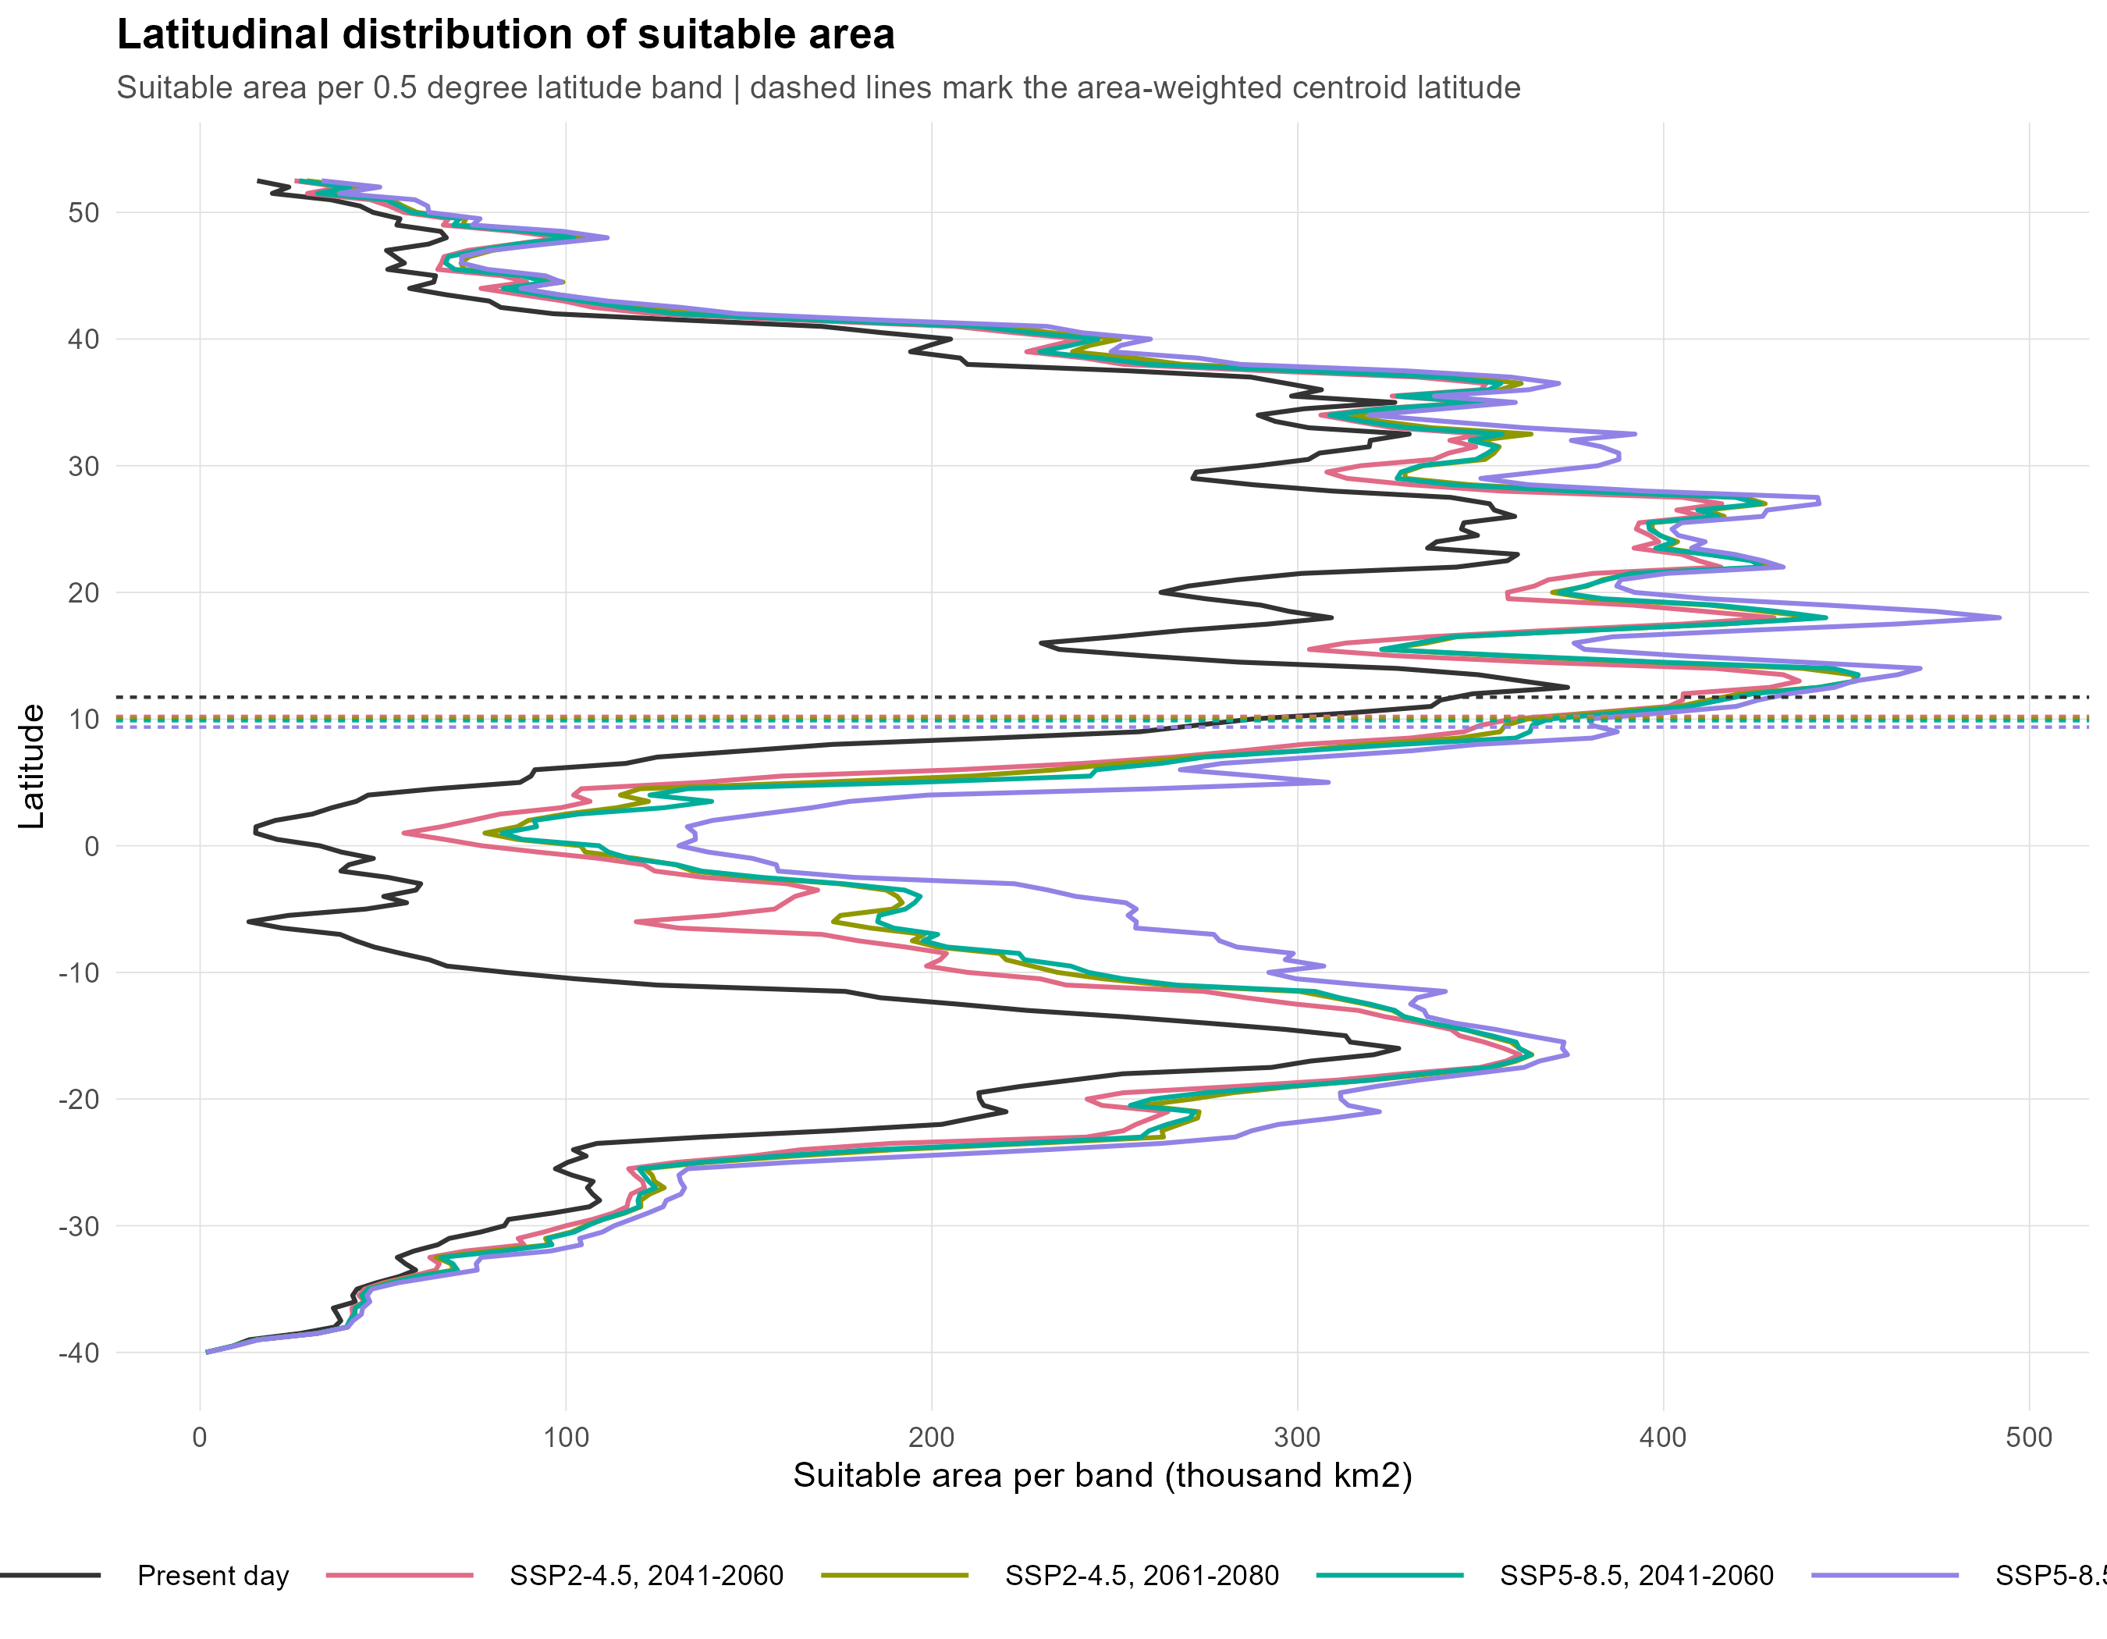
Fig. S9 Suitable area per 0.5° latitude band at present and in each scenario; dashed lines mark the area-weighted centroid latitude

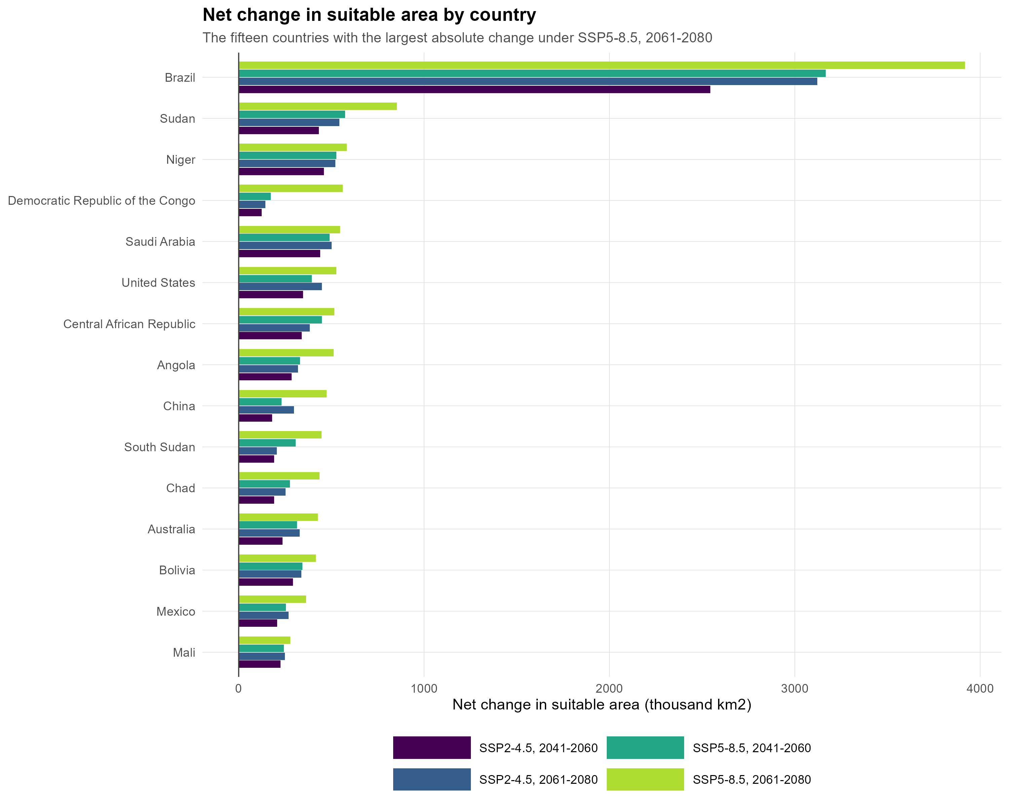
Fig. S10 The fifteen countries with the largest net change in suitable area under SSP5-8.5, 2061–2080, shown for all four scenarios

Reference
Yao S-M, Huang Y-F, Yang J-I (2020) The screening of resistance against Meloidogyne graminicola in oats. Agriculture 10:352. https://doi.org/10.3390/agriculture10080352

