# 7 Working with Web Frameworks

This chapter covers the following recipes:

* Creating an Express Web App
* Creating a Hapi Web App
* Creating a Koa Web App
* Adding a view layer
* Adding Logging
* Implementing Authentication

## Introduction

Node core supplies a strong set of well balanced primitives that allow us to create all manner of systems, for service-based architectures, to realtime data server, to robotics there's just enough in the Node core for purpose built libraries to arise from the Node community and ecosystem.

Building web site infrastructure is a very common use case for Node,and several high profile web frameworks have grown to become staple choices for creating web applications.

In this chapter we're going to explore the popular frameworks, and look at common tasks such as implementing server logging, sessions, authentication and validation.

## Creating an Express Web App

Express has long been the most popular choice of web framework, which is unsurprising since it was the first Node web framework of a high enough quality for mass consumption while also drawing from familiar paradigms presented in the Sinatra web framework for Ruby on Rails.

In this recipe we'll look at how to put together an Express web application.

### Getting Ready

Let's create a folder called app, initialize it as a package, and install express:

$ mkdir app  
$ cd app  
$ npm install --save express

### How to do it

Let's start by creating a few files:

$ touch index.js  
$ mkdir routes public  
$ touch routes/index.js  
$ touch public/styles.css

Now let's open the index.js file in our favorite editor, and prepare to write some code.

At the top of the file we'll load the following dependencies:

const {join} = require('path')  
const express = require('express')  
const index = require('./routes/index')

We'll write the routes/index.js file shortly, but for now let's continue writing the index.js file. Next we'll instantiate an Express object, which we'll call app while also setting up some configuration:

const app = express()  
const dev = process.env.NODE_ENV !== 'production'  
const port = process.env.PORT || 3000

Next we'll register some Express middleware, like so:

if (dev) {  
 app.use(express.static(join(__dirname, 'public')))  
}

And mount our index route at the / path:

app.use('/', index)

We'll finish off the index.js file by telling the Express application to listen on the port which we defined earlier.

app.listen(port, () => {  
 console.log(`Server listening on port ${port}`)  
})

Our index.js file is requiring ./routes/index, so let's write the routes/index.js file:

const {Router} = require('express')  
const router = Router()  
  
router.get('/', function (req, res) {  
 const title = 'Express'  
 res.send(`  
 <html>  
 <head>  
 <title> ${title} </title>  
 <link rel="stylesheet" href="styles.css">  
 </head>  
 <body>  
 <h1> ${title} </h1>  
 <p> Welcome to ${title} </p>  
 </body>  
 </html>  
 `)  
})  
  
module.exports = router

Now for a little bit of style. Let's complete the picture with a very simply CSS file in public/styles.css

body {  
 padding: 50px;  
 font: 14px "Lucida Grande", Helvetica, Arial, sans-serif;  
}

We should be able to run our server with:

$ node index.js

If we access our server at http://localhost:3000 in a browser, we should see something like the following image:

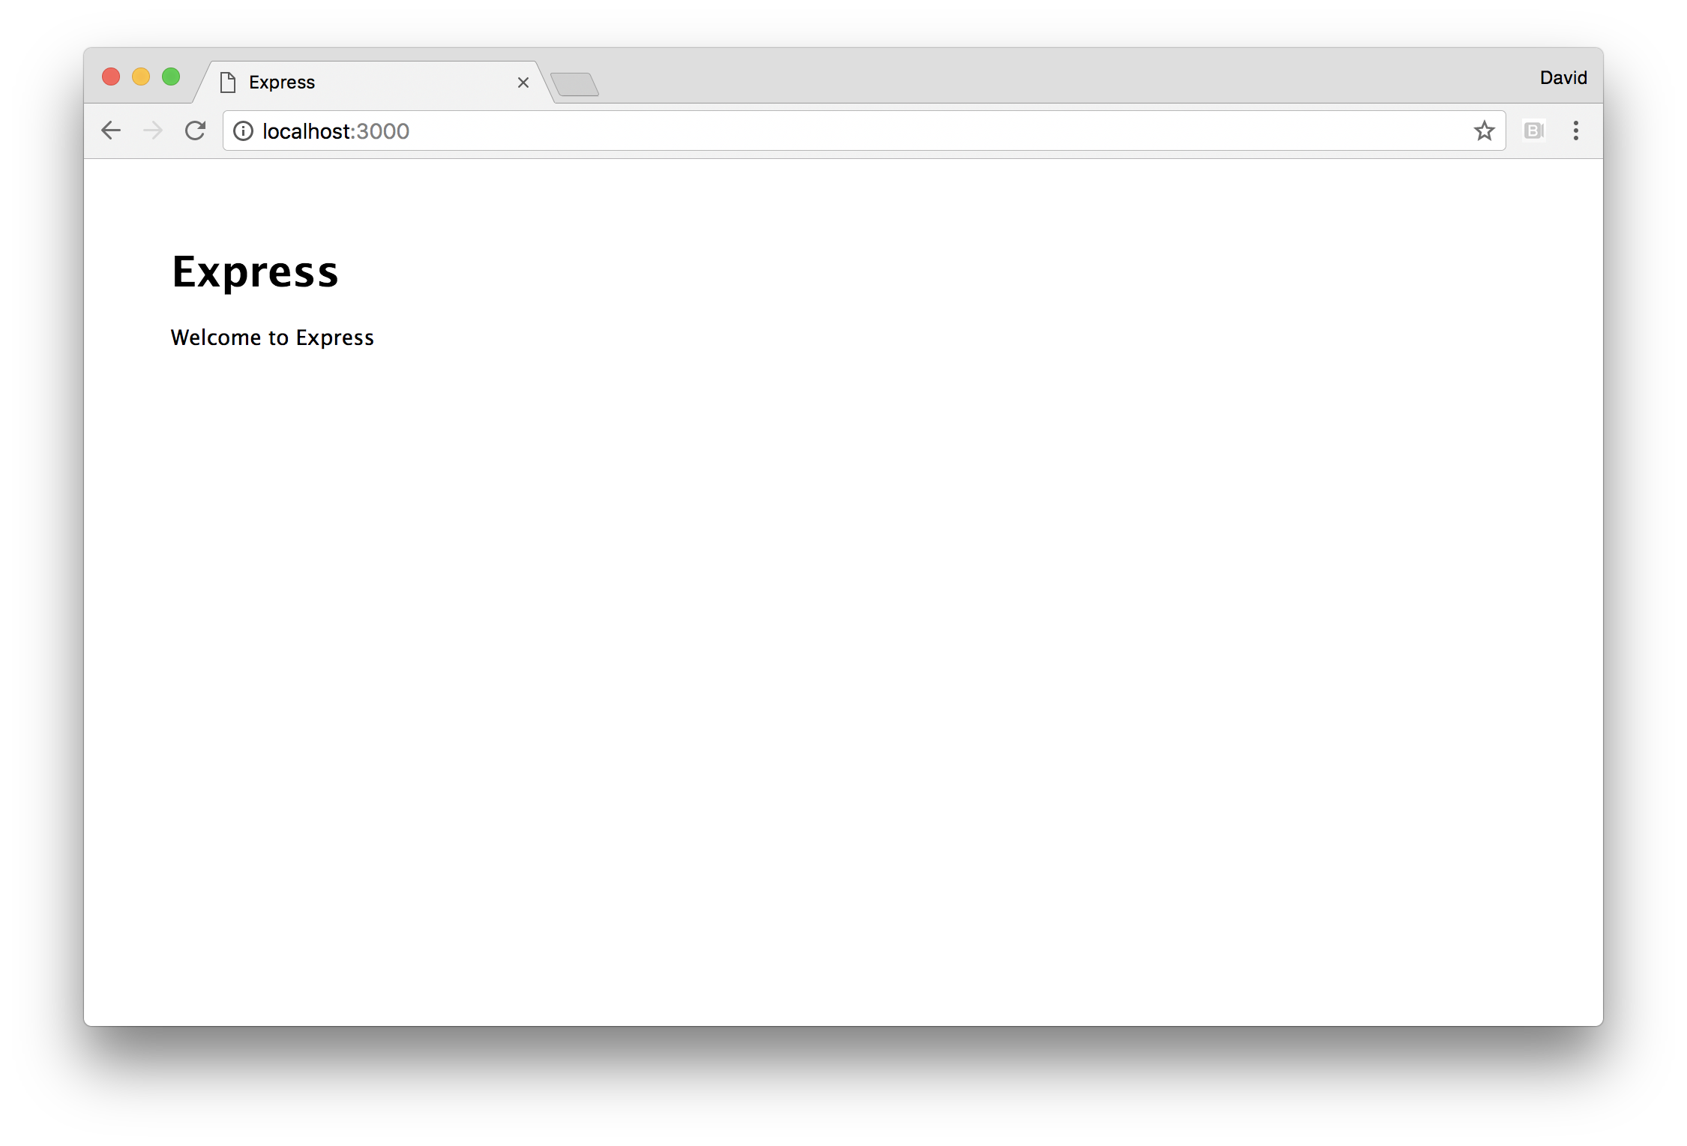

### How it works

Express is a framework built on top of Node's core http (and https when relevant) module.

#### The core http module

See **Chapter 5 Wielding Web Protocols** for more on the Node's core http module.

Express decorates the req (http.IncomingMessage) and res (http.ServerResponse) objects which are passed to the http.createServer request handler function.

To explain this using code, at a very basic level Express essentially performs the following internally:

const http = require('http')  
http.createServer((req, res) => {   
 /* add extra methods and properties to req and res */   
}))

When we call the express function, it returns an instance which we called app which represents our Express server.

The app.use function allows us to register "middleware" which at a fundamental level is a function that is called from the same http.createServer request handling function.

Again, for a pseudo-code explanation:

const http = require('http')  
http.createServer((req, res) => {   
 /* call the middleware registered with app.use */  
 /* wait for each piece of middleware to finish  
 before calling the next (wait for the next cb) */  
}))

Each piece of middleware may call methods on req and res, and extend the objects with additional methods or properties.

The express.static method comes bundled with Express. It returns a middleware function which is passed into app.use. This function will attempt to locate a file based on supplied configuration (in our case, we set the root directory to the public folder) for a given route. Then it will create a write stream from the file and stream it to the request object (req). If it can't find a file it will pass control to the next middleware by calling the next callback.

We only use the static middleware in development mode (based on the value of the dev reference, which is assigned based on whether the NODE_ENV environment variable is set to "production"). This assumes a production scenario where a reverse proxy (such as Nginx or Apache or, even better a CDN) handles static file serving. While Node has come a long way in recent years, Node's strength remains in generating dynamic content - it still doesn't usually make sense to use it for static assets in production.

The order of middleware is significant, because middleware executes in cascading fashion. For instance, if we register static file handling middleware before route handling middleware in the case of name collision (where a route could apply to a file or a dynamic route), the file handling middleware will take precedence. However, if the route handling middleware is first, the dynamic route takes will serve the request first instead.

The app.use function can accept a string as the first argument, which determines a "mount point" for a piece of middleware. This means instead of the middleware applying to all incoming requests it will only be called when there is a route match.

Route handlers are essentially the same mounted middleware, but are constructed with Express' Router utility for cleaner encapsulation. In our routes/index.js file we create a router object which we called router. Router objects have methods which correspond to the HTTP verbs (such as GET, PUT, POST, PATCH, DELETE) in relevant specification ([rfc7231](https://tools.ietf.org/html/rfc7231)).

Most commonly we would use GET and POST for web facing applications. We use router.get to register a route (/), with and supply a route handling function (which is technically also middleware).

In our route handler, we pass res.send a string of HTML content to respond to the client.

The res.send method is added by Express, it's the equivalent of res.end but with additional features such as content type detection.

We export the router instance from the routes/index.js, then load it into the index.js file and pass it to app.use (as the second argument, after a mount point string argument (/)).

The router instance is itself, middleware. It's a function that accepts req, res and next arguments. When called, it checks its internal state based on any routers registered (via get etcetera), and responds accordingly.

The function we pass to router.get can also take a next callback function. We ignored the next callback function in our case (we didn't define it in the route handling functions parameters), because this route handler is a terminal point - there is nothing else to be done after sending the content. However, in other scenarios there may be cause to use the next callback and even pass it an error to propagate request handling the next piece of middleware (or route middleware, since a route registering method (like get) can be passed multiple subsequent route handling functions).

At the end of index.js we call app.listen and pass it a callback function. This will in turn call the listen method on the core http server instance which Express has created internally, and pass our supplied callback to it. Our callback simply logs that the server is now listening on the given port.

#### What About SSL

While Express can work with HTTPS, we recommend that the general approach should be to terminate SSL at the load balancer (or reverse proxy) for optimal efficiency.

### There's more

Let's explore some more of the functionality offered by Express.

#### Production

Our Express server defines a dev reference, based on the value of the NODE_ENV environment variable. This is a standard convention in Node. In fact Express will behave differently when NODE_ENV is set to production - for instance views will be cached in memory.

We can check out production mode with

$ NODE_ENV=production node index.js

We should notice this removes styling from our app. This is because we only serve static assets in development mode, and the <link> tags in our views will be generating 404 errors in attempts to fetch the public/styles.css file.

#### Route Parameters and POST requests

Let's copy our app folder to params-postable-app, and then install the body-parser middleware module:

$ cp -fr app params-postable-app  
$ cd params-postable-app  
$ npm install --save body-parser

#### CAUTION!

This example is for demonstration purposes only! Never place user input directly into HTML output in production without sanitizing it first. Otherwise, we make ourselves vulnerable to XSS attacks. See *Guarding Against Cross Site Scripting (XSS)* in **Chapter 8 Dealing with Security** for details.

In the index.js file, we'll load the middleware and use it.

At the top of index.js file we'll require the body parser middleware like so:

const bodyParser = require('body-parser')

Then we'll use it, just above the port assignment we'll add:

app.use(bodyParser.urlencoded({extended: false}))

#### Use extended: false

We set extended to false because the qs module which provides the parsing functionality for bodyParse.urlencoded has options which could (without explicit validation) allow for a Denial of Service attack. See the **Anticipating Malicious** in **Chapter 8 Dealing with Security** for details.

Now in routes/index.js we'll alter our original GET route handler to the following:

router.get('/:name?', function (req, res) {  
 const title = 'Express'  
 const name = req.params.name  
 res.send(`  
 <html>  
 <head>  
 <title> ${title} </title>  
 <link rel="stylesheet" href="styles.css">  
 </head>  
 <body>  
 <h1> ${title} </h1>  
 <p> Welcome to ${title}${name ? `, ${name}.` : ''} </p>  
 <form method=POST action=data>  
 Name: <input name=name> <input type=submit>  
 </form>  
 </body>  
 </html>  
 `)  
})

We're using Express' placeholder syntax here to define a route parameter called name. The question mark in the route string indicates that the parameter is optional (which means the original functionality for the / route is unaltered). If the name parameter is present, we add it into our HTML content.

We've also added a form which will perform a POST request to the /data route. By default it will be of type application/x-www-form-urlencoded which is why we use the urlencoded method on the body-parser middleware.

Now to the bottom of routes/index.js we'll add a POST route handler:

router.post('/data', function (req, res) {  
 res.redirect(`/${req.body.name}`)  
})

Now let's start our server:

$ node index.js

Then load navigate our browser to http://localhost:3000 we should be able to supply a name to the input box, press the submit button and subsequently see our name in the URL bar and on the page.

#### CAUTION!

This example is for demonstration purposes only! Never place user input directly into HTML output in production without sanitizing it first. Otherwise, we make ourselves vulnerable to XSS attacks. See * *Anticipating Malicious Input* and *Guarding Against Cross Site Scripting (XSS)* in **Chapter 8 Dealing with Security** for details.

#### Creating Middleware

Middleware (functions which are passed to app.use) is a fundamental concept in Express (and other web frameworks).

If we need some custom functionality (for instance, business logic related), we can create our middleware.

Let's copy the app folder from our main recipe to the custom-middleware-app and create a middleware folder with an answer.js file:

$ cp -fr app custom-middleware-app  
$ cd custom-middleware-app  
$ mkdir middleware  
$ touch middleware/answer.js

Now we'll place the following code in middleware/answer.js:

module.exports = answer  
  
function answer () {  
 return (req, res, next) => {  
 res.setHeader('X-Answer', 42)  
 next()  
 }  
}

Finally we need to modify the index.js file in two places. First at the top, we add our answer middleware to the dependency loading section:

const {join} = require('path')  
const express = require('express')  
const index = require('./routes/index')  
const answer = require('./middleware/answer')

Then we can place our answer middleware at the top of the middleware section, just underneath the port assignment:

app.use(answer())

Now let's start our server:

$ node index.js

And hit the server with curl -I to make a HEAD request and view headers:

$ curl -I http://localhost:3000

We should see output similar to:

HTTP/1.1 200 OK  
X-Powered-By: Express  
X-Answer: 42  
Content-Type: text/html; charset=utf-8  
Content-Length: 226  
ETag: W/"e2-olBsieaMz1W9hKepvcsDX9In8pw"  
Date: Thu, 13 Apr 2017 19:40:01 GMT  
Connection: keep-alive

With our X-Answer present.

Middleware isn't just for setting custom headers, there's a vast range of possibilities, parsing the body of a request and session handling to implementing custom protocols on top of HTTP.

### See also

* *Hardening Headers in Web Frameworks* in **Chapter 8 Dealing With Security*
* *Creating an HTTP Server* in **Chapter 5 Wielding Web Protocols**
* *Anticipating Malicious Input* in **Chapter 8 Dealing with Security**
* *Guarding Against Cross Site Scripting (XSS)* in **Chapter 8 Dealing with Security**
* *Consuming a Service* in **Chapter 10 Building Microservice Systems**
* *Standardizing service boilerplate* in **Chapter 10 Building Microservice Systems**
* *Adding a View Layer* in this Chapter
* *Implementing Authentication* in this Chapter

## Creating a Hapi Web App

Hapi is a fairly recent addition to the "enterprise" web framework offerings. The Hapi web framework has a reputation for stability, but tends to perform slower (for instance, see https://raygun.com/blog/node-performance/) while also requiring more boilerplate than alternatives. With a contrasting philosophy and approach to Express (and other "middleware" frameworks like Koa and Restify) Hapi may be better suited to certain scenarios and preferences. For instance, teams in large organizations that have a leaning towards Object Oriented Programming, particular where Java is the prevailing tradition, may find Hapi more fitting to the cultural proclivities.

In this recipe, we'll create a simple Hapi web application.

### Getting Ready

Let's create a folder called app, initialize it as a package, and install hapi and inert:

$ mkdir app  
$ cd app  
$ npm install --save hapi inert

### How to do it

Let's start by creating a few files:

$ touch index.js  
$ mkdir routes public  
$ touch routes/index.js  
$ touch routes/dev-static.js  
$ touch public/styles.css

We'll begin by populating the index.js file.

At the top of index.js let's require some dependencies:

const hapi = require('hapi')  
const inert = require('inert')  
const routes = {  
 index: require('./routes/index'),  
 devStatic: require('./routes/dev-static')  
}

Now we'll instantiate a Hapi server, and set up dev and port constants:

const dev = process.env.NODE_ENV !== 'production'  
const port = process.env.PORT || 3000  
  
const server = new hapi.Server()

Next we'll supply Hapi server connection configuration:

server.connection({  
 host: 'localhost',  
 port: port  
})

We're only going to use inert (a static file handling Hapi plugin) in development mode, so let's conditionally register the inert plugin, like so:

if (dev) server.register(inert, start)  
else start()

We'll finish off index.js by supplying the start function we just referenced:

function start (err) {  
 if (err) throw err  
  
 routes.index(server)  
   
 if (dev) routes.devStatic(server)  
  
 server.start((err) => {  
 if (err) throw err  
 console.log(`Server listening on port ${port}`)  
 })  
}

This invokes our route handlers, and calls server.start.

Our index.js file is relying on two other files, routes/index.js and routes/devStatic.js.

Let's write the routes/index.js file:

module.exports = index   
  
function index (server) {  
 server.route({  
 method: 'GET',  
 path: '/',  
 handler: function (request, reply) {  
 const title = 'Hapi'  
 reply(`  
 <html>  
 <head>  
 <title> ${title} </title>  
 <link rel="stylesheet" href="styles.css">  
 </head>  
 <body>  
 <h1> ${title} </h1>  
 <p> Welcome to ${title} </p>  
 </body>  
 </html>  
 `)  
 }  
 })  
}

And now the routes/dev-static.js file:

module.exports = devStatic   
  
function devStatic (server) {  
 server.route({  
 method: 'GET',  
 path: '/{param*}',  
 handler: {  
 directory: {  
 path: 'public'  
 }  
 }  
 })  
}

Finally we need to supply the public/styles.css file:

body {  
 padding: 50px;  
 font: 14px "Lucida Grande", Helvetica, Arial, sans-serif;  
}

Now we can start our server:

$ node index.js

If we navigate to http://localhost:3000 in our browser, we should see something like the following:

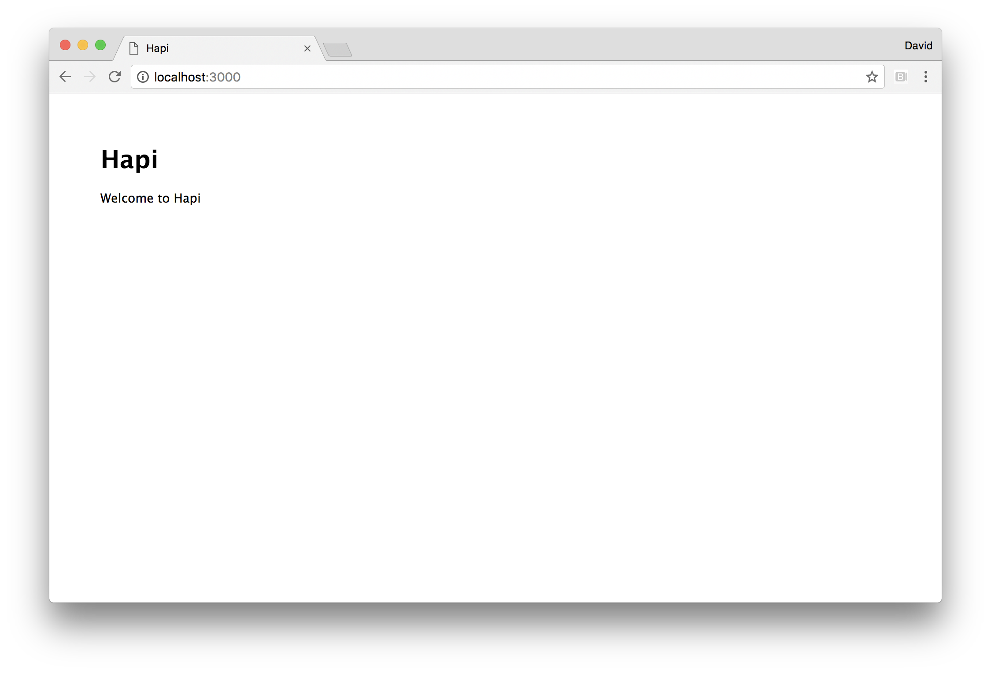

### How it works

After we create a hapi.Server instance (which we named server) we call the connection method. This will register the settings we pass in a list of connections.

When we later call server.start Hapi creates an http (or https if a tls object is supplied with key and cert buffer values). Unlike Express or Koa, Hapi allows for multiple connections, which in turn will create multiple core http server instances (with Express or Koa we would simply instantiate multiple instances of Express/Koa and reuse any routes/middleware between them as required).

In our case we call server.connection once, as a result, upon calling server.start, a single http server is created which listens to port 3000 (unless otherwise set in the PORT environment variable, according to how we've defined the port constant).

We use the separate inert Hapi plugin to serve static files in development mode. The server.register function can take a single plugin, or an array of plugins. We currently only have one plugin (and only when dev is true), so we pass the inert plugin to server.register and supply the start function as the second argument. The second argument to server.register is a callback, which is triggered once plugins are loaded. If our server was in production mode (that is, if the NODE_ENV environment variable was set to production), then we simply call start directly as we have no other plugins to register.

We have two routes files, routes/index.js and routes/dev-static.js. These files simply export a function that takes the server object which we created in index.js.

In both routes/index.js and routes/dev-static.js we call server.route to register a new route with Hapi.

The server.route method takes an object which describes the route. We supply an object with method, path and handler properties in both cases.

#### Route options

In addition to the required three properties (method, path, handler), another possible key on the settings object passed to server.route is the config property. This allows for a vast amount of behavioral tweaks both for internal Hapi and for additional plugins. See <https://hapijs.com/api#route-options> for more information.

In routes/index.js we set the method to GET, the path to / (because it's our index route) and the handler to a function which accepts request and reply arguments.

The request and reply parameters while analogous to the parameters passed to the http.createServer request handler function (often called req and res) are quite distinct. Unlike Express which *decorates* req and res, Hapi creates separate abstractions (request and reply) which interface with req and res internally.

In the handler function, we call reply as a function, passing it our HTML content.

In routes/dev-static.js the path property is using route parametization with segment globbing to allow match any route. In our case the use of param in /{param*} is irrelevant. It could be named anything at all, this is just a necessity to get the required functionality. The asterisk following param will cause any number of route segments (parts of the route separated by /) to match. Instead of a function, the handler in our routes/dev-static.js file is an object with directory set to an object containing a path property which points to our public folder. This is as route configuration settings by the inert plugin.

Our start function checks for any error (rethrowing if there is one) and passes the server object to the the routes.index and routes.devStatic functions, then calls server.start which causes Hapi to create the http server and bind to the host and port supplied to server.connection earlier on. The server.start method also takes a callback function, which is called once all servers have been bound to their respective hosts and ports. The callback we supply checks and rethrows an error, and logs out confirmation message that the server is now up.

### There's more

Let's explore some more of Hapi's functionality.

#### Creating a plugin

Let's copy the app folder from our main recipe to the custom-plugin-app and create a plugins folder with an answer.js file:

$ cp -fr app custom-plugin-app  
$ cd custom-plugin-app  
$ mkdir plugins  
$ touch plugins/answer.js

We'll make the contents of plugins/answer.js look like so:

module.exports = answer  
  
function answer (server, options, next) {  
 server.ext('onPreResponse', (request, reply) => {  
 request.response.header('X-Answer', 42)  
 reply.continue()  
 })  
 next()  
}  
  
answer.attributes = {name: 'answer'}

The next callback is supplied to allow for any asynchronous activity. We call it to let Hapi know we've finished setting up the plugin. Under the hood Hapi would call the server.register callback once all the plugins had called their respective next callback functions.

#### Events and Extensions

There are a variety of server events (which we can listen to with server.on) and "extensions". Extensions are very similar to server events, except we use server.ext to listen to them and must call reply.continue() when we're ready to proceed. See <https://hapijs.com/api#request-lifecycle> as a starting point to learn more.

We use the onPreResponse extension (which is very much like an event) to add our custom header. The onPreResponse extension is the *only* place we can register headers (the onRequest extension is too early and the response event is too late).

We'll add the answer plugin near the top of the index.js file like so:

const answer = require('./plugins/answer')

Then at the bottom of index.js we'll modify the boot up code to the following:

const plugins = dev ? [answer, inert] : [answer]  
server.register(plugins, start)  
  
function start (err) {  
 if (err) throw err  
  
 routes.index(server)  
   
 if (dev) routes.devStatic(server)  
  
 server.start((err) => {  
 if (err) throw err  
 console.log(`Server listening on port ${port}`)  
 })  
}

#### Label Selecting

Each Hapi connection can be labelled with one or more identifiers, which can in turn be used to conditionally register plugins and define routes or perform other connection specific tasks.

Let's copy the app folder from our main recipe to label-app:

$ node index.js

Now we'll alter our index.js to the following:

const hapi = require('hapi')  
const inert = require('inert')  
const routes = {  
 index: require('./routes/index'),  
 devStatic: require('./routes/dev-static')  
}  
  
const devPort = process.env.DEV_PORT || 3000  
const prodPort = process.env.PORT || 8080  
  
const server = new hapi.Server()  
  
server.connection({  
 host: 'localhost',  
 port: devPort,  
 labels: ['dev', 'staging']  
})  
  
server.connection({  
 host: '0.0.0.0',  
 port: prodPort,  
 labels: ['prod']  
})  
  
server.register({  
 register: inert,  
 select: ['dev', 'staging']  
}, start)  
  
function start (err) {  
 if (err) throw err  
  
 routes.index(server)  
   
 routes.devStatic(server)  
  
 server.start((err) => {  
 if (err) throw err  
 console.log(`Dev/Staging server listening on port ${devPort}`)  
 console.log(`Prod server listening on port ${prodPort}`)  
 })  
}

We removed the dev constant as we're using Hapi labels to handle conditional environment logic. We now have two port constants, devPort and prodPort and we use them to create two server connections. The first listens on the local loopback interface (localhost) as normal, on the devPort which defaults to port 3000. The second listens on the public interface (0.0.0.0), on the prodPort default to port 8080.

We add label property to each connection, on the first we supply an array of ['dev', 'staging'] and to the second a string containing prod. This means we can treat our development connection as a staging connection when it makes sense - for instance in our case we're using inert for static file hosting on both development and staging but in production we assume a separate layer in the deployment architecture is handling this.

We've removed the if statement checking for dev and have instead housed the inert plugin in an object as we pass it to server.register. Passing inert directly or passing as the register property of an object are equivalent. However passing it inside an object allows us to supply other configuration. In this case add a select property which is set to ['dev', 'staging']. This means the inert plugin will only register on the development connection, but will not be present on the production connection.

In the start function we've also removed the if(dev) statement preceeding our call to routes.devStatic. We need to modify routes/dev-static.js so that the static route handler is only registered for the development connection.

Let's change routes/dev-static.js to the following:

module.exports = devStatic   
  
function devStatic (server) {  
 server.select(['dev', 'staging']).route({  
 method: 'GET',  
 path: '/{param*}',  
 handler: {  
 directory: {  
 path: 'public'  
 }  
 }  
 })  
}

We've added in call to server.select. When we call route on the resulting object, the route is only applied to connections that match the supplied labels.

We can confirm that our changes are working by running our server:

$ node index.js

And using curl to check whether the development server delivers static assets (which it should) and the production server responds with 404:

$ curl http://localhost:3000/styles.css

This should respond with the contents of public/styles.css.

However the following should respond with {"statusCode":404,"error":"Not Found"}:

$ curl http://localhost:8080/styles.css

This approach does uses more ports than necessary in production, which may lead to reduced performance and does beg some security questions. However, we could side step these problems while still getting the benefits of labelling (in this specific case) by reintroducing the dev constant and only conditionally creating the connections based on whether dev is true or false.

For example:

const dev = process.env.NODE_ENV !== 'production'  
  
if (dev) server.connection({  
 host: 'localhost',  
 port: devPort,  
 labels: ['dev', 'staging']  
})  
  
if (!dev) server.connection({  
 host: '0.0.0.0',  
 port: prodPort,  
 labels: 'prod'  
})

However this would require a modification to any conditional routing, since there Hapi requires at least one connection before a route can be added. For instance in our case we would have to modify the top of the function exported from routes/dev-static.js like so:

function devStatic (server) {  
 const devServer = server.select(['dev', 'staging'])  
 if (!devServer.connections.length) return  
 devServer.route({ /* ... etc ... */ })  
}

### See also

* *Hardening Hapi* in the *There's More* section of *Hardening Headers in Web Frameworks* in **Chapter 8 Dealing With Security**
* *Creating an HTTP Server* in **Chapter 5 Wielding Web Protocols**
* *Anticipating Malicious Input* in **Chapter 8 Dealing with Security**
* *Guarding Against Cross Site Scripting (XSS)* in **Chapter 8 Dealing with Security**
* *Adding a View Layer* in this Chapter
* *Implementing Authentication* in this Chapter

## Creating a Koa Web App

Koa is an evolution of the middleware concept in line with updates to the JavaScript language. Originally in Koa v1, flow control was handled by re-purposing EcmaScript 2015 (ES6) Generator functions (using the yield keyword to freeze function execution) combined with promises. In Koa v2, a more normative route is taken using EcmaScript 2016 async/await syntax.

It's a minimalist web framework compared to Express (and far more minimalist compared to Hapi). Koa is more closely comparable to the Connect web framework (which was the precursor to Express). This means that functionality which tends to come as standard in other web frameworks (such as route handling) is installed separately as Koa middleware.

In this recipe, we're going to create a Koa (v2) web application.

#### Node 8+ Only

This recipe focuses on Koa 2, using up-to-date async/await syntax which is only supported from Node 8 onwards.

### Getting Ready

Let's create a folder called app, initialize it as a package, and install koa, koa-router and koa-static:

$ mkdir app  
$ cd app  
$ npm install --save koa koa-router koa-static

### How to do it

We'll start by creating a few files:

$ touch index.js  
$ mkdir routes public  
$ touch routes/index.js  
$ touch public/styles.css

Now let's kick off the index.js file by loading necessary dependencies:

const Koa = require('koa')  
const serve = require('koa-static')  
const router = require('koa-router')()  
const {join} = require('path')  
const index = require('./routes/index')

Next we'll create a Koa app and assign dev and port configuration references:

const app = new Koa()  
const dev = process.env.NODE_ENV !== 'production'  
const port = process.env.PORT || 3000

Next we'll register relevant middleware and routes:

if (dev) {  
 app.use(serve(join(__dirname, 'public')))  
}  
  
router.use('/', index.routes(), index)  
  
app.use(router.routes())

Finally in index.js we'll bind Koa's internal server to our port by calling app.listen:

app.listen(port, () => {  
 console.log(`Server listening on port ${port}`)  
})

Our index.js file is relying on routes/index.js so let's write it.

Our code in routes/index.js should look as follows:

const router = require('koa-router')()  
  
router.get('/', async function (ctx, next) {  
 await next()  
 const { title } = ctx.state  
 ctx.body = `  
 <html>  
 <head>  
 <title> ${title} </title>  
 <link rel="stylesheet" href="styles.css">  
 </head>  
 <body>  
 <h1> ${title} </h1>  
 <p> Welcome to ${title} </p>  
 </body>  
 </html>  
 `  
}, async (ctx) => ctx.state = {title: 'Koa'})  
  
module.exports = router

Finally the public/styles.css file:

body {  
 padding: 50px;  
 font: 14px "Lucida Grande", Helvetica, Arial, sans-serif;  
}

let's start our server with:

$ node index.js

And access http://localhost:3000 in a browser, we should see something like the following image:

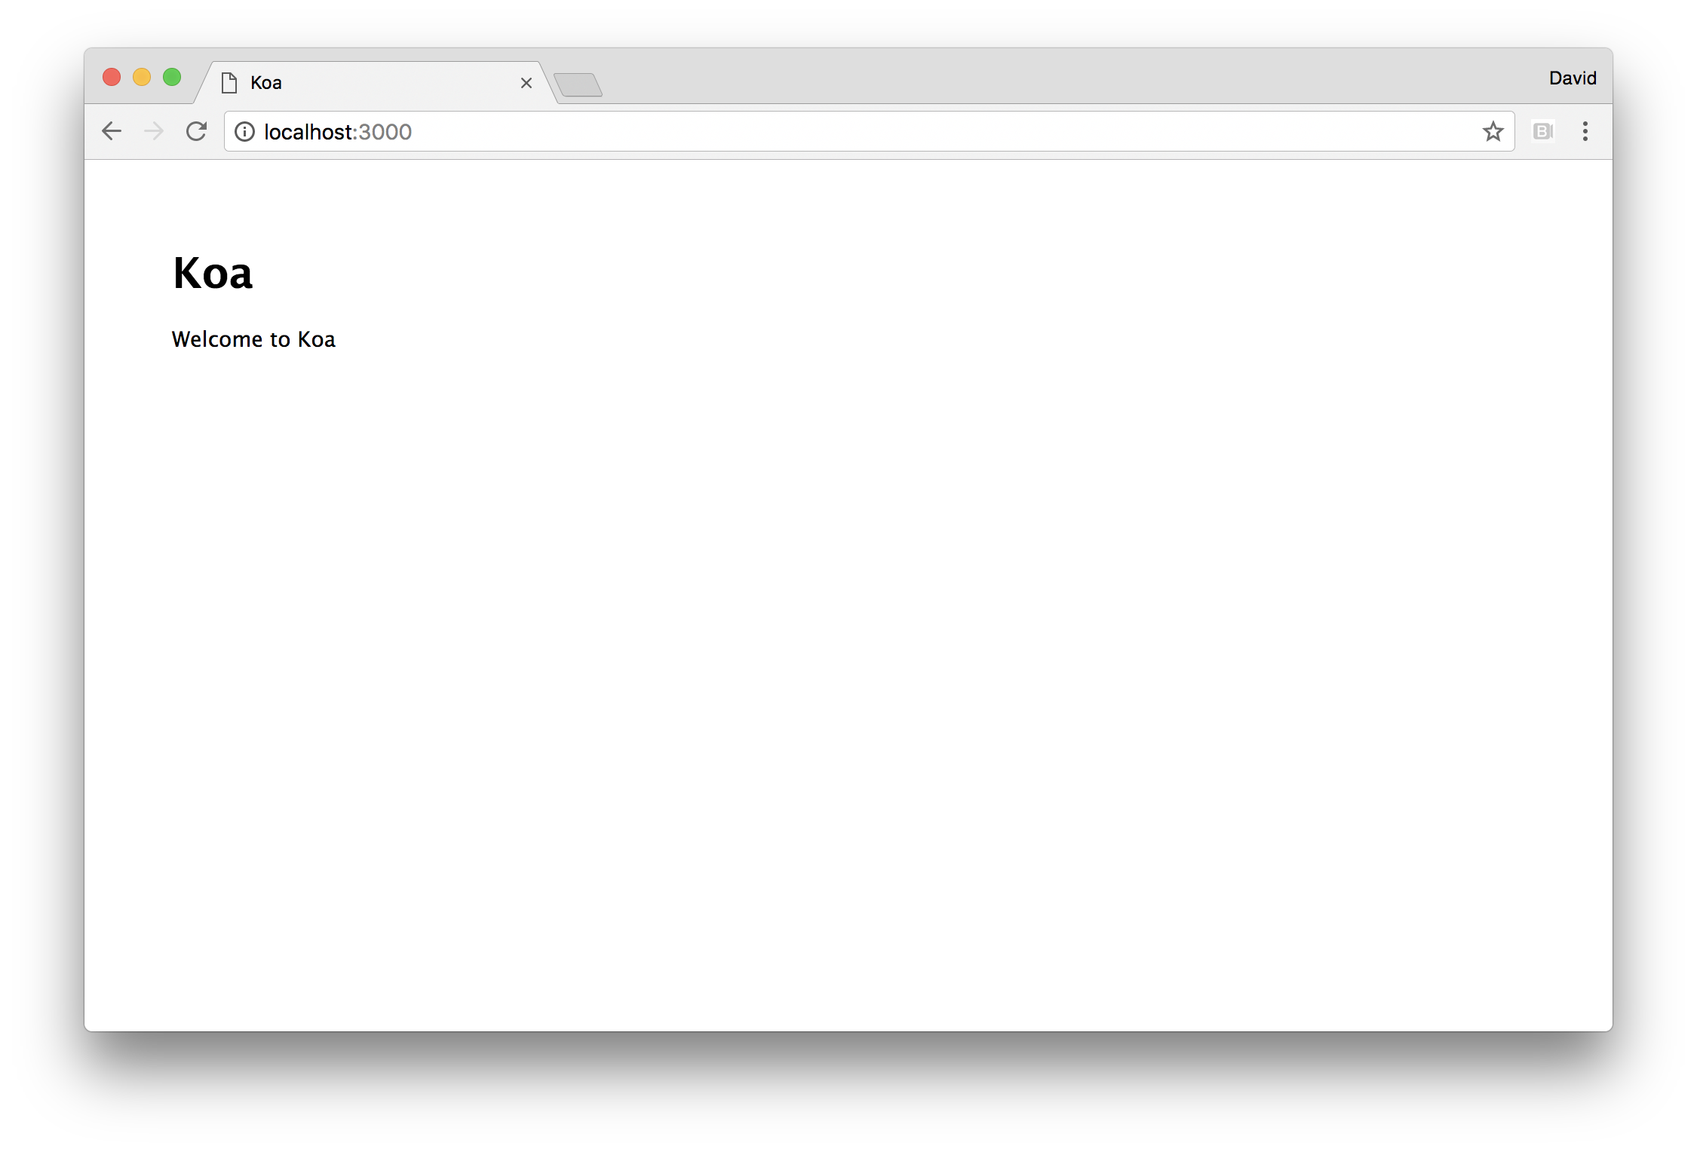

### How it works

Since Koa is a bare bones web framework, we installed koa-static and koa-router along with koa and use them in our index.js file.

#### Essential Knowledge

To understand how Koa works at a basic level, we need a fundamental understanding of JavaScript Promises (in particular ES 2015 Promises) and of async/await syntax. See https://medium.com/@bluepnume/eb148164a9c8 for an excellent article on how these abstractions interact.

The koa-static module returns a Koa middleware function which is passed into app.use. Koa middleware accepts a context object (often called ctx) and a next function. The next function always returns a promise.

The koa-static middleware attempts to locate files as per our defined path (the public folder), then creates a write stream from a file (if found) to the ctx.request object which is Node's core http request object (an instance of http.IncomingMessage often called req). If the file isn't found it passes on control to the next piece of middleware.

The koa-router middleware is superficially similar to the Router utility in Express. However, we register other router instances with our main router instance (our router object in index.js) by calling router.use. This allows us to  
set mount points for a particular set of routes. Then we pass the main router instance into app.use.

In routes/index.js we load koa-router and call it as a function (the same as we do in index.js) to create another router instance. We can call methods on the router object that correspond to HTTP verbs (such as get, post, delete, put etcetera).

We register the / route with router.get, meaning we've set up a GET route that will respond to requests to the / path.

We've taken a contrived approach to handling this route, in order to demonstrate how control flow works in Koa.

We supply two functions to the router.get call, both of them prefixed with the async keyword. An async function always returns a promise, which Koa is expecting.

Our first function immediately calls the next function with the await keyword (await next()). This means the execution of the function pauses until the promise returned from next is resolved.

The next function will (indirectly) call whichever piece of middleware is next in the stack. In our case, it's the route specific middleware, that is, the third argument passed to router.get, which is also an async function.

This second function simply sets ctx.state to an object containing a title property. Since it's an async function it returns a promise, which our first function waits to be resolved because await next() in this case relates to the resolution of the next route middleware (the third function supplied to router.get).

The line following await next() then assigns the title constant based on the contents of ctx.state. In this case title will now equal "Koa". Then we set ctx.body to our HTML content with the title constant interpolated.

This asynchronous dance is completely unnecessary, we could have just set the title constant directly in the first function and not bothered with the second function. However, the point of supplying this example in this recipe was to showcase Koa's control flow behavior in action.

This declarative fine grained control over where a function should defer to subsequent middleware before the function continues to execute is what makes Koa special in comparison to Express and Hapi.

#### A note about promises

This book has taken a light touch approach to promises, since their usage on the server side is a matter of some contention. While the concept of promises is excellent, their specification in the language have unfortunate drawbacks the detailing of which is far too in depth and out of scope - but primarily concerns traceability and analysis which has an effect on certain production diagnostics, such as post mortems. However, Koa is a futuristic framework (which is on the brink of being modern), and promise adoption continues to increase so these issues will hopefully be resolved (or at least alternative approaches will arise) in future.

### There's more

Let's explore more Koa functionality.

#### Creating Middleware

Let's copy the app folder from our main recipe to the custom-middleware-app and create a middleware folder with an answer.js file:

$ cp -fr app custom-middleware-app  
$ cd custom-middleware-app  
$ mkdir middleware  
$ touch middleware/answer.js

Our middleware/answer.js file should look like the following:

module.exports = answer  
  
function answer () {  
 return async (ctx, next) => {  
 ctx.set('X-Answer', 42)  
 await next()  
 })  
}

In our main index.js file we can load our answer middleware like so:

const answer = require('./middleware/answer')

And then register the middleware with Koa as follows:

app.use(answer())

Our answer function returns an async function, which sets our custom header using ctx.set and then delegates execution to subsequent middleware by calling next with await (await next()).

#### Performing Asynchronous Lookups

Koa's use of promises via async functions does make a very clear declarative syntax when it comes to common scenarios involving asynchronous operations.

For instance, let's consider our routes/index.js file, imagine we had to lookup the title from a database.

With async/await it would look something like the following:

const router = require('koa-router')()  
  
router.get('/', async function (ctx, next) {  
 const title = await pretendDbLookup('title')  
 ctx.body = `  
 <html>  
 <head>  
 <title> ${title} </title>  
 <link rel="stylesheet" href="styles.css">  
 </head>  
 <body>  
 <h1> ${title} </h1>  
 <p> Welcome to ${title} </p>  
 </body>  
 </html>  
 `  
})  
  
function pretendDbLookup () {  
 return Promise.resolve('Koa')  
}   
  
module.exports = router

We can check this by copying the app folder from the main recipe to async-ops-app and placing the above in routes/index.js.

As long as the asynchronous operation returns a promise, we can use await inside Koa middleware and route handlers to perform asynchronous operations in a syntactically aesthetic manner. On a side note pretendDbLookup could have been written as async function pretendDbLookup () { return 'Koa' } and the net result would be same (a promise which resolves to the string "Koa").

### See also

* *Hardening Koa* in the *There's More* section of *Hardening Headers in Web Frameworks* in **Chapter 8 Dealing With Security**
* *Creating an HTTP Server* in **Chapter 5 Wielding Web Protocols**
* *Anticipating Malicious Input* in **Chapter 8 Dealing with Security**
* *Guarding Against Cross Site Scripting (XSS)* in **Chapter 8 Dealing with Security**
* *Adding a View Layer* in this Chapter
* *Implementing Authentication* in this Chapter

## Adding a view layer

At a basic level, web frameworks are primarily responsible for delivering dynamically generated HTML to a web browser.

We tend to use a view layer of some kind, generally in the form of a template language, as a declarative way to integrate data with HTML to produce the desired combined output.

In this recipe we'll learn how to use views with Express, and in the *There's More* section we'll explore the same with the Hapi and Koa.

### Getting Ready

For this recipe we're going to copy the express application from our **Creating an Express Web App** recipe (we'll cover view layers for Hapi and Koa in the *There's More* section).

Let's copy the folder called express-views and add the ejs module:

$ cp -fr creating-an-express-web-app/app express-views  
$ cd express-views  
$ npm install --save ejs

### How to do it

Let's start by creating a views folder and placing a view file in there, which we'll call index.ejs:

$ mkdir views  
$ touch views/index.ejs

Next we'll configure Express using app.set to configure the view engine and location of the views folder.

We'll place the following just underneath the port assignment in the main index.js file:

app.set('views', join(__dirname, 'views'))  
app.set('view engine', 'ejs')

Now for our view, we'll fill the views/index.js file with the following content:

<html>  
 <head>  
 <title> <%= title %> </title>  
 <link rel="stylesheet" href="styles.css">  
 </head>  
 <body>  
 <h1> <%= title %> </h1>  
 <p> Welcome to <%= title %> </p>  
 </body>  
</html>

#### Escaping Inputs

EJS syntax allows for interpolation with <%= %> or <%- %>. The former (with the equals sign) will escape inputs whereas the latter includes inputs verbatim. While the title template local is set by us (and is therefore trusted input which doesn't require escaping) it's generally good habit to use the <%= %> syntax by default, and then consciously unescape inputs at a later stage (e.g. when optimizing). For more on escaping inputs see the *Guarding Against Cross Site Scripting (XSS)* in **Chapter 8 Dealing with Security**.

Finally we'll modify the GET route in our routes/index.js file to use the template engine:

const {Router} = require('express')  
const router = Router()  
  
router.get('/', function(req, res) {  
 const title = 'Express'  
 res.render('index', {title: 'Express'})  
})  
  
module.exports = router

Now let's start our server:

$ node index.js

Then navigate to http://localhost:3000 we should see the same result as in previous recipes, however this time our page is being rendered from EJS templates.

### How it works

The app.set method is used to alter settings which are used internally by Express (although can also be used a general store for application code too). We set the views namespace to the location of our views folder. This is actually unnecessary in our case, since Express defaults to this location anyway, but it's good to be explicit nonetheless.

The view engine setting sets the default extension for rendering. For instance in our routes/index.js file we call res.render with index. Express takes this to mean views/index.ejs because of the views setting and the view engine setting.

#### Alternative View Engines

We use EJS in this recipe because it's popular and easy to understand due to the use of embedded JavaScript syntax. For alternative template engines see https://github.com/expressjs/express/wiki#template-engines For incompatible view engines, there's the [consolidate](http://npm.im/consolidate) module, which maps a wide range of template engines.

We do not require the ejs module directly, Express will attempt to require the view engine based on the file extension. Since the file extension is exploded from index to views/index.ejs, the first time we load our view, Express parses out the extension (ejs) and requires it. Template engines that are compatible with Express export an __express function which will integrates the render engine with Express. Essentially the act of rendering views/index.js results in the app.engine('ejs', require('ejs').__express)) being called on first render which maps the ejs extension to the function supplied by the ejs modules exported __express property. To use an alternative extension with the same view engine (say, html), we could call app.engine('html', require('ejs').__express)) in the main index.js file.

#### A note on CSS preprocessing

While web frameworks do support CSS preprocessing on the fly (such as Sass, Less and Stylus) we would recommend avoiding this work in the web server layer. Instead, build assets (including CSS processing) as part of a build pipeline, then host them on a CDN. CSS preprocessing could be performed in the web server in development, but the time it takes to run this as separate process would be similar. Using a build pipeliine in development is also advisable.

### There's more

Let's see how to render views with Hapi and Koa, plus a way to organize and render views in a framework independent way.

#### Adding a view layer to Koa

Let's copy the application we created in the **Creating a Koa Web App** recipe, and call it koa-views.

We'll install the ejs and koa-views module:

$ cp -fr creating-a-koa-web-app/app koa-views  
$ cd koa-views  
$ npm install --save koa-views ejs

We'll also copy the views folder from the main recipe to the koa-views/views:

$ cp -fr ../express-views/views views

Next we'll require koa-views module among the other dependencies at the top of index.js:

const {join} = require('path')  
const Koa = require('koa')  
const serve = require('koa-static')  
const views = require('koa-views')  
const router = require('koa-router')()  
const index = require('./routes/index')

Next just beneath where we assign the port constant in index.js we'll add the following code:

app.use(views(join(__dirname, 'views'), {  
 extension: 'ejs'  
}))

#### Alternative View Engines in Koa

The koa-views middleware depends upon the consolidate module, which has a list of supported template engines at http://npm.im/consolidate#supported-template-engines

Now let's turn our attention to the routes/index.js file:

const router = require('koa-router')()  
  
router.get('/', async function (ctx, next) {  
 await next()  
 await ctx.render('index')  
}, async (ctx) => ctx.state = {title: 'Koa'})  
  
module.exports = router

We can run our server node index.js and check http://localhost:3000 in a browser to verify that everything is working as before.

The koa-views middleware adds a render function to the ctx object, which we use to render a template. The koa-views middleware already knows that the extension is ejs and where the views folder is so it converts the string we pass (index) to views/index.ejs and attempts to load that view. Like Express, koa-views will require the ejs module by itself.

We could have passed our template locals as the second argument to ctx.render, much like we do in the main recipe with Express' res.render method.

However, koa-views will automatically set template locals based on ctx.state. In Express there is a equivalent behavior, any keys set on res.locals is loaded as template state as well.

However, with Koa, we can set the state in subsequent middleware (or route middleware), and then wait for ctx.state to be set (using await next() prior to rendering.

Again this slightly over complicated for teaching purposes, our GET route in routes.js could be written thusly:

router.get('/', async (ctx, next) => {  
 await ctx.render('index', {title: 'Koa'})  
})

The ctx.render method is called with await, without using await an error occurs (headers sent after response finished) because due to a race condition, the rendering process isn't able to complete before the request finishes. For instance, the following will cause a server error (and a 404 GET response code):

// WARNING THIS WON'T WORK~  
router.get('/', async (ctx, next) => {  
 ctx.render('index', {title: 'Koa'})  
})

The return value of an async function is a promise, which only resolves (completes) when all await statements have resolved. If we don't call ctx.render with await, the promise returned from ctx.render resolves in *parallel* to the outer async function and the promise returned from the async function tends to resolve before the promise returned from ctx.render. When the promise from the async route middleware function resolves, subsequent middleware and Koa internals continue to execute until eventually the response is ended - but without using await on the ctx.render promise, the rendering process attempts to continue after the response has finished, resulting in the server error.

#### Adding a view layer to Hapi

Let's copy the app folder we created in the *Creating a Hapi Web App* recipe to the hapi-views folder, install the vision (a Hapi view manager) and ejs modules and copy the views folder from our main recipe into the hapi-views directory:

$ cp -fr creating-a-hapi-web-app/app hapi-views  
$ cd hapi-views  
$ npm install --save vision ejs  
$ cp -fr ../express-views/views views

At the top of index.js we'll include the vision and ejs modules:

const hapi = require('hapi')  
const inert = require('inert')  
const vision = require('vision')  
const ejs = require('ejs')

Near the bottom of index.js we'll update the plugins we want to register (based on the dev constant):

const plugins = dev ? [vision, inert] : [vision]  
server.register(plugins, start)

Now we'll call the new server.views method, in our start function with relevant settings:

function start (err) {  
 if (err) throw err  
  
 server.views({  
 engines: { ejs },  
 relativeTo: __dirname,  
 path: 'views'  
 })  
  
 routes.index(server)  
   
 if (dev) routes.devStatic(server)  
  
 server.start((err) => {  
 if (err) throw err  
 console.log(`Server listening on port ${port}`)  
 })  
}

Finally let's update the route handler in routes/index.js:

module.exports = index   
  
function index (server) {  
 server.route({  
 method: 'GET',  
 path: '/',  
 handler: function (request, reply) {  
 const title = 'Hapi'  
 reply.view('index', {title})  
 }  
 })  
}

The vision plugin decorates the server object by adding a views method, and the reply function with a view method.

When we call server.views in the start function, we set the engines property to an object with a key of ejs containing the ejs module (we used ES2015 shorthand object properties, { ejs } is the same as {ejs: ejs}). The key on the engines object corresponds to the extension used for a given view, if there is only one property of the engines object then it becomes the default view extension. So when we call reply.view with index Hapi knows to assume we mean views/index.ejs.

#### Alternative View Engines in Hapi

The vision middleware used for template rendering has a standard interface for hooking in different template engines. See https://github.com/hapijs/vision#examples for several examples of template engines integrating with vision.

#### ES2015 Template Strings as Views

With the advent of ES2015 tagged template strings, and their implementation into Node's JavaScript engine (V8) multi-line strings with interpolation syntax became supported natively. If we wish to take a minimalist, framework independent approach to a web servers view layer implementation we could use functions that return template strings instead of template engines.

Let's copy the app folder from the *Creating an Express Web App* recipe and call it express-template-strings, create a views folder with an index.js file:

$ cp -fr creating-an-express-web-app/app express-template-strings  
$ cd express-template-strings  
$ mkdir views  
$ touch index.js

This would generally be more performant, can be used with any web framwork without the need for compatibility facades and as a native part of JavaScript, doesn't require us to learn yet another DSL.

However, it's important not to forget a primary function that template engines typically provides: context aware escaping. In our case, title is a trusted template input, however if we were taking user input and displaying it in a template we would need to HTML escape (in this case) the input. Check out *Guarding Against Cross Site Scripting (XSS)* in **Chapter 8 Dealing with Security**  
for more information.

### See also

* *Creating an HTTP Server* in **Chapter 5 Wielding Web Protocols**
* *Anticipating Malicious Input* in **Chapter 8 Dealing with Security**
* *Guarding Against Cross Site Scripting (XSS)* in **Chapter 8 Dealing with Security**
* *Implementing Authentication* in this Chapter

## Adding Logging

A web server should provide some form of log data, particularly of incoming requests and their responses before it can be considered production worthy.

In this recipe we look at using pino, which is a high performance JSON logger with Express. In the *There's More* section we'll look at alternative loggers and integrating logging into Koa and Hapi.

### Getting Ready

Let's copy the express-views folder from our previous recipe into a new folder we'll call express-logging, and install pino and express-pino-logger:

$ cp -fr adding-a-view-layer/express-views express-logging  
$ cd express-logging  
$ npm install --save pino express-pino-logger

### How to do it

We'll require pino and express-pino-logger at the top of the index.js file:

const {join} = require('path')  
const express = require('express')  
const pino = require('pino')()  
const logger = require('express-pino-logger')({  
 instance: pino  
})  
const index = require('./routes/index')

Notice how we instantiate a Pino instance by immediately calling the function returned from require('pino') and then pass that as the instance property of the object passed to the function returned from require('express-pino-logger').

This creates the logger middleware, let's register the middleware. Just underneath the second call to app.set we can add the following line:

app.use(logger)

At the bottom of index.js we'll modify the app.listen callback like so:

app.listen(port, () => {  
 pino.info(`Server listening on port ${port}`)  
})

Let's also add a log message to the GET route in our routes/index.js file:

router.get('/', function (req, res) {  
 const title = 'Express'  
 req.log.info(`rendering index view with ${title}`)  
 res.render('index', {title: 'Express'})  
})

Now let's start our server:

$ node index.js

Then, if we make a request to the server by navigating to http://localhost:3000 in the browser, log messages similar to those shown in the following image should be generated.

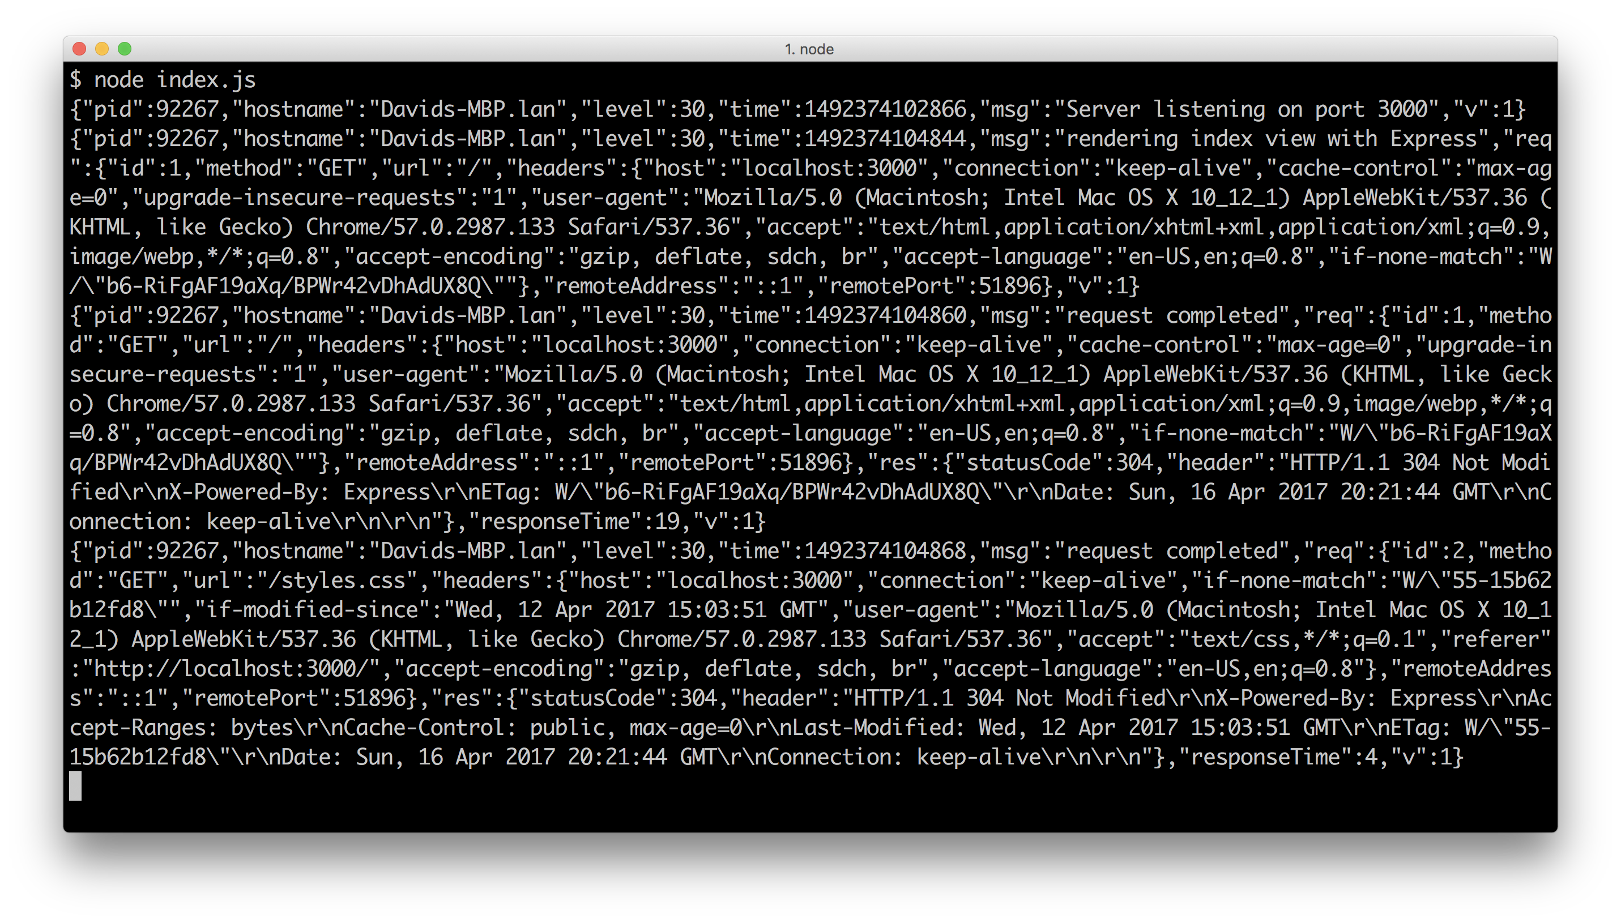

#### Pino

For more on pino and express-pino-logger see http://npm.im/pino and http://npm.im/express-pino-logger

### How it works

We require pino and express-pino-logger which is a middleware wrapper around pino. We separate the creation of the logger (using pino) and the middleware instantiation, passing the logger instance into the middleware, so that the logger instance can be used independently.

The Pino logger has a Log4J interface - an Apache logger written for Java which has become a common, intuitive abstraction across other languages. Messages can be logged at different levels by calling methods on a logging instance (trace, debug, info, warn, error, fatal). The general log level is info.

So we changed our console.log in the app.listen callback to pino.info, which writes a JSON log message on server start, like:

{"pid":92598,"hostname":"Davids-MBP.lan","level":30,"time":1492375156224,"msg":"Server listening on port 3000","v":1}

When we register logger in app.js the express-pino-logger middleware function adds a log object to every incoming request (as req.log). Each log object is unique to that request, and contains a req property with various data about the request, along with a unique generated id - which allows us to trace any log messages to a specific client request.

So our call to req.log.info outputs JSON similar to:

{"pid":92598,"hostname":"Davids-MBP.lan","level":30,"time":1492375259910,"msg":"rendering index view with Express","req":{"id":1,"method":"GET","url":"/","headers":{"host":"localhost:3000","user-agent":"curl/7.49.1","accept":"*/*"},"remoteAddress":"::ffff:127.0.0.1","remotePort":52021},"v":1}

Additionally the express-pino-logger middleware generates a log message for each completed request, adding a res key to the JSON describing the status code, headers and response time.

So we'll also see a log message like:

{"pid":92598,"hostname":"Davids-MBP.lan","level":30,"time":1492375259931,"msg":"request completed","req":{"id":1,"method":"GET","url":"/","headers":{"host":"localhost:3000","user-agent":"curl/7.49.1","accept":"*/*"},"remoteAddress":"::ffff:127.0.0.1","remotePort":52021},"res":{"statusCode":200,"header":"HTTP/1.1 200 OK\r\nX-Powered-By: Express\r\nContent-Type: text/html; charset=utf-8\r\nContent-Length: 182\r\nETag: W/\"b6-RiFgAF19aXq/BPWr42vDhAdUX8Q\"\r\nDate: Sun, 16 Apr 2017 20:40:59 GMT\r\nConnection: keep-alive\r\n\r\n"},"responseTime":26,"v":1}

Other JSON loggers and their respective middleware wrappers work in much the same way, however we focus on Pino in this recipe because it adds significantly less overhead to the server.

#### Log Processing

Talk about transports, give e.g. elasticsearch etc

### There's more

Let's take a look at some pino utilities, alternative loggers and adding logging to Hapi and Koa.

#### Pino Transports and Prettifying

It's advisable to keep as much log processing work outside of the main web server Node process as possible. To this end the Pino logging philosophy promotes piping log output to a separate process (which we call a logging transport).

This separate process may move the logs into a database, or message bus, or may apply data transforms or both.

For instance, if we wanted to marshal logs into an Elasticsearch database (which would allow us to analyse log messages with Kibana which is excellent data visualisation and anaalysis tool for Elasticsearch) in a production setting, we could use the pino-elasticsearch transport and pipe our server log output to it like so:

$ node index | pino-elasticsearch

See the pino-elasticsearch readme for more information (http://npm.im/pino-elasticsearch).

Another type of transport that's more for development purposes is a prettifier. The pino module supplies it's own prettifier, if we install pino globally:

$ npm install -g pino

This will install a CLI executable called pino on our system.

Then if we run our server from the main recipe and pipe the servers output to pino executable:

$ node index.js | pino

After navigating to http://localhost:3000, we should see something like the following:

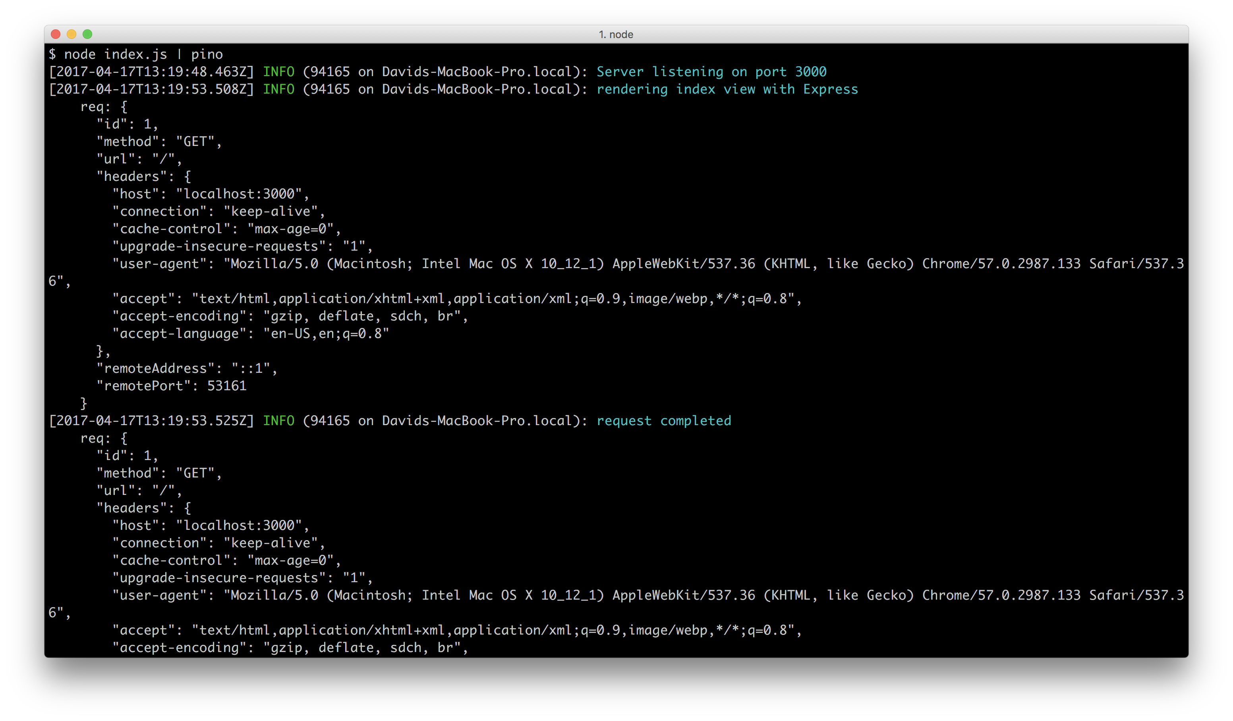

An alternative prettifer for pino which provides more concise information is the pino-colada module.

If we install pino-colada globally:

$ npm install -g pino-colada

And pipe our server output through the pino-colada executable now on our system:

$ node index.js | pino-colada

We should see something like the following, once we've hit http://localhost:3000:

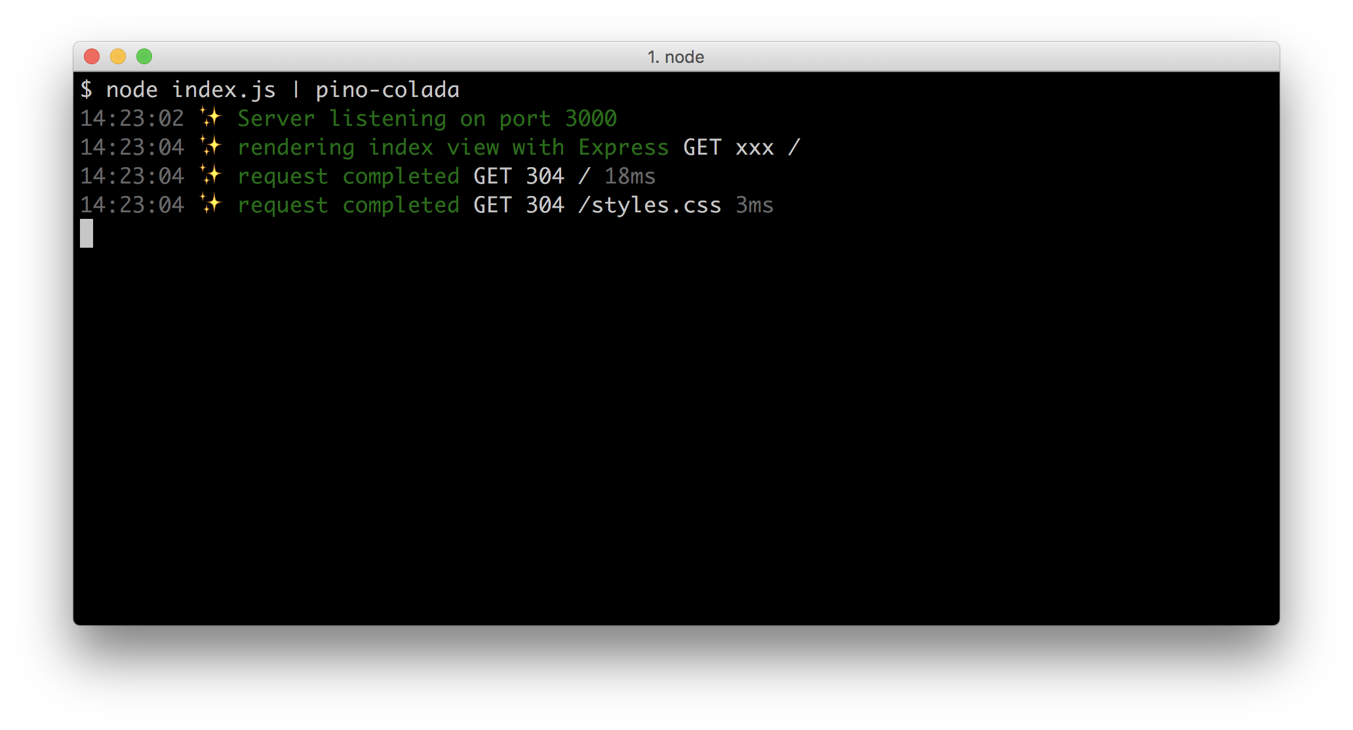

#### Logging with Morgan

Another alternative logger is the Morgan logger, which can output logs in different formats. These can be defined using preset labels, a tokenized string or a function.

We'll use Morgan to make our Express server log messages in the common Apache log format,

Let's copy the express-views folder from our previous recipe into a new folder we'll call express-morgan-logging, and install morgan:

$ cp -fr adding-a-view-layer/express-views express-morgan-logging  
$ cd express-morgan-logging  
$ npm install --save morgan

Near the top of the index.js file, we can load morgan like so:

const morgan = require('morgan')

Then around the middleware, we can register it as the first middleware like so:

app.use(morgan('common'))

We pass common to configure Morgan to output messages in common Apache log format.

let's start our server with node index.js and make a request to http://localhost:3000 we should see something similar to the following:

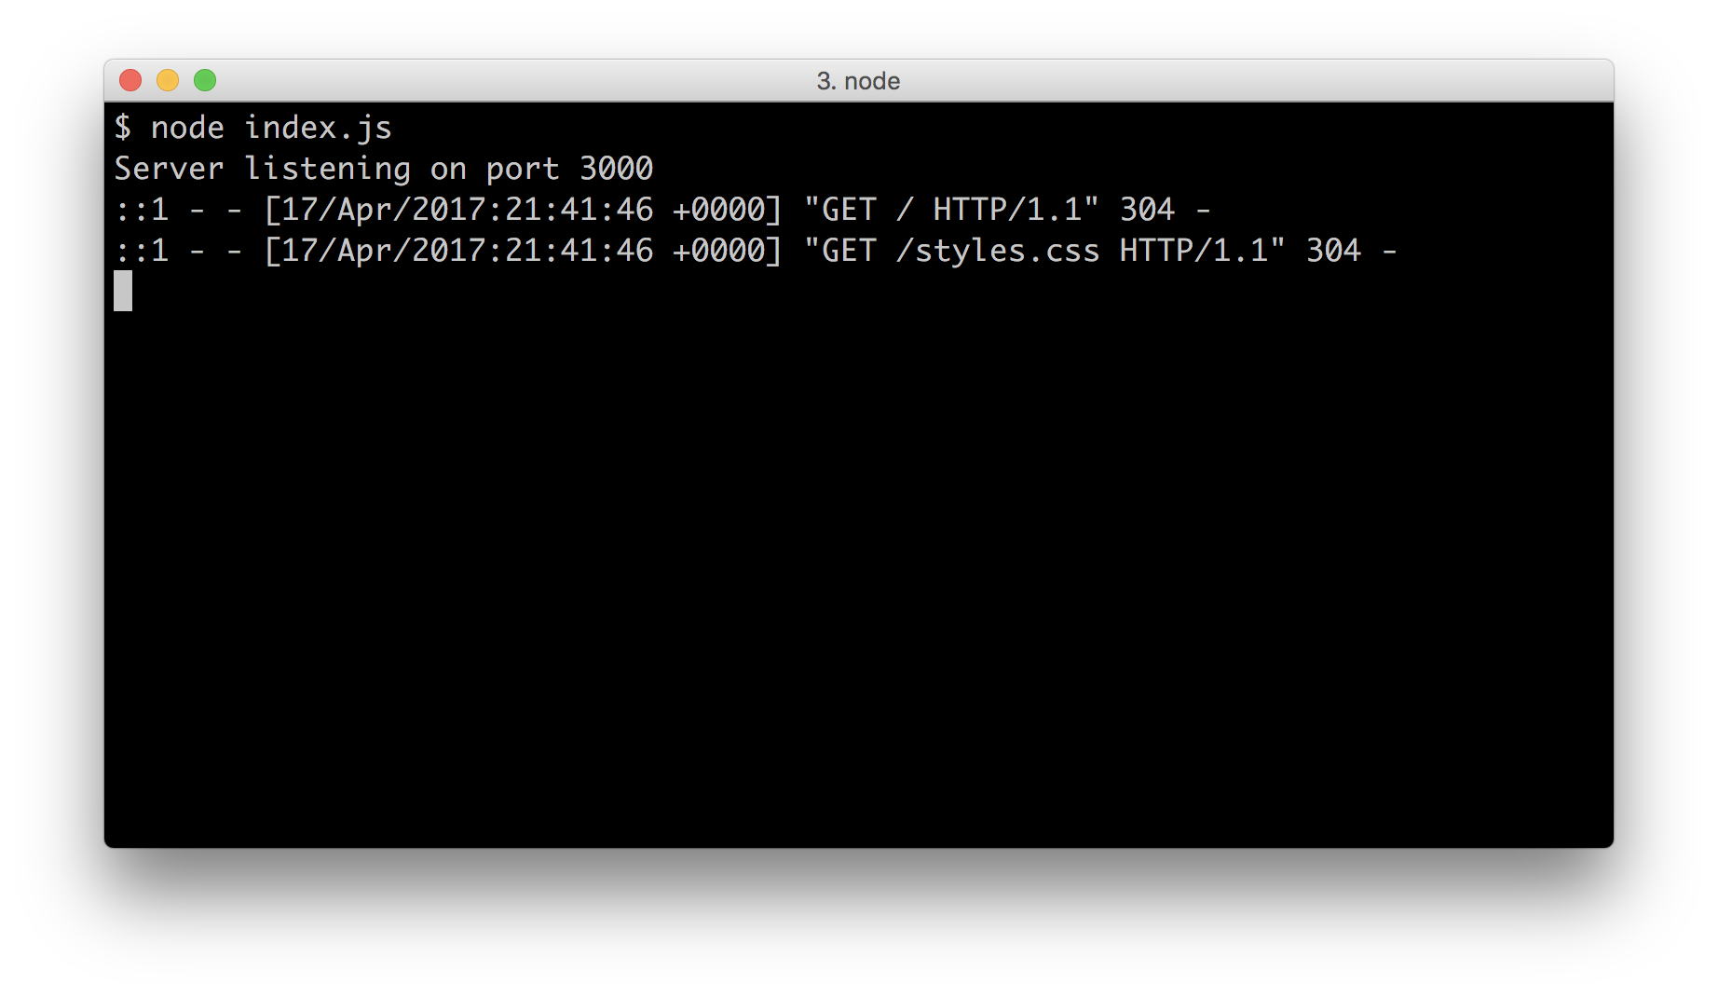

Morgan is a nice lightweight logger that can provide Apache style (and other common) log formats that may integrate well into pre-existing deployments. However it will only work for request/response logging, custom log messages are not supported.

#### Logging with Winston

A very popular alternative to pino is the winston logger.

In the main, the winston logger has the same Log4J interface as Pino, however it differs greatly from pino in philosophy.

The winston logger supplies a large amount of features and configuration options - such as log rotation, multiple destinations based on log levels, and in process logging transformations.

These come with the winston logger as standard, and are used in the same Node process as the server (which from a performance perspective is something of a trade off).

Let's copy the express-views folder from our previous recipe into a new folder we'll call express-winston-logging, and install winston and express-winston:

$ cp -fr adding-a-view-layer/express-views express-morgan-logging  
$ cd express-morgan-logging  
$ npm install --save morgan

Now we'll add the following to our dependencies at the top of the index.js file:

const winston = require('winston')  
const expressWinston = require('express-winston')

Just above where we instantiate the Express app (const app = express()), we'll create a Winston logger instance, configured to output to process.stdout in JSON format:

const logger = new winston.Logger({  
 transports: [  
 new winston.transports.Console({  
 json: true  
 })  
 ]  
})

By default, the winston.transports.Console transport will output logs in the format ${level}: ${message}. However we can set the json option to true to enable JSON logging.

In the middleware section of index.js we'll register the express-winston middleware , passing it the Winston logger instance (logger) like so:

app.use(expressWinston.logger({  
 winstonInstance: logger  
}))

Finally at the bottom of index.js we'll use the logger instance to output the initial server log:

app.listen(port, () => {  
 logger.info(`Server listening on port ${port}`)  
})

We won't modify the routes/index.js file to log a request-linked message, as Winston does not support this.

If we run our server (node index.js) and make a request to http://localhost:3000 we should see output similar to the following:

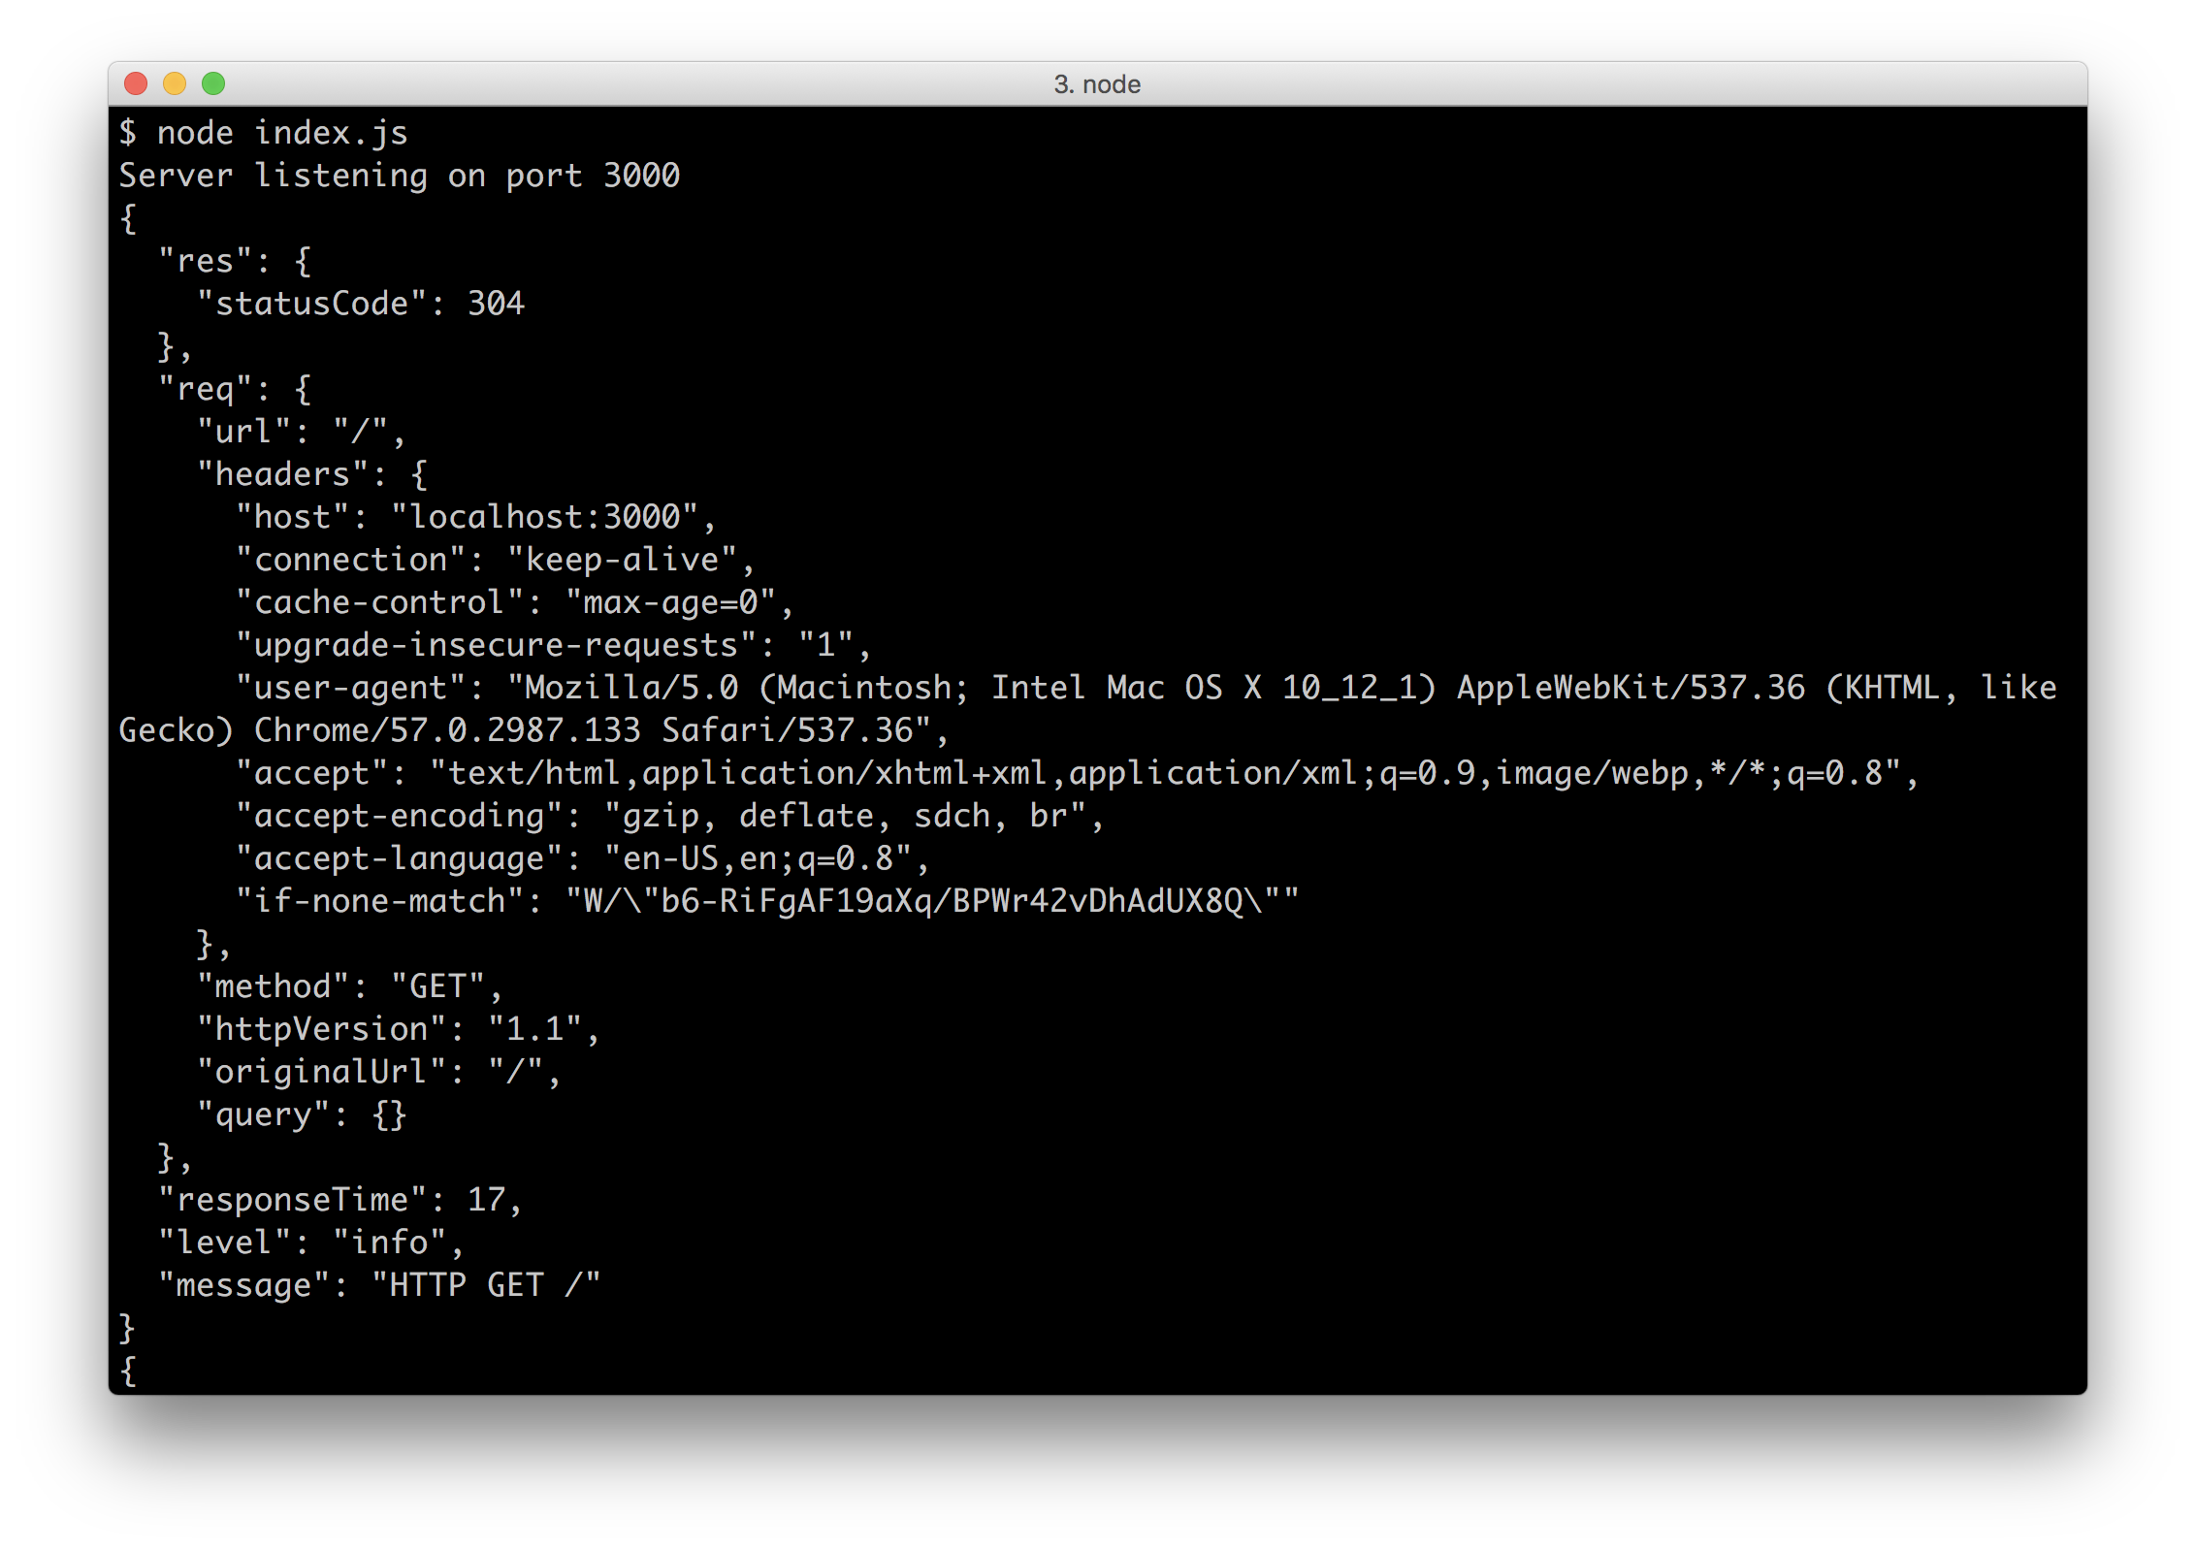

The winston logger and its express-winston counterpart have a vast API with many options, see the respective Readmes (http://npm.im/winston and http://npm.im/express-winston) for more information.

#### Adding Logging to Koa

Setting up logging with Koa is very similar to logging with Express. Let's copy the koa-views folder which we created in the *There's More* section of the *Adding a View Layer* recipe and name it koa-logging, we'll also install pino and koa-pino-logger:

$ cp -fr adding-a-view-layer/koa-views koa-logging  
$ cd koa-logging  
$ npm install --save pino koa-pino-logger

Near the top of our index.js we'll add the following:

const pino = require('pino')()  
const logger = require('koa-pino-logger')({  
 instance: pino  
})

Then, still in index.js underneath where we configure view settings, we'll register the logging middleware like so:

app.use(logger)

At the bottom of index.js we'll update the app.listen callback to use pino.info instead of console.log:

app.listen(port, () => {  
 pino.info(`Server listening on port ${port}`)  
})

Finally in routes/index.js we'll add a log message to our GET route:

router.get('/', async function (ctx, next) {  
 await next()  
 ctx.log.info(`rendering index view with ${ctx.state.title}`)  
 await ctx.render('index')   
}, async (ctx) => ctx.state = {title: 'Koa'})

When we start our server with node index.js and navigate to http://localhost:3000 we'll see similar log output to the log messages in the main recipe.

#### Adding Logging to Hapi

For high performance logging in Hapi, there's the hapi-pino plugin.

Let's copy the hapi-views folder from the *There's More* section of the *Adding a View Layer* recipe, and call it hapi-logging and install the pino and hapi-pino modules.

$ cp -fr adding-a-view-layer/hapi-views hapi-logging  
$ cd hapi-logging  
$ npm install --save pino hapi-pino

Near the top of our index.js file we'll require and instantiate pino, and load the hapi-pino plugin:

const pino = require('pino')()  
const hapiPino = require('hapi-pino')

Next we'll add the logger to our plugins (both development and production plugins):

const plugins = dev ? [{  
 register: hapiPino,  
 options: {instance: pino}  
}, vision, inert] : [{  
 register: hapiPino,  
 options: {instance: pino}  
}, vision]

Notice how we pass the hapiPino plugin inside an object with a register property and an options property containing and object with instance property referencing the pino logger instance. This instructs Hapi to supply the options provided to the hapi-pino plugin at instantiate time (Hapi instantiates plugins internally).

At the bottom of index.js, inside the start function, we'll modify the server.start callback to use server.log instead of console.log:

server.start((err) => {  
 if (err) throw err  
 server.log(`Server listening on port ${port}`)  
 })

Finally we'll update the routes/index.js file by adding an info log message in the request handler:

module.exports = index   
  
function index (server) {  
 server.route({  
 method: 'GET',  
 path: '/',  
 handler: function (request, reply) {  
 const title = 'Hapi'  
 request.logger.info(`rendering index view with ${title}`)  
 reply.view('index', {title})  
 }  
 })  
}

The hapi-pino plugin modifies the server.log method to output info log messages with pino (it's also possible to get the entire logger instance by calling server.logger()).

Starting our server (node index.js) and hitting http://localhost:3000 should again yield similar JSON logs as output in the main recipe.

#### Capturing debug logs with with Pino

In **Chapter 1 Debugging Processes** we discuss the [debug](http://npm.im/debug) module which is used to conditionally output debug logs based on namespeces defined on the DEBUG variable. Both Express and Koa (and the dependencies they use) use the debug module heavily.

The pino-debug module can hook into the debug logs, and wrap them in JSON logs, all while logging at ten times the speed of debug module. This affords us the opportunity of high resolution production logging.

Let's check it out copying our express-logging folder from the main recipe, saving as express-pino-debug-logging and installing pino-debug:

$ cp -fr express-logging express-pino-debug-logging  
$ cd express-pino-debug-logging  
$ npm install --save pino-debug

Now we start our server using the -r (require) Node flag, with pino-debug. This will automatically load pino-debug as the process starts:

$ DEBUG=* node -r pino-debug index.js

If we hit the http://localhost:3000 route this will give us plenty of (low overhead) logging information.

### See also

* *Enabling debug logs* in **Chapter 1 Debugging Processes**
* *Enabling core debug logs* in **Chapter 1 Debugging Processes**
* *Creating an Express Web App* in this chapter
* *Creating a Hapi Web App* in this chapter
* *Creating a Koa Web App* in this chapter

## Implementing Authentication

A common scenario for web sites is an elevated privileges area that requires a user to identify themselves via authentication.

The typical way to achieve this is with sessions, so in this recipe we're going to implement an authentication layer with our Express server and in the *There's More* section we'll do the same with Koa and Hapi.

### Getting Ready

Let's copy the express-logging folder from the previous section and name the new folder express-authentication, we'll also need to install express-session and body-parser:

$ cp -fr ../adding-logging/express-logging express-authentication  
$ cd express-authentication

### How to do it

We're going to need the body-parser module (so we can accept and parse POST requests for a login form), and the express-session module. Let's begin by installing those:

$ npm install --save express-session body-parser

Along with modifying a few files, we're also going to create a routes/auth.js file and views/login.ejs file:

$ touch routes/auth.js views/login.ejs

Let's require the express-session and body-parser at the top of the index.js file:

const session = require('express-session')  
const bodyParser = require('body-parser')

Underneath where we load the index route, we'll also load our auth route:

const index = require('./routes/index')  
const auth = require('./routes/auth')

HTTP sessions rely on cookies, we want to use secure cookies in production, behind an SSL terminating load balancer but it's easier to have non-secure cookies server over HTTP in developemnt.

So underneath where we set our views we'll add the following configuration settting:

if (!dev) app.set('trust proxy', 1)

Next, underneath where we register the logger middleware, we'll register session and body parser middleware:

app.use(session({  
 secret: 'I like pies',  
 resave: false,  
 saveUninitialized: false,  
 cookie: {secure: !dev}  
}))  
app.use(bodyParser.urlencoded({extended: false}))

We'll also set another mount point, /auth for our auth routes, underneath the original / mount point,:

app.use('/', index)  
app.use('/auth', auth)

We're going to supply a login link if the user does not have escalated privileges, and a logout link if they do, also acknowledging the user by name.

Let's modify views/index.ejs like so:

<html>  
 <head>  
 <title> <%= title %> </title>  
 <link rel="stylesheet" href="styles.css">  
 </head>  
 <body>  
 <h1> <%= title %> </h1>  
 <p> Welcome to <%= title %> </p>  
 <% if (user) { %>  
 <p> Hi <%= user.name %>! </p>  
 <p> <a href=/auth/logout> Logout </a> </p>  
 <% } else { %>  
 <p> <a href=/auth/login> Login </a> </p>  
 <% } %>   
 </body>  
</html>

Now for the login screen, let's create a views/login.ejs file with the following content:

<html>  
 <head>  
 <title> Login </title>  
 <link rel="stylesheet" href="../styles.css">  
 </head>  
 <body>  
 <h1> Login </h1>  
 <% if (fail) { %>   
 <h2> Try Again </h2>  
 <% } %>  
 <form method=post action=login>  
 User: <input name=un> <br>  
 Pass: <input type=password name=pw> <br>  
 <input type=submit value="login">  
 </form>  
 </body>  
</html>

If login fails, our view/login.ejs template will include a "Try Again" message.

Now for our auth routes, let's populate routes/auth.js with the following code:

const { Router } = require('express')  
const router = Router()  
  
router.get('/login', function (req, res, next) {  
 res.render('login', {fail: false})  
})  
  
router.post('/login', function (req, res, next) {  
 if (req.session.user) {  
 res.redirect('/')  
 next()  
 return  
 }  
 if (req.body.un === 'dave' && req.body.pw === 'ncb') {  
 req.session.user = {name: req.body.un}  
 res.redirect('/')  
 next()  
 return  
 }  
  
 res.render('login', {fail: true})  
  
 next()  
})  
  
router.get('/logout', function (req, res, next) {  
 req.session.user = null  
 res.redirect('/')  
})  
  
module.exports = router

#### Password Security

It goes without saying, but we'll say it anyway: don't check plaintext passwords in real life. Always store a cryptographically secure hash of the password and check against the hash of user supplied password.

Finally we'll tweak the GET route in routes/index.js as follows:

router.get('/', function (req, res) {  
 const title = 'Express'   
 req.log.info(`rendering index view with ${title}`)  
 const user = req.session.user  
 res.render('index', {title, user})  
})

#### Session storage and production worthiness

The express-session module has a standard MemoryStore interface, that can be used to store sessions in a database. However, by default the session storage mechanism is in-process storage - the lack of a peer dependency makes for faster development. However, tokens are not expired, so a process would eventually crash. See the *There's More* section for alternative storage options.

Now let's start our server:

$ node index.js

When we navigate to http://localhost:3000 in a browser, we should see an initial screen like the following:

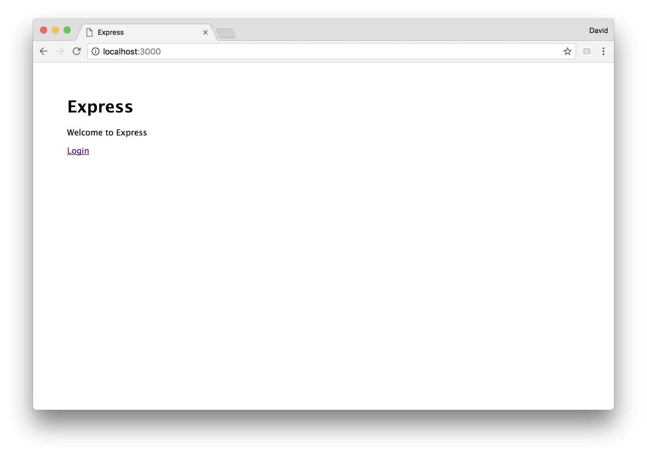

Upon clicking the login button we should see the following login view:

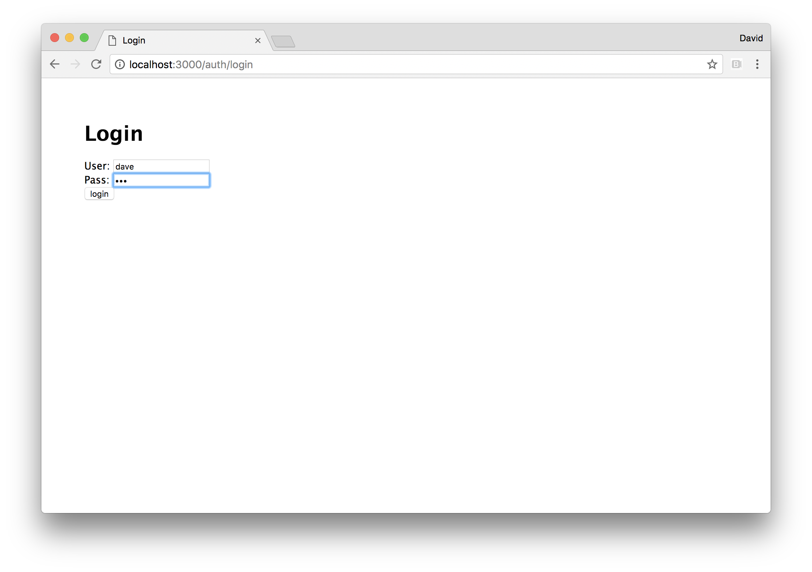

Then after logging in, we're redirected back to the index page as an authenticated user, and should see something similar to the following:

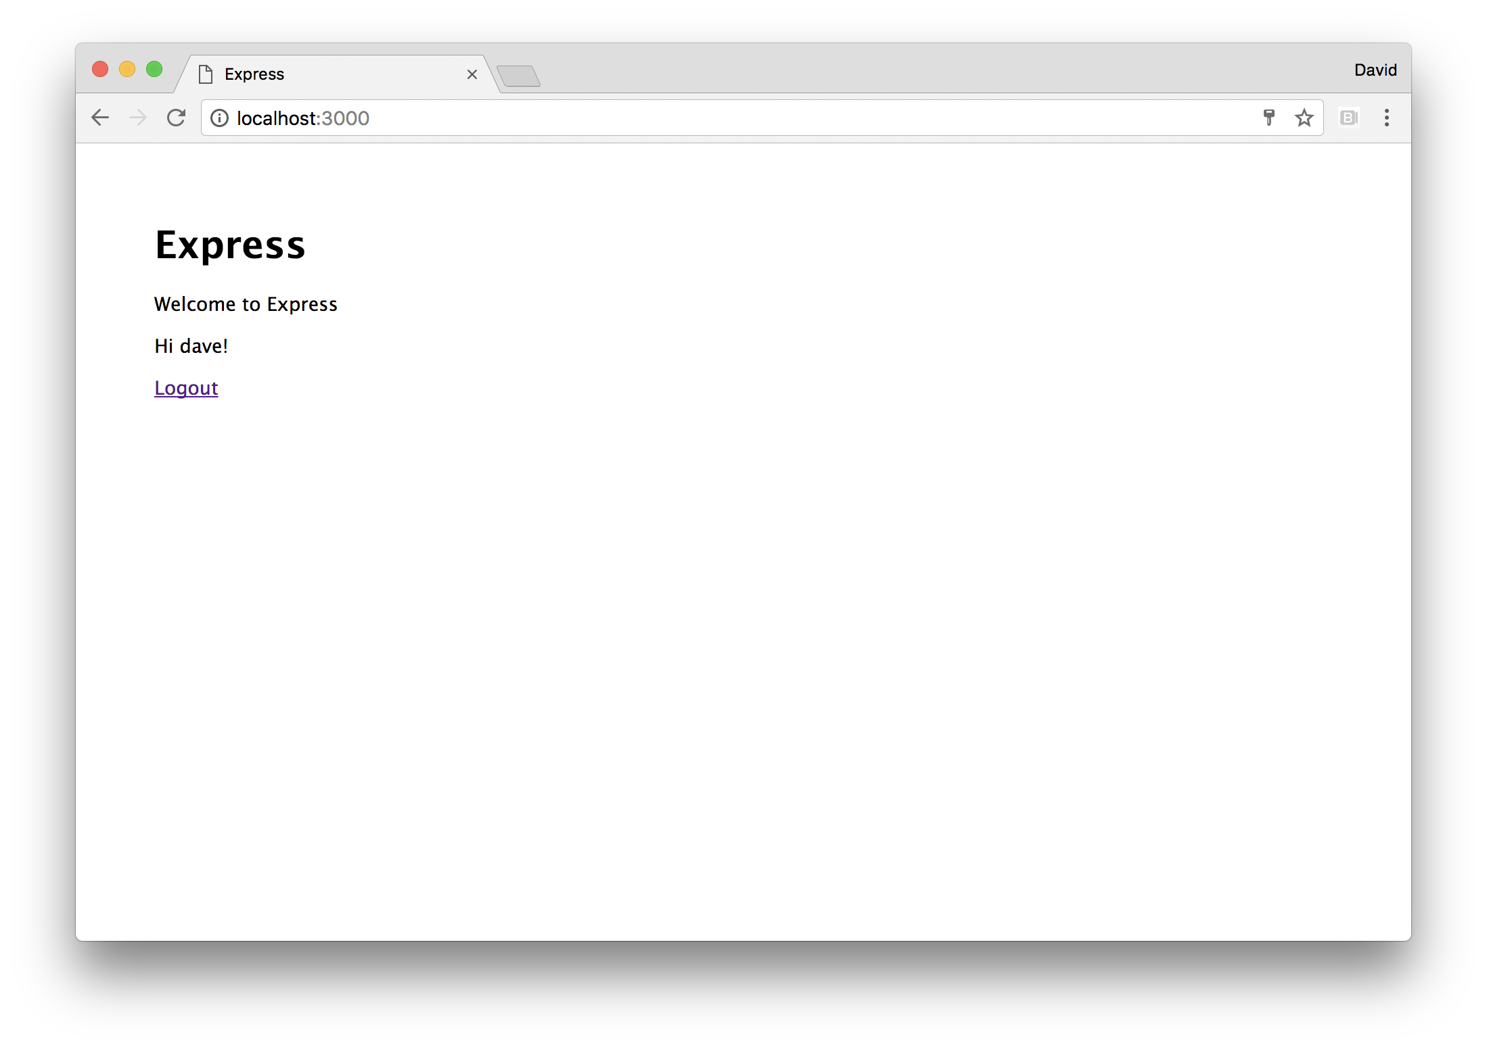

If we click the logout link, we'll see the first screen again.

### How it works

Perhaps the easiest way to discuss our authentication implementation is to analyze if from a user flow perspective.

The first route, the / (index) route conditionally displays a login or logout link, plus the users name if logged in. The views/index.ejs template contains the logic which checks for a truthiness of a user template local and if it doesn't exist presents a login link, pointing to /auth/login. The user local passed to the template in routes/index.js is the value on req.session.user.

We registered express-session middleware on our Express app in index.js, which means every req object has a session object. However, prior to logging in, the user does not have a session, it's simply an empty object where user is undefined (which equates to false in the the views/index.js if statement).

When the /auth/login link is clicked a GET request to /auth/login is made from the browser. In the main index.js file we mounted the auth routes at /auth with app.use. So a request to /auth/login matches the /login GET route in routes/auth.js. The route handler the views/login.ejs view with fail set to false.

When the HTML form is filled out and submitted, the browser creates a URL Encoded string of the inputs according to the input elements names. So in our case, given the user name of dave and password of ncb the browser creates a request body of pw=dave&un=ncb. The browser makes a POST request to the /auth/login route - because that's how the HTMl form was configured, the action attributed was set to login (which expands to /auth/login based on relative path) and the method attribute was set to post.

The body-parser module is covered in the *There's More* section (subheading *Route Parameters and POST requests*) of the first recipe of this chapter, *Creating an Express Web App*.

In short, a POST request has a message body. By default browser HTML forms send the message body in URL Encoded format (the same as we see with the "search" portion of GET urls, the parameters after the question mark). We use the urlencoded method of the body-parser module to create body parsing middleware converts an incoming POST request to the /login route to an object on req.body.

The POST /auth/login route handler in routes/auth.js handles the login request and will take one of three actions.

If there's is already a session, with an associated user object (that is, if req.session.user exists), it will redirect to the / (index) route.

Next we validate the request POST message (req.body). We do a simple conditional check on username and password, but this could be adapted to check a database of usernames and password hashes.

If the POST body is invalid, the /auth/login POST route will respond to the request by rendering the views/loging.ejs template again, but this time with fail set to true. Which will cause the template to render with a Try Again message.

If the POST body is valid we set req.session.user. At this point, a session identifer is created. Then we redirect to the / route. The redirect response will contain a Set-Cookie HTTP header, containing a key and value that holds the session key name (which defaults to connect.sid) and the session identifier.

#### Session Key Name

To avoid server fingerprinting, we should make a practice of configuring web servers to set a generic session key name. See the *Avoiding Fingerprinting* subheading of the *There's More* section in the *Hardening Headers in Web Frameworks* recipe in **Chapter 8 Dealing with Security** for details.

As the browser dutifily makes a new request for the / route (as per the HTTP redirection), it will pass the string which came through the Set-Cookie header back to the browser under the Cookie header.

The express-session middleware will intercept the request, and recognize the connect.sid portion of the Cookie header, extract the session identifier and match query the session storage for any state is associated with the identifer. State is then placed onto the req.session object. In our case the user object is added to req.session. The routes/index.js GET handler will pass the req.session.user object into the res.render method, and the views/index.ejs template will enter the first logic branch in the conditional statement checking for truthiness of the user template local.

This time when the views/index.ejs renders, it will include a welcome message to the logged in user ("Hi dave!") and a logout link pointing to /auth/logout.

When the /auth/logout link is clicked, the /logout GET route in routes/auths.js is passed the request and response objects. We set req.session to null which unsets the session (the session data is released from the session store). Then we redirect back to the index route (/).

The browser will continue to cache and send the obsolete session cookie until it expires, however the session identifer will have no matches in the store so our server will treat the browser as if it has no session (which it doesn't). Upon logging in again, the browser receives a new session cookie which replaces the old cookie.

The session cookie sent to the browser may or may not be marked with a "Secure" attribute. This attribute instructs the browser to never send the session cookie back to the server over HTTP - this helps to avoid person in the middle attacks designed to steal session cookies. However, the Secure attribute cannot be set in the first place if an incoming request is made over HTTP (and of course, even if it could, we wouldn't be able to receive the users session cookie back without HTTPS).

In production, we should absolutely use HTTPS and send secure session cookies, in development it's more convenient to use HTTP (which means we can't use secure cookies).

So we assume a production environment that applies SSL encryption to connections at a load balancer or reverse proxy layer, but our web server serves content to the load balancer (or reverse proxy) via HTTP. To make this work we set the Express trust proxy setting to 1. Which means trust exactly one proxy IP to deliver unencrypted content *as if* it was encrypted when that proxy adds an X-Forwarded-Proto header with the value of HTTPS to the request. When this is the case, express-session will set the Secure attribute on the session cookie, even though it's technically served over HTTP to the proxy layer.

The trust proxy setting can also (preferably) be set to a whitelist array of accepted proxy IP addresses to trust (or for more complex setups, a predicate function which checks the IP for validitiy). We only do this in production, based on the value of the dev constant (which is set based on the NODE_ENV environment variable). We also use the dev constant to determine whether a session cookie should be secure or not. When we call the session function (which is exported from express-session) we pass an options object, with secure set to the opposite of dev (!dev).

### There's more

Let's look at implementing authentication in Hapi and Koa.

### Session Authentication in Hapi

Let's implement authentication in our Hapi server.

We'll copy the hapi-logging folder which we created in the *There's More* section of the previous recipe (*Adding Logging*) name it hapi-authentication. We'll also copy the views folder from the main recipe, install the yar module, and create a routes/auth.js file:

$ cp -fr ../adding-logging/hapi-logging hapi-authentication  
$ cd hapi-authentication  
$ cp -fr ../express-authentication/views views  
$ npm install --save yar  
$ touch routes/auth.js

Let's require the yar module in the index.js module, and require the routes/auth.js file within our routes object:

const yar = require('yar')  
const routes = {  
 index: require('./routes/index'),  
 auth: require('./routes/auth'),  
 devStatic: require('./routes/dev-static')  
}

Let's add yar to the plugins declaration:

const plugins = dev ? [{  
 register: hapiPino,  
 options: {instance: pino}  
}, {  
 register: yar,  
 options: {  
 cookieOptions: {  
 password: 'I really really really like pies',  
 isSecure: false  
 }  
 }  
}, vision, inert] : [{  
 register: hapiPino,  
 options: {instance: pino}  
}, {  
 register: yar,  
 options: {  
 cookieOptions: {  
 password: 'something more secure than a bit about pies',  
 isSecure: true  
 }  
 }  
}, vision]

The password has to be at least 32 bytes to be secure, hence the usage of longform passwords.

In development isSecure is set to false whereas in production isSecure is to set to true. As with our main recipe, we assume a production that serves content over HTTPS from a proxy layer (load balancer/reverse proxy). We don't need to set a trust proxy setting equivalent in Hapi, Hapi will implicitly trust proxies X-Forwarded-Proto headers and allow the Secure attributed to be set on the session cookie accordingly.

We'll add the auth route in the start function, between the index and devStatic routes:

/* inside start function: */   
 routes.index(server)  
 routes.auth(server)  
   
 if (dev) routes.devStatic(server)

Now let's fill out the auth/routes.js file:

module.exports = auth  
  
function auth (server) {  
  
 server.route({  
 method: ['GET', 'POST'],  
 path: '/auth/login',  
 handler: function (request, reply) {  
 if (request.auth.isAuthenticated) {  
 reply.redirect('/');  
 return  
 }  
  
 if (request.method === 'get') {  
 reply.view('login', {fail: false})  
 return  
 }  
  
 if (request.method === 'post') {  
 if (request.payload.un === 'dave' && request.payload.pw === 'ncb') {  
 request.yar.set('user', {name: request.payload.un})  
 reply.redirect('/')  
 } else {  
 reply.view('login', {fail: true})  
 }  
 }  
 }  
 })  
  
 server.route({  
 method: 'GET',  
 path: '/auth/logout',  
 handler: function (request, reply) {  
 request.yar.reset()  
 reply.redirect('/')  
 }  
 })  
}

Finally we'll alter our routes/index.js file like so:

module.exports = index   
  
function index (server) {  
 server.route({  
 method: 'GET',  
 path: '/',  
 handler: function (request, reply) {  
 const title = 'Hapi'  
 const user = request.yar.get('user')  
 request.logger.info(`rendering index view with ${title}`)  
 reply.view('index', {title, user})  
 }  
 })  
}

We can start our server with node index.js and execute the same user flow as in the main recipe to get the same results.

Our Hapi implementation is almost conceptually similar to the Express implementation in the main recipe. The API's differ (request.yar.get('user') instead of request.session.user, and so forth) but more potently there is a fundamental difference in approach to session storage.

The yar module, by default, will use a hybrid storage approach, keeping state first client-side and the server-side when client side state limits are met.

The yar plugin will store up to 1KB of session state in the cookie itself - which allows for server-stateless sessions. A common use case of this approach is holding fine-grained permission flags.

The cookie is encrypted and decrypted server side (via the [iron](http://npm.im/iron) module) using the password set through the yar options object as the key. This means intermediaries (and clients) cannot decode the state in the cookie.

The amount of state stored in the session cookie be increased via the yar plugins maxCookieSize option, although we should avoid setting this above 4093 bytes since that's (historically - it may be 4096 bytes in recent iOS Safari versions) the maximum cookie size in mobile Safari (and is therefore the lowest common denomitor of browser cookie limit).

Equivalent behavior is available in Express with the [cookie-session](http://npm.im/cookie-session) middleware which has an API similar to express-session.

Hapi's yar plugin, however, will also begin to use server side storage if maxCookieSize is exceeded. The storage mechanism is determined by Hapi's server.cache API, which can be configured with different storage mechanisms, typically via the catbox caching service. See http://npm.im/catbox, and https://github.com/hapijs/hapi/blob/master/API.md#servercacheprovisionoptions-callback for more information.

### Session Authentication in Koa

Let's implement the same authentication as our main recipe, but this time using Koa!

Let's copy the koa-logging folder which we created in the *There's More* section of the previous recipe (*Adding Logging*) name it koa-authentication, copy the views folder from the main recipe, install the koa-bodyparser and koa-generic-session modules, and create a routes/auth.js file:

$ cp -fr ../adding-logging/koa-logging koa-authentication  
$ cd koa-authentication  
$ cp -fr ../express-authentication/views views  
$ npm install --save koa-bodyparser koa-generic-session  
$ touch routes/auth.js

Let's require the two additional modules we installed near the top of the index.js as well as loading our new routes/auth.js file:

const bodyParser = require('koa-bodyparser')  
const session = require('koa-generic-session')  
const index = require('./routes/index')  
const auth = require('./routes/auth')

Koa has an internal concept of cookies - and also of signed cookies. Not only this, but it uses the [keygrip](http://npm.im/keygrip) module internally to supply a rotated credentials system.

So, to allow our session cookie to be signed, need to set the app.keys property to an array of possible keys (each key should be a minimum of 32 bytes), like so:

app.keys = ['koa has integrated secret management', 'add another key for rotated credentials benefits']

Next we'll register the koa-generic-session and koa-bodyparser middleware:

app.use(session())  
app.use(bodyParser())

Now we'll configure our main Koa router instance with a new /auth mount point that uses the routes defined on our auth router (which we'll create in routes/auth.js shortly):

router.use('/', index.routes())  
router.use('/auth', auth.routes())  
  
app.use(router.routes())

Our routes/auth.js file should look as follows:

const router = require('koa-router')()  
  
router.get('/login', async (ctx) => {  
 await ctx.render('login', {fail: false})  
})  
  
router.post('/login', async (ctx) => {  
 const { session, request } = ctx  
 const { body } = request  
 if (session.user) {  
 ctx.redirect('/')  
 return  
 }  
 if (body.un === 'dave' && body.pw === 'ncb') {  
 session.user = {name: body.un}  
 ctx.redirect('/')  
 return  
 }  
  
 await ctx.render('login', {fail: true})  
})  
  
router.get('/logout', async (ctx, next) => {  
 ctx.session.user = null  
 ctx.redirect('/')  
})  
  
module.exports = router

Finally we'll modify our routes/index.js like so:

const router = require('koa-router')()  
  
router.get('/', async function (ctx) {  
 const title = 'Koa'  
 ctx.log.info(`rendering index view with ${title}`)  
 const user = ctx.session.user  
 await ctx.render('index', {title, user})  
})  
  
module.exports = router

We can now start our server (node index.js) and follow the same user authentication flow as in the main recipe.

There are two (official) Koa modules for session management, koa-generic-session and koa-session. We used koa-generic-session to duplicate the behavior of the main recipe. The koa-generic-session middleware uses the same store API as express-session, which means all of the compatible stores for express-session will work with koa-generic-session. The koa-session module can also use external stores, but has a slightly different API (promise returning functions) but by default will store state in the session cookie.

However unlike yar (see the previous *Session Authentication In Hapi* recipe) at the time of writing koa-session doesn't have a maxmium size limit for cookies, nor does it supply a hybrid approach to cookie and external storage - we either use cookie storage or external storage.

#### CAUTION!

This either/or approach to where cookies are stored (in browser or server side) can lead to accidentally becoming incompatible with some browsers and not others. For instance if all cookies on a particular domain become greater than 4096 bytes logins will fail on Chrome, Safari, and Firefox but not Internet Explorer. On the other hand, a vivid awareness of hard limit could help architectural design decisions in preventing state bloat, and allow for stateless (on the server side) sessions.

### See also

* *Receiving POST data* in **Chapter 5 Wielding Web Protocols**
* *Anticipating Malicious Input* in **Chapter 8 Dealing with Security**
* *Guarding Against Cross Site Scripting (XSS)* in **Chapter 8 Dealing with Security**
* *Adding a View Layer* in this Chapter
* *Implementing Authentication* in this Chapter