**Region of change(ROC)**

The price rate of change (ROC) is a [technical indicator](https://www.investopedia.com/terms/t/technicalindicator.asp) of momentum that measures the percentage change in price between the current price and the price n periods in the past.

The Rate-of-Change (ROC) indicator, which is also referred to as simply Momentum, is a pure [momentum oscillator](http://stockcharts.com/school/doku.php?id=chart_school:technical_indicators:introduction_to_technical_indicators_and_oscillators#momentum_oscillators) that measures the percent change in price from one period to the next. The ROC calculation compares the current price with the price “n” periods ago. The plot forms an oscillator that fluctuates above and below the zero line as the Rate-of-Change moves from positive to negative. As a momentum oscillator, ROC signals include centreline crossovers, divergences and overbought-oversold readings. Divergences fail to foreshadow reversals more often than not so this article will forgo a discussion on divergences. Even though centreline crossovers are prone to whipsaw, especially short-term, these crossovers can be used to identify the overall trend. Identifying overbought or oversold extremes comes naturally to the Rate-of-Change oscillator.

**BREAKING DOWN 'Price Rate Of Change - ROC'**

The ROC is classed as a momentum or velocity indicator because it measures strength of price momentum by the [rate of change](https://www.investopedia.com/terms/t/trader.asp). For example, if a stock's price at the close of trading today is $10, and the closing price five trading days prior was $7, then the ROC over that time frame is approximately 43, calculated as (10 - 7 / 7) x 100 = 42.85.

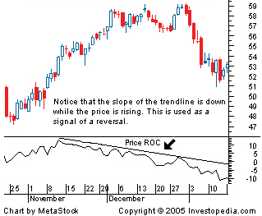

**Formula:**

ROC = [(Most recent closing price - Closing price n periods ago) / Closing price n periods ago](https://www.investopedia.com/terms/r/rateofchange.asp) x 100

**Example:**

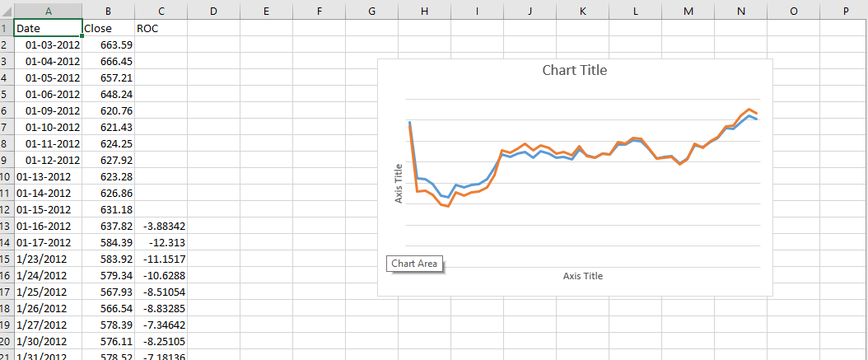

**Use case of Rate of Change Indicator:**

Like most momentum oscillators, the ROC appears on a chart in a separate window below the price chart. The ROC is plotted against a zero line that differentiates positive and negative values. To traders, positive values indicate upward buying pressure or momentum, while negative values below zero indicate selling pressure or downward momentum. Increasing values in either direction, positive or negative, indicate increasing momentum, and decreasing values indicate waning momentum.

The ROC is also sometimes used to indicate overbought or oversold conditions for a security. Positive values that are greater than 30 are generally interpreted as indicating overbought conditions, while negative values lower than negative 30 indicate oversold conditions.

One potential problem with using the ROC indicator is that its calculation gives equal weight to the most recent price and the price from n periods ago, despite the fact that most technical analysts consider more recent price action to be of more importance in determining likely future price movement.

**Python code:**

import pandas as pd

import matplotlib.pyplot as plt

df = pd.read_csv('G:/internship/datasets/RELIANCE.NS.csv')

df = df.iloc[:,3]

#Compute Roc

def ROC(df,n):

N=df['Close'].diff(n)

D=df['Close'].shift(n)

ROC=pd.Series(N/D,name='Rate of Change')

df=df.join(ROC)

return df

#data=web.DataReader('^NSEI',data_source='yahoo',start='1/4/2017',end='6/4/2017')

df=pd.DataFrame(df)

n=5

ROC_RELIANCE=ROC(df,n)

ROC=ROC_RELIANCE['Rate of Change']

print(ROC)

#represent them in chart

fig=plt.figure(figsize=(7,5))

ax=fig.add_subplot(2,1,1)

ax.set_xticklabels([])

plt.plot(df['Close'],lw=1)

plt.title('NSE Price Chart')

plt.ylabel('Close Price')

plt.grid(True)

bx=fig.add_subplot(2,1,2)

plt.plot(ROC,lw=1,label='ROC')

plt.legend(loc=2,prop={'size':9})

plt.ylabel('ROC Values')

plt.grid(True)

plt.setp(plt.gca().get_xticklabels(),rotation=30)

plt.show()

**Graph**

