Stochastic Indicator

## **Stochastic indicator:**

The STOCHASTIC indicator shows us information about momentum and trend strength. As we will see shortly, the indicator analyses price movements and tells us how fast and how strong the price moves.

“Stochastics measures the momentum of price. If you visualize a rocket going up in the air – before it can turn down, it must slow down. Momentum always changes direction before price.” – [George Lane](http://en.wikipedia.org/wiki/George_Lane_%28technical_analyst%29), the developer of the Stochastic indicator

## **Momentum:**

Before we get into using the Stochastic, we should be clear about what momentum actually is.

Investopedia defines momentum as “The rate of acceleration of the price of a security.” via [Investopedia](https://www.tradeciety.com/how-to-use-the-stochastic-indicator/www.investopedia.com/terms/m/momentum.asp)

I am always a fan of going into how an indicator analyzes price and without getting too deep into the mathematics, this is how the indicator analyzes price:

The stochastic indicator analyzes a price range over a specific time period or price candles; typical settings for the Stochastic are 5 or 14 periods/price candles. This means that the Stochastic indicator takes the absolute high and the absolute low of that period and compares it to the closing price. We will see how this works with the following two examples and I have chosen a 5 period Stochastic which means that the Stochastic only looks at the last 5 candlesticks.

##### **Formula:**

Fast %K = 100 SMA ( ( ( Close - Low ) / ( High - Low ) ),Time Period )

Fast %D = SMA ( Fast %K )

Where:

* Close = the current closing price
* Low = the lowest low in the past n periods
* High = the highest high in the past n periods

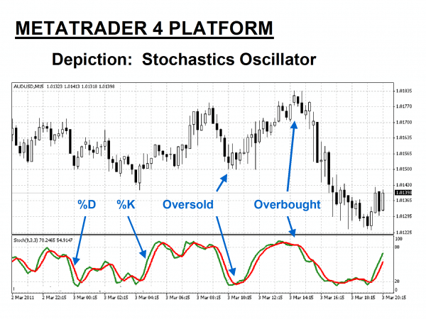

In the example above, the “Green” line is the Stochastics “%K” value, while the “Red” line represents the “%D” signal line that acts like a moving average. Stochastics values below 20 and over 80 are worthy of attention.

Example:

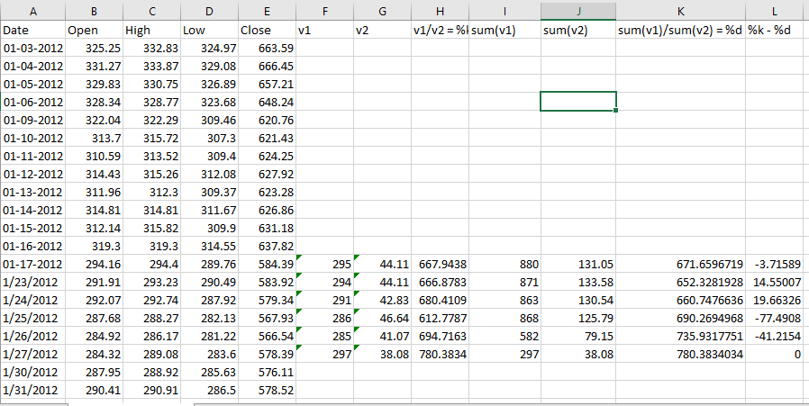

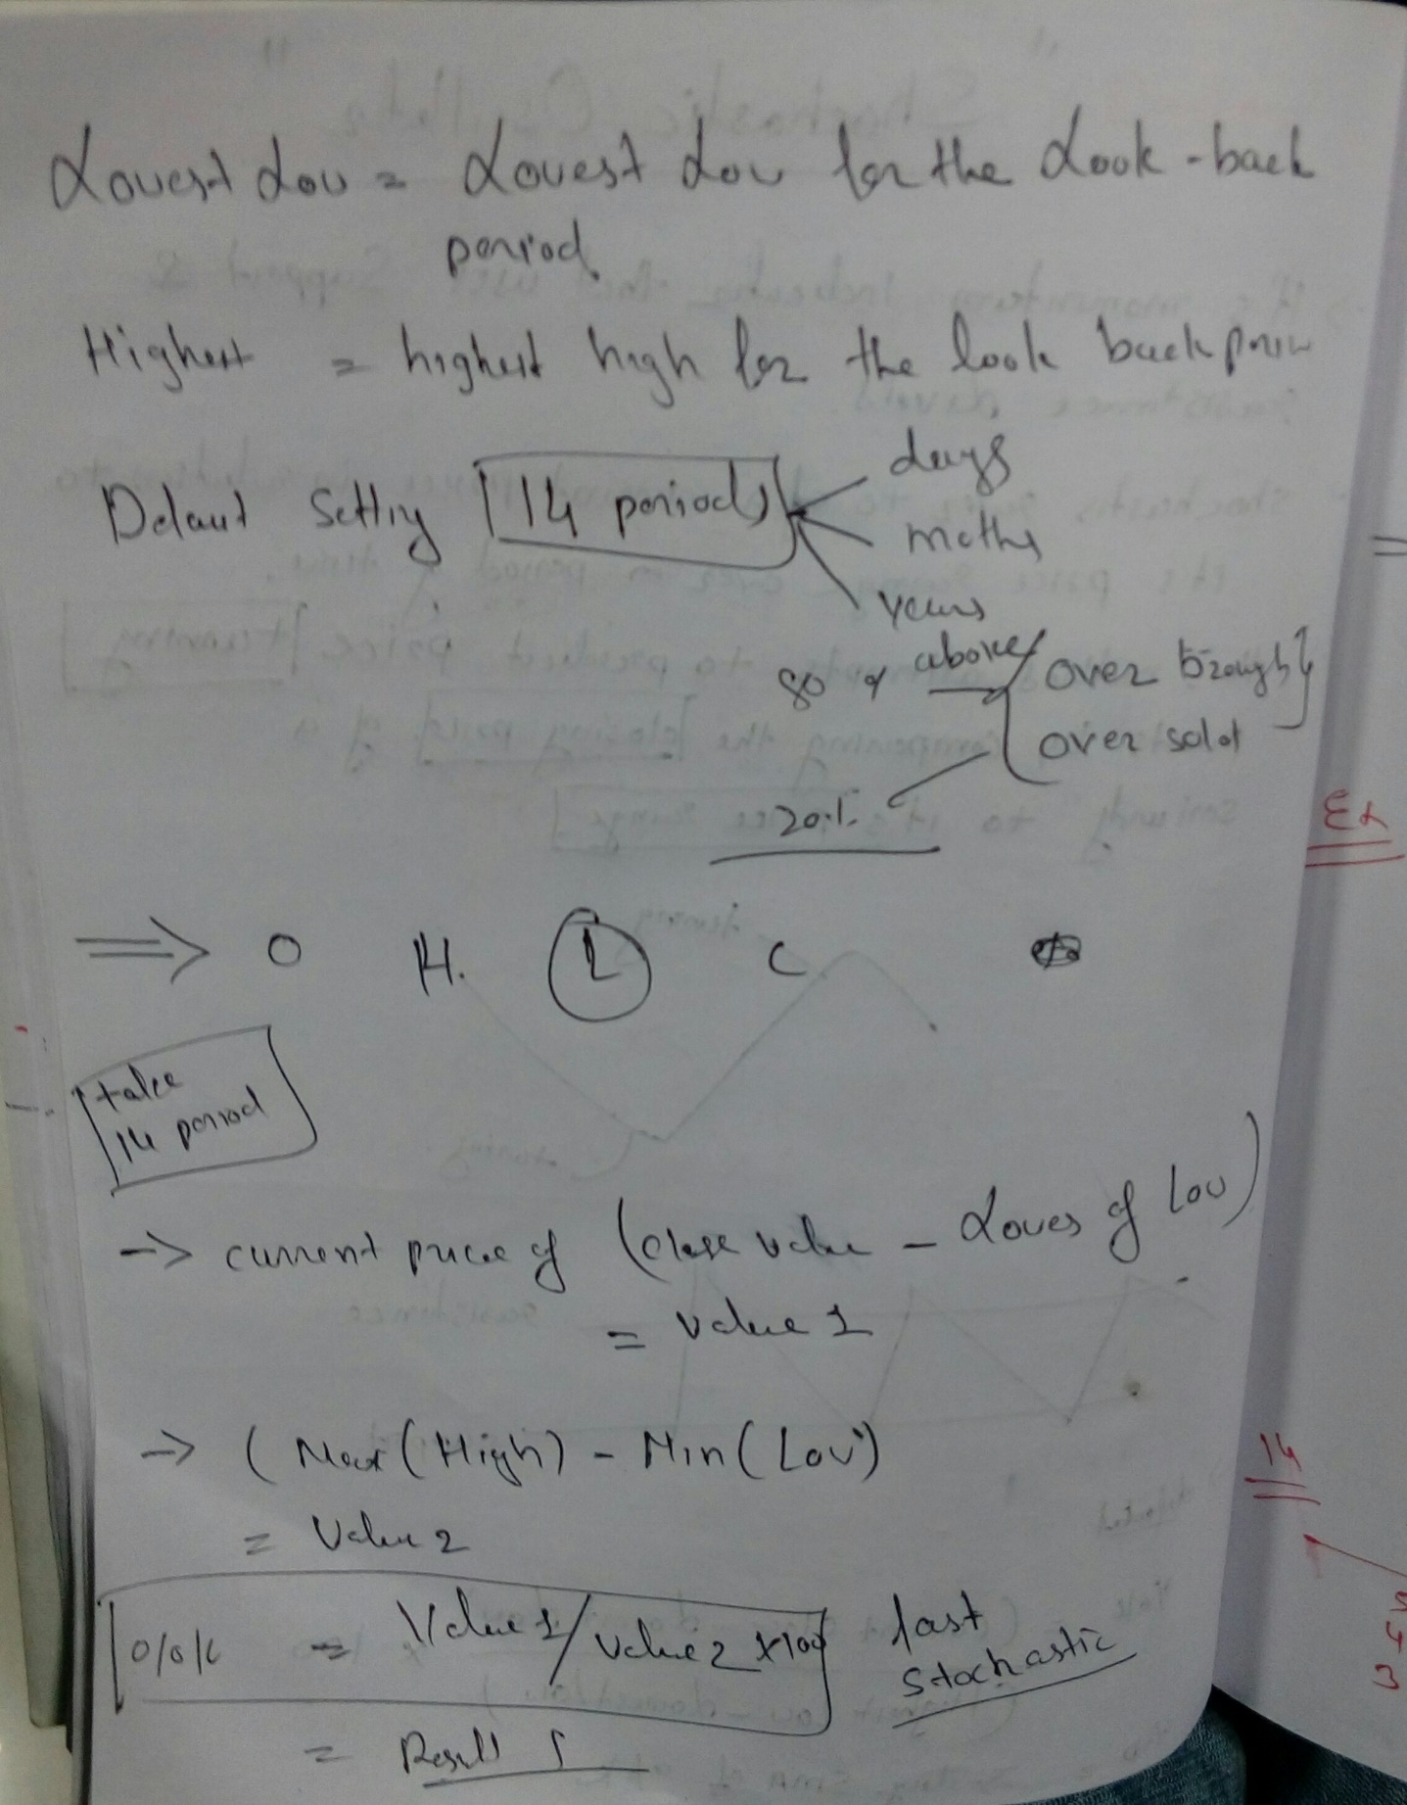

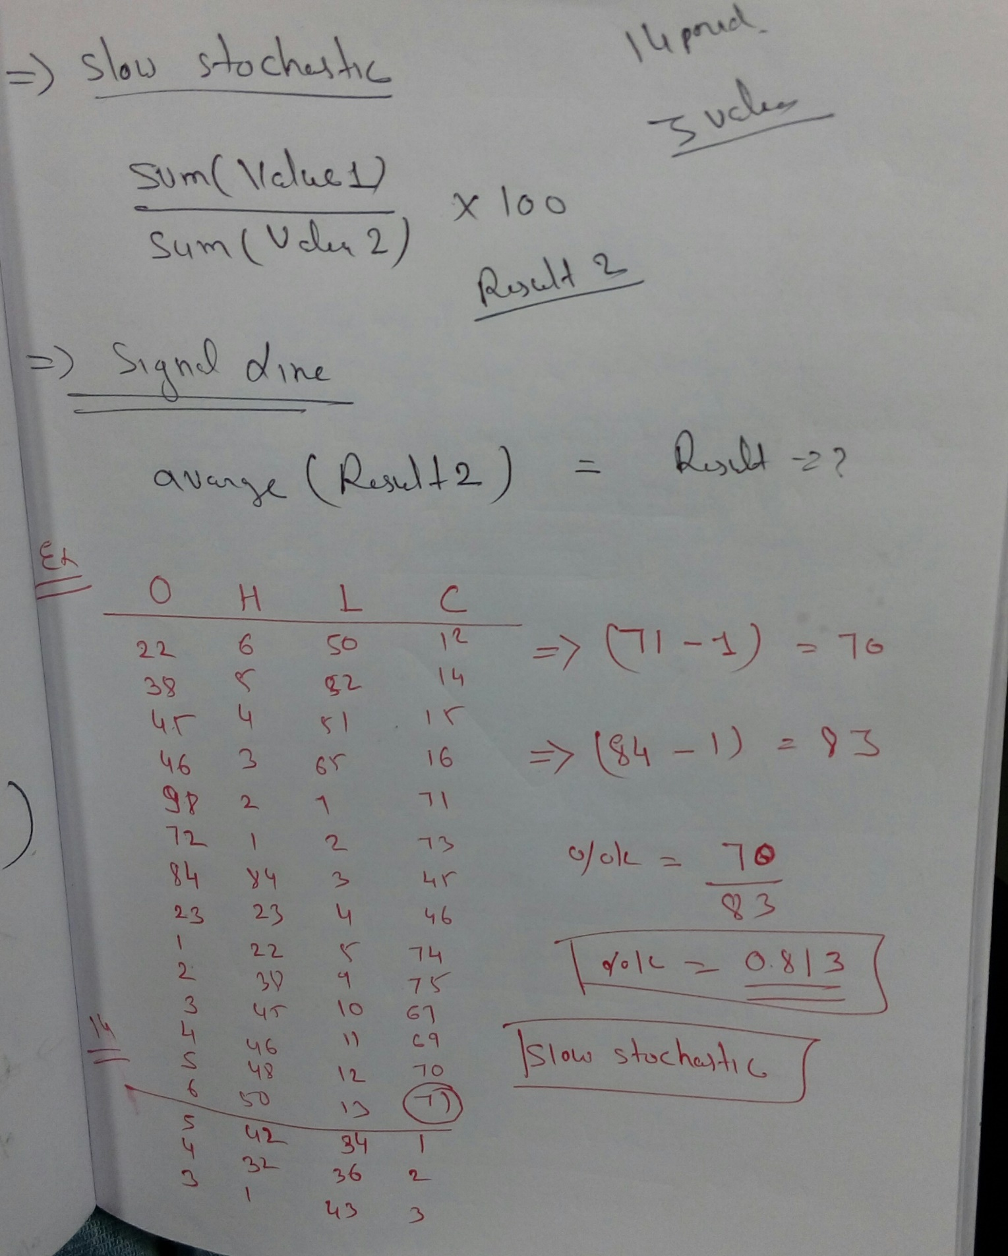

**Applications:**

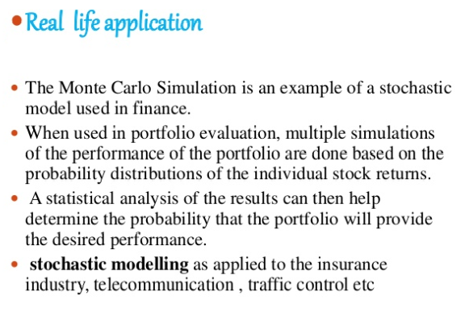

**Python Programming**

#import relevant modules

import pandas as pd

import numpy as np

import matplotlib.pyplot as plt

#download data into DataFrame and create moving averages columns

df = pd.read_csv('G:/internship/datasets/Google_Stock_Price1.csv')

#print out first 5 rows of data DataFrame to check in correct format

df.head()

#Create the "L14" column in the DataFrame

df['L14'] = df['Low'].rolling(window=14).min()

#Create the "H14" column in the DataFrame

df['H14'] = df['High'].rolling(window=14).max()

#Create the "%K" column in the DataFrame

df['%K'] = 100*((df['Close'] - df['L14']) / (df['H14'] - df['L14']) )

#Create the "%D" column in the DataFrame

df['%D'] = df['%K'].rolling(window=3).mean()

fig, axes = plt.subplots(nrows=2, ncols=1,figsize=(7,3.5))

df['Close'].plot(ax=axes[0]); axes[0].set_title('Close')

df[['%K','%D']].plot(ax=axes[1]); axes[1].set_title('Oscillator')

output:

