**In-Class Activity 2**

**Points-40**

**Please follow the following instructions to complete this assignment.**

1. Open Xcode from the launchpad of your mac.
2. Click on create a new Xcode project. Select the iOS template and click on the App application.
3. Click on next which will prompt you to choose options for the project.
4. Provide product name as **Lastname_****BookCheckoutApp**, “**nwmsu**” for organization identifier, “**storyboard**” as interface and swift as language.
5. Click on next and select an appropriate location to save your app and click on create. A project directory will be loaded.
6. From the project navigator click on “Main.storyboard” file, a blank mobile screen will be loaded where the required fields for an app need to be added.
7. Rename the ViewController file to **AvalabilityCheckViewController.**
8. Embed the **AvalabilityCheckViewController** into a navigation controller.
9. For the data please download the **Book.swift** file from the canvas assignment page.
10. Add 2 text fields one takes a username and other text field tasks BookId as input.
11. Add a button and name it as *check Availability* and for the outlet action give name as **checkoutBookAction**.

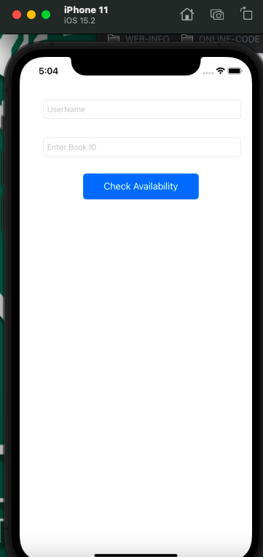

1. Create a label to hold the book found status text.
2. Name the label with appropriate outlet name.
3. Add an image view in the **AvalabilityCheckViewController** and name it appropriately while naming the outlet.
4. Add a new button and change the button text to **checkout Book**.
5. When we click on ***check Availability*** button, if the entered book id is found in the array, update the status label and update the image with the image from the array and show the Checkout Book Button.

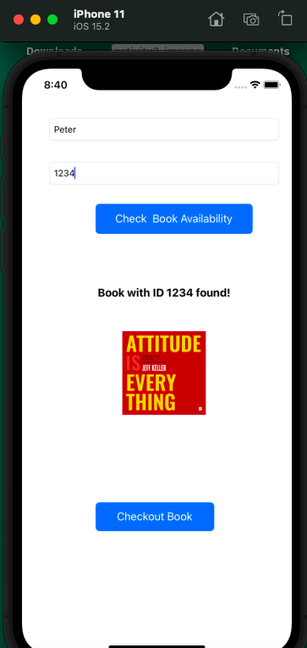

1. If the entered book id is not found in the array then just update the status label to **“Book Not Found!”** and hide image and total available books label.

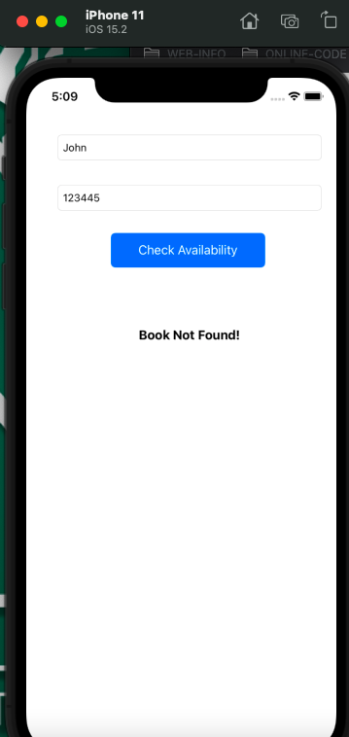

1. Create a new view controller from the library. Create a new cocoa file and name it has **CheckoutConfirmationViewController.** In the main storyboard change the class name of the view controller to CheckoutConfirmationViewController**.**
2. Now create an segue from the **checkoutBook** button to the CheckoutConfirmationViewController and name the segue identifier as **checkoutSegue**.
3. User will be able to navigate to the CheckoutConfirmationViewController if and only if the book id is existing in the array.
4. In the new controller added, add a label to print the success text with username entered in the previous controller and another label to hold the name of the book and an image view to hold the image of the book.
5. Refer **studentApp** for accessing and sending the data using structs.
6. All the information of the checked-out book should be sent through prepare function in the **AvalabilityCheckViewController.**

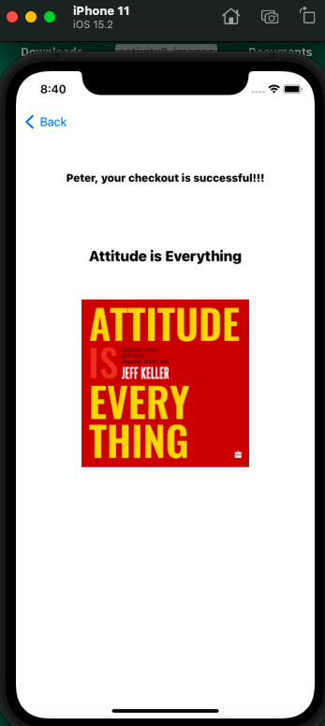

1. When you click on back in the CheckoutConfirmationViewController all the information in the **AvalabilityCheckViewController** should reset. Hint: Clear contents in the prepare function after assigning the details to destination.

**Please submit your app as compressed file, your compressed files should contain Lastname_ BookCheckoutApp folder and Lastname_ BookCheckoutApp.xcodeproj file. Please check your submission by downloading the submitted file and rechecking in Xcode.**