LAB REPORT #4: Intro to Petri Nets 5th Nov 2018

TEAM NAME ……………..……………..

You are asked to answer the questions included in sections Task 1 – Task 4.

**IMPORTANT: FOR ALL NETWORKS REMEMBER TO USE THE SAME SYMBOLS FOR PLACES AND TRANSITIONS AS ON THE LAB REPORT’s FIGURES.**

Generate all possible states, in the format (P0, P1, P2) for the Petri Net shown below. Can this network run infinitely long?

|  |  |
| --- | --- |
|  |  |

Modify the network to the below setting, and again generate all possible states. Explain why these states are different from states generated above (use proper terminology, such as predicates, places, tokens, firing, and transitions). Can this network run infinitely long, and if not what are the end-states?

Note that arcs have numbers on them, and there is a different initial marking.

|  |  |
| --- | --- |
|  |  |

Build a semaphore network with the below initial marking, as shown below. Process 1 is denoted on the left, and process 2 on the right.

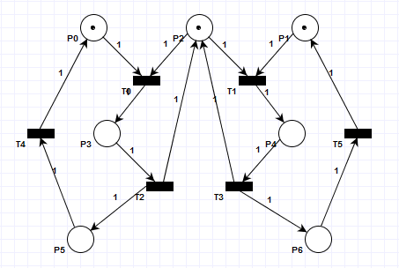

Answer the following questions:

## Enumerate all states of the semaphore in the (P0, P1, P2, P3, P4, P5, P6) format.

Hint: you can use “Analysis Module Manager → Reachability/Coverability Graph” option.

## Which of the states represent a situation when process 1 **OR** process 2 take possession of the shared resource?

## Is it possible to reach state (0, 0, 0, 1, 1, 0, 0)? What does this state represent?

Build a semaphore network for three processes with the below initial marking.

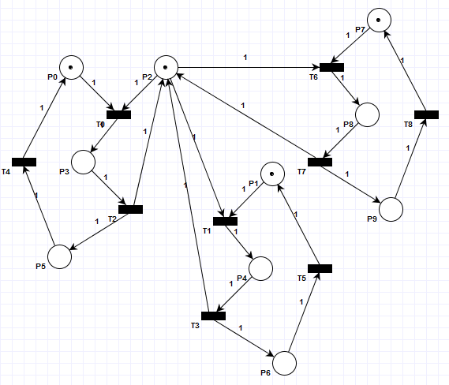

Answer the following questions:

## How many states does this network have?

## Which places are responsible for showing if a given process has access to the shared resource?

## Is it possible that this network will have more than 4 OR less than 3 tokens in any possible state? If yes, then list these states.

## Generate four starvation cycles for this network. Represent the cycles in terms of the firing sequences. Is it possible to have more than 4 starvation cycles for this network?

## Modify the 3 processes semaphore model to the below one, including the initial marking.

Note that some arcs have numbers on them, and there is a different initial marking.

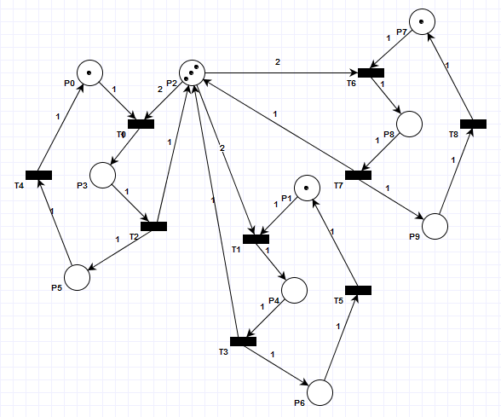

Is it possible that two processes will be able to access the shared resource at the same time in the above model? If yes, then give the state that shows this situation.

Is the number of tokens bounded in this network (is it possible to have a place that may have continuously increasing number of tokens)? If yes, then what is the maximum number of tokens in the network? Also, in this case list all the states in which the maximum number of tokens occurs.   
Use the (P0, P1, P2, P3, P4, P5, P6, P7, P8, P9) format

What is the minimum number of tokens in the above network?

Start by loading and compiling the two semaphores network model created in **TASK 2**. Use the “Analysis module manager” section.

## Perform the state enumeration with initial marking (1, 1, 1, 0, 0, 0, 0), and answer the following questions

### How many reachable states are there for this network and initial marking?

### How many places in this network never receive any tokens, how many receive a single token, and how many receive more than one token?

no tokens:

single token:

more than one token:

### Explain what does it mean that a network is strictly conservative

### Does the network have any deadlocks, is it bounded and safe?

### List all t-invariants of the network.

## Perform the state enumeration with initial marking (2, 0, 2, 0, 0, 0, 0), and answer the following questions.

### Which transitions can be fired in state S2 (1, 0, 2, 0, 0, 1, 0)?

### List all the reachable states in the (P0, P1, P2, P3, P4, P5, P6) format

### How many places in this network never receive any tokens, how many receive a single token, and how many more than one token?

no tokens:

single token:

more than one token: