Test Results:

- Encrytion & Decrytion Test

- Tampered Test

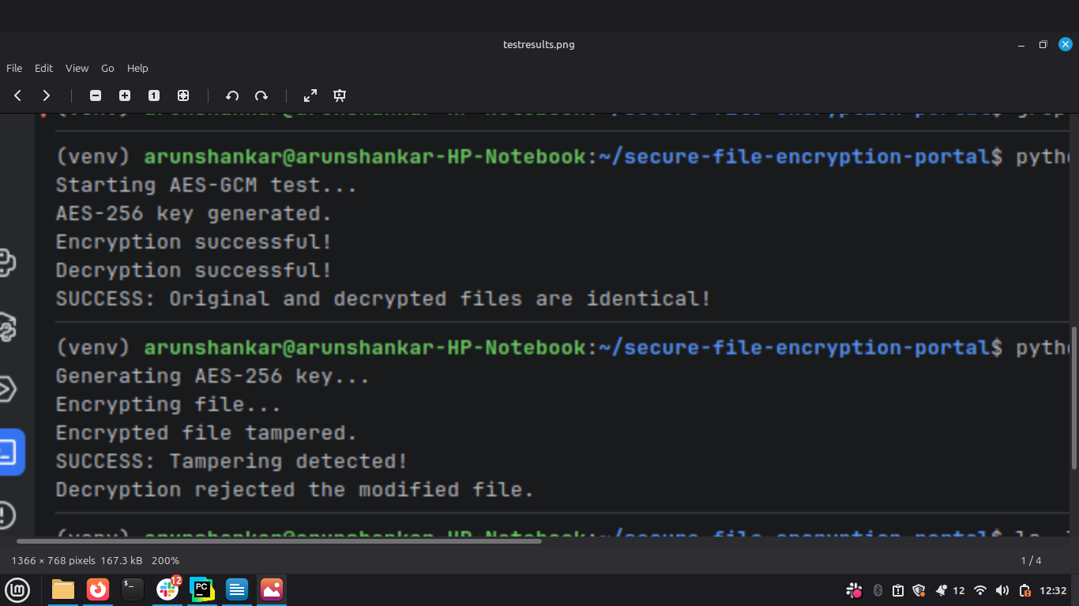
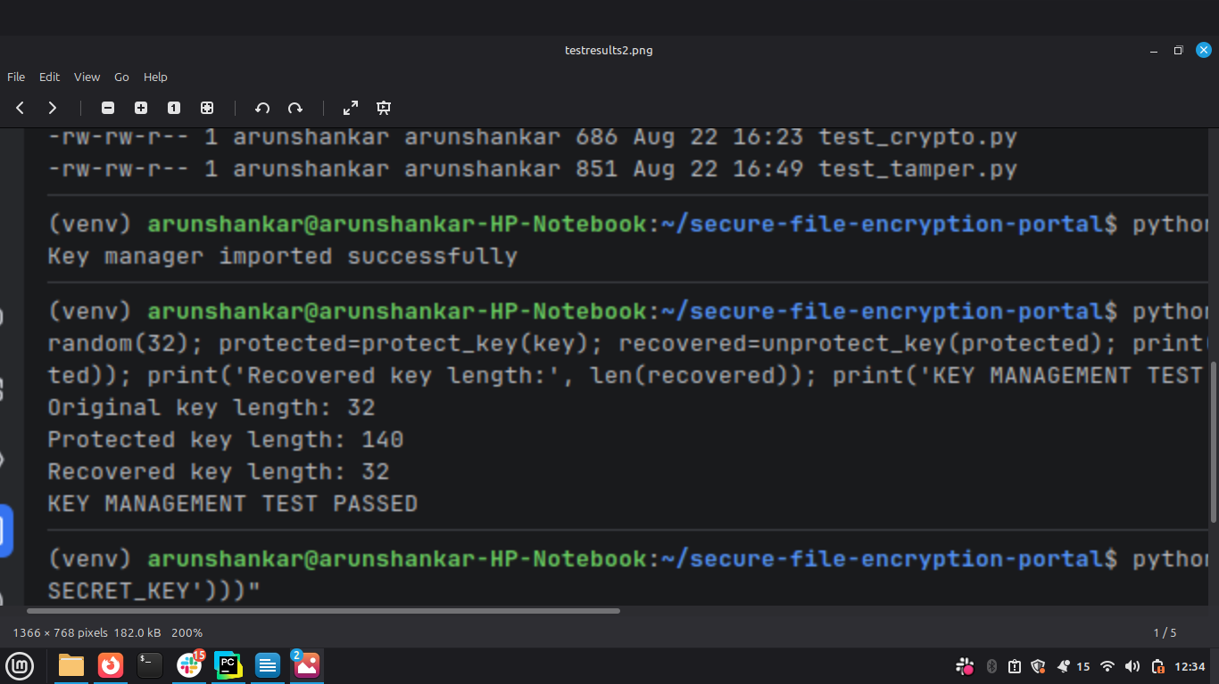
- Key Management Test

