Trader Performance vs. Market Sentiment
An Analysis of Hyperliquid Trading Behavior Against the Bitcoin Fear & Greed Index
Dataset: Historical Trader Data (Hyperliquid) · Bitcoin Market Sentiment Dataset — 2024
211,224 trades · 32 accounts · 246 traded assets · Jan – Dec 2024

Executive Summary
This report examines 211,224 trades from 32 Hyperliquid accounts against daily Bitcoin market sentiment (Fear & Greed Index) for 2024, to identify how sentiment regimes relate to trader performance, risk-taking, and behavior.

Headline Findings
- Win rates are lowest in Extreme Fear (76.2%) and Greed (76.9%), and highest in Extreme Greed (89.2%) and Fear (87.3%) — performance does not move in a straight line with sentiment.
- Risk-adjusted returns (mean PnL / volatility of PnL) are best in Extreme Greed (0.123) and worst in Extreme Fear (0.044) — the same average profit in Fear regimes comes with far more volatility.
- Trading activity spikes sharply in Extreme Fear (1,529 trades/day on average) versus Greed (261/day) — traders are most active exactly when performance is weakest and most volatile.
- Average position size is largest in Fear (US$7,816) and smallest in Extreme Greed (US$3,112), suggesting traders size up during uncertainty rather than during confirmed uptrends.
- Short (Sell) positioning rises steadily from Extreme Fear (48.9%) to Extreme Greed (55.1%), showing a mild but consistent tendency to fade the crowd as greed increases.
- Performance is highly concentrated: the top 5 accounts by cumulative PnL each generated over $800K, while the bottom 5 lost between $31K and $168K — sentiment alone explains only part of the outcome; account-level skill dominates.

1. Methodology
Two datasets were merged on trade date:
- Historical Trader Data (Hyperliquid): 211,224 rows covering account, coin, execution price, size, side, direction, closed PnL, fees, and timestamps.
- Bitcoin Market Sentiment Dataset: daily Fear & Greed Index classification (Extreme Fear, Fear, Neutral, Greed, Extreme Greed), 2018–2025, filtered to the trading window.
Trade timestamps were converted to calendar dates and joined against the daily sentiment label. Only 6 of 211,224 trades (<0.01%) had no matching sentiment date and were excluded. "Closed PnL" rows equal to zero (position-opening entries with no realized profit/loss) were excluded from PnL and win-rate calculations, leaving 104,402 realized trades for performance analysis; all 211,218 matched rows were retained for activity, sizing, and directional analysis.

2. Profitability by Market Sentiment
Realized trade PnL varies meaningfully across sentiment regimes. Extreme Greed and Fear post the highest average and median PnL per trade, while Extreme Fear and Neutral are the weakest.
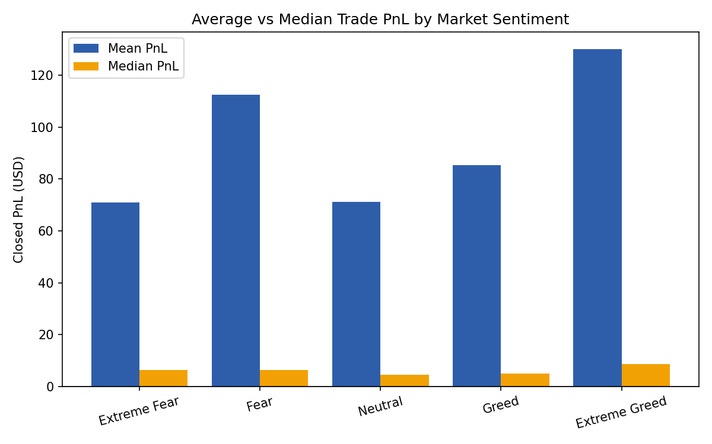
Figure 1 — Mean and median closed PnL per trade by sentiment regime.
Sentiment | Trades | Mean PnL | Median PnL | Total PnL
Extreme Fear | 10,406 | $71.03 | $6.39 | $739,110
Fear | 29,808 | $112.63 | $6.35 | $3,357,155
Neutral | 18,159 | $71.20 | $4.58 | $1,292,921
Greed | 25,176 | $85.40 | $4.93 | $2,150,129
Extreme Greed | 20,853 | $130.21 | $8.53 | $2,715,171

Note the gap between mean and median across all regimes: median PnL is a small fraction of the mean everywhere, meaning a small number of large winning trades pull average profitability up. This is a fat-tailed return distribution, not a case of "typical" trades being highly profitable.

3. Win Rate by Market Sentiment
Win rate tells a different story from raw PnL. Extreme Greed and Fear have the highest share of profitable trades, while Extreme Fear and Greed are weakest.
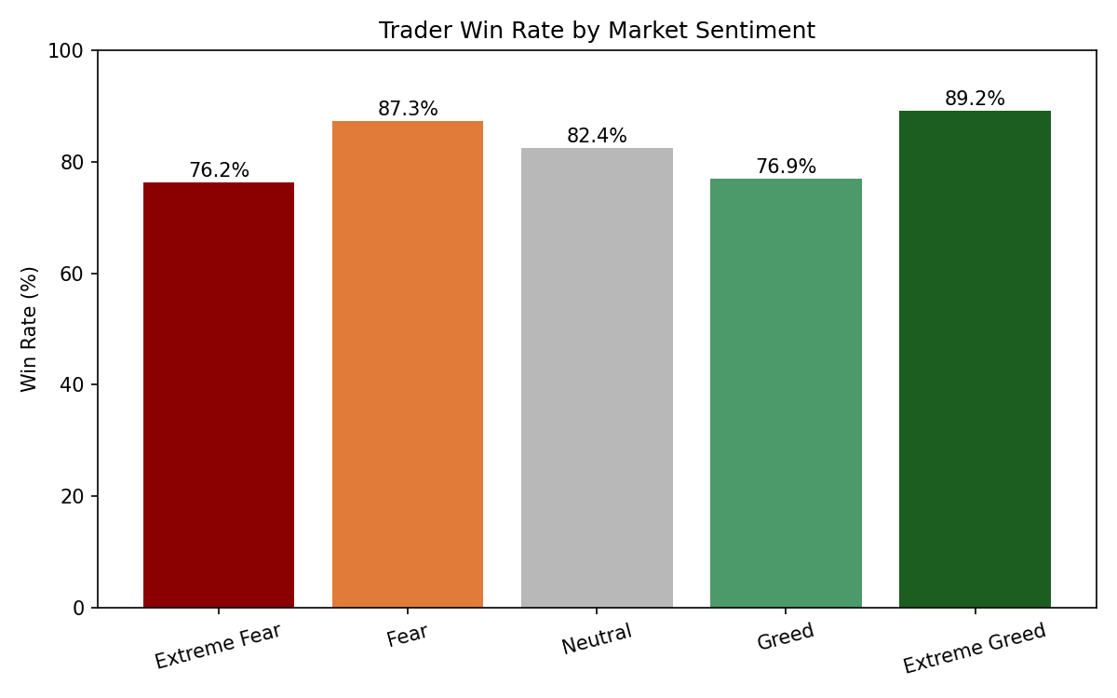
Figure 2 — Share of realized trades closed with positive PnL, by sentiment.
The dip in Greed (76.9%) relative to both its neighbors (Fear 87.3%, Extreme Greed 89.2%) is notable — it suggests "Greed" is a transitional, less predictable regime, whereas the extremes (Extreme Fear, Extreme Greed) produce more decisive, higher-conviction outcomes once a trade is closed.

4. Risk-Adjusted Performance
Average PnL alone overstates how attractive a regime is if it comes with high volatility. Dividing mean PnL by the standard deviation of PnL within each regime gives a simple risk-adjusted view.
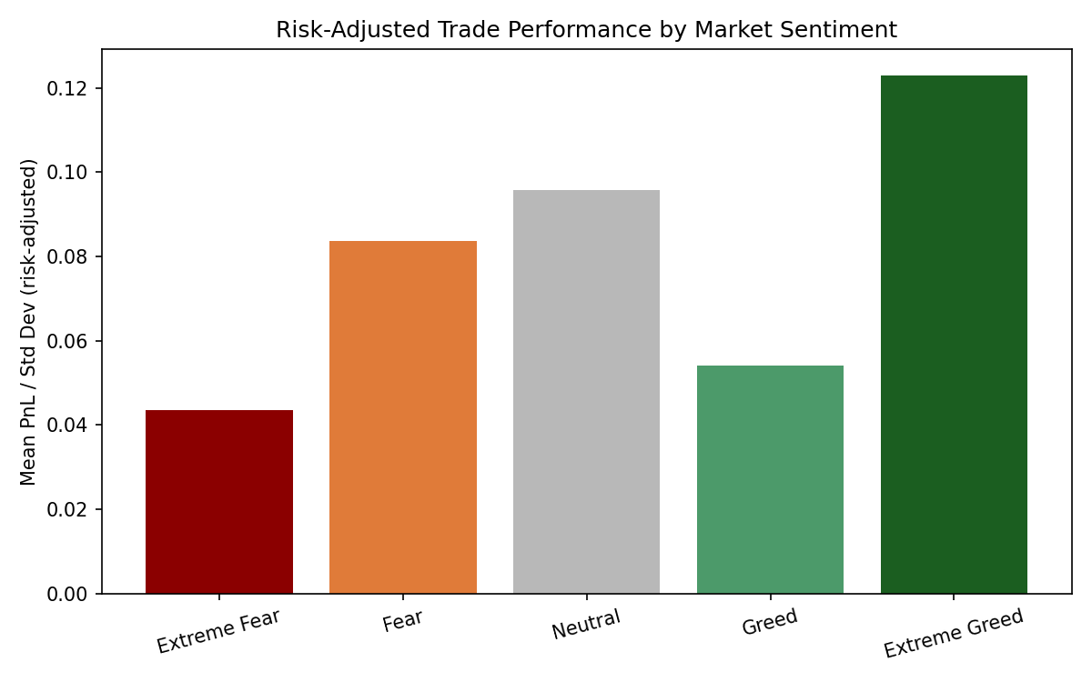
Figure 3 — Risk-adjusted trade performance (mean PnL ÷ PnL volatility) by sentiment.
Extreme Greed offers the best risk-adjusted profile (0.123) — reasonably strong average returns with comparatively contained volatility (std. dev. $1,058). Extreme Fear is the worst on this measure (0.044): its average PnL is unremarkable, yet volatility is the highest of any regime ($1,628), meaning outcomes swing widely trade to trade. Fear looks attractive on raw average PnL alone, but its risk-adjusted score (0.084) is roughly two-thirds of Extreme Greed's, reflecting its own elevated volatility ($1,345).

5. Trading Activity and Position Sizing
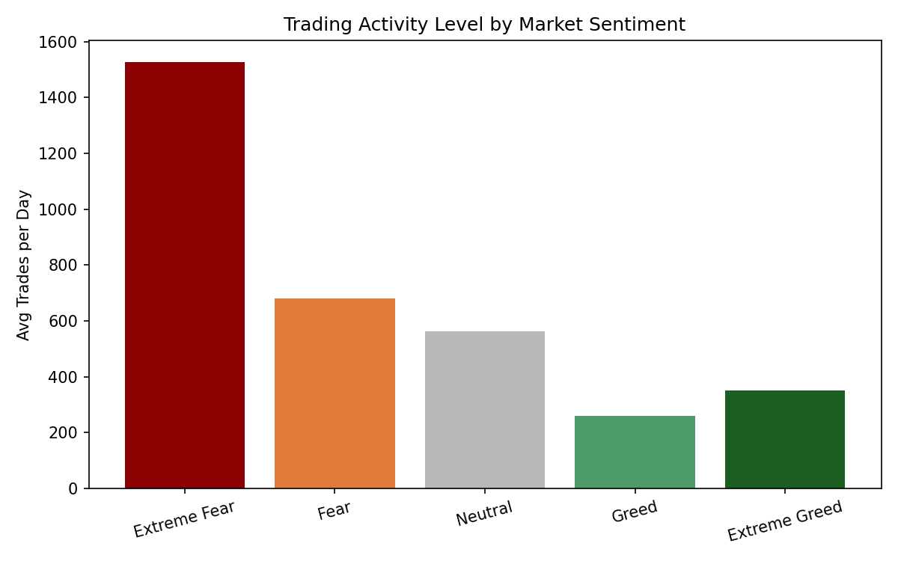
Figure 4 — Average number of trades per day, by sentiment.
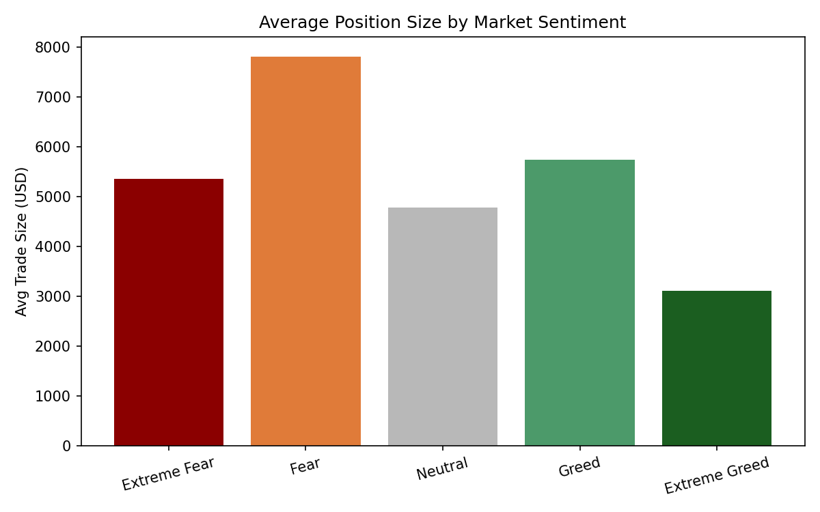
Figure 5 — Average trade size (USD), by sentiment.
Activity is dramatically higher during Extreme Fear (1,529 trades/day on average) than any other regime — roughly 4x Neutral and nearly 6x Greed. Average position sizing is also elevated in Fear ($7,816) and Extreme Fear ($5,350) relative to Extreme Greed ($3,112). Together, these patterns indicate traders in this dataset behave more reactively and take on larger, more frequent positions exactly when the market is most stressed and PnL volatility is highest — a combination that increases exposure to tail risk rather than reducing it.

6. Directional Positioning
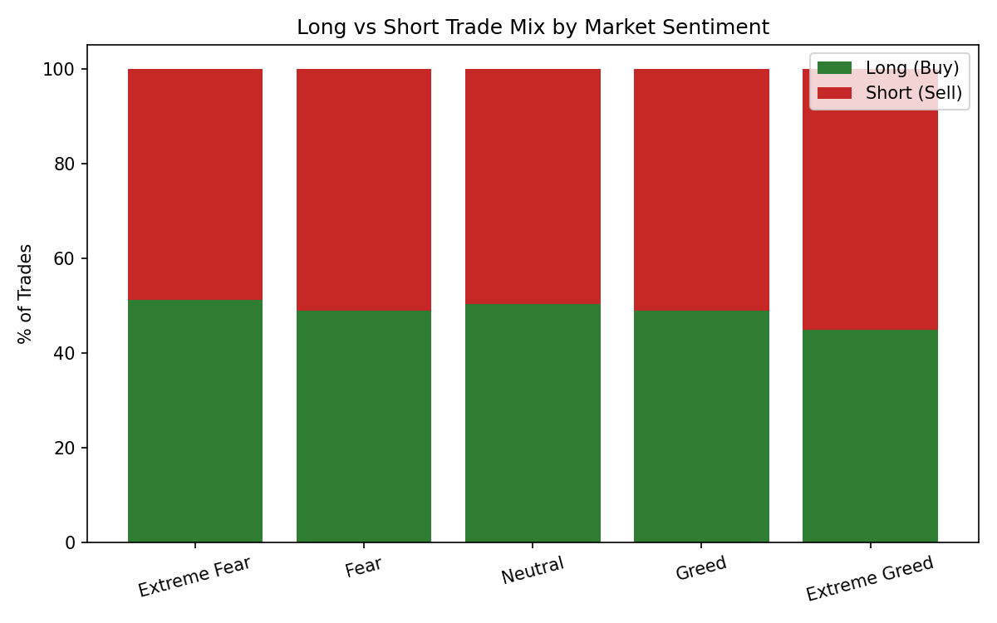
Figure 6 — Long (Buy) vs. short (Sell) trade share, by sentiment.
Short positioning increases steadily as sentiment moves from Extreme Fear (48.9% short) to Extreme Greed (55.1% short). This is a mild contrarian tilt: traders lean progressively more bearish as the crowd gets greedier, and progressively more balanced/bullish as fear peaks. It's a modest effect (roughly a 6-point swing across the full sentiment range), not a dramatic regime flip, but it is directionally consistent and shows up cleanly across all five sentiment buckets.

7. Tail Risk by Sentiment
Looking at the frequency of outsized trades (realized PnL beyond ±$500) sharpens the risk picture:
Sentiment | Large Loss Rate (< -$500) | Large Win Rate (> $500)
Extreme Fear | 2.82% | 3.66%
Fear | 0.51% | 4.19%
Neutral | 0.81% | 3.50%
Greed | 0.93% | 3.73%
Extreme Greed | 0.39% | 4.42%

Extreme Fear stands out sharply: large losses occur more than 5x as often as in any other regime (2.82% of trades vs. 0.39–0.93% elsewhere), while its large-win rate is only middling. Extreme Greed has the best asymmetry — the lowest large-loss rate (0.39%) paired with the highest large-win rate (4.42%). This asymmetry is the clearest single signal in the dataset: Extreme Fear is where tail risk concentrates.

8. Account-Level Concentration
Performance is not evenly distributed across the 32 accounts in the dataset. The top 5 accounts by cumulative realized PnL each generated over $800,000, while the weakest 5 accounts lost between roughly $31,000 and $168,000 over the year.
This matters for interpreting the sentiment findings above: sentiment-level averages are influenced by a small number of high-volume, high-skill accounts. When individual top accounts are examined, their best-performing sentiment regime varies — some peak in Extreme Fear, others in Extreme Greed — indicating that skilled traders adapt strategy to regime rather than following one fixed sentiment-based rule. Sentiment is a useful macro backdrop, but account-level strategy and discipline remain the dominant driver of outcomes.

9. Strategic Recommendations

For risk management
- Reduce position size and/or trade frequency during Extreme Fear. This regime combines the highest trade volume, the largest average position size, the highest PnL volatility, and by far the highest large-loss rate — a stacked set of risk factors.
- Set tighter stop-losses specifically in Extreme Fear and Greed regimes, where win rates dip below 77%, versus Fear/Extreme Greed where win rates exceed 87%.

For opportunity-seeking
- Extreme Greed offers the strongest risk-adjusted profile in this dataset — highest win rate (89.2%), best large-win/large-loss asymmetry, and best risk-adjusted return (0.123). It merits a larger allocation of capital and confidence relative to its trade volume, which is currently the second-lowest of any regime.
- Fear (not Extreme Fear) is the most profitable regime in absolute terms ($112.63 mean PnL/trade) and worth active participation, but position sizing should still respect its above-average volatility.

For strategy design
- Consider a mild contrarian short bias as sentiment moves toward Extreme Greed, consistent with the directional data — but treat this as a secondary signal (a ~6-point shift), not a standalone strategy.
- Because account-level variation outweighs sentiment-level variation, use sentiment as one input among several (position sizing, volatility regime, individual track record) rather than a sole trading signal.

10. Limitations
- Sentiment is measured daily and market-wide (BTC-based); it is applied uniformly to all trades on a given date regardless of the specific asset traded, which may not reflect asset-specific sentiment for smaller altcoins.
- The dataset covers 32 accounts only — findings reflect this specific trader population and may not generalize to the broader market.
- "Closed PnL" rows with value 0 were treated as non-realized entries and excluded from performance metrics; if some genuinely break-even trades were also excluded, win rates could be marginally overstated.
- Correlation between sentiment and performance does not establish causation — skilled traders may simply trade more successfully in certain regimes for reasons unrelated to sentiment itself.

