S.ARUN
Full Stack Developer
Salem,TamilNadu | arunsubramani1607@gmail.com | +919361499299 | [LinkedIn / Portfolio URL]

PROFESSIONAL SUMMARY
Full Stack Software Engineer with 2+ years of experience designing, developing, and deploying scalable web and mobile applications. Experienced in delivering enterprise software solutions across Defence, Manufacturing, Education, and E-commerce domains. Strong expertise in backend architecture, REST APIs, geospatial applications, database design, cloud deployment, and modern application development.
CASE STUDIES
Advanced Geospatial Defence Platform
Technology: Flask, Angular, PostgreSQL, CesiumJS, GeoServer
Challenge:Design and develop a secure, enterprise-scale geospatial platform capable of supporting complex mission planning, real-time spatial analysis, 3D terrain visualization, and offline map operations in restricted network environments.
Solution: Built a full-stack geospatial system integrating 3D terrain rendering, advanced map editing tools, GeoServer services, offline tile caching, region management, and high-performance geospatial APIs.
Results:
- Developed 35+ REST APIs and 8+ geospatial modules.
- Implemented 3D terrain & elevation visualization using CesiumJS.
- Integrated Google Maps, GeoServer, offline maps, and tile caching.
- Built region assignment, map drawing, and multi-layer visualization.
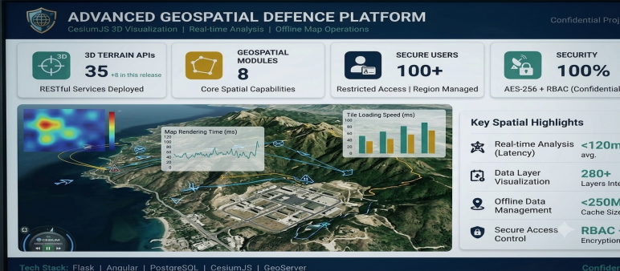

Textile Production Monitoring System
Client: Textile Manufacturing Company
Technology Stack: FastAPI, Flutter , React, SQL Server, PostgreSQL
Challenge:Replace manual production monitoring with a real-time digital platform.
Solution: Developed a production monitoring system with live dashboards, machine analytics, downtime monitoring, shift reports, and WhatsApp alerts.
Results:
- Developed 40+ REST APIs.
- Automated production, efficiency, and downtime reporting.
- Implemented WhatsApp Business API notifications.
- Built real-time dashboards for production monitoring.
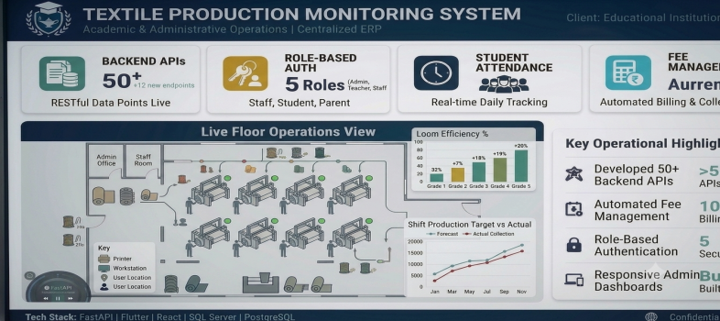
School Management System
Client : Educational Institutions
Technology Stack: FastAPI, Flutter , Nextjs, PostgreSQL
Challenge:Centralize academic and administrative operations.
Solution: Built a complete ERP system for student, staff, attendance, exams, and fee management.
Results:
· Developed 50+ backend APIs.
· Implemented role-based authentication.
· Automated attendance and fee management.
· Built responsive admin dashboards.
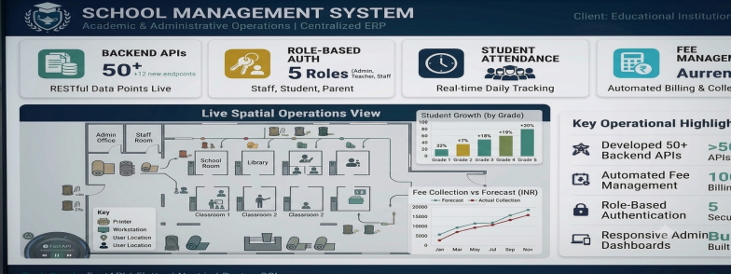
CORE COMPETENCIES
- Full Stack Web & Mobile Application Development
- Backend API Design & Microservices Architecture
- Geospatial & GIS Application Development
- Enterprise Software & ERP System Development
- Database Design & Performance Optimization
- Cloud Deployment & DevOps
- Secure Authentication & Role-Based Access Control (RBAC)
TECHNICAL SKILLS
Languages: Python, JavaScript, TypeScript, SQL
Frontend: React.js, Next.js, Angular 19+, Flutter, HTML5, CSS3, Tailwind CSS
Backend: FastAPI, Flask, Django, REST APIs
Databases: PostgreSQL, MSSQL, SQL Server, SQLite
GIS & Mapping: CesiumJS, GeoServer, Google Maps API, Tile Caching
Tools & Platforms: Git, GitHub, Firebase, Docker, Postman, VS Code, Android Studio
Cloud & Deployment: Render, Vercel, PythonAnywhere, Nginx
WORK EXPERIENCE
XOZO Technology Pvt Ltd — Full Stack Software Engineer/2026 – Present

- Led a team of 3 developers in the successful delivery of multiple enterprise software projects.
- Independently architected and delivered 4+ production-ready applications across multiple industries.
- Designed and implemented 120+ REST APIs, improving system scalability and maintainability.
- Worked directly with clients to gather requirements, estimate timelines, and deliver high-quality solutions.
- Mentored junior developers through code reviews, technical guidance, and task planning.

TNL Technologies Private Limited — Full Stack Developer /2025

- Delivered multiple business applications by collaborating with clients to understand and implement project requirements.
- Designed scalable backend services and business workflows to improve operational efficiency.
- Built secure authentication, reporting, and data management modules for enterprise applications.
- Contributed to the successful delivery of projects while ensuring code quality and timely releases.

Big Bang Boom Solutions Pvt. Ltd. — Software Developer / 2024

- Contributed to the development of secure defence software solutions, including geospatial and mapping-based applications.
- Implemented backend modules and supported feature development for enterprise systems.
- Participated in testing, debugging, deployment, and maintenance of mission-critical applications.
- Worked closely with senior engineers to deliver reliable software in a collaborative development environment.

EDUCATIONAL QUALIFICATION
Qualification | Institution | Year
B.E. – Electrical and Electronics Engineering | Dhirajlal Gandhi College of Technology | 2023
Higher Secondary Certificate (HSC) | Wisdom Gates Higher Secondary School | 2019

PERSONAL PROFILE
Date of Birth: 16-07-2001
Nationality:Indian
Languages Known:Tamil (Native), English (Professional), Hindi (Intermediate)

