**Abstract:**

Predicting the amount of daily rainfall improves agricultural productivity and secures food and water supply to keep citizens healthy. To predict rainfall, several types of research have been conducted using data mining and machine learning techniques of India’s environmental datasets. An erratic rainfall distribution in the country affects the agriculture on which the economy of the country depends on. Wise use of rainfall water should be planned and practiced in the country to minimize the problem of the drought and flood occurred in the country. The main objective of this study is to identify the relevant atmospheric features that cause rainfall and predict the rainfall using machine learning techniques. The dataset was collected from the internet to measure the performance of machine learning technique.

**Introduction:**

Rainfall prediction is crucial for increasing agricultural productivity which in turn secures food and quality water supply for citizens of one country. The scarcity of rainfall has a negative influence on the aquatic ecosystem, quality water supply, and agricultural productivity. Agriculture and water quality depend on the rainfall and water amount on a daily, monthly and annual basis. Therefore, accurate prediction of daily rainfall is a challenging task to manage the rainfall water for agriculture and water supply. Various researchers conducted studies to improve the prediction of daily, monthly and annual rainfall amounts using different countries' meteorological data. The machine learning algorithms are proved to be better replacing the traditional deterministic method to predict the rainfall. Consequently, this case study analyse the rainfall using machine learning algorithm.

**Objectives:**

The primary objective of this rainfall prediction case study is to leverage machine learning models to enhance the rainfall predictions. Traditional meteorological methods often face challenges in capturing the complex patterns and interactions influencing rainfall. Therefore, the specific goals of this study are as follows :

**To Improve Prediction Accuracy:** Evaluate the performance of the machine learning models in comparison to traditional methods and aim to achieve higher accuracy in predicting rainfall events.

**Contribute to Decision-Making:** Provide insights that can contribute to informed decision-making in sectors heavily influenced by rainfall condition.

**Methodology:**

**Data preparation:**

For this study, the raw data were collected from the India’s metrological department site. The data features such as year, month, date, subdivision and rainfall were included. The raw data recorded for 115 years (1901–2015) were used for the study.

**Loading and Previewing the Dataset:** Using **Pandas**, For load a dataset **(Rainfall.csv)** that containing information.

**Summary Statistics:** Calculate summary statistics for numerical features like mean, median, and standard deviation.

**Data Visualization:** Utilizing **Matplotlib.Pyplot** to create plots for features and visualize diagrams for rainfall prediction analysis.

**Train-Test Split:** Using **Sklearn.Model_Selection** to split the dataset into training and testing sets, ensuring a robust evaluation of the model.

**Linear Regression Model:** **Utilize Sklearn.Linear_Model** to train a linear regression model to predict rainfall intensity.

**Results:**

TOTAL SUBDIVISION IS 36

* Arunachal Pradesh : 3418.857143
* Coastal Karnataka :3408.409649
* Konkan & goa :2977.686087

The above subdivisions are having highest rainfall ratios.

* Haryana Delhi & Chandigarh : 530.496522
* Saurashtra & Kutch : 495.161739
* West Rajasthan : 292.673043

The above subdivisions are having lowest rainfall ratios.

* Max : 61815.6 occurred in [1961]
* Mean : 50182.83826086956
* Overall MAD (Training) : 86.26988104217529
* Overall MAD (Testing) : 86.92516041017902

The given diagrams represent the outcome of the case study:

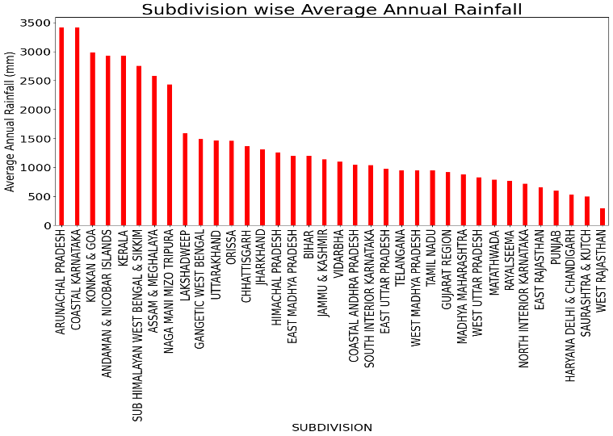

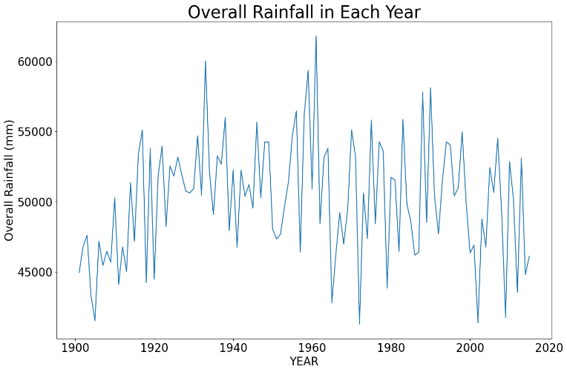

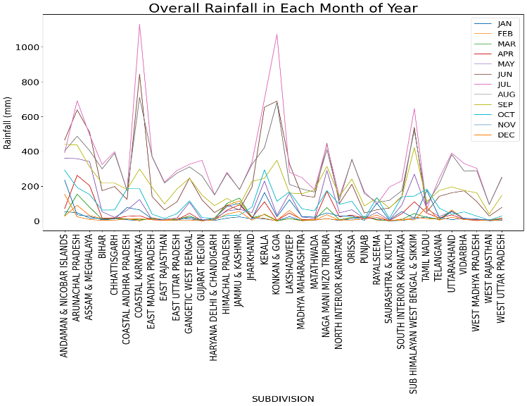

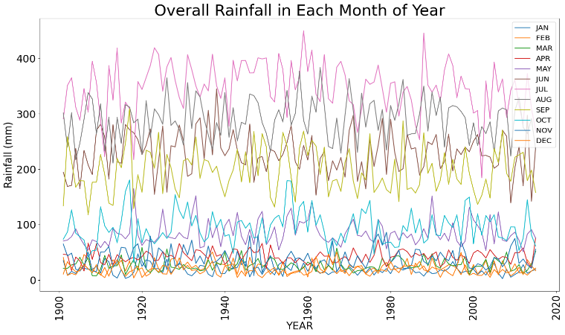

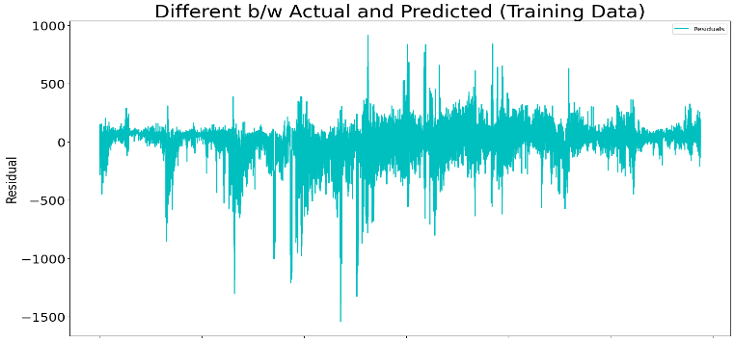

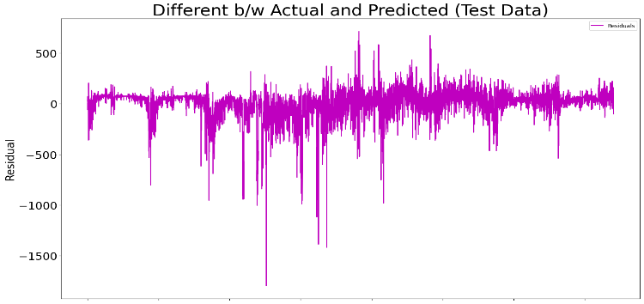

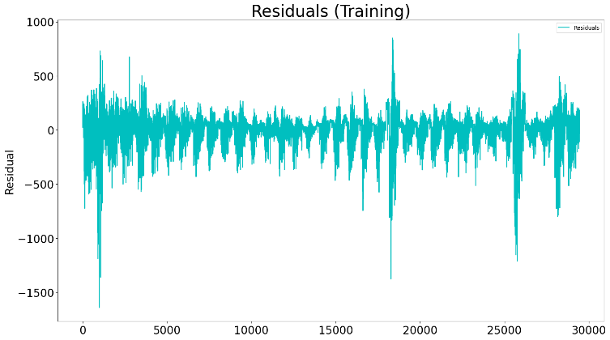

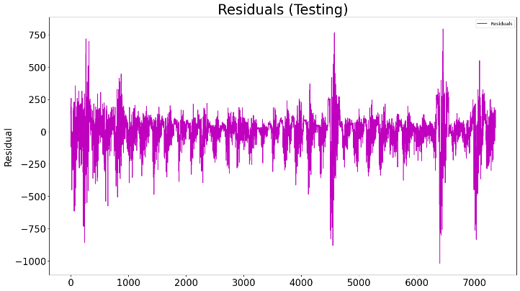

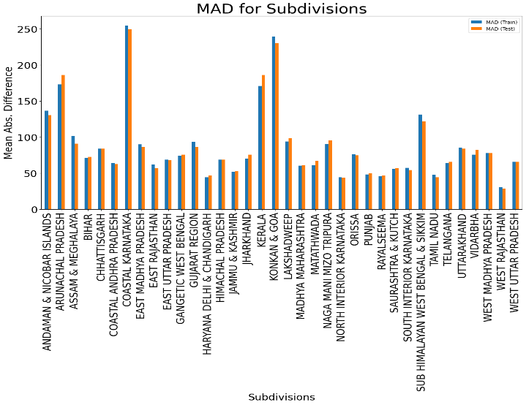

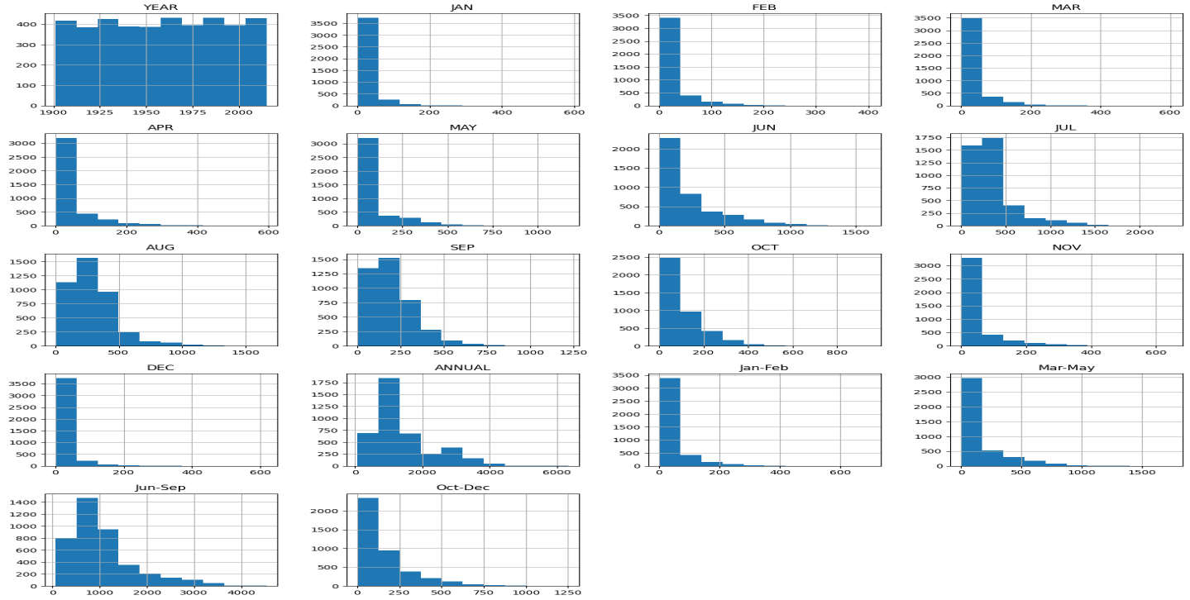

**Conclusion:**

In conclusion, this rainfall prediction case study has provided valuable insights into the application of machine learning model for improving the accuracy of rainfall forecasts. The key findings and outcomes of the study can be summarized. And it helps to get:

* **Improved Prediction Accuracy:** The Linear regression model successfully captured and it intricate patterns in meteorological data, leading to more precise rainfall predictions.
* **Decision-Making Support:** The insights gained from this study have direct implications for decision-making in sectors heavily reliant on rainfall predictions.

**References:**

Parmar, Aakash, Kinjal Mistree, and Mithila Sompura. "Machine learning techniques for rainfall prediction: A review." 2017 International Conference on Innovations in information Embedded and Communication Systems. 2017.

**Websites:**

* [Ministry of Electronics & Information Technology](https://www.meity.gov.in), Government of India.
* India Meteorological Department Ministry of Earth Sciences, New Delhi, India