
Bastion Setup
Apache Guacamole
Version – 1.0

Table of Contents
1. Document Control Page 3
2. Introduction 4
3. Purpose 4
4. Prerequisites 5
5. Service Decomposition 6
6. Deployment and Configuration 8
6.1. Installation of Docker 8
6.2. Installation of Docker Compose 10
6.3. Setting up Apache Guacamole and its configurations 11
6.4. Creating Docker Compose file 11
6.5. Configuring Guacamole 14
6.6. Configuring Nginx 17
6.7. Creating PostgreSQL folder 18
6.8. Creating Docker Secrets 19
6.9. File Structure of Guacamole 20
7. Starting Docker-Compose: 21
8. Setting up Guacamole Database 24
8.1. Creating the Guacamole database 24
8.2. Granting Guacamole access to the database 25
9. Using Apache Guacamole 26
9.1. Creating New Connection 27
9.2. Launching the New connection 29
10. Database Backup and Restoring 30
10.1. Backup Database 30
10.2. Restoring database 32
11. Monitoring and Logging 33
11.1. Docker Container logs 34
12. Access Control 36
13. Security Considerations 37
14. Maintenance 37
15. Upgrades 37
16. Troubleshooting 38
17. Appendices 39
18. Glossary and Terms 40
19. Conclusion 42

Document Control Page
: -
Bastion Setup:
Version | Release Date | Author | Changes
1.0 |  | Arun Karthick Venkatesan

Effective Date | 10 – August – 2023
Reviewed By
Approval Date
Approved By

Introduction
:
In an era where remote access to critical systems and resources has become paramount, implementing a secure and efficient method for managing these servers as a comprehensive resource for operations engineers and administrators to seamlessly establish a robust Bastion setup utilizing Apache Guacamole.
Apache Guacamole is an open-source, cross-platform, clientless remote desktop gateway. Users can use a web browser to operate distant computers or virtual machines, and administrators can govern who can connect and how using an extensible authentication and permission framework. It supports protocols like VNC, RDP, SSH, and SFTP.

Source: The Apache Software Foundation!
Figure 1 Apache Guacamole logo
The comprehensive guide for setting up and configuring a Bastion host using Apache Guacamole in Docker as Container. Guacamole can be deployed using Docker, removing the need to build guacamole-server from source or configure the web application manually. The Guacamole project provides officially supported Docker images for both Guacamole and guacd which are kept up-to-date with each release.

Purpose
:
The Primary objective of this documentation is to provide a clear and structured guide to setup a Bastion host using the powerful capabilities of Apache Guacamole. A Bastion host, often referred to as a jump host, acts as a gateway between external users and internal users and internal resources, offering a controlled and secure pathway for remote access. Apache Guacamole adds a layer of convenience by offering a web – based interface that simplifies access to remote systems, reducing complexity and enhancing productivity.
Among the chief benefits of Apache Guacamole is its ability to run fully within a web browser, requiring no plugins or client software. This translates into easy installation and ease of use. It boosts work-from-anywhere initiatives by ensuring secure and seamless remote access to business resources. Its multi-protocol support caters to a wide range of industry needs, while its high customizability ensures that it can meet various distinct business demands.
Apache Guacamole is completely free to use and distribute, easy to use due to its clientless nature, allowing access through any web browser, particularly the seamless remote access it offers and its compatibility with multiple protocols like SSH, RDP, and VNC. There are no associated license costs. However, businesses may incur costs in case they opt for additional services such as custom development, consultancy, or third-party integrations.

Prerequisites
:
Before embarking on the setup process, it’s essential to ensure that we have all the necessary components and requirements in place. This documentation will guide you through the setting up and configuration of Apache Guacamole as docker container, outlining the steps needed to create a secure and efficient Bastion setup. Make sure to review the prerequisites section carefully to ensure a smooth implementation.
The following are the things needed to setup Apache Guacamole as Docker container:
- VM Machine
In this case we are using machine with Ubuntu 22.04 LTS 64-bit Operating System.
- Docker
Docker software is an open-source tool that deploys applications inside virtual containers. Containers package all the dependencies and code your app needs to run into a single file, which will run the same way on any machine. This allows for fast, consistent, portable, and scalable delivery of your applications. You can also use Docker to safely try out new software without installing them on your system.
The Docker deployment of Apache Guacamole will involve four separate containers (docker images), linked together at creation time:
guacamole/guacd – backend
It is the Heart of Guacamole which provides the guacd daemon, built from the released guacamole-server source with support for VNC, RDP, SSH, telnet, and Kubernetes.
guacamole/guacamole – frontend
The Guacamole web application is where the user interacts. It is running within Tomcat 8 with support for WebSocket. The configuration necessary to connect to guacd and PostgreSQL will be generated automatically when the image starts based on Docker links or environment variables.
PostgreSQL – database
The database that Guacamole will use for authentication and storage of connection configuration data.
Nginx – reverse proxy
Nginx can be used as a reverse proxy and supports WebSocket out-of-the-box. Both Apache and Nginx require some additional configuration for proxying of WebSocket to work properly
This separation is important, as it facilitates upgrades and maintains proper separation of concerns. With the database separate from Guacamole and guacd, those containers can be freely destroyed and recreated at will. The only container which must persist data through upgrades is the database.

Service Decomposition
:
Service decomposition involves breaking down a complex application into smaller, manageable components known as containers. Containers are isolated environments that package an application along with its dependencies and configuration. These containers interact with each other through well-defined relationships and wiring mechanisms.
This approach provides several benefits, including scalability, portability, and ease of deployment. Containers communicate via APIs, network protocols, or shared data volumes, forming the foundation of a microservices architecture.
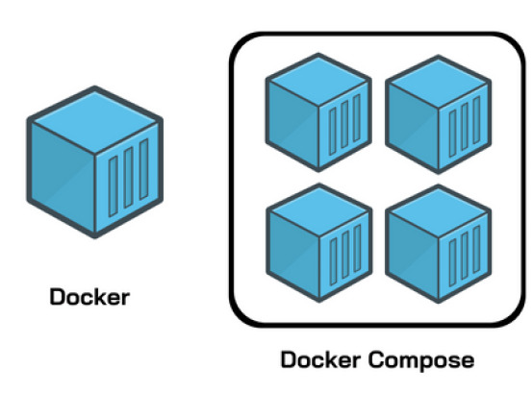
Source: Knoldus Blogs
Figure 2 Docker and Docker Compose
- Docker Compose
Docker Compose is a powerful tool designed to simplify the deployment and management of multi-container applications. It allows you to define and orchestrate complex applications consisting of multiple interconnected services within a single configuration file.
The YAML Configuration
This configuration is written in YAML format and is typically named docker-compose.yml. With Docker Compose, you can specify various aspects of your application, such as the Docker images to be used for each service, environment variables, network configurations, volume mounts, port mappings, and dependencies between services (these parameters are explained below in docker-compose file). This declarative approach enables you to define the desired state of your application's infrastructure, making it easy to replicate the same environment across different development, testing, and production stages.
The docker-compose.yml file starts by defining a version, indicating the format and features supported by Docker Compose. Under the services section, you list each individual service as a separate entry. Each service is defined by an image (the base Docker image to use), a custom container_name, environment variables defined using environment, volumes to be mounted using volumes, port mappings with ports, and dependencies using depends_on. You can create custom networks using the networks section to control communication between services. The links parameter, although now largely replaced by depends_on, used to enable networking between containers. Furthermore, Docker Compose supports the use of secrets to securely manage sensitive information like passwords and API keys. These secrets can be stored externally and injected into the appropriate services, maintaining security while enabling easy configuration changes.
Once the docker-compose.yml file is defined, you can use the docker-compose command-line tool to manage your application. You can create and start all the defined services with a single command, and Docker Compose handles the orchestration of containers, networking, and volumes. This greatly simplifies the deployment process, making it easier to maintain consistency between development, testing, and production environments. In essence, Docker Compose streamlines the process of setting up and running complex applications composed of multiple containers, reducing the complexity of Docker container orchestration while providing a clear and unified configuration approach.
Let’s see an example of docker-compose with a Simple Web application that uses a database:
version: '3.9'
services:
web:
image: nginx:latest
container_name: web_service
ports:
- "80:80"
database:
image: postgres:latest
environment:
- POSTGRESQL_DB: my_own_database
- POSTGRESQL_USER: my_username
- POSTGRESQL_PASSWORD: my_password
On the above example we have defined Nginx for web service and PostgreSQL for Database. The web service uses the Nginx image and maps port 80 of the host to port 80 of the container. The database service uses the PostgreSQL image and sets environment variables for the database name, user, and password.
In the following sections, we’ll delve into the process of creating docker-compose, configuration details, access control strategies, security considerations, and more.

Deployment and Configuration
:
We need to install Docker, Docker-Compose plugin and related dependencies then proceed with creating docker-compose.yml file. If these packages are installed already you can skip this part and proceed with creating docker-compose file and configurations.

Installation of Docker
:
First, start by updating the packages to the latest version available.
sudo apt update
sudo apt upgrade
Install some packages which allows you to use the packages over HTTPS.
sudo apt install apt-transport-https ca-certificates curl software-properties-common
Add the GPG key of Docker repository.
curl -fsSL https://download.docker.com/linux/ubuntu/gpg | sudo gpg --dearmor -o /usr/share/keyrings/docker-archive-keyring.gpg
Now add the Docker repository of Ubuntu 22.04 (jammy) to the apt sources.
echo "deb [arch=$(dpkg --print-architecture) signed-by=/usr/share/keyrings/docker-archive-keyring.gpg] https://download.docker.com/linux/ubuntu $(lsb_release -cs) stable" | sudo tee /etc/apt/sources.list.d/docker.list > /dev/null
Update the packages index and setup your server to install Docker from official Docker repo.
sudo apt update
sudo apt-cache policy docker-ce
You will receive an output similar to the below content.
Output
docker-ce:
Installed: (none)
Candidate: 5:20.10.14~3-0~ubuntu-jammy
Version table:
5:20.10.14~3-0~ubuntu-jammy 500
500 https://download.docker.com/linux/ubuntu jammy/stable amd64 Packages
5:20.10.13~3-0~ubuntu-jammy 500
500 https://download.docker.com/linux/ubuntu jammy/stable amd64 Packages
Finally, install Docker.
sudo apt install docker-ce docker-ce-cli containerd.io
Once Docker is installed and the process is enabled to start on boot.
systemctl start docker
systemctl enable docker
To check the status of Docker you can use the following command.
sudo systemctl status docker
The output will be like this.
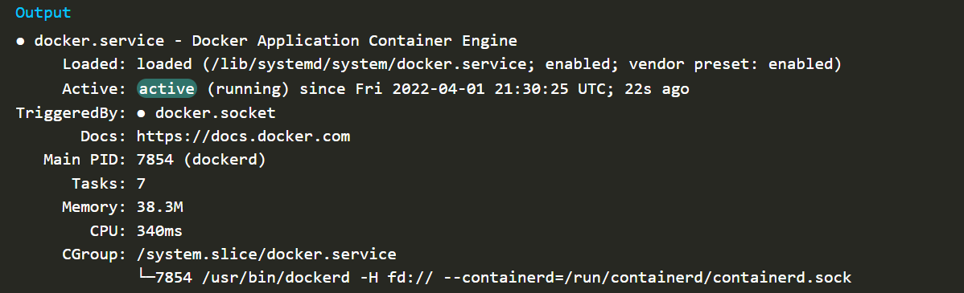
Screenshot 1: Docker Status
Configure Sudo permissions for Docker (optional)
The docker command can only be executed as root user by default. If you need to run the docker command without sudo, you need to add your username to the docker group.
sudo usermod -aG docker username
Now restart your terminal to see the changes. From now the user can access the docker command without sudo.
Using Docker Commands
To view the system information about Docker.
docker info
Download hello-world Image to check whether you can download and access the docker images.
docker run hello-world
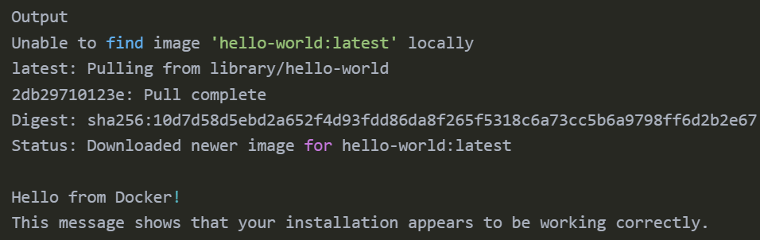
Screenshot 2: Output of hello-world docker image
This message shows that your installation appears to be working correctly. So, then you can access and download images from Docker Hub.

Installation of Docker Compose
:
After the successful installation of Docker, move on to install Docker Compose. We will create a directory with the help of the following “mkdir” command:
mkdir -p ~/.docker/cli-plugins/
After doing so, utilize the below-given “curl” command for installing Docker Compose on Ubuntu 22.04:
curl -SL https://github.com/docker/compose/releases/download/v2.5.0/docker-compose-linux-x86_64 -o ~/.docker/cli-plugins/docker-compose
In the next step, set the executable permissions to the “docker-compose” command:
chmod +x ~/.docker/cli-plugins/docker-compose
Then, verify the version of the installed Docker Compose:
docker compose version

#output:
Docker Compose version v2.20.2
Finally, on our Ubuntu 22.04 system, we have installed Docker Compose version “2.20.2”
You can also run Docker-compose’s Simple Web application example to check whether Docker Compose is working or not.

Setting up Apache Guacamole and its configurations
:
Let’s proceed with creating Docker-Compose file, configurations, and database extensions for Apache Guacamole.

Creating Docker Compose file
:
Let us create a folder for keeping the Guacamole related files together. The user can create the folder in their desired path.
mkdir /home/user/docker/ #folder for guacamole
In this folder, we are going to store docker-compose.yml, guacamole & nginx configuration files and Postgres Database storage.
Create the docker-compose.yml file and paste the below contents in it:
#filepath: /home/user/docker/docker-compose.yml
version: '3.9'
services:
guacamole:
image: guacamole/guacamole:latest
container_name: guacamole
restart: always
environment:
- GUACD_HOSTNAME=guacd
- GUACD_PORT=4822
- POSTGRESQL_HOSTNAME=postgres
- POSTGRESQL_PORT=5432
- POSTGRESQL_DATABASE=guacamole_database
- POSTGRESQL_USER=/home/run/secrets/gm_user
- POSTGRESQL_PASSWORD_FILE=/run/secrets/gm_pass
volumes:
- guac_data:/etc/guacamole/
- /home/user/docker/guacamole/guacd.conf:/etc/guacamole/guacd.conf
- /home/user/docker/guacamole/user-mapping.xml:/etc/guacamole/user-mapping.xml
- /home/user/docker/guacamole/guacamole.properties:/etc/guacamole/
guacamole.properties
- /home/user/docker/guacamole/extensions/:/etc/guacamole/extensions
- /home/user/docker/guacamole/lib/:/etc/guacamole/lib
- /home/user/docker/guacamole/lib/postgresql-42.6.0.jar:/etc/guacamole/lib/postgresql-42.6.0.jar
expose:
- 8080
ports:
- 8080:8080/tcp # Guacamole is on :8080/guacamole #enable this if using nginx .
depends_on:
- guacd
- postgres
links:
- guacd
networks:
- guacamole_net
secrets:
- gm_user
- gm_pass

guacd:
image: guacamole/guacd:latest
container_name: guacd
restart: always
hostname: guacd
expose:
- 4822
ports:
- 4822:4822
networks:
- guacamole_net

postgres:
image: postgres:latest
hostname: postgres
container_name: postgres
restart: always
environment:
- POSTGRES_DB=postgres
- POSTGRES_USER_FILE=/run/secrets/db_user
- POSTGRES_PASSWORD_FILE=/run/secrets/db_pass
volumes:
- type: bind #data binded to host machine
source: /home/user/docker/postgres/data
target: /var/lib/postgresql/data
ports:
- 5432:5432
networks:
- guacamole_net
secrets:
- db_user
- db_pass

nginx:
image: nginx
container_name: nginx
restart: unless-stopped
ports:
- 80:80
- 443:443 #enable when using ssl
volumes:
- nginx_data:/etc/nginx/conf.d/
- /opt/docker/nginx/default.conf:/etc/nginx/conf.d/default.conf
- /opt/docker/nginx/guacamole.conf:/etc/nginx/conf.d/guacamole.conf
depends_on:
- guacamole
networks:
- guacamole_net

secrets:
gm_user:
file: /home/user/docker/.safe/gm_user.txt #guacamole_user
gm_pass:
file: /home/user/docker/.safe/gm_pass.txt #guacamole_password
db_user:
file: /home/user/docker/.safe/db_user.txt #postgres_user
db_pass:
file: /home/user/docker/.safe/db_pass.txt #postgres_password

volumes:
guacamole_data:
#postgres_data:
nginx_data:

networks:
guacamole_net:
driver: bridge
Note: Once the Docker container are successfully executed, the user need to remove or comment the exposed ports of Guacamole, Guacd and PostgreSQL, only the Nginx port should be exposed. The user can change or modify new names to Docker containers, hostname, database name, database username, database password, docker secret files, volumes, networks, server name and adding or removing parameters in configuration files.
Parameters explained:
- version: Specifies the version of the Docker Compose file format being used. In this case, version '3.9' is being used.
- services: Defines the various services (containers) that will be part of your application.
- image: Specifies the Docker image to be used for a particular service. It's essentially the base image that the container will be built from.
- container_name: Sets a custom name for the container. If not specified, Docker generates a name based on the service name.
- environment: Allows you to set environment variables within the container. These are used to provide configuration or other dynamic values to your application.
- volumes: Defines volumes to be mounted in the container. Volumes are used to persist data or configuration between container restarts.
- ports: Maps container ports to host machine ports. The format is HOST_PORT:CONTAINER_PORT. It allows you to access services running inside the container from outside.
- depends_on: Specifies the services that a service depends on. Docker ensures that dependent services are started before the service that depends on them.
- links: Deprecated in favor of depends_on, links used to create a link between containers. It's used to establish network communication between containers.
- networks: Defines the networks that services are connected to. Containers within the same network can communicate with each other.
- secrets: Provides a way to manage sensitive data, like passwords, outside of the Compose file. Secrets can be defined in a separate secure manner and used within the services.
- hostname: Specifies the hostname of the container.

Configuring Guacamole
:
Once after creating docker-compose.yml, the next crucial step is configuring it to suit the specific use case and security requirements. This section will guide through the essential configuration steps to ensure a secure and seamless Bastion setup.
GUACAMOLE_HOME is the name given to Guacamole’s configuration directory, which is located at /etc/guacamole by default. All configuration files, extensions, etc. reside within this directory. The structure of GUACAMOLE_HOME is rigorously defined, and consists of the following optional files:
guacamole.properties
The main Guacamole configuration file. Properties within this file dictate how Guacamole will connect to guacd and used to configure Guacamole in situations where the defaults are insufficient, or to provide additional configuration information for extensions. Also we have included the PostgreSQL parameters to configure Guacamole for database authentication and with password complexity. These properties are specific to the database being used, and must be set correctly for authentication to work. The properties absolutely required by the database authentication extension are relatively few and self-explanatory, describing only how the connection to the database is to be established, and how Guacamole will authenticate when querying the database. For more information regarding the Guacamole parameters, the user can refer to the Configuring Guacamole and PostgreSQL parameters, the user can refer to the Database Authentication for Guacamole.

Copy and paste the below parameters into the guacamole.properties file:
#filepath: /home/user/docker/guacamole/guacamole.properties
# Hostname and port of guacamole proxy
enable-environment-properties: true
guacd-hostname: 123.123.123.123
guacd-port: 4822
# Auth provider class (authenticates user/pass combination, needed if using the provided login screen)
auth-provider: net.sourceforge.guacamole.net.auth.postgresql.PostgreSQLAuthenticationProvider
guacd.packet-fifo-size: 0
guacd-ssl: true
postgresql-hostname: postgres
postgresql-port: 5432
postgresql-database: guacamole_databse
postgresql-username: guacamole_user
postgresql-password: guacamole_password
postgresql-ssl-mode: allow
#password_complexity_
postgresql-user-password-min-length: 8
postgresql-user-password-require-multiple-case: true
postgresql-user-password-require-symbol: true
postgresql-user-password-require-digit: true
postgresql-user-password-prohibit-username: false
postgresql-user-password-min-age: 7
postgresql-user-password-max-age: 7
postgresql-user-password-history-size: 6
postgresql-default-max-connections: 1
postgresql-default-max-group-connections: 1
postgresql-user-required: true
postgresql-auto-create-accounts: true
basic-user-mapping: /guacamole/user-mapping.xml #default authentication
guacd.conf
guacd is configured with a configuration file called guacd.conf, by default located in /etc/guacamole. This file follows a simple, INI-like format:
Copy and paste the below parameters into the guacd.conf file.
#filepath: /home/user/docker/guacamole/guacd.conf
[daemon]
pid_file = /var/run/guacd.pid

[server]
bind_host = 123.123.123.123 #guacdport
bind_port = 4822 #guacdport

#[ssl]
#server_certificate = /etc/ssl/certs/guacd.crt #uncomment if available
#server_key = /etc/ssl/private/guacd.key #uncomment if available
extensions/
The install location for all Guacamole extensions. Guacamole will automatically load all .jar files within this directory on startup. Currently, we are using database authentication, we should download necessary Guacamole extension .jar & schema/ directory of the database and place the files accordingly shown in Figure 1
Path for the files as follows:
Guacamole extension | /home/user/docker/guacamole/extensions/postgresql/guacamole-auth-jdbc-postgresql-1.5.3.jar
SQL schema scripts | /home/user/docker/guacamole/extensions/postgresql/schema/

use the link to download: Apache Guacamole Releases Archieve
Go to this link and select the version you want, then download the necessary authentication files (currently we will download guacamole-auth-jdbc-1.5.3.tar.gz).
Extract the zip file, go to the folder, list the files, and copy theses files to the extensions folder.
#extract the downloaded file
tar -xvf guacamole-auth-jdbc-1.5.3.tar.gz

#go the extract folder
cd guacamole-auth-jdbc-1.5.3/postgresql/

#listing the files in folder will give 1 file and 1 folder
ls
guacamole-auth-jdbc-postgresql-1.5.3.jar schema/

#copy them to the extension folder
ls
cp -r * /home/user/docker/guacamole/extensions/ #* refers to all files
lib/
The search directory for libraries required by any Guacamole extensions. Guacamole will make the .jar files within this directory available to all extensions. If your extensions require additional libraries, such as database drivers, this is the proper place to put them. For PostgreSQL, we need provide JDBC driver for your database, Guacamole will not be able to connect and authenticate users.
Path for the file as follows:
JDBC driver | /home/user/docker/guacamole/lib/postgresql-42.6.0.jar

use the link to download: JDBC Driver for PostgreSQL.
Directly download into lib/ folder or download in another folder, then copy the file to the lib folder.
User-mapping.xml
The default authentication provider used by Guacamole reads all username, password, and configuration information from a file called the “user mapping” located at GUACAMOLE_HOME/user-mapping.xml. This authentication method is intended to be sufficient for small deployments of guacamole and a relatively-easy means of verifying that Guacamole has been properly set up.
#filepath: /home/user/docker/guacamole/user-mapping.xml
<user-mapping>
<!-- Per-user authentication and config information -->
<authorize username="USERNAME" password="PASSWORD">
<protocol>vnc</protocol>
<param name="hostname">123.123.123.123</param>
<param name="port">8080</param>
<param name="password">VNCPASS</param>
</authorize>
</user-mapping>

Configuring Nginx
:
Nginx does support WebSocket for proxying, but requires that the “Connection” and “Upgrade” HTTP headers are set explicitly due to the nature of the WebSocket protocol. From the Nginx documentation:
The proxy configuration belongs within a dedicated location block, declaring the backend hosting Guacamole and explicitly specifying the “Connection” and “Upgrade” headers mentioned earlier:
default.conf
This Nginx configuration file contains settings for the default server block. Parameters related to proxying requests to Guacamole, guacd, and PostgreSQL are defined here.
#filepath: /home/user/docker/nginx/default.conf
server {
listen 8080;
listen [::]:8080;
server_name web.example.com;

location / {
proxy_pass http://guacamole:8080/guacamole/; # Assuming Guacamole is running on port 8080
proxy_buffering off;
proxy_http_version 1.1;
proxy_set_header Upgrade $http_upgrade;
proxy_set_header Connection $http_connection;
proxy_set_header X-Forwarded-For $proxy_add_x_forwarded_for;
proxy_set_header Host $host;
}
}
guacamole.conf
If available, this file contains additional Nginx configuration specific to the Guacamole service.
#filepath: /home/user/docker/nginx/guacamole.conf
server {
listen 80;
server_name web.example.com;

location / {
proxy_pass http://123.123.123.123:8080/guacamole/;
proxy_buffering off;
proxy_http_version 1.1;
proxy_set_header X-Forwarded-For $proxy_add_x_forwarded_for;
proxy_set_header Upgrade $http_upgrade;
proxy_set_header Connection $http_connection;
proxy_cookie_path /guacamole/ /;
}
location /websocket-tunnel {
proxy_pass http://123.123.123.123:8080/websocket-tunnel;
proxy_http_version 1.1;
proxy_set_header Upgrade $http_upgrade;
proxy_set_header Connection "upgrade";
}
}

Creating PostgreSQL folder
:
We need to create a folder (volume) outside the container and link the folder to the PostgreSQL database. We have already given the instructions to save the data outside folder in docker-compose.yml¸ now we need to create the folder like mentioned in YML file.
A volume mount is a great choice when you need somewhere persistent to store your application data. A bind mount is another type of mount, which lets you share a directory from the host’s filesystem into the container.
volumes:
- type: bind #data binded to host machine
source: /home/user/docker/postgres/data
target: /var/lib/postgresql/data

Creating Docker Secrets
:
Docker secrets is Docker’s secrets management service, offered as part of its container orchestration stack. In Docker, a secret is any piece of data, like passwords, SSH private credentials, certificates, or API keys, that shouldn’t be stored unencrypted in plain text files. Docker secrets automates the process of keeping this data secure.
Secrets management is essential for container security and any application that handles configuration variables, SSH keys, passwords, API tokens, private certificates, or other data that should not be accessible to anyone outside of your organisation.
Secrets can be used to authenticate and authorise access to applications and services, as well as to verify a user's identity. Once you start running multiple instances of your containerized applications, you must keep, synchronise, and rotate all secrets.
To use secrets on your Docker container and through Docker Compose, you will need to make sure that you are running your Docker Engine in Swarm mode.
Enabling Swarm Mode by running the following command in your machine:
docker swarm init #it will enable swarm mode
Once enabled, you can create the docker secrets and use it in the docker-compose file, follow the below instructions:
Create a file with extension “.txt” and insert the necessary content to it, then follow the below command to create docker secret:
docker secret create my_secret /path/to/secret/file.txt #docker secret
The above command will create the secret with an ID, you can create as many secret you want and can be viewed using the below command.
docker secret ls

#output
ID NAME DRIVER CREATED UPDATED
r3hxye15 my_secret About an hour ago About an hour ago
a5sv19dr my_secret1 About an hour ago About an hour ago

To use within the docker-compose.yml file:
environment:
- POSTGRES_USER_FILE=/run/secrets/my_secret
- POSTGRES_PASSWORD_FILE=/run/secrets/my_secret1
secrets:
- my_secret
- my_secret1

secrets:
my_secret:
file: /home/user/docker/.safe/my_secret.txt
my_secret1:
file: /home/user/docker/.safe/my_secret1.txt

File Structure of Guacamole
:
We need to create docker-compose.yml, guacamole & nginx configuration files, database authentication files and PostgreSQL Database storage in a well standard structure, so that the user can check which folder or files are included before starting the docker-container.
tree #command within the “docker” folder
tree /home/user/docker/ #to install tree command -> “sudo apt install tree”
The below screenshot is for reference of including the necessary files in a specified manner.
Screenshot 3: Directory or File structure for setting up Apache Guacamole

Starting Docker-Compose:
After setting up all the configuration files, go the folder that contains docker-compose.yml file, and start the docker containers using the command below:
docker-compose up or docker compose up #start the containers
Once the command is entered you can see the Docker will pull required images, then start the containers, like the below screenshots:
Screenshot 4: Docker Compose is started, Docker Images are downloading to local repository
Screenshot 5: Docker Images are downloaded, starting the Docker Container and
real-time logs are provided for each containers.
Detached Mode (Background)
A Docker Compose command, like a docker run command, launches the services in the foreground by default. To execute this in the background, use the compose-up command with the -d or we can also use the --detach option. Use the below commands for running in background.
docker-compose up -d or docker-compose up --detach #running background
After executing this command, the docker will print the container names and will leave the terminal to user in interactive mode (normal mode).
theuser@server_name:/home/user/docker$ docker-compose up -d
Creating network "docker_guacamole_net" with driver "bridge"
Creating postgres ... done
Creating guacd ... done
Creating guacamole ... done
Creating nginx ... done
theuser@server_name:/home/user/docker$
If we start containers in the background, we can use docker ps to get their details and the user cannot see the real-time logs when starting in detached mode, the Docker Logs are explained in the Docker Container logs.
To see the generated logs, use the below command:
docker-compose logs #will list out the logs
docker-compose logs -f # following the logs in real-time
Refer to this webpage to know more about the Docker Compose commands and their usages: Docker-Compose commands.
Docker Container Status
To check the status of the running container, use the below command (open a new terminal, go to the docker-compose folder and execute this command):
docker compose ps #with status and exposed ports
The output will be displayed a below screenshot:
Screenshot 6: Docker Container listed with status and ports.
Stop and remove containers, networks
If you want to stop the containers, run docker-compose stop in the docker-compose directory, or press Ctrl-C to stop a docker-compose process running in the foreground. When you execute docker compose stop, the running containers are stopped and they are not removed.
docker-compose stop #stop the containers
Whereas when you execute docker compose down, the running containers are stopped and removed (open a new terminal, go to the docker-compose folder and execute this command).
docker-compose down #stop and remove the containers

docker-compose down –-rmi <all> #stop then remove the containers, images & network
Screenshot 7: Docker Network & Containers are stopped and removed.
Screenshot 8: Docker Network, Containers & Images are stopped and removed.

Setting up Guacamole Database
:
After completing the above instructions, start the docker-compose file, the docker file run the containers, the Postgres will be running with the “postgres” container name and in port “5432”, then open the PostgreSQL container using the below command in a new terminal.
docker exec -it postgres /bin/bash

#Login as postgres_user into postgres (as per docker-compose)
psql -U postgres_user -d postgres #(default database)

Creating the Guacamole database
:
The database authentication module will need a database to store authentication data and a user to use only for data access and manipulation. You can use an existing database and existing user, but for the sake of simplicity and security, these instructions assume you will be creating a new database and new user that will be used only by Guacamole and only for this authentication module. Most distributions will provide a convenient MySQL or PostgreSQL package which will set up everything for you, including the root database user.
As you are in the postgres container, copy the 2 files in the schema/ folder into any folder of the container, for the sake of clarity, we are saving these files inside the tmp/ folder and proceed to create the database and table in it by following the below commands:
cat /home/user/docker/guacamole/extensions/schema/postgresql/schema/001-create-schema.sql
cat /home/user/docker/guacamole/extensions/schema/postgresql/schema/002-create-admin-user.sql
#copy the contents and paste them into the file with same name inside the postgres container and save the files inside the schema/ folder
Copy and paste the below command to create the database and tables in it
cat schema/*.sql | psql -d guacamole_database -f –
If the above command does not make any changes first, execute the commands from below heading and try again using the following command:
cat schema/*.sql | psql -U guacamole_user -d guacamole_database -f -

Granting Guacamole access to the database
:
For Guacamole to be able to execute queries against the database, you must create a new user for the database and grant that user sufficient privileges to manage the contents of all tables in the database. The user created for Guacamole needs only SELECT, UPDATE, INSERT, and DELETE permissions on all Guacamole tables. Additionally, for PostgreSQL, the user will need SELECT and USAGE permission on all sequences within all Guacamole tables. No other permissions should be granted.
The below instruction will refer to the user as “guacamole_user” (defined in docker-compose) but the user can be named whatever you like and choose a real password for your user rather than the string “guacamole_password” used as a placeholder below
guacamole=# CREATE USER guacamole_user WITH PASSWORD 'guacamole_password'; #password must be in single quotes
CREATE ROLE
guacamole=# GRANT SELECT,INSERT,UPDATE,DELETE ON ALL TABLES IN SCHEMA public TO guacamole_user;
GRANT
guacamole=# GRANT SELECT,USAGE ON ALL SEQUENCES IN SCHEMA public TO guacamole_user;
GRANT
guacamole=# \q
We have already placed the necessary files to database authentication, the files are placed in folders as mentioned in below: (referred to Configuring guacamole’s extensions and lib)
Guacamole extension | /home/user/docker/guacamole/extensions/postgresql/guacamole-auth-jdbc-postgresql-1.5.3.jar
SQL schema scripts | /home/user/docker/guacamole/extensions/postgresql/schema/
JDBC driver | /home/user/docker/guacamole/lib/postgresql-42.6.0.jar

Using Apache Guacamole
Guacamole provides access to much of the functionality of a desktop from within your web browser. Although most people use remote desktop tools only when necessary, Guacamole must be aimed at becoming a primary means of accessing desktops, and the interface is thus intended to be as seamless and unobtrusive as possible.
To open and access the Apache Guacamole via web browser: Open your web browser and type http://123.123.123.123:8080/guacamole/ or https://web.
example.com/guacamole/ in the address bar (refer to screenshot 9). You will see the following welcome screen. Enter the username and password to access the Guacamole web interface. The default username and password is: guacadmin
Screenshot 9: Apache Guacamole login page with IP address and Server name
Dashboard of the Apache Guacamole looks like below screenshot 5:
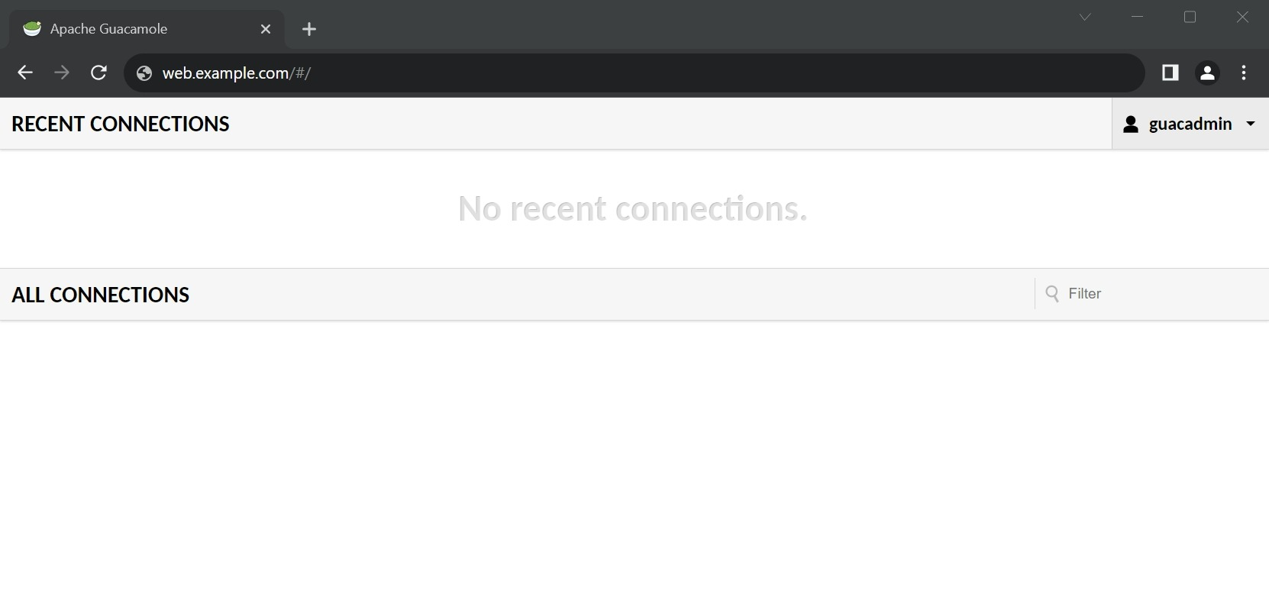
Screenshot 10: Apache Guacamole Dashboard
As new user, we haven't created any remote desktop connections yet. The first thing you must do is to change the default user guacadmin's password. To do so, go to Settings page of guacadmin and go to the Preferences tab. Enter your current password, New password, again the new password for confirmation and update the password.
Screenshot 11: Changing password for current user (guacadmin).

Creating New Connection
:
Now, Create new remote desktop connection. To do so, go to guacadmin -> Settings -> Connections. And then, Click New Connection.
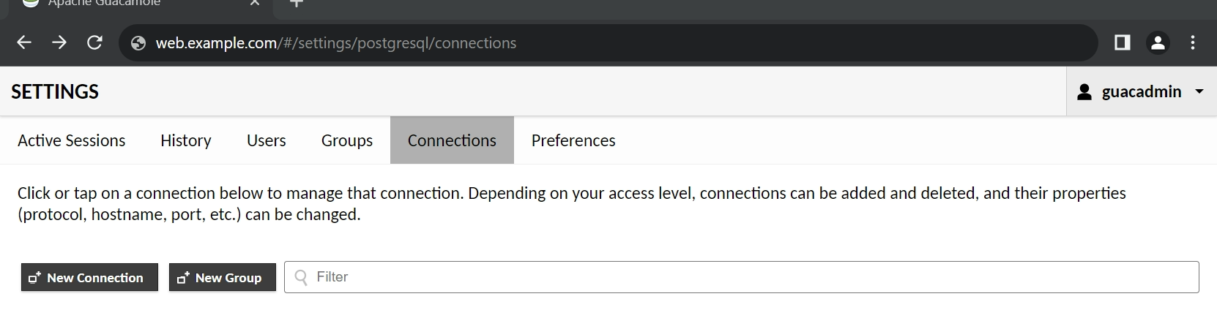
Screenshot 12: Creating New connection in Guacamole.
Enter your remote system details such as name, IP address or hostname, port number, username and password of the remote system details. Also, you need to select the type of protocol from the Protocol drop-down menu. Once entered the necessary details click Save option to create the new connection in guacamole. Similarly, you can create other connections by selecting different protocols such as RDP, VNC and telnet etc.
- Connection Name: Provide a descriptive name for the connection. This name will help users identify the resource they're connecting to.
- Protocol: Select the appropriate protocol for the connection (e.g., RDP, SSH, VNC).
- Hostname/IP Address: Enter the hostname or IP address of the remote server you want to connect to.
- Port: Specify the port number for the connection. This might vary depending on the selected protocol.
- Credentials: Input the necessary credentials, such as username and password, required to log in to the remote server.
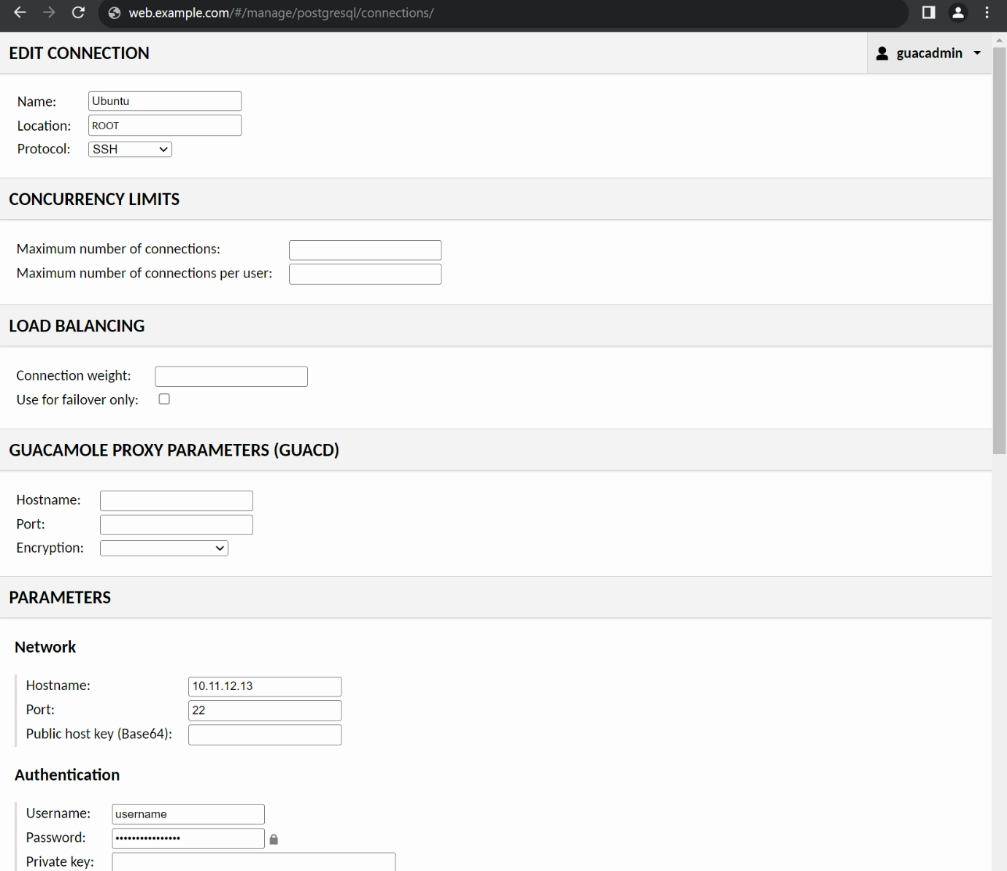
Screenshot 13: Add necessary details of the machine.

Launching the New connection
:
Once you created the New Connection, you can launch it from the Dashboard (Home of the logged in user) of Guacamole webpage. Newly added connection will be listed under ALL CONNECTIONS. To connect with the machine, the user can click on the name Ubuntu (marked in red rectangle) to access it remotely.
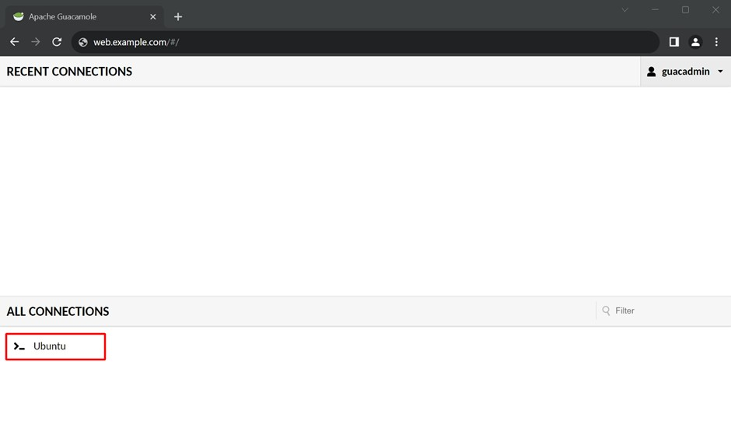
Screenshot 14: Added connection listed in ALL CONNECTIONS of Guacamole Dashboard.
The connection is successful and machine is accessible via Apache Guacamole.
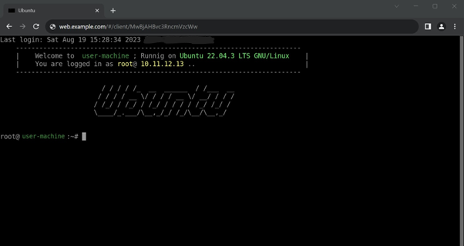
Screenshot 15: Connection is established via Apache Guacamole.

Database Backup and Restoring
:

Backup Database
:
A database backup is a coping or moving of the data and possibly the structure of a database at a specific point in time. The purpose of creating database backups is to ensure data protection and availability in the face of various types of data loss, system failures, or disasters. There are some few key purposes of performing database backups:
- Data Protection: Backups are essential to protect valuable and sensitive data from accidental deletion, corruption, or other types of data loss. If the original data becomes compromised, you can restore it from a backup.
- Disaster Recovery: In the event of a system failure, hardware malfunction, or a catastrophic event, having up-to-date backups allows you to quickly recover your data and restore operations. This helps minimize downtime and business disruption.
- Point-in-Time Recovery: Backups enable you to restore your database to a specific point in time, which is crucial for recovering from errors or data corruption that might not be immediately noticed. This is especially important in situations where only a portion of the data is affected.
- Database Migration: Backups can be used to migrate a database to a different server or environment. By restoring a backup onto a new server, you can replicate the data without needing to recreate the entire database from scratch.
- Testing and Development: Backups can be used as a source for creating test environments or development copies of the database. This allows developers to work with realistic data without affecting the production system.
- Archiving Data: Backups can serve as archives for historical data that is no longer actively used but needs to be retained for reference or compliance purposes.
- Preventive Measures: Regularly creating backups encourages good data management practices and serves as a preventive measure against potential data loss.
It's important to note that there are different types of backups, such as full backups, incremental backups, and differential backups. Each type has its own advantages and trade-offs in terms of storage requirements and recovery speed. The choice of backup strategy depends on factors like data criticality, recovery time objectives, and available resources.
The database backup in PostgreSQL is made with the SQL-dump method, it will generate a text file with SQL commands that, when fed back to the server, then recreate the database in the same state as it was at the time of the dump. PostgreSQL provides the utility program pg_dump for this purpose. The basic usage of this command is:
pg_dump database_name > outfile
To back up a PostgreSQL database manually a single database by logging into the database container, then use the following command:
pg_dump -c -U guacamole_user -d guacamole_database > /var/lib/postgresql/data/backup/backup_name.sql
#guacamole_user- role/user of the database
#guacamole_database- name of the database to backup
#/var/lib/postgresql/data/backup/- default place to save backup
#backup_name.sql- name of the backup with extension
To create a Periodic Database Backup, we are going to create a shell script, save it in the Postgres folder mounted on the host machine (outside the container) and assign it to crontab job, backup will take place every day at 2:00 AM.
Shell Script (databasebackup.sh) for creating a backup from Postgres Container and save it in the host machine to a designated folder. You can also run this script manually to create a backup. The backup file name will contain Year, Month, Date and Time of the backup happened (using timestamp).
#filepath: /home/user/postgresql/
#!/bin/bash

CNT_NAME="postgres"
DB_USER="guacamole_user"
DB_NAME="guacamole_database"
TIMESTAMP=$(date +%Y_%m_%d_%H_%M)
# File paths inside the container and on the host
PATHFILE="/home/user/docker/postgres/backup"
# Access the PostgreSQL container and perform backup
docker exec -t $CNT_NAME pg_dumpall -c -U "$DB_USER" -d "$DB_NAME" > "$PATHFILE/backup_$TIMESTAMP.sql"
# Make the backup of PostgreSQL to host
The detailed explanation of the arguments used in pg_dump and pg_dumpall be found on the PostgreSQL’s official website on the documentation section of pg_dumb and pg_dumpall.
To assign a Crontab job:
#Open and edit the crontab
crontab -e
#enter the below sentence to assign a cron job
00 02 * * * /home/user/docker/postgres/databasebackup.sh
#Backup will be initiated at 02:00 on every day.
The basic usage of cron is to execute a job in a specific time, the User can change or schedule the cron job to execute at desired time. Refer to the examples below:
#At 00:00 on Friday.
0 0 * * FRI /home/user/postgresql/databasebackup.sh

#At 02:30 on Sunday in every 2nd month from January through December.
30 02 * 1-12/2 SUN /home/user/postgresql/databasebackup.sh
To know more about Crontab refer to this site: geekforgeeks - Crontab
To create a Crontab with an explantion, refer to this site: crontab.guru
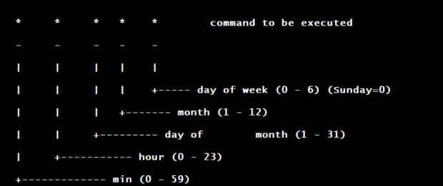
Source: www.adminschoice.com
Figure 3 Crontab’s field explanation

Restoring database
:
Restoring a database, is the action of copying the backed up data and restoring it at its original or new place. We perform restore action on a database so as to return the data to its original state before being lost, stolen or corrupted. There are several causes due to which one needs to restore a database like – due as human errors sometimes data gets corrupted; some malicious attacks on the database might infect it; due to power outages; natural calamities like floods, storms etc. Thus, in these cases, a data restore makes a usable copy of data and ensures that restored backup data is inline and consistent with the state of the data before the damage occurred.
Login into the PostgreSQL container as instructed in the Setting up Guacamole Database and proceed with the below instructions:
Let’s now create a placeholder database for our purpose which will be used to restore the backup. To do so, run the below script.
CREATE DATABASE backup_database ENCODING=’UTF-8’ OWNER=’guacamole_user’;
CREATE DATABASE #output: database is created
The Database is now created as “backup_database”. Now to restore the database, use the pg_restore command supplied with some arguments.
pg_restore -U guacamole_user -d backup_database -v "/home/user/docker/postgres/
backup/backup_2023_01_01_00_00.sql" #location of the database backup file
It is important to note here that, we need to exit from the psql terminal to run pg_restore command. To exit from psql terminal, type “\q” to exit.
The detailed explanation of the arguments be found on the PostgreSQL’s official website on the documentation section of pg_restore.

Monitoring and Logging
:
Logging is an essential part of containerizing applications as it helps developers keep track of patterns, troubleshoot issues, and fix bugs. By default, Guacamole logs all messages to the console. Servlet containers like Tomcat will automatically redirect these messages to a log file, catalina.out in the case of Tomcat, which you can read through while Guacamole runs. Messages are logged at four different log levels, depending on message importance and severity:
error
Errors are fatal conditions. An operation, described in the log message, was attempted but could not proceed, and the failure of this operation is a serious problem that needs to be addressed.
warn
Warnings are generally non-fatal conditions. The operation continued, but encountered noteworthy problems.
info
"Info" messages are purely informational. They may be useful or interesting to administrators, but are not generally critical to proper operation of a Guacamole server.
debug
Debug messages are highly detailed and oriented toward development. Most debug messages will contain stack traces and internal information that is useful when investigating problems within code.

Docker Container logs
:
Docker offers built-in logging solutions and additional features that ensure effective log management. The docker logs command batch-retrieves logs present at the time of execution and it only works with containers utilizing the JSON-file or journald logging driver.
The command syntax for retrieving container logs is:
docker container logs [option] container_id or container_name
Replace container_id with the ID number of the container you want to inspect. To find the container ID, use the docker ps command to list running containers. Also docker provides multiple CLI options to display logs in different formats
The options used for configuring the output according to individual needs:
Command Option Description
--details Display additional details provided to logs.
--follow, -f Follow log output.
--since Display logs since a specified timestamp (e.g. 2022-05-06T14:48:33Z) or relative (e.g. 20m).
--tail, -n Specify the number of lines to show from the end of the logs.
--timestamps, -t Show timestamp.
--until Display logs before a specified timestamp.
See the below image, the Docker is running the four container with unique ID.
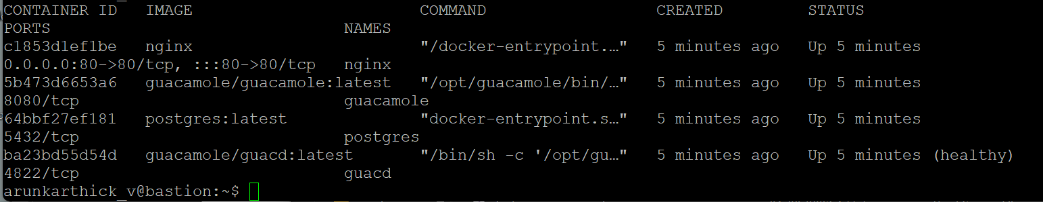
Screenshot 16: Currently running Docker containers
To display its logs, run:
docker logs c1853d1ef1be #with container ID

docker logs nginx #with container Name
As in the image below, Docker responds by listing the event logs (partial output) for that specific container in the output.
Screenshot 17: Logs of Nginx Docker container while running
We can continuously watch the log output in real-time after running the docker-compose file. For example, see the below screenshot of the Docker container logs of guacamole (partial output) is list out with Error, Info and Warn log levels, while running the docker containers, with this real-time log we can easily check and rectify the issues occurring with the docker containers. To know more about the Docker Log output, refer to this website: Docker-compose Logs.
Screenshot 18: Above image: ERROR and INFO logs of Guacamole Docker container &
Below image: Error log on Guacamole container about unable to authenticate on PostgreSQL

Access Control
:
Access control is a critical component of the Bastion setup to maintain security and manage user permissions effectively. Apache Guacamole offers a flexible and comprehensive system for controlling user access to remote resources. This section will guide you through setting up access control to ensure that only authorized users can utilize the Bastion host.
- User Authentication:
Authentication Providers: Apache Guacamole supports various authentication methods such as LDAP, RADIUS, and Database. Choose the authentication provider that aligns with your organization's security policies.
Configuration: Configure the authentication provider in the guacamole.
properties file. Provide the necessary details such as server addresses, ports, and credentials.
- User Management:
User Mapping: Edit the user-mapping.xml file to map user accounts to connections and groups. Define the connections and groups each user can access.
- Permission Management:
Connection Permissions: Specify whether users have read-only or full-control permissions for each connection. This ensures that users can only perform actions they are authorized to perform.
Group Permissions: Apply permissions at the group level to streamline access control. Users within a group inherit the permissions assigned to that group.
- Testing and Monitoring:
Testing Access: Thoroughly test user access using different user accounts to ensure that permissions are correctly enforced.
Logging and Auditing: Monitor Guacamole logs to track user activities and diagnose any access-related issues.
- Regular Review and Maintenance:
Periodic Auditing: Regularly review user permissions and access logs to ensure that only authorized users have access and that permissions are up to date.

Security Considerations
:
Maintaining a robust security posture is crucial for Bastion setup to protect sensitive resources and data. Apache Guacamole offers various security features that can be leveraged to enhance the security of your remote access environment.
These are the outlines which are important security considerations to keep in mind:
- Network Security
- Encryption
- Authentication and access control
- User monitoring and Auditing
- Regular updates
- Physical Security
- Backup and Disaster Recovery
- Intrusion Detection and Prevention
- User education
- Incident response plan
- Third-Party integrations

Maintenance
:
Maintenance of Bastion setup using Apache Guacamole involves regularly updating the Guacamole software and its dependencies to ensure optimal performance, security, and compatibility. It includes tasks such as backing up configuration data and user settings, monitoring system logs for anomalies, reviewing user access and permissions, testing connections and disaster recovery processes, staying informed about security vulnerabilities, and applying patches promptly, educating users about best practices, and keeping documentation up to date. By proactively addressing these tasks, we can ensure a secure, reliable, and efficient remote access environment that aligns with organization's needs and enhances overall operational resilience.

Upgrades
:
Upgrades in Bastion setup involve transitioning to newer versions of Apache Guacamole and associated components, offering improved features, bug fixes, and enhanced security. This process includes assessing compatibility with existing configurations, testing upgrades in a controlled environment, ensuring proper data backup and migration, updating dependencies to maintain stability, and verifying that user access, permissions, and connections are retained after the upgrade. By effectively managing upgrades, you leverage the latest capabilities while minimizing disruptions to your remote access environment, ultimately enhancing efficiency and security.

Troubleshooting
:
Troubleshooting in Bastion setup with Apache Guacamole involves diagnosing and resolving issues that may arise during remote access operations. It encompasses identifying connectivity problems, examining error messages in logs, checking network configurations for firewalls or DNS issues, ensuring proper authentication settings, and confirming that server resources are sufficient. Troubleshooting also involves testing connections from different devices, verifying user credentials, and reviewing system status indicators.
- Unable to connect to remote desktop:
- Check if the remote server is up and running.
- Verify that the connection parameters (hostname, port, protocol) are correct.
- Ensure that the user credentials are accurate and have necessary permissions.
- Look for any firewall or network issues blocking the connection.
- Blank screen or distorted display:**
- Make sure that the display settings (color depth, resolution) are appropriate for the remote system.
- Verify that the Guacamole client's browser supports HTML5 and the required codecs.
- Check if there are any browser extensions causing conflicts.
- Authentication issues:
- Double-check the user authentication configuration in Guacamole's settings.
- Verify that the database or authentication provider is properly configured.
- Test the authentication provider separately to ensure it's working correctly.
- Connection timeout or disconnects:
- Check if there's an idle timeout configured on the Guacamole server or the remote system.
- Inspect the Guacamole logs for any error messages related to disconnections.
- Investigate network stability and latency issues that could be causing disconnects.
- SSL certificate errors:
- Ensure that the SSL certificate used by Guacamole is valid and properly configured.
- Check the browser's security settings to make sure it's not blocking the certificate.
- Verify that the certificate's common name matches the Guacamole server's hostname.
- Guacamole web application not loading:
- Look for any errors in the Guacamole server logs.
- Clear your browser's cache and cookies, then try accessing the Guacamole web app again.
- Check if there are any conflicts with other applications running on the same server.
- Clipboard or file transfer not working:
- Ensure that clipboard and file transfer settings are enabled in the Guacamole connection configuration.
- Verify that the necessary plugins are installed and enabled on the Guacamole server.
- Check if the browser has permission to access the clipboard.
By systematically addressing these aspects, you can pinpoint and resolve problems efficiently, ensuring uninterrupted and secure remote access for users. Refer to this link for more information: Apache Guacamole Troubleshooting.

Appendices
:
The appendices section of the documentation serves as a supplementary resource for users seeking additional information and tools. It includes useful references such as command line examples for common tasks, configuration file templates, glossaries explaining technical terms, and links to external resources such as official documentation, community forums, and relevant articles. By providing appendices, you empower users with extra knowledge and tools that complement the main documentation, offering comprehensive guidance and facilitating their understanding and implementation of the Bastion setup using Apache Guacamole.

Glossary and Terms
:
This glossary provides definitions for key terms used in the context of Bastion setup documentation using Apache Guacamole. It's aimed at assisting users in understanding technical terminology and concepts related to remote access and security.
- Bastion Host: A secure gateway that acts as an intermediary between external users and internal resources, providing controlled access to sensitive systems without exposing them directly to the internet.
- Remote Access: The ability to connect to and control a computer or network from a remote location, often facilitated through protocols like RDP, SSH, or VNC.
- Authentication: The process of verifying the identity of a user, typically involving the use of usernames, passwords, and additional factors like two-factor authentication (2FA) to ensure secure access.
- Authorization: The process of granting or restricting access to specific resources or actions based on the authenticated user's permissions and roles.
- Connection: A configuration in Apache Guacamole that defines the parameters for connecting to a remote server or service, including details like hostname, port, protocol, and credentials.
- Cross-platform: A product or system that can work across multiple types of platforms or operating environments. A platform can refer to a hardware device, an operating system, a software framework, or a programming language.
- Connection Group: An organizational unit used in Apache Guacamole to categorize and manage related connections for easier user access and administration.
- Clientless Remote Desktop Gateway: It provides a secure and encrypted connection to the server with no plug-ins or client software are required, which is perfect for when you need access from a mobile device or any device with a web browser
- LDAP (Lightweight Directory Access Protocol): A protocol used for accessing and managing directory information, often used for user authentication and authorization.
- Open source: It is source code or software that is made freely available for possible modification and redistribution. It encourages open collaboration with products such as source code, blueprints, and documentation freely available to the public.
- RADIUS (Remote Authentication Dial-In User Service): A protocol that provides centralized authentication, authorization, and accounting for remote access to networks and services.
- SSL/TLS Encryption: Secure Socket Layer (SSL) or Transport Layer Security (TLS): It is the protocols used to encrypt data transmitted between the client and server, ensuring confidentiality.
- Single Sign-On (SSO): An authentication process that allows users to access multiple applications with a single set of credentials, improving convenience and security.
- Role-Based Access Control: A method of controlling access to resources based on the roles assigned to users, allowing fine-grained permission management.
- Two-Factor Authentication (2FA): An additional layer of security requiring users to provide two forms of authentication (e.g., password and OTP) before accessing a system.
- Intrusion Detection System (IDS): Software or hardware that monitors network traffic for suspicious activities or unauthorized access attempts.
- Backup and Restore: The process of creating copies of data (backups) to ensure data recovery in case of data loss or system failure (restore).
- Incident Response Plan: A structured approach detailing how an organization will respond to and manage security incidents, aiming to minimize damage and reduce recovery time.
- Load Balancing (Optional): Distributing incoming network traffic across multiple servers to ensure optimal resource utilization, performance, and redundancy.
- Command Reference: A list of commands and their usage within Apache Guacamole for quick access to perform specific actions.
- apt-transport-https: It allows the use of repositories accessed via the HTTP Secure protocol (HTTPS), also referred to as HTTP over TLS
- ca-certificates: These digital certificates are data files used to cryptographically link an entity with a public key. Web browsers use them to authenticate content sent from web servers, ensuring trust in content delivered online.
- Curl: It is a command line tool that enables data transfer over various network protocols. It communicates with a web or application server by specifying a relevant URL
- Software-properties-common: Software Property applications is an internet technology business concept pursuant to which, inter alia, customers will be able to view a video instead of a static image when viewing potential items for purchase, rent, etc.

Conclusion
:
Setting up Apache Guacamole as a Docker container using Docker Compose offers a multitude of advantages that streamline the deployment process and enhance remote desktop access capabilities. This approach combines the power of containerization with a simplified orchestration tool, resulting in a comprehensive solution for efficiently managing and scaling Guacamole deployments.
Apache Guacamole serves as a robust and flexible open-source remote desktop gateway. By encapsulating its components within Docker containers, administrators can achieve consistent behavior across various environments. This consistency minimizes compatibility issues that might arise due to differences in system configurations. Each container holds its own isolated environment, eliminating potential conflicts between dependencies and ensuring that the application operates as intended.
Docker Compose, an orchestration tool for defining and running multi-container applications, simplifies the setup process even further. Through a declarative configuration file, administrators can define the different components required for Guacamole's functionality, such as the Guacamole client, the Guacamole server, and associated databases. This approach streamlines the process of creating and managing these containers, allowing users to launch the entire Guacamole environment with a single command. Such simplicity facilitates both initial setup and subsequent replication, reducing the learning curve for administrators.
Beyond ease of deployment, the Docker containerization of Guacamole promotes security through isolation. Each component resides within its own container, ensuring that potential vulnerabilities are contained and unable to compromise the entire system. This separation minimizes the attack surface, mitigating the impact of security breaches and safeguarding sensitive data. Moreover, administrators can employ Docker's security features, such as network segmentation and access controls, to fortify the overall security posture of the deployment.
The modular architecture of Guacamole aligns seamlessly with Docker's container approach. This modularity not only facilitates easier troubleshooting and updates but also empowers administrators to scale their deployments effortlessly. Whether expanding to accommodate a growing user base or adapting to fluctuating workloads, administrators can spin up additional containers to distribute the load and maintain optimal performance.
In terms of maintenance and updates, Docker Compose simplifies the process by enabling the granular management of containers. Updates can be performed independently for each container, minimizing disruption to the entire environment. This approach contrasts with traditional monolithic applications, where updating one component might require downtime for the entire system. Consequently, administrators can ensure continuity of service while applying necessary updates and patches.
In conclusion, setting up Apache Guacamole as a Docker container using Docker Compose presents a holistic solution that capitalizes on the benefits of both containerization and orchestration. This approach offers consistency, scalability, and security while simplifying deployment, management, and maintenance. As remote desktop access becomes increasingly critical in modern work environments, this method empowers organizations to establish a reliable and resilient infrastructure that can adapt to evolving demands. By embracing the containerized Guacamole deployment model, organizations can enhance productivity and security while reducing complexities.

