#1Brand

1. GetAllBrand

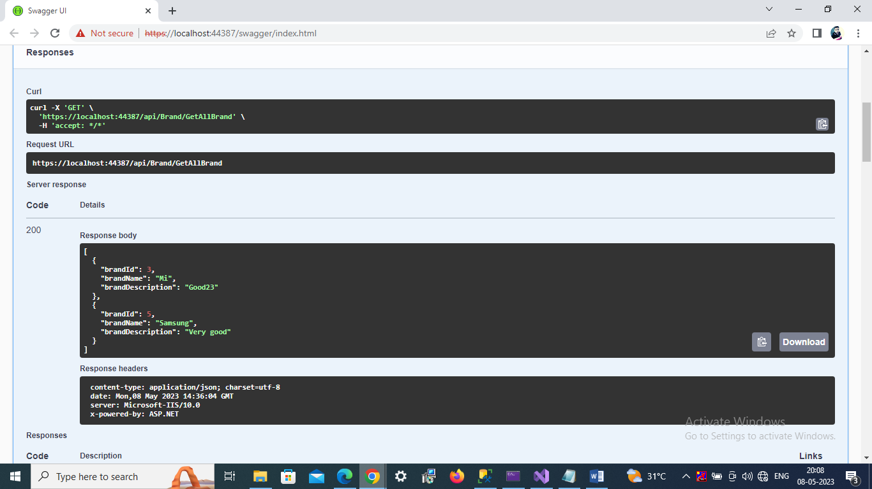

2. GetBrandById

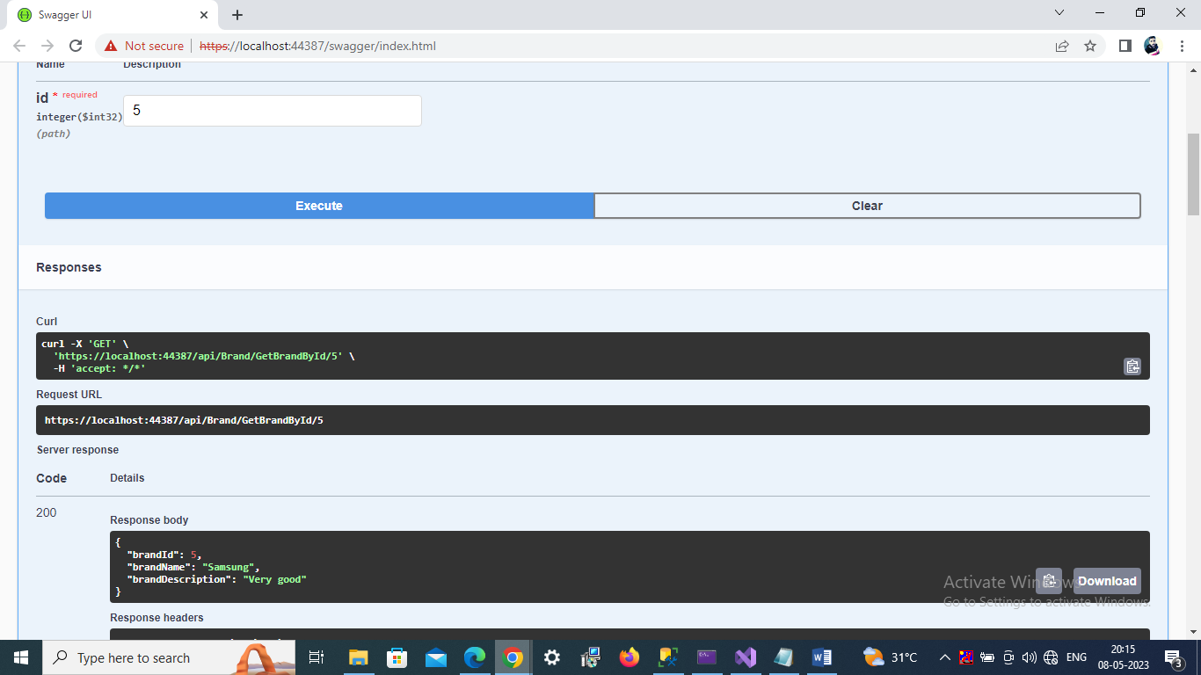

3. Add brand(Post)

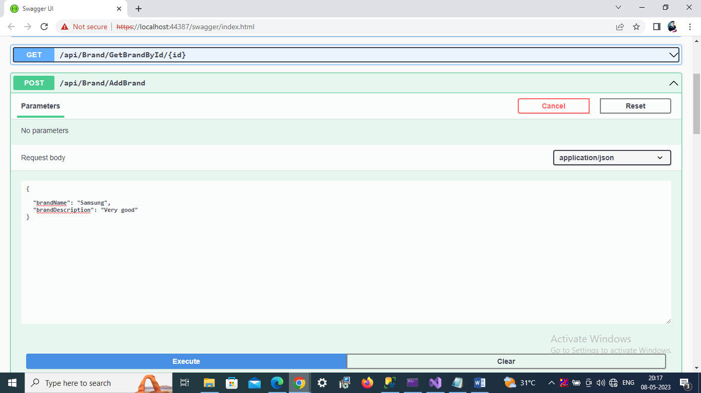

4. Update brand

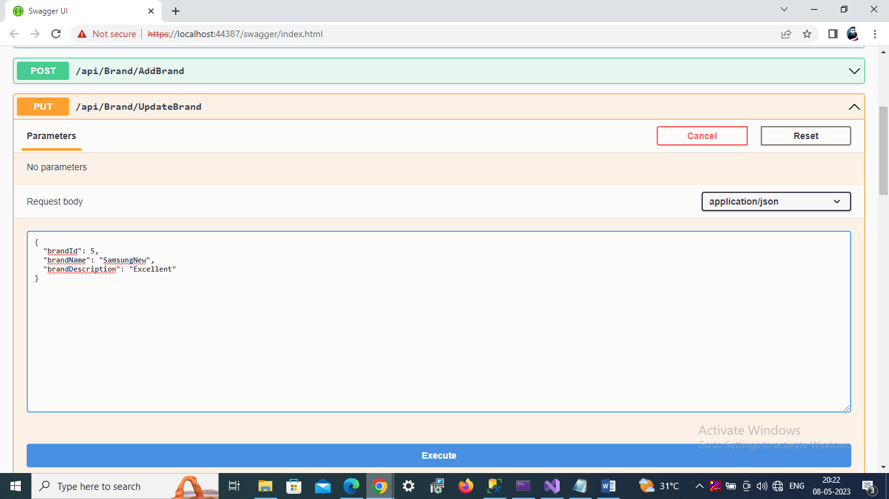

5. delete brand

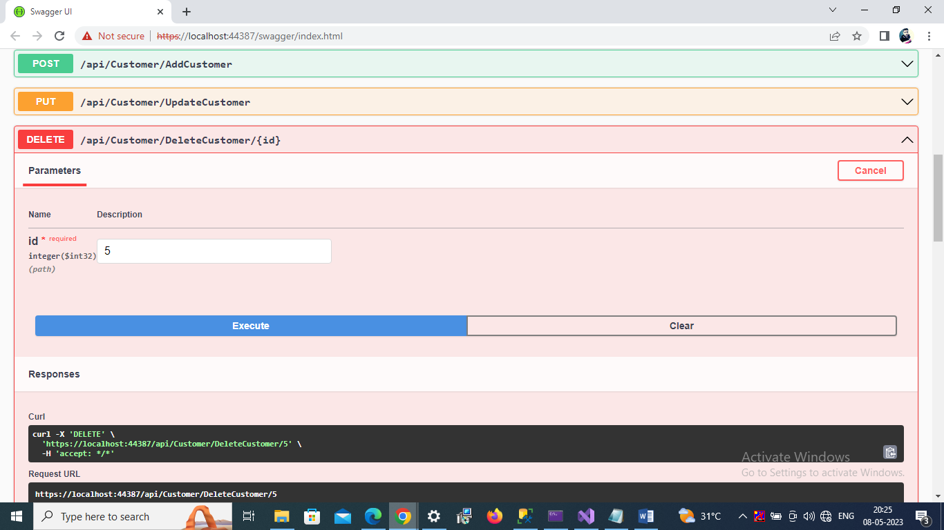

#2Customer

1. GetAllCustomer

2. GetCustomerById

3.AddCustomer

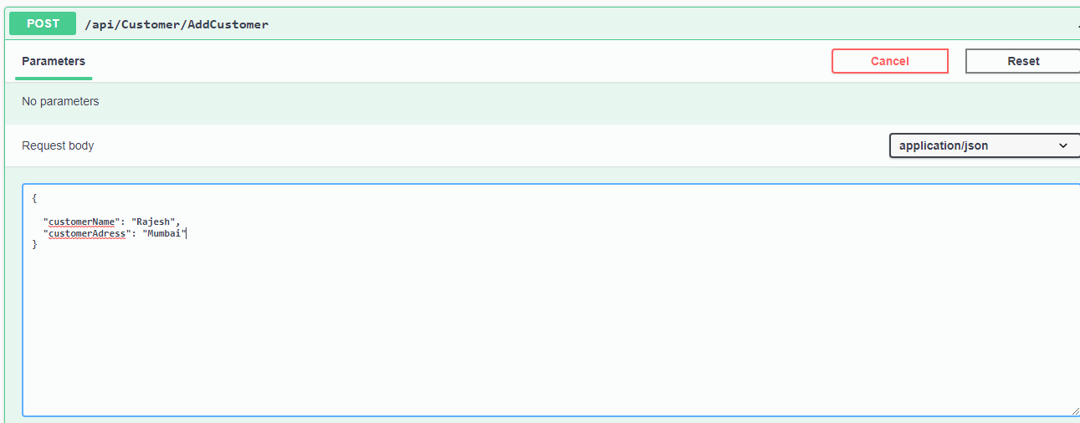

4. UpdateCustomer

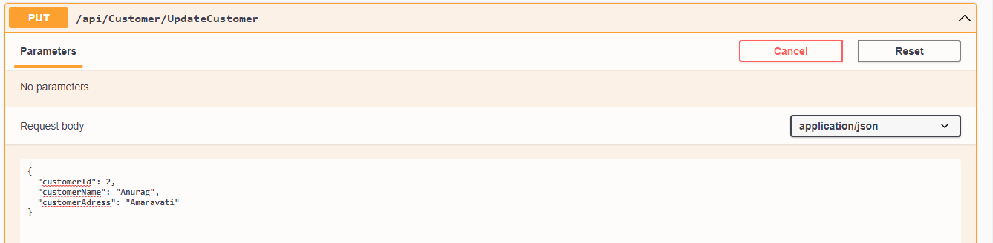

5. DeleteCustomer

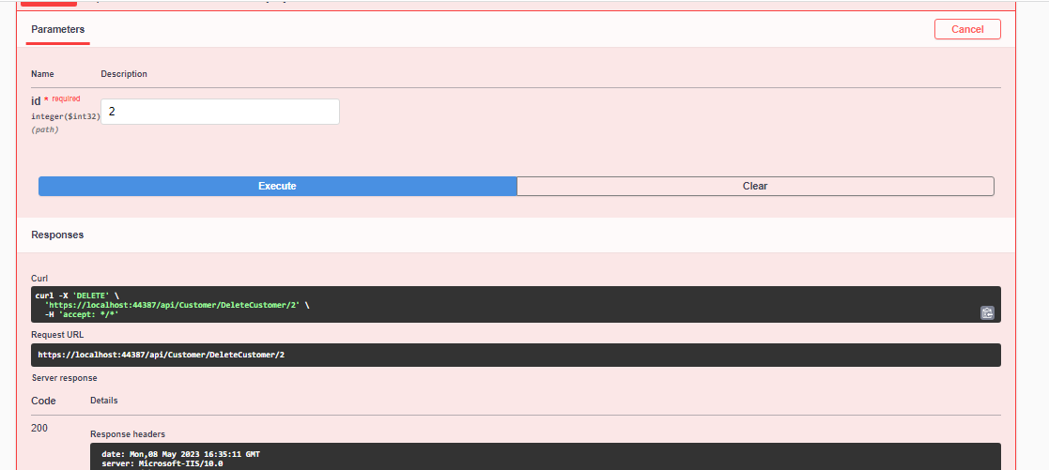

#3Mobile

1. GetAllMobile

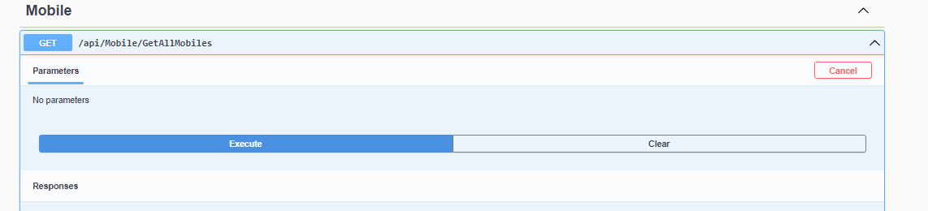

2. GetMobileById

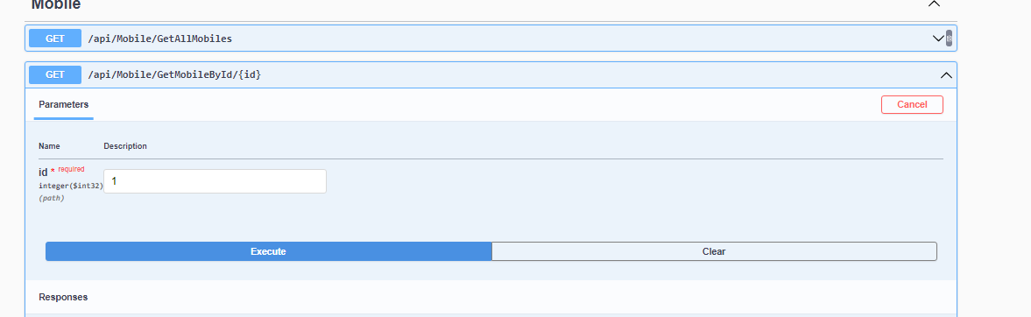3.AddMobile

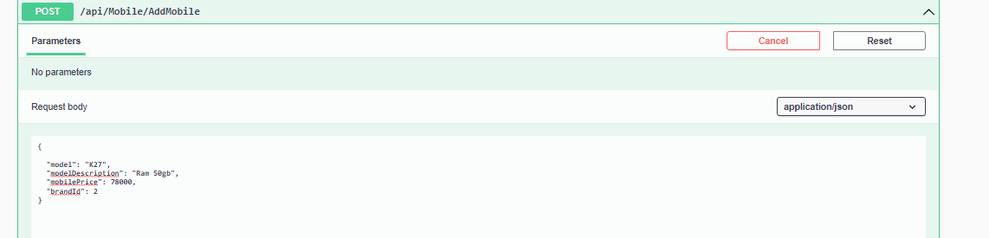

4. UpdateMobile

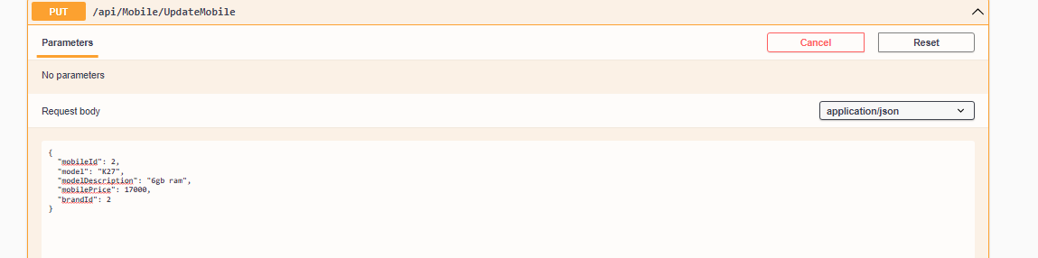

5. DeleteMobile

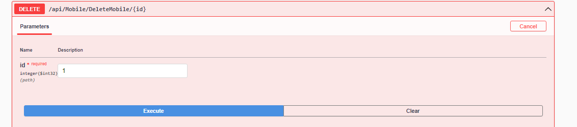

#3Sale

1. GetAllSalesDetails

a. Show all Sale product list

b. displays all sale details

2. GetSaleById

a. application will accept the sale id

b. application will display one sale details

c. if sale id doesn’t exists then application will return http status code 204 “no content”

.

3.SaleProduct

a. Add new sale record

b. application will accept saleid details like saledate, saleprice,discount & finalprice

c. application will save data in DB

d. application will return success http status code 201 created

4. Updatesale

a. application will accept the sale id

b. based on sale id record will be modified in the database.

c. if id not matched then application will give error

d. if applicaton modified data then application will return status 200 ok

5. DeleteSaleRecord

a. application will accept the Saleid

b. based on saleid record will be Deleted.

c.if record not found gives error.