Mongo DB
Before embedding test cases
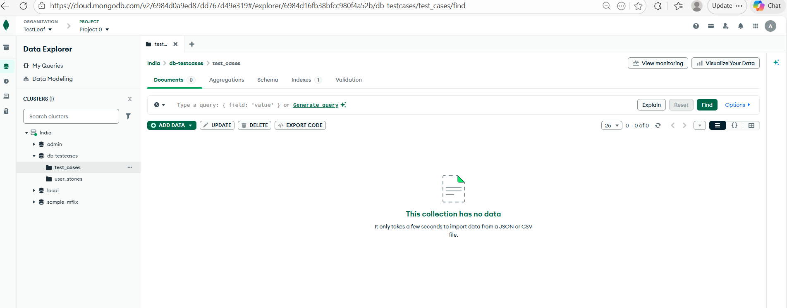
Before embedding user stories
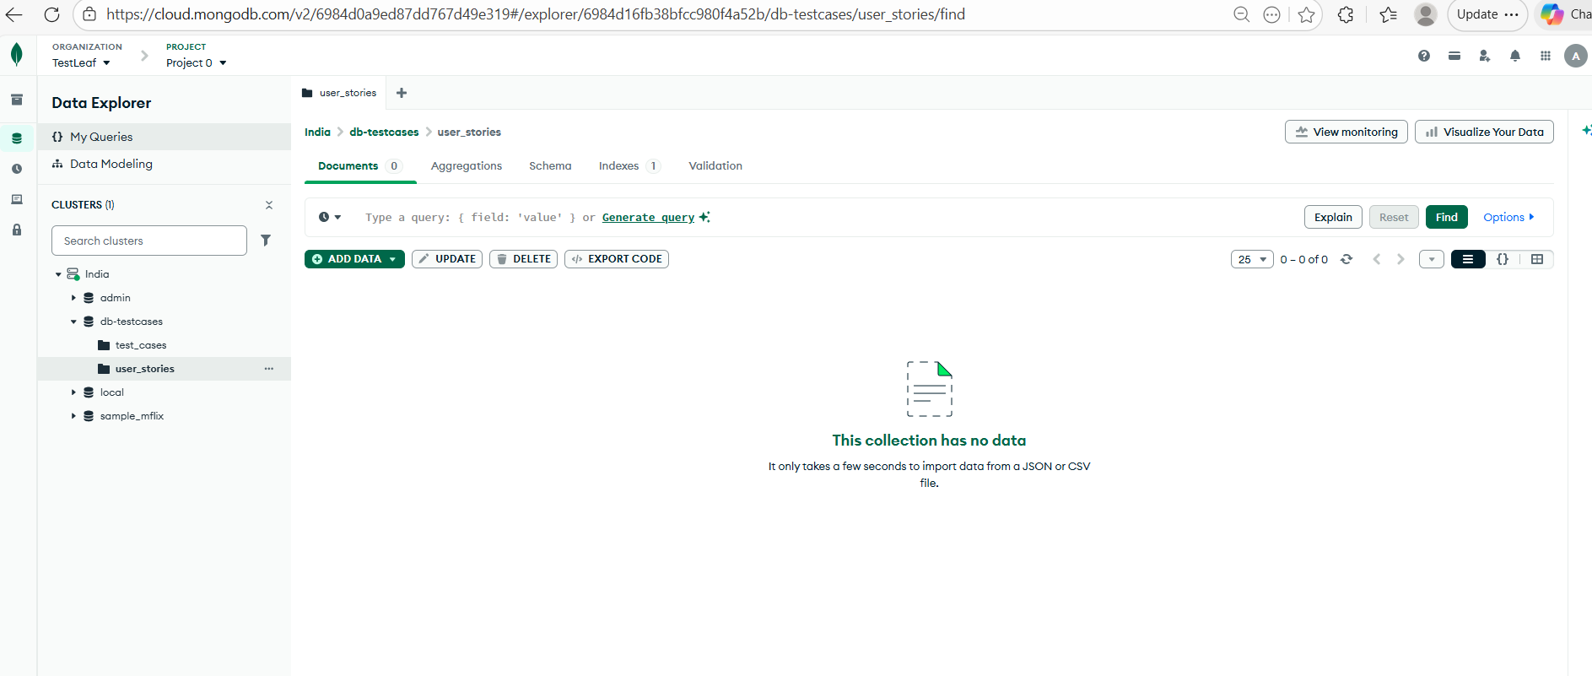
Created vector index in Mongo DB based on the index name in .env file
MongoDB Vector search Index

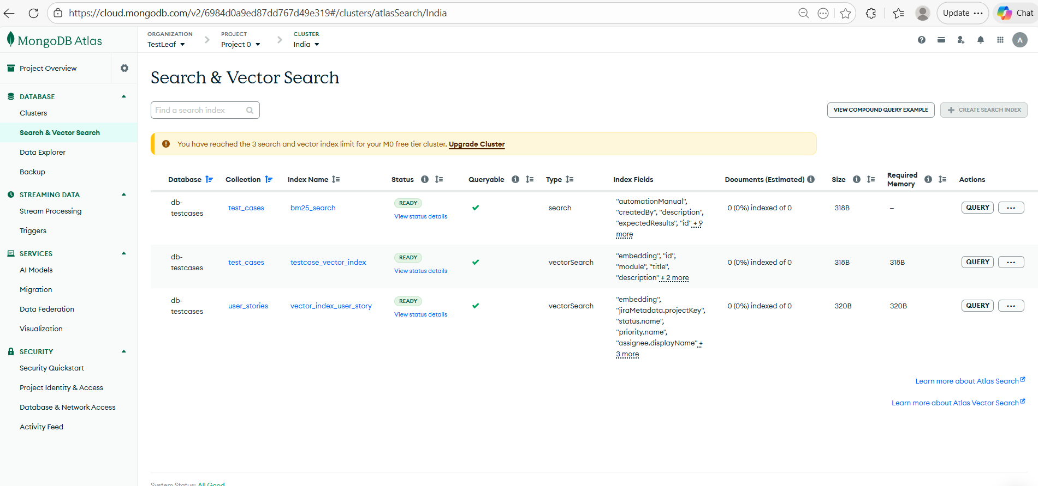

Converting test cases to JSONL
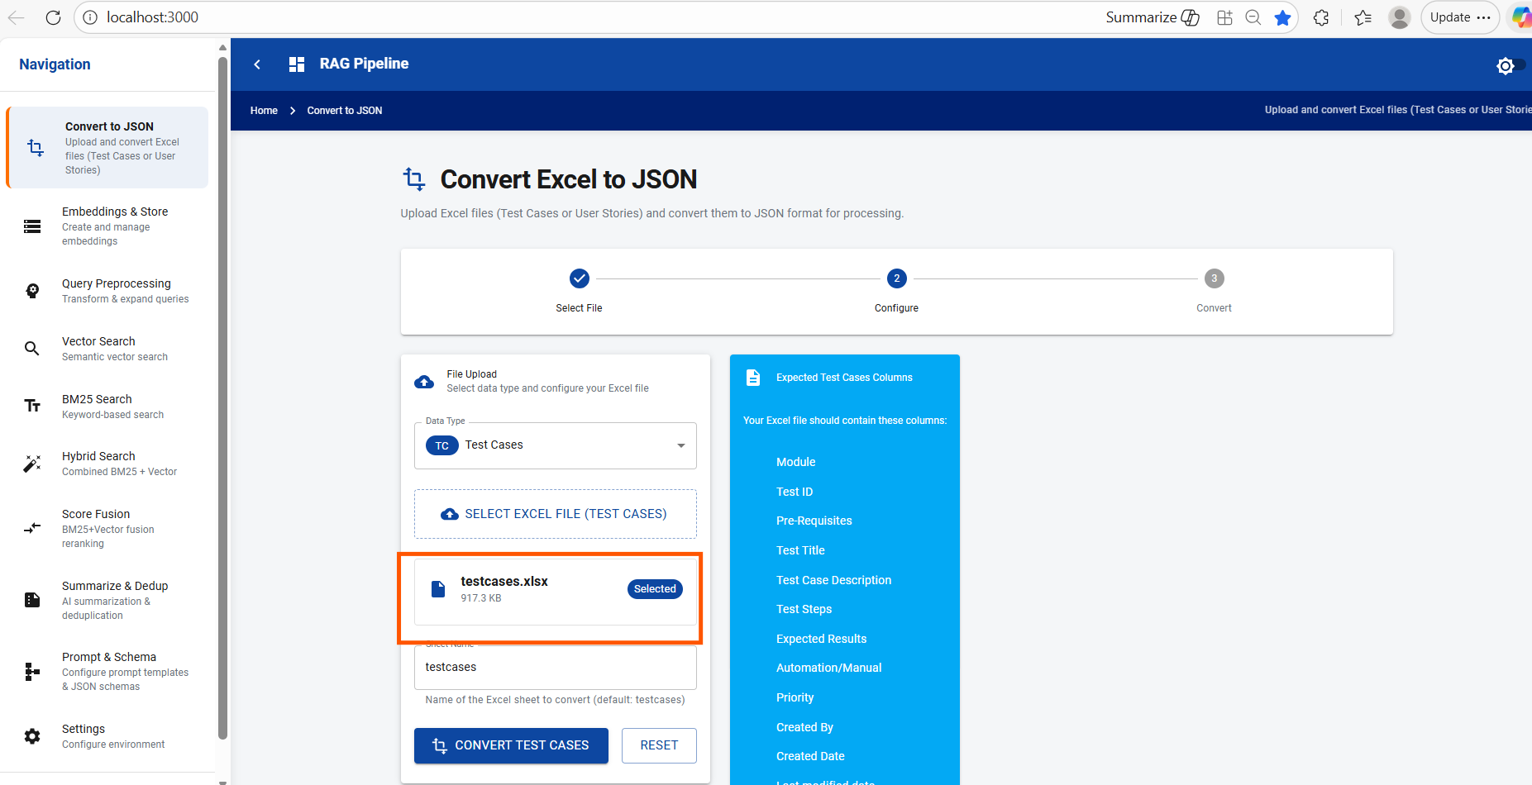

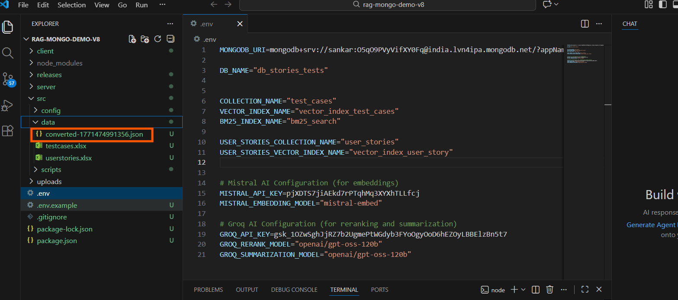
Embedding the test cases in MongoDB
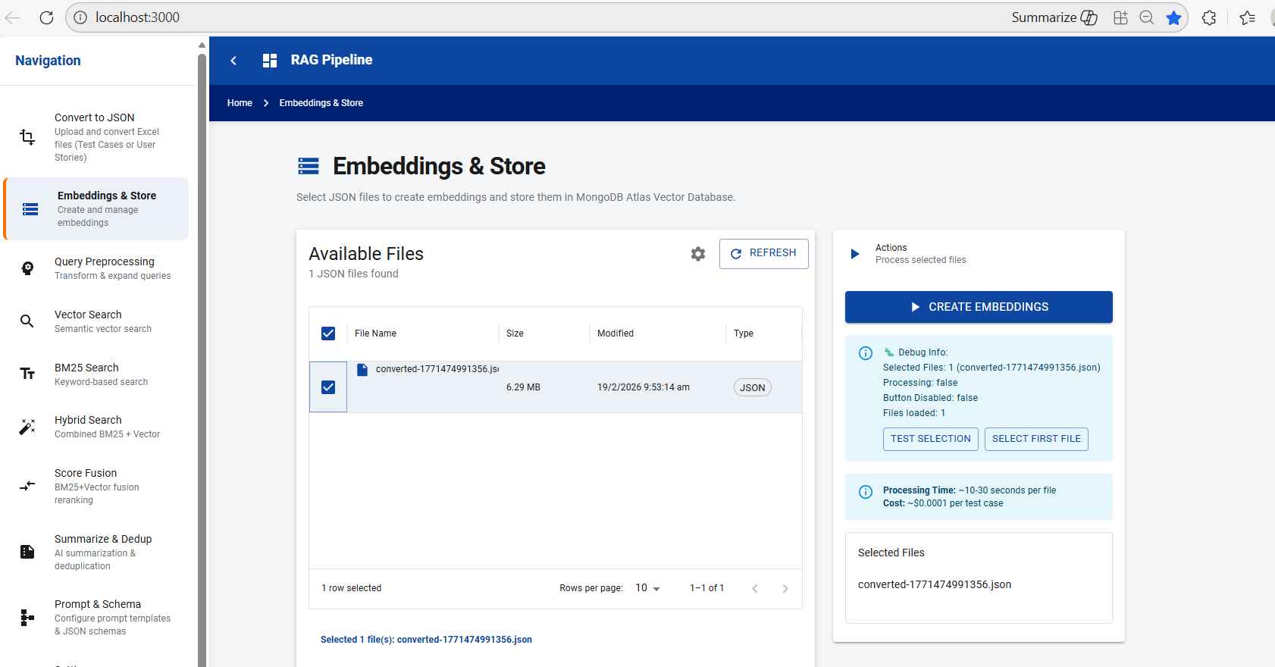

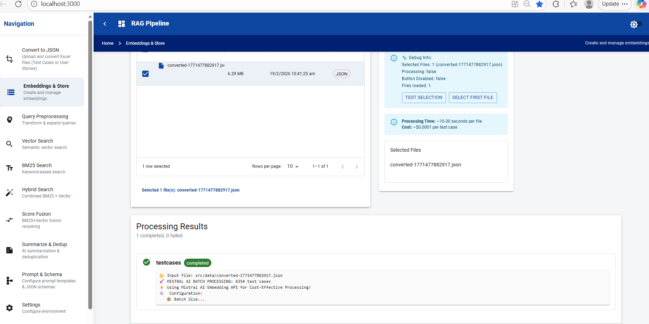

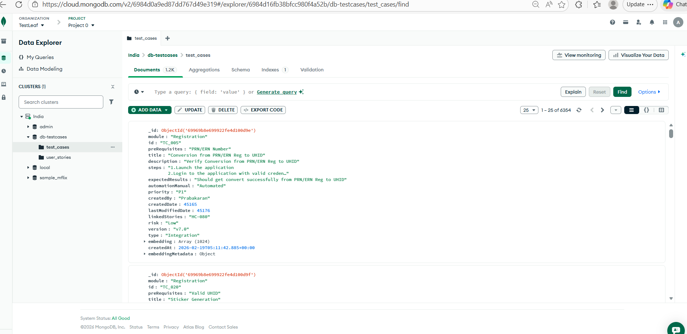

Embedding user stories in MongoDB
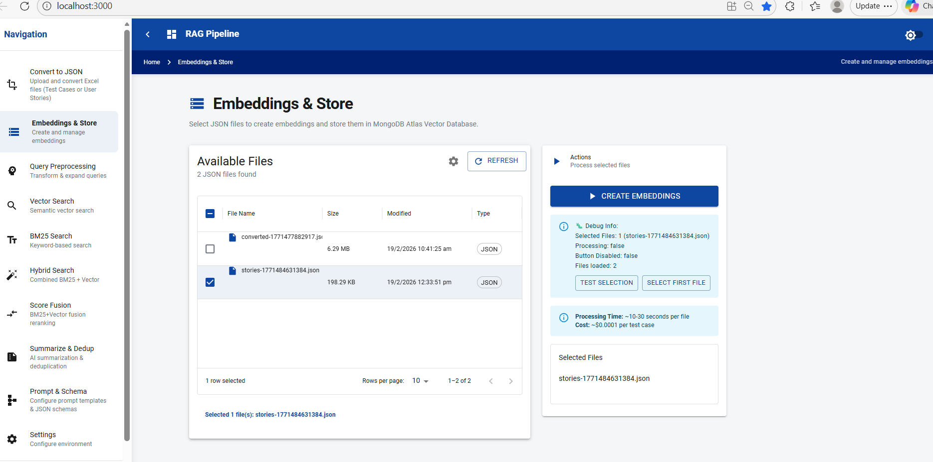

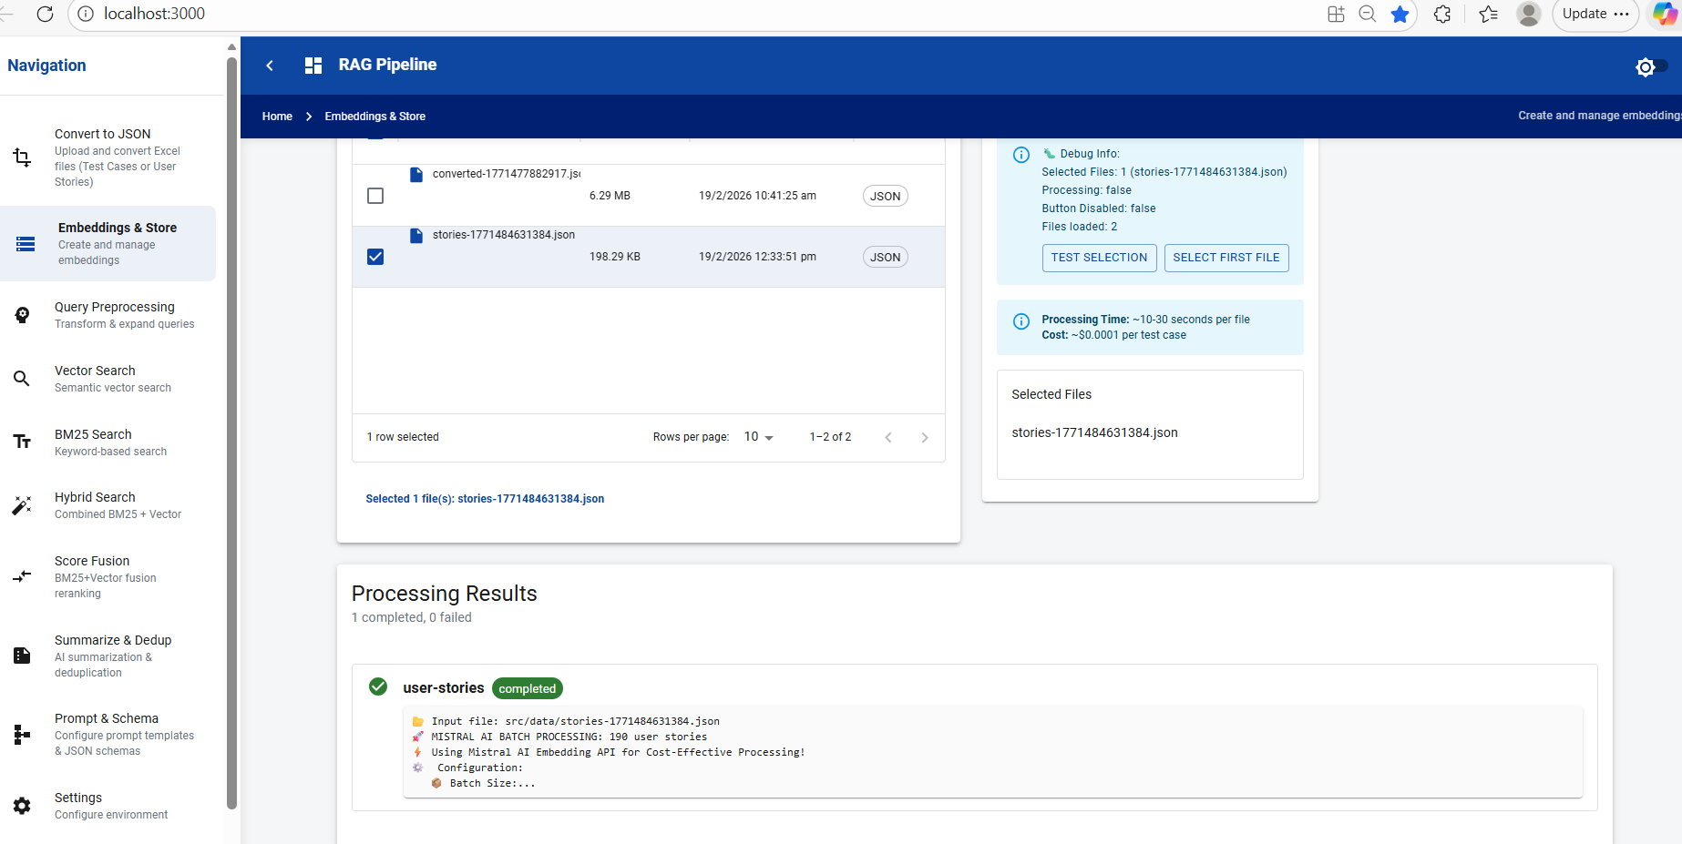

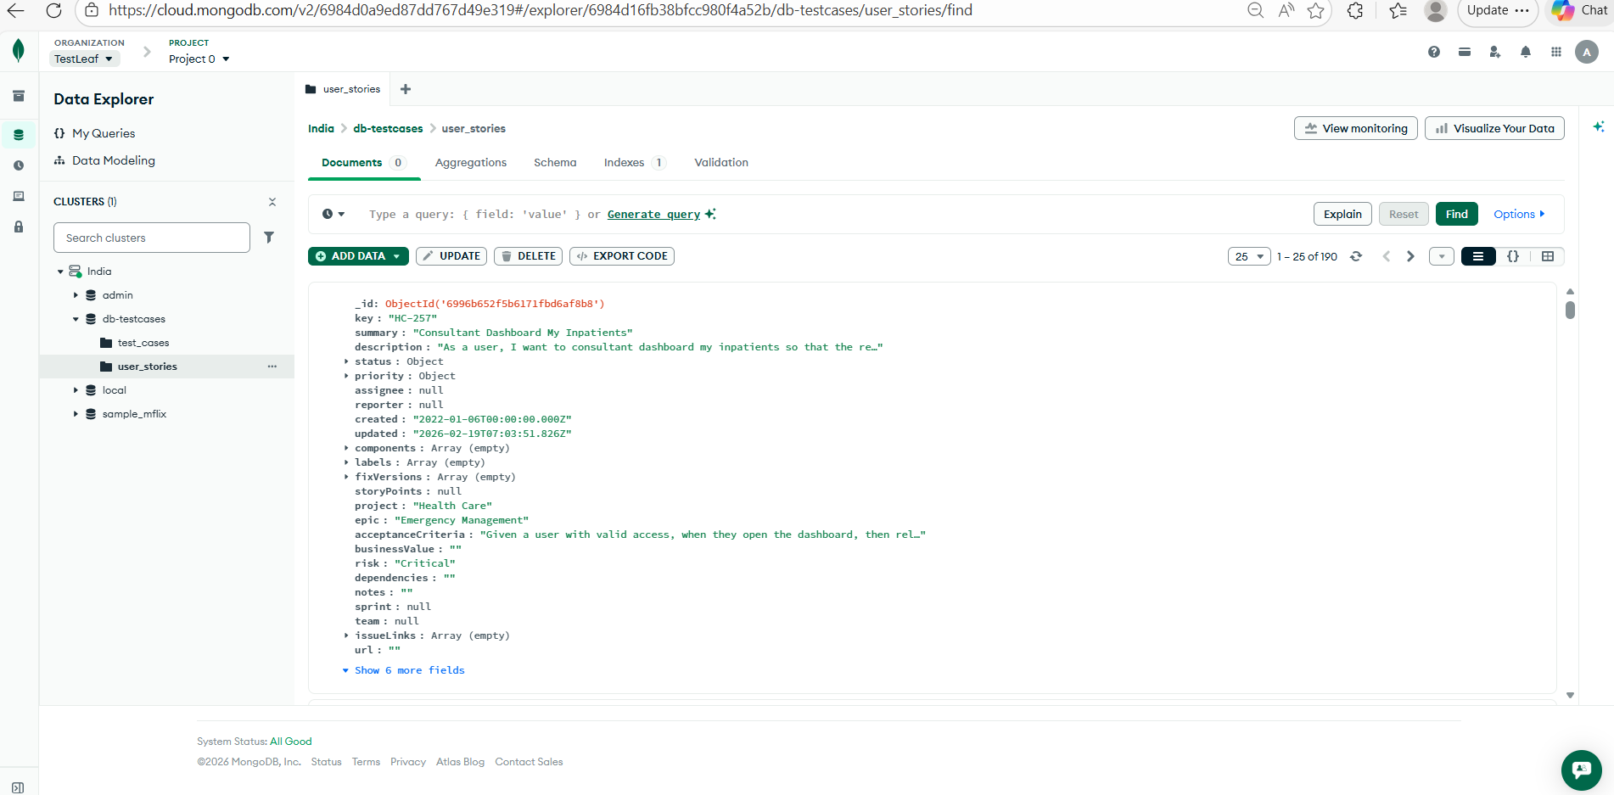

BM25 Search Index

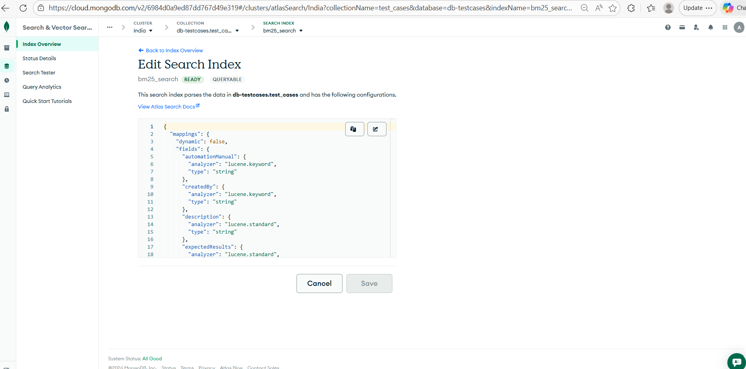

{
"mappings": {
"dynamic": false,
"fields": {
"automationManual": {
"analyzer": "lucene.keyword",
"type": "string"
},
"createdBy": {
"analyzer": "lucene.keyword",
"type": "string"
},
"description": {
"analyzer": "lucene.standard",
"type": "string"
},
"expectedResults": {
"analyzer": "lucene.standard",
"type": "string"
},
"id": {
"analyzer": "lucene.keyword",
"type": "string"
},
"linkedStories": {
"analyzer": "lucene.keyword",
"type": "string"
},
"module": {
"analyzer": "lucene.standard",
"type": "string"
},
"preRequisites": {
"analyzer": "lucene.standard",
"type": "string"
},
"priority": {
"analyzer": "lucene.keyword",
"type": "string"
},
"risk": {
"analyzer": "lucene.keyword",
"type": "string"
},
"steps": {
"analyzer": "lucene.standard",
"type": "string"
},
"title": {
"analyzer": "lucene.standard",
"type": "string"
},
"type": {
"analyzer": "lucene.keyword",
"type": "string"
},
"version": {
"analyzer": "lucene.keyword",
"type": "string"
}
}
}
}
Query Preprocessing
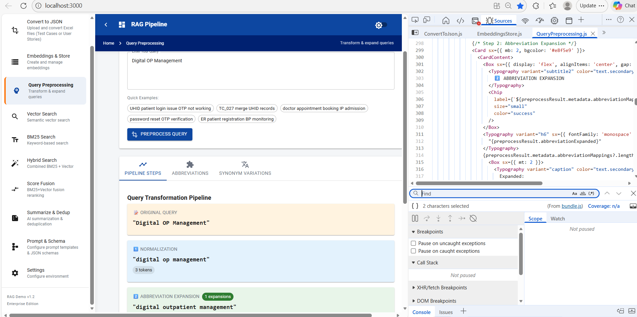

Vector search
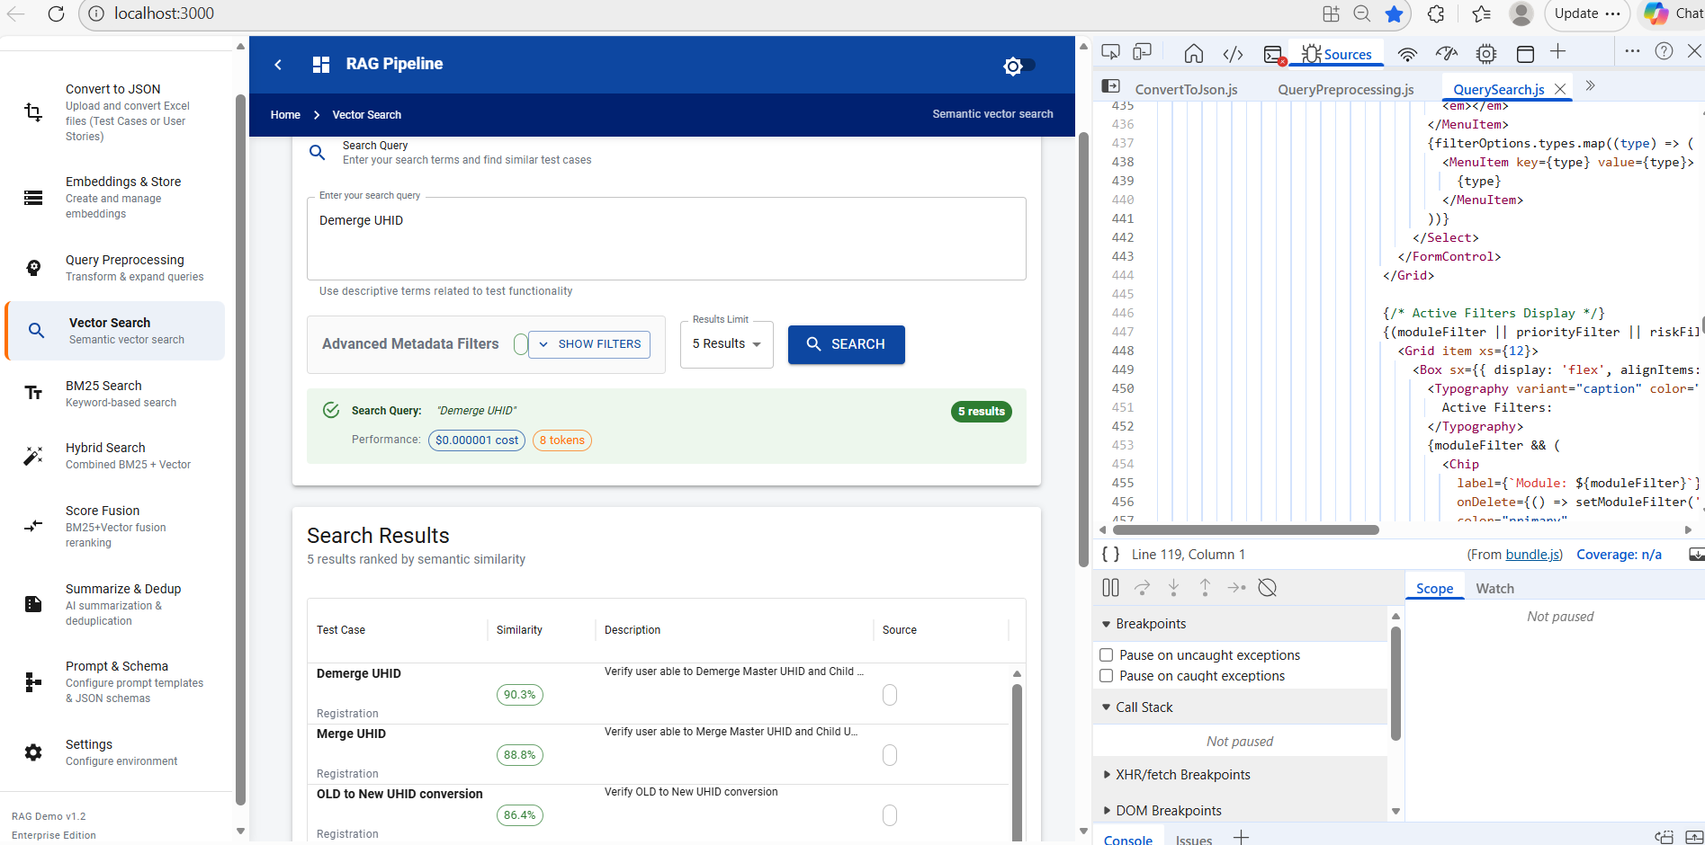
BM25 Search
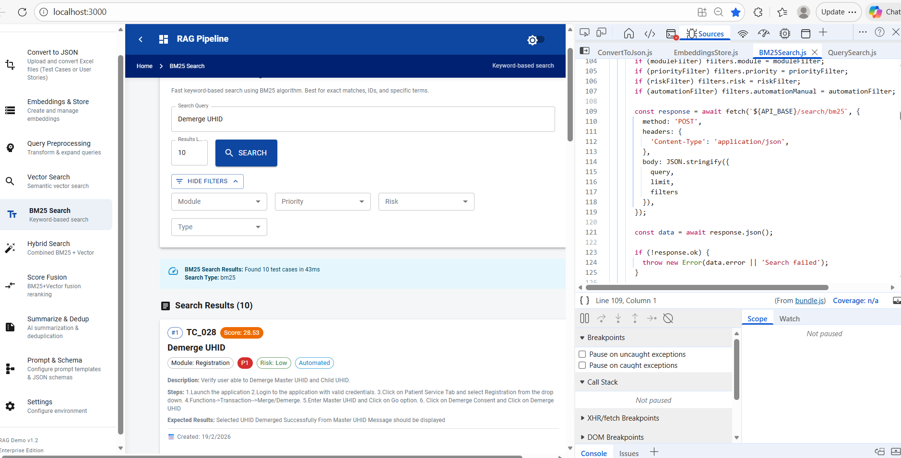
Hybrid Search
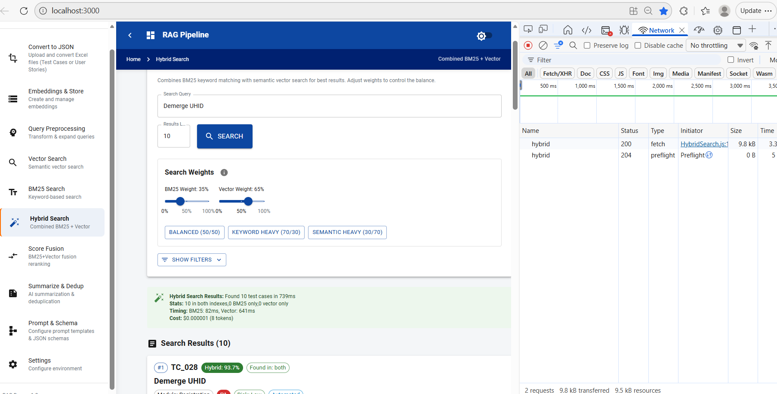

Summarization and De-duplication
